|  |  |
| --- | --- |
|  | **MINISTRY OF EDUCATION AND TRAINING** |

|  |
| --- |
| **FPT UNIVERSITY** |
| Capstone Project Document |
| HOLALAND SYSTEM |

|  |  |
| --- | --- |
| **Hola Team** | |
| **Group Members** | Phạm Hữu Thọ – HE130924 (Leader)  Nguyễn Minh Tuấn –HE130922 (Member)  Đoàn Quốc Việt HE –130470 (Member)  Nguyễn Hoàng Đức – SE06110 (Member)  Phạm Thế Anh HE –130515 (Member) |
| **Supervisor** | Nguyễn Tất Trung |
| **Capstone Project code** | HolaLand |

- Hanoi, December 19, 2021 -

**Table of Contents**

Contents

Acknowledgment 9

Definition and Acronyms 9

I. Project Introduction 10

1. Overview 10

1.1 Project Information 10

1.2 Project Team 10

1.2.1 Supervisor 10

1.2.2 Team Members 10

2. Product Background 10

3. Existing Systems 10

4. Business Opportunity 11

5. Software Product Vision 11

6. Project Scope & Limitations 11

6.1 Limitations & Exclusions 12

6.2 Major Features 12

6.3 Business flows 12

6.3.1 Member Process 12

6.3.2 Recruiter Process 13

II. Project Management Plan 13

1. Overview 13

1.1 WBS & Estimation 13

1.2 Project Objectives 15

1.3 Project Risks 16

2. Management Approach 16

2.1 Project Process 16

2.2 Quality Management 17

2.3 Training Plan 19

3. Master Schedule 19

4. Project Organization 21

4.1 Team & Structures 21

4.2 Roles & Responsibilities 21

5. Project Communication 22

5.1 Communication Plan 22

5.2 External Interface 22

5.2.1 FU Contacts 22

5.2.2 Customers Contact 22

6. Configuration Management 23

6.1 Tools & Infrastructures 23

6.2 Document Management 23

6.3 Source Code Management 23

III. Software Requirement Specification 23

1. Product Overview 23

2. User Requirements 24

2.1 Overview 24

2.1.1 Use Case Diagram 24

2.1.2 System Actors 29

2.1.3 Use Case List 30

2.2 Use Case Specification 34

2.2.1 Guest 34

2.2.2 Registered User 46

2.2.3 Student 58

2.2.4 Recruiter 67

2.2.5 Seller 75

2.2.5 Admin 85

3. Functional Requirements 88

3.1 System Functional Overview 88

3.1.1 Screen Flow 88

3.1.2 Screen Descriptions 88

3.1.3 Screen Authorization 90

3.1.4 Screen Mockup 91

3.1.5 Entity Relationship Diagram 114

4. Non-Functional Requirements 116

4.1 External Interfaces 116

4.1.1.User interfaces 116

4.1.2.Software interfaces 116

4.1.3.Hardware interfaces 116

4.1.4.Communications interfaces 116

4.2 Quality Attributes 116

4.2.1 Usability 116

4.2.2 Reliability 117

4.2.3 Performance 117

4.2.4 Dependence 117

4.2.5 Supportability 117

4.2.6 Design Constraints 117

4.2.7 Support Documents 117

4.2.8 Purchased Components 117

5. Other Requirements 118

5.1 Business Rules 118

5.2 Application Messages List 119

IV. Software Design Description 119

1. Overall Description 119

1.1 Assumptions 119

1.2 Design Constraints 120

2. System Architecture Design 120

2.1 Overall Architecture 120

2.2 System Architecture 121

2.3 Package Diagram 123

2.3.1 Diagram 123

2.3.2 Package Explanation 123

3. System Detailed Design 125

3.1 Guest 125

3.1.1 Sign-up 125

3.1.2 View club 125

3.1.3 View detail club 128

3.1.4 View list job 131

3.1.5 View detail job 133

3.1.6 View all store 135

3.1.7 View detail store 137

3.1.8 View rating and comment 138

3.1.9 View list bus 140

3.1.10 View detail bus routes 141

3.1.11 View list motorcycle taxi driver 143

3.2 Registered User 144

3.2.1 Sign in 144

3.2.2 View profile info 146

3.2.3 Change password 148

3.2.4 Update profile info 149

3.2.5 Update address 150

3.2.6 View list order 152

3.2.7 Cancel order 154

3.2.8 Order food 156

3.2.9 Rate and comment store 158

3.2.10 Report order 159

3.2.11 Search food 161

3.3 Student 163

3.3.1 View list job hire 163

3.3.2 View list applied for a job 164

3.3.3 View list job save 166

3.3.4 Create a request to find a job 167

3.3.5 Delete request find a job 169

3.3.6 View manage request find a job 172

3.3.7 Apply for a job 173

3.3.8 Save job 173

3.4 Recruiter 174

3.4.1 View list find a job 174

3.4.2 View detail request find a job 176

3.4.3 Hire worker 177

3.4.4 View list apply for a job 178

3.4.5 Create request recruitment 179

3.4.6 Delete request recruitment 181

3.4.7 View manage request recruitment 183

3.5 Seller 185

3.5.1 Update shop information 185

3.5.2 Update tag of food 187

3.5.3 Add items to the shop 188

3.5.4 Update items 189

3.5.5 Delete items 190

3.5.6 View list seller order 192

3.5.7 Reject order 193

3.5.8 View Data – Statistics 194

3.6 Admin 195

3.6.1 Manage Account 195

3.6.2 View request find job/recruitment 195

3.6.3 Approve/Reject the request 195

3.6.4 View list report restaurant 195

3.6.5 Delete restaurant 195

4. Class Specification 195

4.1 Controller 195

4.1.1 FptUniversity Controller 195

4.1.2 Traffic Controller 196

4.1.3 Work Controller 196

4.1.4 Main Controller 199

4.1.5 Profile Controller 199

4.1.6 Food Controller 201

4.1.7 FoodCart Controller 201

4.1.8 FoodManageStore Controller 202

4.1.9 FoodOrder Controller 203

4.1.10 FoodStore Controller 205

4.1.11 Search Controller 206

4.2 Service 207

4.2.1 Module Work 207

4.2.2 Module Food 210

4.2.3 Module FPT University 213

4.2.4 Module Traffic 213

4.3 Repository 213

4.3.1 Module Work 213

4.3.2 Module Food 217

4.3.3 Module FPT University 219

4.3.4 Module Traffic 219

4.4 Entity 220

4.4.1 Module Work 220

4.4.2 Module Food 225

4.4.3 Module FPT University 229

4.4.4 Module Traffic 230

5. Data & Database Design 232

5.1 Database Design 232

5.1.1 Module Work 232

5.1.2 Module Food 233

5.1.3 Module FPT University & Module Traffic 233

5.2 Data File Design 233

5.2.1 Module Work 233

5.2.2 Module Food 242

5.2.3 Module FPT-University 247

5.2.4 Module Traffic 249

V. Software Testing Documentation 251

1. Overall Description 251

1.1 Test Model 251

1.2 Testing Levels 252

1.3 Testing Types 252

2. Test Plan 253

2.1 Test Stages 253

Table: Test Stages 254

2.2 Resources 254

a. Human Resources 254

b. Environment 255

2.3 Test Milestones 255

2.4 Deliverables 255

3. Test Cases 255

4. Test Reports 255

VI. Release Package & User Guides 256

1. Deliverable Package 256

1.1 Source codes & documents 256

1.2 Known Issues, Limitations & Restrictions 256

2. Installation Guides 256

2.1 System Requirements 256

2.2 Installation Instruction 256

2.2.1 Install HolaLand project 256

3. User Manual 257

3.1 Terms and definitions 257

3.2 System requirements 257

3.3 Application Usage 257

3.3.1 Guest 257

3.3.2 Registered User 265

3.3.3 Student 273

3.3.4 Recruitment 278

3.3.5 Seller 282

3.3.6 Admin 287

3.4 Troubleshooting 287

VII. Appendix 287

1. Glossary [Optional] 287

2. References [Optional] 287

3. Others [Optional] 287

# Acknowledgment

First of all, the HoLa team would like to express their deepest gratitude to all the members who completed this capstone project together. And at the same time, we have also contributed a small part to the development of the FPT University training system.

The group would like to send special gratitude to our dear teacher Mr. Nguyen Tat Trung, who has taught and accompanied us for the past 4 months. He is also the one who gave us a golden opportunity to carry out this great project.

Finally, the group would like to thank all the teachers in the school for the past four years who have constantly supported and encouraged us to pass on knowledge, inspiration, motivation, etc... to support the team’s growth and complete the project.

# Definition and Acronyms

|  |  |
| --- | --- |
| **Acronym** | **Definition** |
| BR | Business Rule |
| CI | Communications interface |
| CRUD | Create, Read, Update, Delete |
| ERD | Entity Relationship Diagram |
| FK | Foreign Key |
| GUI | Graphical User Interface |
| HOLA | HolaLand System |
| N/A | Not Available |
| PK | Primary Key |
| PM | Project Manager |
| SDD | Software Design Description |
| SRS | Software Requirement Specification |
| UC | Use Case |
| UI | User Interface |
| USA | Usability |
| WBS | Work Breakdown Structure |

# I. Project Introduction

## 1. Overview

- This chapter provides an overview of the project include background information, a literature review of the existing system and raising a proposal for ideas of improvement.

### 1.1 Project Information

* Project name: **HolaLand System**
* Project code: **HOLA**
* Group name: **Hola Team**
* Group code: **SWP490-G16**
* Software type: **Website**
* Timeline: **September 6, 2021 – December 20, 2021**

### 1.2 Project Team

#### 1.2.1 Supervisor

|  |  |  |  |
| --- | --- | --- | --- |
| **Full Name** | **Email** | **Phone Number** | **Title** |
| Nguyễn Tất Trung | trungnt77@fe.edu.vn | 0904399139 | Lecturer |

*Table 1.1: Supervisor information*

#### 1.2.2 Team Members

|  |  |  |  |
| --- | --- | --- | --- |
| **Full Name** | **Email** | **Phone Number** | **Title** |
| Phạm Hữu Thọ | [thophhe130924@fpt.edu.vn](mailto:ThoPHHE130924@fpt.edu.vn) | 0367212444 | Leader |
| Nguyễn Minh Tuấn | [tuannmhe130922@fpt.edu.vn](mailto:tuannmhe130922@fpt.edu.vn) | 0395507690 | Member |
| Đoàn Quốc Việt | [vietdqhe130470@fpt.edu.vn](mailto:vietdqhe130470@fpt.edu.vn) | 0839696866 | Member |
| Nguyễn Hoàng Đức | [ducnhse06110@fpt.edu.vn](mailto:ducnhse06110@fpt.edu.vn) | 0326633311 | Member |
| Phạm Thế Anh | [anhpthe130515@fpt.edu.vn](mailto:anhpthe130515@fpt.edu.vn) | 0986520934 | Member |

*Table 1.2: Team member information*

## 2. Product Background

According to FPT University's enrollment data in 2018 is 5000 students, 7000 students in 2019, and 9000 students in 2020... The number of enrollments is increasing year by year. To help high school students research about the school, the school has established an admissions committee, events, and field trips at the school to facilitate high school students to have can research more about the school, helping them have more choices when applying for college aspirations. However, the school has only met a preliminary number of students and has not yet met enough information that many students and parents want to know such as: how to eat, where to eat, what to eat, is there any places for weekend entertainment, can I work part-time... Besides, the website also integrates food ordering. Those are the problems of new students. Therefore, the Hola Land system was born to solve all the above problems. Moreover, the technical team also develops several analytical functions that are especially useful for managers and decision-makers.

## 3. Existing Systems

The available systems: **FU Share** ( URL: <https://fushare.netlify.app/> )

**FU Share** is a page for all students living and studying at FU to share simple and necessary knowledge to adapt most effectively. The areas that the page shares include: study, food, accommodation, entertainment, and culture at FPT University to help students equip themselves with additional luggage and be ready for difficulties, challenges. This is also a place where the old FU students can contribute and share knowledge with the new FU student.

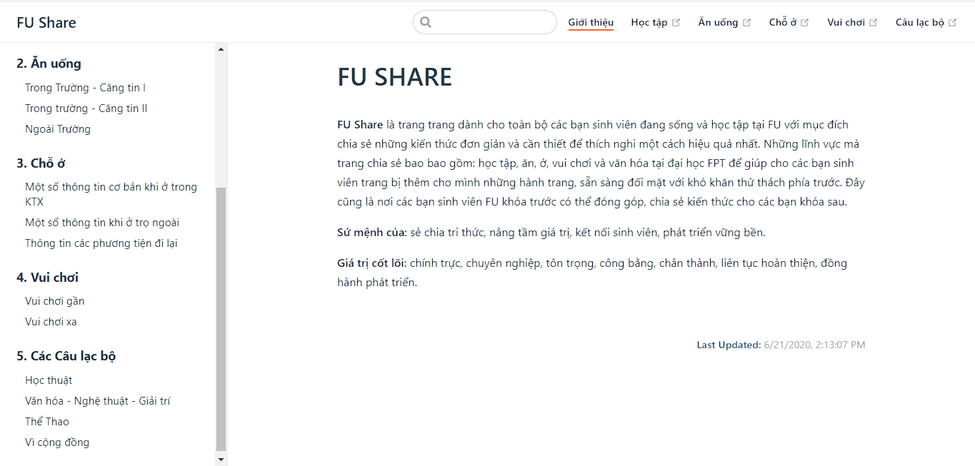

**Strengths**:

* Provide information for students of FPT University.

**Limitations**:

* No interaction, just information show
* Old information is not updated

## 4. Business Opportunity

We created this website for community purposes. To help new students have the more simple and necessary knowledge to adapt to life at FU in the most effective way. In addition, Hola Land is also a bridge to help students find jobs; order food more conveniently.

## 5. Software Product Vision

The Hola Land system is an internet-based application that helps to provide students with knowledge about FU better and more effectively than conventional methods. In this system, users will register for an account, look up information about FPT University, search for job opportunities, order food, and many other benefits through the system. The admissions department will also spend less time advising new students. In the next 3-5 years, when major universities open new campuses in Hoa Lac. Hola Land will expand and grow beyond FPT University and it will become the leading system for students in Hoa Lac.

## 6. Project Scope & Limitations

Due to time constraints, we will not be implementing some of the intended functionality, although we are aware that they are also important and useful to system users:

* system motel: find a motel, book motel, motel location…

### 6.1 Limitations & Exclusions

LI-1: We can't apply to other areas, only limited to fpt university

LI-2: In a short time, we have not been able to fully develop utilities for users to use most conveniently.

### 6.2 Major Features

There are 5 types of users in the HolaLand System:

|  |  |  |
| --- | --- | --- |
| **#** | **Type of User** | **Description** |
| 1 | Guest | The user has not yet registered an account. |
| 2 | Student | The student is a registered user with an FPT email account and they can use features such as: find a job |
| 3 | Recruiter | Recruiter is a registered user with an email account and they can use main features such as recruitment. |
| 4 | Seller | The seller is a registered user with an email account and they own one store at HolaLand. |
| 5 | Admin | A person who has the highest permission level and is responsible for managing the website. |

*Type of User in HolaLand System*

HolaLand System will provide the following functions to the above users:

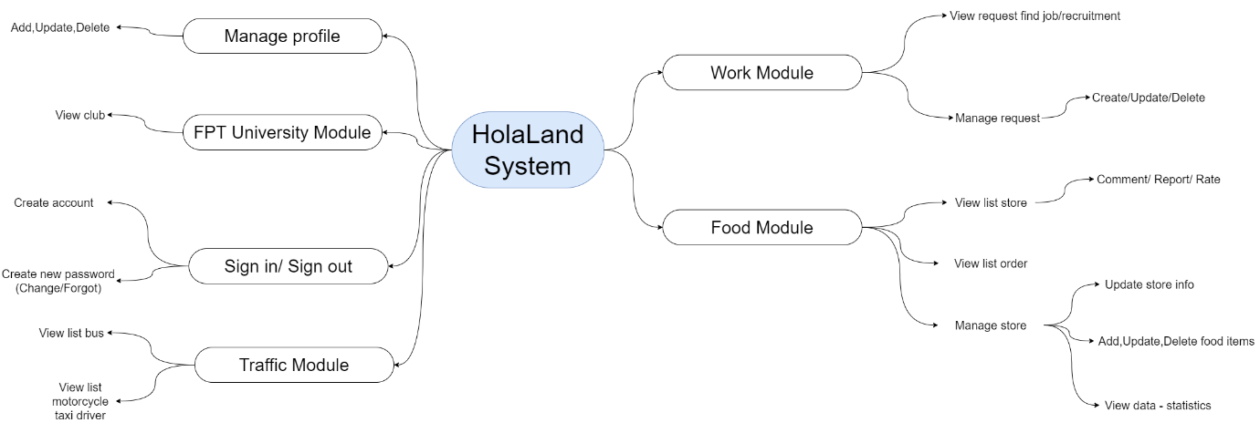

*Main functions of HolaLand System*

### 6.3 Business flows

#### 6.3.1 Member Process

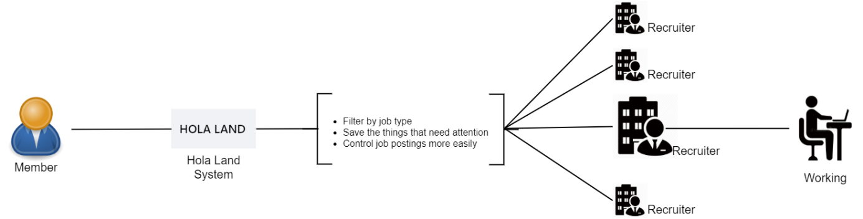

First, the Student (who is looking for a job) will create a request that includes many attributes: job type, working time, location, salary, title, description, experience... When the Member clicks click "Post" button, a Request will be generated.

The request will be listed and made public for all Recruiter to see and apply.

A recruiter can view members' profiles and then make decisions about which members to choose.

After the Recruiter selects a Member, the Member will receive a notification and have the right to accept it or not.

If the Member accepts, the request will change its status and the other Recruiter can no longer apply.

The request will close automatically when the expiration date is reached.

#### 6.3.2 Recruiter Process

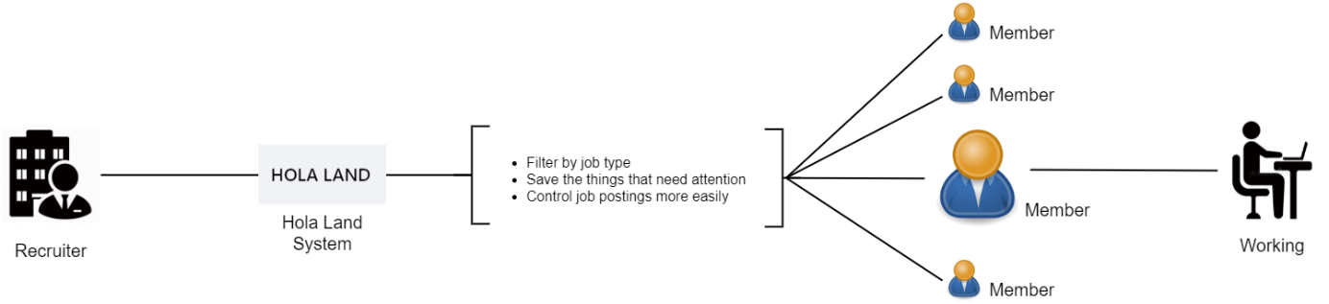

First, the Recruiter (who needs to hire a member) will create a request that includes many attributes: experience, gender, job type, salary, working location, title, description, requirements, benefits… When the Owner clicks the "Post" button, the Request will be created.

Requirements will be listed and made public for all Members to see and apply.

After Members apply for a job, the Recruiter can view members' profiles to then make a decision on which Member to choose.

After the Recruiter selects or does not a Member, the Member will receive a notification.

The request will close automatically when the expiration date is reached.

# II. Project Management Plan

## 1. Overview

### 1.1 WBS & Estimation

|  |  |  |  |
| --- | --- | --- | --- |
| **WBS ID** | **WBS Item** | **Complexity** | **Est.Effort (man-days)** |
| **1** | **Project Initiating** |  | **27** |
| 1.1 | Prepare Project Ideas | Medium | 10 |
| 1.2 | List up requirements | Medium | 5 |
| 1.3 | Define the scope of the project | Simple | 2 |
| 1.4 | Team meeting | Simple | 5 |
| 1.5 | Create Report 1 (Project Introduction) | Simple | 5 |
| **2** | **Project Planning** |  | **37** |
| 2.1 | Create Report 2 (Project Introduction) | Simple | 5 |
| 2.2 | Select Tools and techniques | Simple | 2 |
| 2.3 | Technical Training/Self Study | Medium | 25 |
| 2.4 | Team meeting | Simple | 5 |
| **3** | **Project Executing** |  | **281** |
| **3.1. Iteration 1** | | | **71** |
| **3.1.1** | **Analyzing & Designing** |  | **40** |
| 3.1.1.1 | Define & analyze requirements | Complex | 10 |
| 3.1.1.2 | List up use case | Medium | 5 |
| 3.1.1.3 | Define & analyze the main business flow | Complex | 10 |
| 3.1.1.4 | Design main screen mockup | Medium | 10 |
| 3.1.1.5 | Design database | Medium | 5 |
| **3.1.2** | **Code & Implementation** |  | **10** |
| 3.2.1 | Configuration & Setup environment | Medium | 5 |
| 3.2.2 | Create base project | Medium | 5 |
| **3.1.3** | **Document** |  | **20** |
| 3.1.3.1 | Create report 3 (System requirement specification) | Simple | 10 |
| 3.1.3.2 | Create report 4 (Software Design Description) | Simple | 10 |
| **3.1.4** | **Summary & Evaluation Iteration 1** |  | **1** |
| **3.2. Iteration 2** | | | **100** |
| **3.2.1** | **Analyzing & Designing** |  | **9** |
|  | Update list use case | Simple | 2 |
|  | Update database design | Medium | 2 |
|  | Design system architecture | Complex | 5 |
| **3.2.2** | **Code & Implementation** |  | **80** |
|  | Design authentication screen | Medium | 5 |
|  | Design home screen | Medium | 5 |
|  | Design module FPT University screen | Medium | 5 |
|  | Design module Traffic screen | Medium | 5 |
|  | Design module Work screen | Medium | 20 |
|  | Design module Food screen | Medium | 20 |
|  | Code Sign in, Sign up | Medium | 5 |
|  | Code View club, detail club | Simple | 5 |
|  | Code View bus, detail bus routes | Simple | 5 |
|  | Code View motorcycle taxi driver | Simple | 5 |
| **3.2.3** | **Testing** |  | **5** |
|  | Create test case Iteration 2 | Medium | 2 |
|  | Test Iteration 2 | Simple | 1 |
|  | Verify test Iteration 2 | Simple | 1 |
|  | Fix bug Iteration 2 | Medium | 1 |
| **3.2.4** | **Document** |  | **5** |
|  | Update SRS & SDD Iteration 2 | Simple | 5 |
| **3.2.5** | **Summary & Evaluation Iteration 2** |  | **1** |
| **3.3. Iteration 3** | | | **110** |
| **3.3.1** | **Analyzing & Designing** |  | **4** |
|  | Update list use case | Simple | 2 |
|  | Update database design | Simple | 2 |
| **3.3.2** | **Code & Implementation** |  | **90** |
|  | Code View list job, list job hire, list job saved, list find a job, list job apply. | Simple | 30 |
|  | Code Manage request find job, recruitment(CRUD) | Medium | 20 |
|  | Code View list store, detail store | Medium | 15 |
|  | Code Manage Store | Complex | 20 |
|  | Design Profile Screen | Medium | 10 |
| **3.3.3** | **Testing** |  | **5** |
|  | Create test case Iteration 3 | Medium | 2 |
|  | Test Iteration 3 | Simple | 1 |
|  | Verify test Iteration 3 | Simple | 1 |
|  | Fix bug Iteration 3 | Medium | 1 |
| **3.3.4** | **Document** |  | **10** |
|  | Update SRS & SDD Iteration 3 | Simple | 5 |
|  | Create report 5 (Test Document) | Simple | 5 |
| **3.3.5** | **Summary & Evaluation Iteration 3** |  | **1** |
| **4** | **Transition** |  | **20** |
|  | Optimize/Refactor Codes | Complex | 5 |
|  | Deploy Final Code | Simple | 5 |
|  | Create report 6 (User Guides) | Simple | 5 |
|  | Create Report 7 (Final Project Report) | Simple | 5 |
| **5** | **Closing** |  | **10** |
|  | Practice Thesis Presentation | Simple | 5 |
|  | Finalize Thesis Presentation | Simple | 5 |
|  | FINAL PRESENTATION | Simple | 0 |

***Total Estimated Effort (man-days):* 375**

*Table 2.1: WBS & Estimation*

### 1.2 Project Objectives

Objective:

- All team members will follow the task assigned.

- All team members learn new knowledge, new technology.

- Have a beta test before the fishing the implementation phase

|  |  |  |  |  |
| --- | --- | --- | --- | --- |
| # | Quality Stage | No.Of Defects | % of Defect | Notes |
| 1 | Reviewing |  |  | Technical leader reviews code of  embers before creating merging |
| 2 | Unit Test |  |  | Developer creates and tests |
| 3 | Integration Test |  |  | The tester creates and tests |

*Table 2.2: Defect distribution*

### 1.3 Project Risks

|  |  |  |  |  |
| --- | --- | --- | --- | --- |
| # | Risk Description | Impact | Possibility | Response Plans |
| 1 | Incorrect estimates break the project plan | High | High | - Create a schedule carefully  - Add backup time (or backup schedule)  - Focus on close targets |
| 2 | Out of scope | Medium | Medium | -Always check the scope in every meeting.  -Notifications immediately when you see the problem.  -Have complete documentation on scopes before implementation. |
| 3 | Poor Productivity | Medium | High | -Create and review deadlines before starting work. |
| 4 | Inadequate Human Resources | Medium | Low | -Register overtime for team members. |
| 5 | Health has serious problems | Medium | Medium | -Reduced work for members who are having health problems. -Rearranging the schedules of other members to support work. |
| 6 | Technical Difficulties | Medium | Medium | -Choose design patterns appropriate.  -Create architecture design more detail and exactly  -Have a professional in the team |
| 7 | Inadequate Risk Management | High | Medium | -Be prepared to face unexpected risks.  -Hold emergency meetings when there's a big problem. |

*Table 2.3: Project Risks*

## 2. Management Approach

### 2.1 Project Process

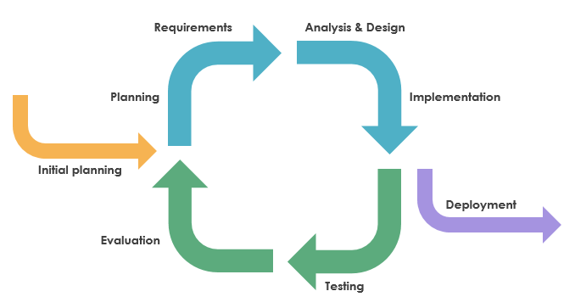

*Figure 2.1 Iterative and Incremental Software Process Model*

This project uses the Iterative and Incremental Software Process Model. This model is mostly used when the scope of the project is big, the major requirements are defined clearly, some more details will be added later in software development. By using this software process model, we break down the developing system task into a series of smaller tasks which will be completed separately, allowing us to take advantage of what was learned during the development of earlier parts of the system. In addition, the iterative model is easier than other models when the issues are discovered. They are fed back to the team, and solutions will be found while the project is still in development, Also, this model has these useful advantages:

* Some main functions can be developed early & quickly.
* Testing and debugging during a smaller iteration are easy.
* More flexible - easy & less costly to change if having.
* Easier to manage risk because risky pieces are identified and handled during its iteration.
* Iterations may be run simultaneously. A design team starts the next iteration while the current one is under test.
* The project team learns from the first iteration and may use best practices and experiences in the next iterations.

### 2.2 Quality Management

- Defect Prevention:

* Once a defect is found, the related person in charge should be notified immediately.
* The defect must be assessed carefully such as "how bad is the defect?", "how long does it take to fix the defect?".
* The deadline for fixing defects must be clearly stated.

- Reviewing:

* The person in charge must be honest and show no favor over any member.
* If something goes wrong, that person must notify the person who takes responsibility for that defect.
* The defect must be logged on Bug Tracking software with details such as priority.
* The person who takes responsibility for the found defects must take action accordingly.

- Integration Testing:

* The person in charge must prepare test cases carefully and accurately. The test cases must match well with the system and architecture design.
* The defect must be logged on Bug Tracking software with details such as priority.
* The person who takes responsibility for the found defects must take action accordingly.
* Internal modules within the system work smoothly.

- Project management

* All tasks and issues are created in Github and Trello for members to follow and execute. The more tasks completed and the fewer bugs that exist, the better the quality of the project is guaranteed.

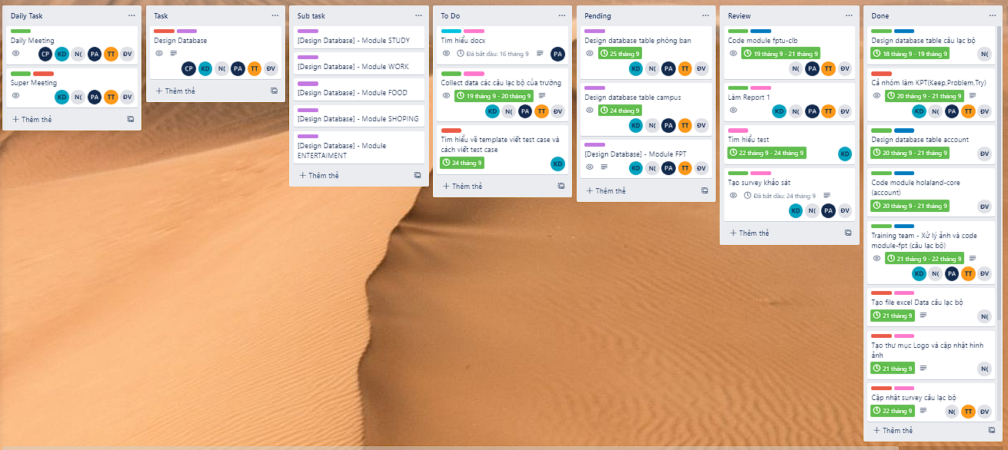

*Figure 2.2: Tasks in Trello*

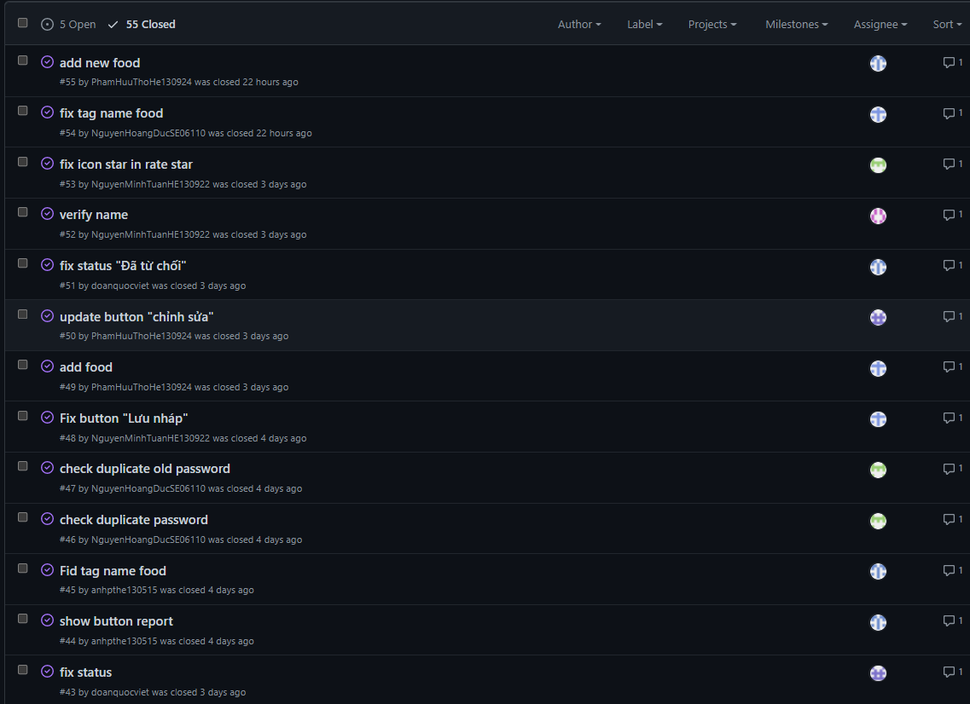

*Figure 2.3: Issues in Github*

### 2.3 Training Plan

|  |  |  |  |
| --- | --- | --- | --- |
| Training Area | Participants | When Duration | Waiver Criteria |
| Java Spring Boot | All team members | 06/09/2021 – 20/09/2021 | Mandatory |
| Javascript | All team members | 06/09/2021 – 20/09/2021 | Mandatory |
| Fork | All team members | 06/09/2021 – 20/09/2021 | Mandatory |
| MySql (DataGrip) | All team members | 06/09/2021 – 20/09/2021 | Mandatory |
| Bootstrap | All team member | 06/09/2021 – 20/09/2021 | Mandatory |

*Table 2.4: Training plan*

## 3. Master Schedule

|  |  |  |  |
| --- | --- | --- | --- |
| # | Deliverable | Due Date | Deliverable Scope |
| 1 | Project Idea | 08/09/2021 |  |
| 2 | Report 1 – Project Introduction | 13/09/2021 | Product Background  Existing Systems  Business Opportunity  Product Vision  Project Scope & Limitations |
| 3 | Report 2 – Project Management Plan | 20/09/2021 | WBS  Project Process  Plan and Schedule  Project Organization  Project Communication  Configuration Management |
| 4 | Report 3 – SRS | 27/09/2021 | Business Rules  Use Case Diagram & Use Case  Description  Functional Requirements  Non-Functional Requirements |
| 5 | Report 4 – Software Design | 04/10/2021 | System Architecture  Architecture Design  Database design |
| 6 | Code & Implement Iteration 1 | 30/10/2021 | Detailed Design  Code & Unit test  Integration & System test cases |
| 7 | Code & Implement Iteration 2 | 20/11/2021 | Detailed Design  Code & Unit test  Integration & System test cases |
| 8 | Report 5 – Test Document | 28/11/2021 | Detailed Design  Code & Unit test  Integration & System test cases |
| 9 | Report 6 – Software User Guides | 6/12/2021 | Deliverable Package  Installation Guides  User Manual |
| 10 | Code & Implement Iteration 3 | 13/12/2021 | Detailed Design  Code & Unit test  Integration & System test cases |
| 11 | Final Code & Report | 20/12/2021 |  |

*Table 2.5: Master Schedule*

## 4. Project Organization

### 4.1 Team & Structures

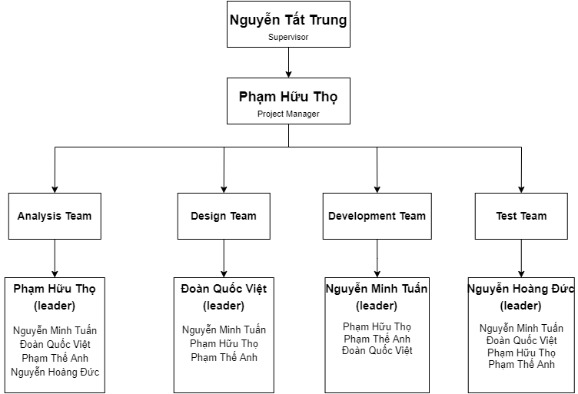

*Figure 2.4: Project Team*

### 4.2 Roles & Responsibilities

|  |  |
| --- | --- |
| **Role** | **Responsibility** |
| Project Manager | Plan and develop schedules, coordinate communication, and generally responsible for keeping the team’s focus on the main goal. |
| Analysis Leader | Analyze Requirement, manage members’ works and report to manager |
| Analysis Member | Analyze Requirement |
| Design Leader | Write documents, create a design document |
| Design Member | Update SRS, SDD document |
| Technical Leader | Responsible for preparing and training technologies that will be used in the project, as well as for overseeing the work being done by other developers. |
| Development Member | Involve in coding the product |
| Test Leader | Create a test plan, create a test case |
| Test Member | Create test case |

*Table 2.6: Role & Responsibilities*

## 5. Project Communication

### 5.1 Communication Plan

|  |  |  |  |  |
| --- | --- | --- | --- | --- |
| **Communication Item** | **Who/ Target** | **Purpose** | **When. Frequency** | **Type, Tool, Method(s)** |
| Daily Meeting | Team Members | Problem reporting and planning Problem-solving support. | 21h, every day | Google Meet |
| Weekly Meeting | Supervisor team members | Review members’ work in a week, report progress, and give problems to be solved. | Every Wednesday | Google Meet |
| Super Meeting | Team Members | Gather requirements, review project, log issue, define next week plan | 20h, Every Sunday | Google Meet |
| Unscheduled Meeting | Team Members | When a serious problem occurs, it needs to be solved immediately |  | Google Meet |

*Table 2.7: Communication plan*

### 5.2 External Interface

#### 5.2.1 FU Contacts

|  |  |  |  |
| --- | --- | --- | --- |
| **Function** | **Contact Person**  **(name, position)** | **Contact address (email, telephone)** | **Responsibility** |
| Supervisor | Nguyen Tat Trung | [trungnt77@fe.edu.vn](mailto:trungnt77@fe.edu.vn)  0904399139 | Provide document template  Instruct the project team  Review deliverables Supervise project status |

*Table 2.8: FU Contact*

#### 5.2.2 Customers Contact

|  |  |  |  |
| --- | --- | --- | --- |
| **Function** | **Contact Person**  **(name, position)** | **Contact address (email, telephone)** | **Responsibility** |
| Supervisor | Nguyen Tat Trung | [trungnt77@fe.edu.vn](mailto:trungnt77@fe.edu.vn)  0904399139 | -Provide document template  -Instruct to project team  -Review deliverables  -Supervise project status |

*Table 2.9: Customers Contact*

## 6. Configuration Management

### 6.1 Tools & Infrastructures

|  |  |
| --- | --- |
| **Category** | **Tools and Technical** |
| **Programming languages** | Java, HTML, CSS, JavaScript |
| **Framework** | Java Spring Boot, Bootstrap |
| **DBMS** | My SQL, DataGrip |
| **IDEs/Editors** | IntelliJ IDEA, Visual Studio Code |
| **UML tools** | Draw.io |
| **Design tool** | Figma |
| **Version Control** | Github, Fork |
| **Project management tool** | Trello, Github |
| **Files management tool** | Google Drive |
| **Document tools** | Microsoft Word 2016, Microsoft Excel 2016 |
| **Testing tool** | Google Chrome |
| **Communication tool** | Messenger |

*Table 2.10: Tools & Techniques*

### 6.2 Document Management

We use Github and Google Drive as our primary tools for sharing, editing, and version control of our documents, along with status Reports within each document. It allows us to see what is changed in the documents and who is responsible for that change and simultaneously compare between versions of the document.

Document tools: Microsoft Office 2016, Microsoft Excel 2016

File management: Google Drive

### 6.3 Source Code Management

-Source code is stored and maintained on Github

- Source code management through Fork

- The overall flow of Fork is:

* The main branch is “master”
* A develop branch is “develop”
* Each task of each module will create its branch to code
* When the branch is done, the technical leader is the person who will review and merge the code of team members

# III. Software Requirement Specification

## 1. Product Overview

Hola Land System is a new software system that brings a lot of value to students' FPT, recruiters, and sellers. The context diagram below illustrates the external entities and system interfaces for version 1.0.

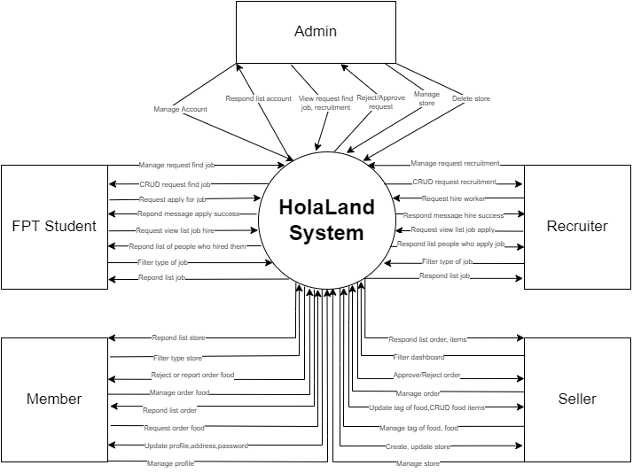

*Figure 3.1: Context Diagram*

*Reference links: https://gitmind.com/context-diagram.html*

## 2. User Requirements

### 2.1 Overview

#### 2.1.1 Use Case Diagram

* Guest:

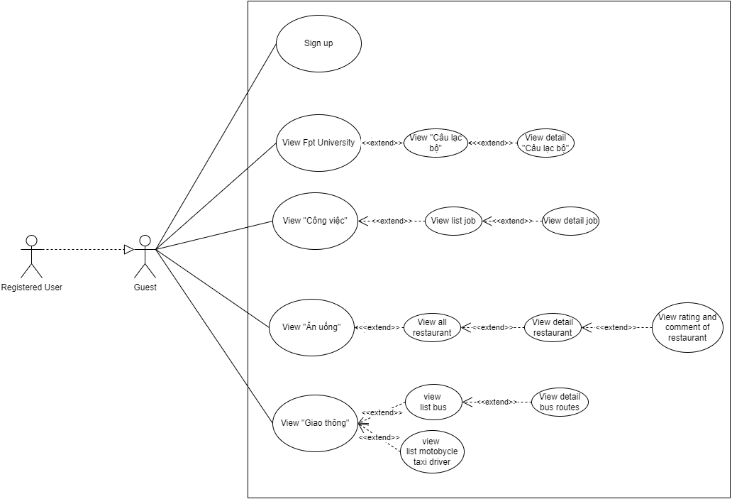

*Figure 3.2: Use Case diagram for Guest*

* Registered User

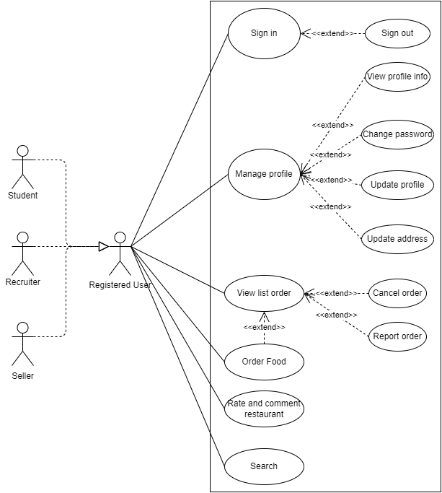

*Figure 3.3: Use Case diagram for Registered User*

* Student

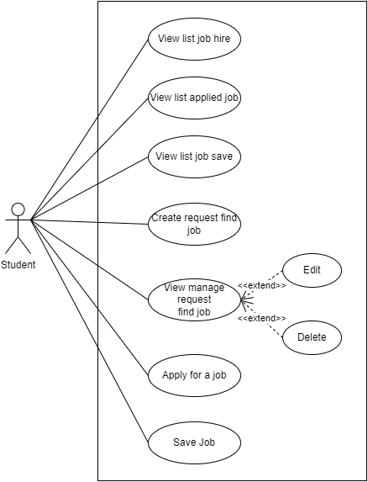

*Figure 3.4: Use Case diagram for Student*

* Recruiter

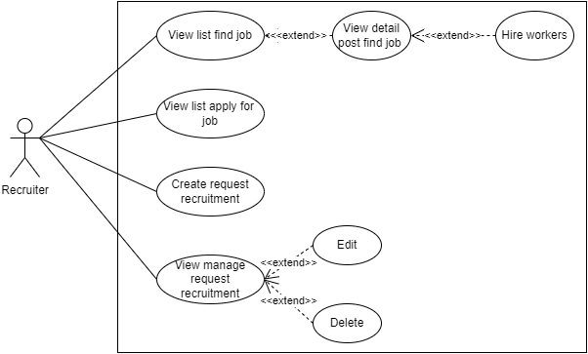

*Figure 3.5: Use Case diagram for Recruiter*

* Seller

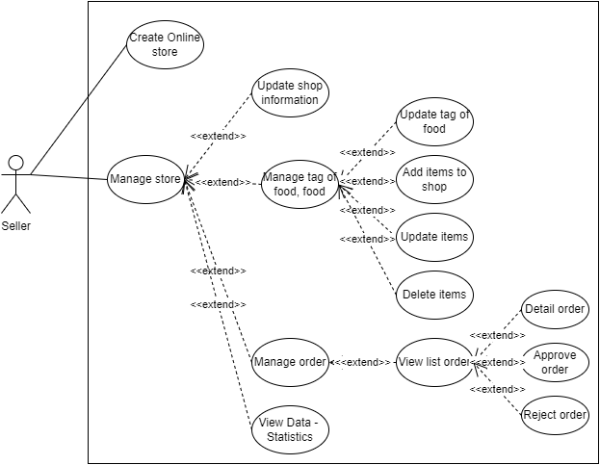

*Figure 3.6: Use Case diagram for Seller*

* Admin

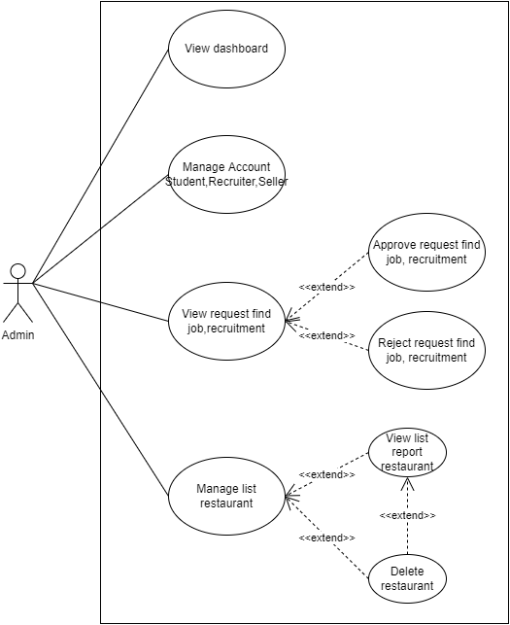

*Figure 3.7: Use Case diagram for Admin*

Reference links: <https://youtu.be/zid-MVo7M-E>

#### 2.1.2 System Actors

|  |  |  |
| --- | --- | --- |
| **#** | **Actor** | **Description** |
| 1 | Guest | The user has not yet registered an account. |
| 2 | Registered User | The user that has registered an account. |
| 3 | Student | The student is a registered user with an FPT email account and they can use features such as: find a job |
| 4 | Recruiter | Recruiter is a registered user with an email account and they can use features such as recruitment. |
| 5 | Seller | The seller is a registered user with an email account and they own one store at HolaLand. |
| 6 | Admin | A person who has the highest permission level and is responsible for managing the website. |

*Table 3.1: System Actors*

#### 2.1.3 Use Case List

|  |  |  |  |
| --- | --- | --- | --- |
| **ID** | **Use Case** | **Primary Actor** | **Secondary Actor** |
|  | Sign-up | Guest | N/A |
|  | View “Câu lạc bộ” | Guest | Registered User |
|  | View detail “Câu lạc bộ” | Guest | Registered User |
|  | View list job | Guest | Registered User |
|  | View detail job | Guest | Registered User |
|  | View all restaurant | Guest | Registered User |
|  | View detail restaurant | Guest | Registered User |
|  | View rating and comment of restaurant | Guest | Registered User |
|  | View list bus | Guest | Registered User |
|  | View detail bus routes | Guest | Registered User |
|  | View list motorcycle taxi driver | Guest | Registered User |
|  | Sign in | Registered User | N/A |
|  | Sign out | Registered User | N/A |
|  | View profile info | Registered User | N/A |
|  | Change password | Registered User | N/A |
|  | Update profile | Registered User | N/A |
|  | Update address | Registered User | N/A |
|  | View list order | Registered User | N/A |
|  | Cancel order | Registered User | N/A |
|  | Report order | Registered User | N/A |
|  | Order food | Registered User | N/A |
|  | Rate and comment restaurant | Registered User | N/A |
|  | Search | Registered User | N/A |
|  | View list job hire | Student | N/A |
|  | View list applied for a job | Student | N/A |
|  | View list job save | Student | N/A |
|  | Create a request to find a job | Student | N/A |
|  | Update request find a job | Student | N/A |
|  | Delete request find a job | Student | N/A |
|  | View manage request find a job | Student | N/A |
|  | Apply for a job | Student | N/A |
|  | Save job | Student | N/A |
|  | View list find a job | Recruiter | N/A |
|  | View detail list find a job | Recruiter | N/A |
|  | Hire worker | Recruiter | N/A |
|  | View list apply for a job | Recruiter | N/A |
|  | Create request recruitment | Recruiter | N/A |
|  | Update request recruitment | Recruiter | N/A |
|  | Delete request recruitment | Recruiter | N/A |
|  | View manage request recruitment | Recruiter | N/A |
|  | Update shop information | Seller | N/A |
|  | Update tag of food | Seller | N/A |
|  | Add items to the shop | Seller | N/A |
|  | Update items | Seller | N/A |
|  | Delete items | Seller | N/A |
|  | View list order | Seller | N/A |
|  | View detail order | Seller | N/A |
|  | Approve order | Seller | N/A |
|  | Reject order | Seller | N/A |
|  | View Data – Statistics | Seller | N/A |
|  | View dashboard | Admin | N/A |
|  | Manage Account  (Student, Recruiter, Seller) | Admin | N/A |
|  | View request find job, recruitment | Admin | N/A |
|  | Approve request find job, recruitment | Admin | N/A |
|  | Reject request find job, recruitment | Admin | N/A |
|  | View list report restaurant | Admin | N/A |
|  | Delete restaurant | Admin | N/A |

*Table 3.2 Use Cases List*

### 2.2 Use Case Specification

#### 2.2.1 Guest

##### 2.2.1.1 UC-01 Sign up

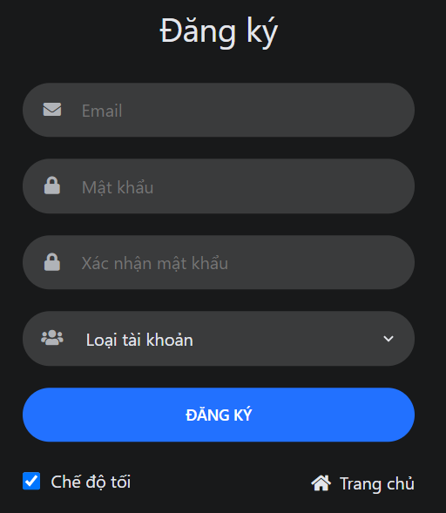

*Figure 3.8: Sign up Screen*

|  |  |  |  |
| --- | --- | --- | --- |
| ID and Name | UC-01 Sign up | | |
| Created By: | Phạm Hữu Thọ | Date Created: | 15/09/2021 |
| Primary Actor: | Guest | Secondary Actors: | N/A |
| Description: | Sign up for an account on the system. | | |
| Trigger: | Users want to register an account. | | |
| Pre-conditions: | 1. User does not have an account 2. No user account yet 3. The user's device is already connected to the internet when logging in | | |
| Post-conditions: | When the normal process completes successfully, a new account will be created with the desired user role and saved to the database. | | |
| Normal flow: | 1. Go to Home Page. 2. Click “Đăng ký” 3. System displays “Sign Up” form. 4. Input username, email, password, confirm password, select account type 5. Clicks “Đăng ký” button. 6. System displays a toast success message. 7. Redirect to Login Screen. | | |
| Alternative Flows: | N/A | | |
| Exceptions: | The system displays an error message when:   1. Not input all fields in the “Sign Up” form 2. Email existed 3. Cannot connect to the server | | |
| Priority: | High | | |
| Frequency of User: | High | | |
| Business Rules: | B01,B03,B04,B09,B10 | | |
| Other Information: | N/A | | |
| Assumptions: | N/A | | |

*Table 3.3 Use Case Specification – Sign up*

##### 2.1.1.2 UC-02 View “Câu lạc bộ”

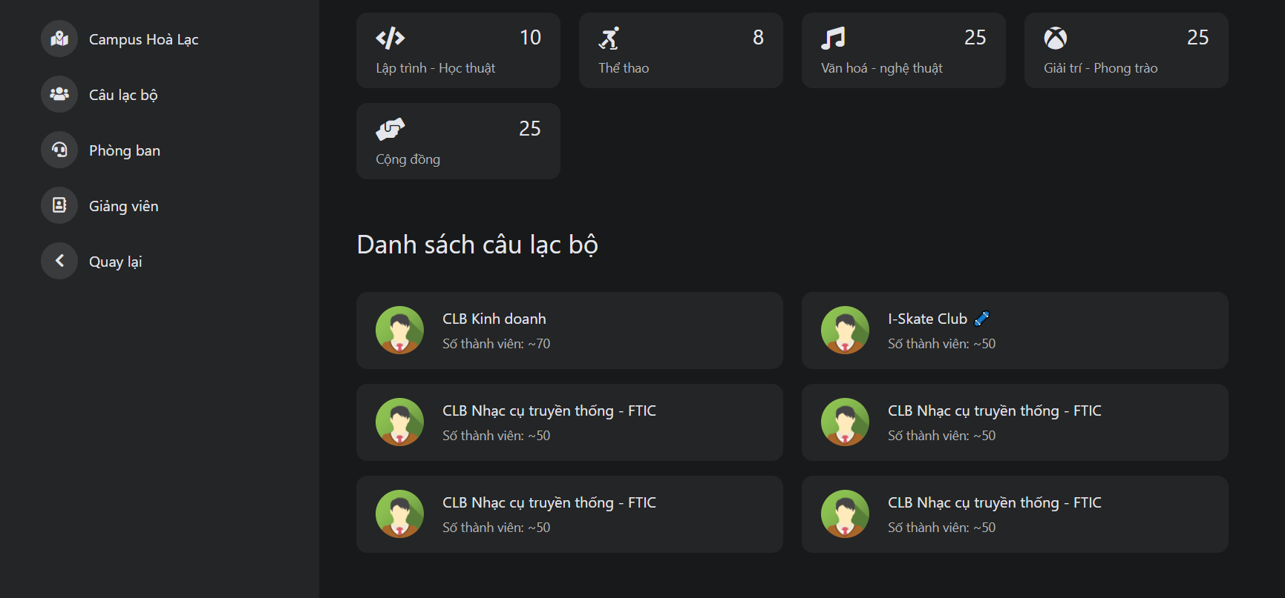

*Figure 3.9: “List club” Screen*

|  |  |  |  |
| --- | --- | --- | --- |
| ID and Name | UC-02 View “Câu lạc bộ” | | |
| Created By: | Đoàn Quốc Việt | Date Created: | 15/09/2021 |
| Primary Actor: | Guest | Secondary Actors: | Registered User |
| Description: | View all club | | |
| Trigger: | The user wants to view the club | | |
| Pre-conditions: | N/A | | |
| Post-conditions: | N/A | | |
| Normal flow: | 1. Go to HomePage 2. Click the button “FPT University” 3. Click “Câu lạc bộ” 4. System display list club FPT University in the screen | | |
| Alternative Flows: | N/A | | |
| Exceptions: | The system displays an error message when:   1. Cannot connect to the server | | |
| Priority: | Normal | | |
| Frequency of Use: | Normal | | |
| Business Rules: | N/A | | |
| Other Information: | N/A | | |
| Assumptions: | N/A | | |

*Table 3.4 Use Case Specification – View club*

##### 2.2.1.3 UC-03 View detail “Câu lạc bộ”

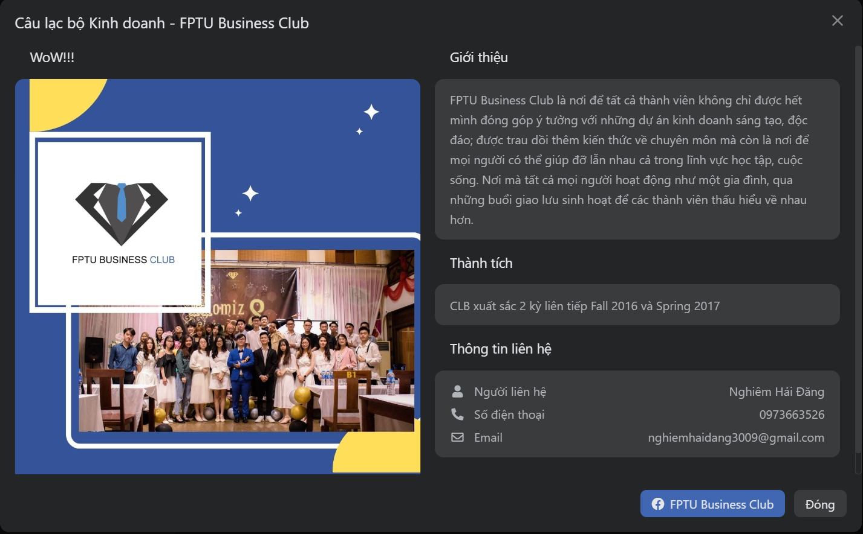

*Figure 3.10: “Detail club” screen*

|  |  |  |  |
| --- | --- | --- | --- |
| ID and Name | UC-03 View detail “Câu lạc bộ” | | |
| Created By: | Đoàn Quốc Việt | Date Created: | 15/09/2021 |
| Primary Actor: | Guest | Secondary Actors: | Registered User |
| Description: | View detail “Câu lạc bộ” | | |
| Trigger: | The users want to view detail “Câu lạc bộ” | | |
| Pre-conditions: | The system has at least 1 club | | |
| Post-conditions: | N/A | | |
| Normal flow: | 1. Go to Home Page 2. Click the button “FPT University” 3. Click “Câu lạc bộ” 4. Click any one club on the screen 5. System display detail one club include photos, descriptions, achievements, contact information in the screen | | |
| Alternative Flows: | N/A | | |
| Exceptions: | The system displays an error message when:   1. Cannot connect to the server | | |
| Priority: | Normal | | |
| Frequency of Use: | Normal | | |
| Business Rules: | N/A | | |
| Other Information: | N/A | | |
| Assumptions: | N/A | | |

*Table 3.5 Use Case Specification – View detail club*

##### 2.2.1.4 UC-04 View list job

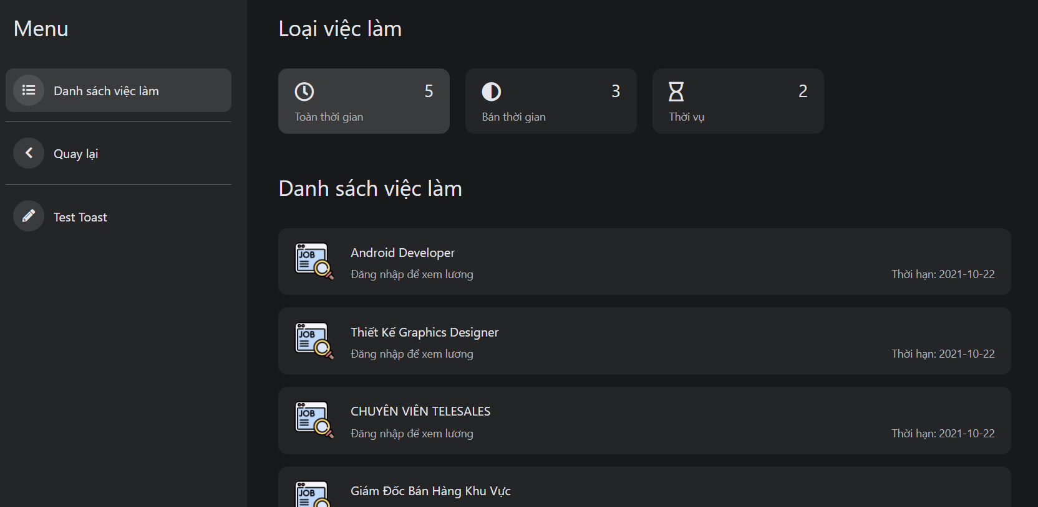

*Figure 3.11: List job recruitment in “Danh sách việc làm” Screen*

|  |  |  |  |
| --- | --- | --- | --- |
| ID and Name | UC-04 View list job | | |
| Created By: | Nguyễn Minh Tuấn | Date Created: | 15/09/2021 |
| Primary Actor: | Guest | Secondary Actors: | Registered User |
| Description: | View all listed job | | |
| Trigger: | The user wants to use the view list job | | |
| Pre-conditions: | N/A | | |
| Post-conditions: | N/A | | |
| Normal flow: | 1. Go to Home Page 2. Click button “Công việc” 3. Click “Danh sách việc làm” 4. System display list job in the screen | | |
| Alternative Flows: | N/A | | |
| Exceptions: | The system displays an error message when:   1. Cannot connect to the server | | |
| Priority: | Normal | | |
| Frequency of Use: | Normal | | |
| Business Rules: | B08 | | |
| Other Information: | N/A | | |
| Assumptions: | N/A | | |

*Table 3.6 Use Case Specification – View list job*

##### 2.2.1.5 UC-05 View detail job

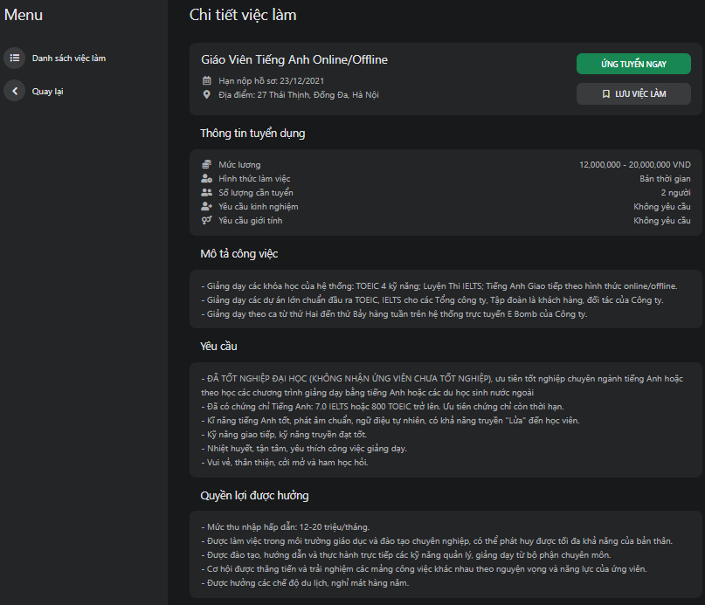

*Figure 3.12: List detail job recruitment in “Danh sách việc làm” Screen*

|  |  |  |  |  |  |
| --- | --- | --- | --- | --- | --- |
| ID and Name | | UC-05 View detail job | | | |
| Created By: | | Phạm Thế Anh | Date Created: | 15/09/2021 | |
| Primary Actor: | | Guest | Secondary Actors: | Registered User | |
| Description: | | View detail post job | | | |
| Trigger: | | The user wants to use view job detail | | | |
| Pre-conditions: | | The system has at least 1 job | | | |
| Post-conditions: | | N/A | | | |
| Normal flow: | | 1. Go to Home Page 2. Click button “Công việc” 3. Click “Danh sách việc làm” 4. Click any one job on the screen 5. System display detail one job in the screen | | | |
| Alternative Flows: | | N/A | | | |
| Exceptions: | | The system displays an error message when:   1. Cannot connect to the server | | | |
| Priority: | | Normal | | | |
| Frequency of Use: | | Normal | | | |
| Business Rules: | | B08 | | | |
| Other Information: | | N/A | | | |
| Assumptions: | | N/A | | | |

*Table 3.7 Use Case Specification – View detail club*

##### 2.2.1.6 UC-06 View all online store

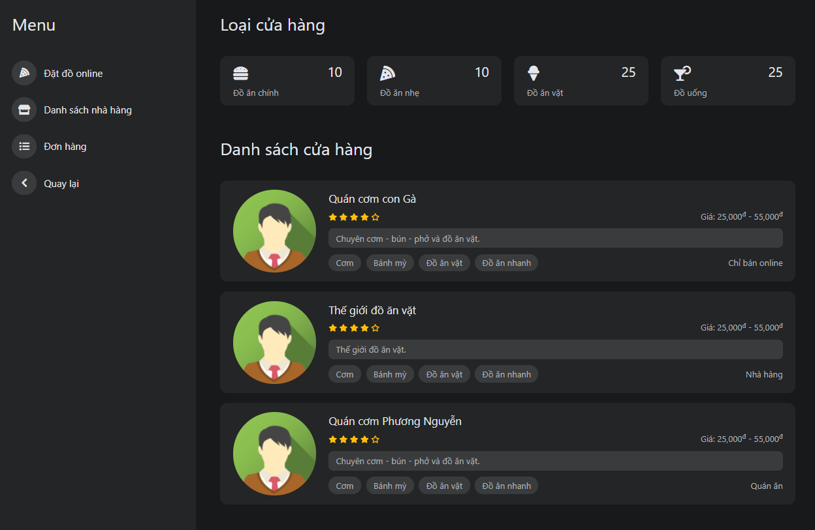

*Figure 3.13:View all online stores in “Đặt hàng online” Screen*

|  |  |  |  |
| --- | --- | --- | --- |
| ID and Name | UC-06 View all online store | | |
| Created By: | Nguyễn Minh Tuấn | Date Created: | 15/09/2021 |
| Primary Actor: | Guest | Secondary Actors: | Registered User |
| Description: | Allow user view list online store in HolaLand websites | | |
| Trigger: | Users want to view a list of online store | | |
| Pre-conditions: | N/A | | |
| Post-conditions: | N/A | | |
| Normal flow: | 1. Go to Home Page 2. Click the button “Ăn uống” 3. Click “Đặt đồ online” 4. System display list online store in the screen | | |
| Alternative Flows: | N/A | | |
| Exceptions: | The system displays an error message when:   1. Cannot connect to the server | | |
| Priority: | High | | |
| Frequency of Use: | High | | |
| Business Rules: | B11 | | |
| Other Information: | N/A | | |
| Assumptions: | N/A | | |

*Table 3.8 Use Case Specification – View all online store*

##### 2.2.1.7 UC-07 View detail online store

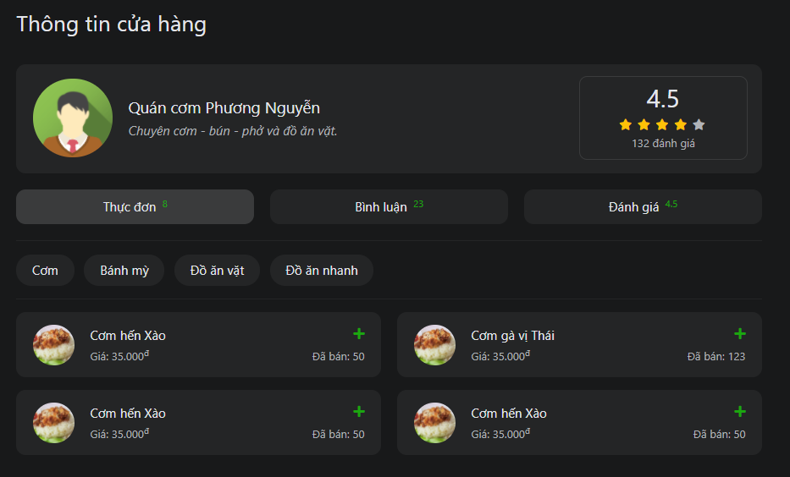

*Figure 3.14:” Detail store” Screen*

|  |  |  |  |
| --- | --- | --- | --- |
| ID and Name | UC-07 View detail online store | | |
| Created By: | Đoàn Quốc Việt | Date Created: | 16/09/2021 |
| Primary Actor: | Guest | Secondary Actors: | Registered User |
| Description: | Allow users can view detailed online store with foods, comments, and reviews | | |
| Trigger: | The user wants to view a detailed online store | | |
| Pre-conditions: | The system has at least 1 online store | | |
| Post-conditions: | N/A | | |
| Normal flow: | 1. Go to Home Page 2. Click the button “Ăn uống” 3. Click “Đặt đồ online” 4. Click any one store on the screen 5. System display detail one online store in the screen | | |
| Alternative Flows: | N/A | | |
| Exceptions: | The system displays an error message when:   1. Cannot connect to the server | | |
| Priority: | High | | |
| Frequency of Use: | High | | |
| Business Rules: | B11 | | |
| Other Information: | N/A | | |
| Assumptions: | N/A | | |

*Table 3.9 Use Case Specification – View detail online store*

##### 2.2.1.8 UC-08 View rating and comment of online store

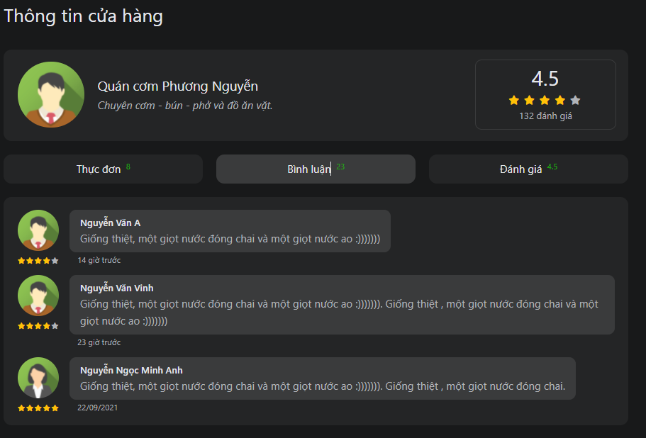

*Figure 3.15:View Rating and Comment Store in detail store screen*

|  |  |  |  |
| --- | --- | --- | --- |
| ID and Name | UC-08 View rating and comment of online store | | |
| Created By: | Phạm Thế Anh | Date Created: | 16/09/2021 |
| Primary Actor: | Guest | Secondary Actors: | Registered User |
| Description: | Allow user can view ratings and comments of online store | | |
| Trigger: | The user wants to view comments and ratings of the restaurant | | |
| Pre-conditions: | N/A | | |
| Post-conditions: | N/A | | |
| Normal flow: | 1. Go to profile restaurant 2. Click “bình luận” 3. System display comment and rating on the screen | | |
| Alternative Flows: | N/A | | |
| Exceptions: | The system displays an error message when:  1. Cannot connect to the server | | |
| Priority: | High | | |
| Frequency of Use: | High | | |
| Business Rules: | B12 | | |
| Other Information: | N/A | | |
| Assumptions: | N/A | | |

*Table 3.10 Use Case Specification – View rate and comment store*

##### 2.2.1.9 UC-09 View list bus

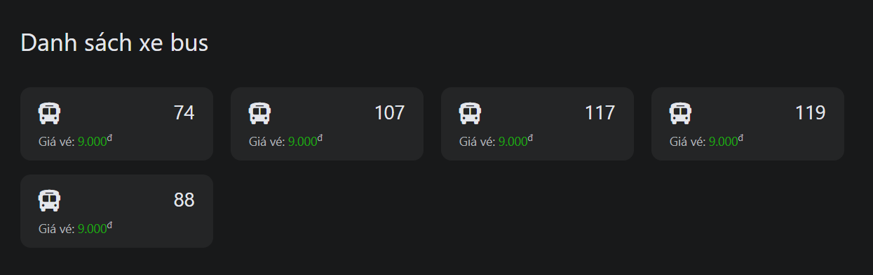

*Figure 3.16:List bus screen*

|  |  |  |  |
| --- | --- | --- | --- |
| ID and Name | UC-09 View list bus | | |
| Created By: | Đoàn Quốc Việt | Date Created: | 16/09/2021 |
| Primary Actor: | Guest | Secondary Actors: | Registered User |
| Description: | View list bus | | |
| Trigger: | The user wants to use view list bus | | |
| Pre-conditions: | N/A | | |
| Post-conditions: | N/A | | |
| Normal flow: | 1. Go to Home Page 2. Click button “Giao thông” 3. Click “Danh sách xe bus” 4. System display list bus in the screen | | |
| Alternative Flows: | N/A | | |
| Exceptions: | The system displays an error message when:   1. Cannot connect to the server | | |
| Priority: | Normal | | |
| Frequency of Use: | Normal | | |
| Business Rules: | N/A | | |
| Other Information: | N/A | | |
| Assumptions: | N/A | | |

*Table 3.11 Use Case Specification – view list bus*

##### 2.2.1.10 UC-10 View detail bus routes

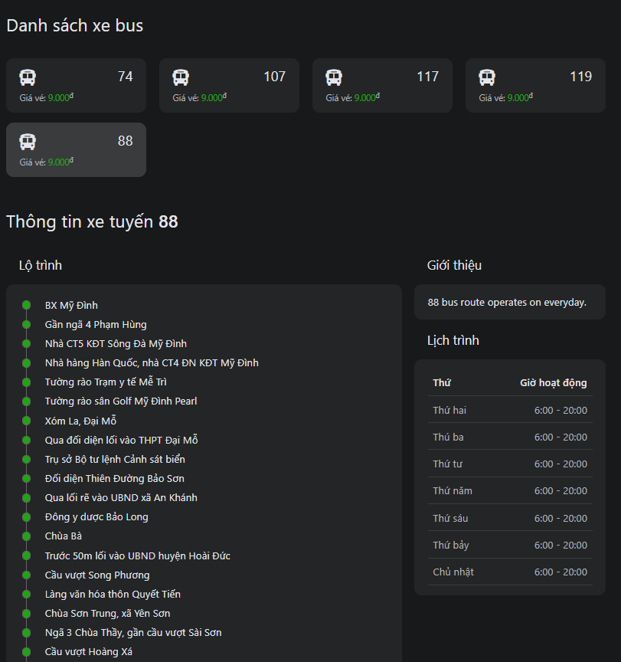

*Figure 3.17:Detail bus screen*

|  |  |  |  |
| --- | --- | --- | --- |
| ID and Name | UC-10 View detail bus routes | | |
| Created By: | Đoàn Quốc Việt | Date Created: | 16/09/2021 |
| Primary Actor: | Guest | Secondary Actors: | Registered User |
| Description: | View detail bus routes, introduction, schedule | | |
| Trigger: | The user wants to use view detail bus routes | | |
| Pre-conditions: | The system has at least 1 bus | | |
| Post-conditions: | N/A | | |
| Normal flow: | 1. Go to Home Page 2. Click button “Giao thông” 3. Click “Danh sách xe bus” 4. Click button bus number 5. System display detail bus routes on the screen | | |
| Alternative Flows: | N/A | | |
| Exceptions: | The system displays an error message when:   1. Cannot connect to the server | | |
| Priority: | Normal | | |
| Frequency of Use: | Normal | | |
| Business Rules: | N/A | | |
| Other Information: | N/A | | |
| Assumptions: | N/A | | |

*Table 3.12 Use Case Specification – detail bus routes*

##### 2.2.1.11 UC-11 View list motorcycle taxi driver

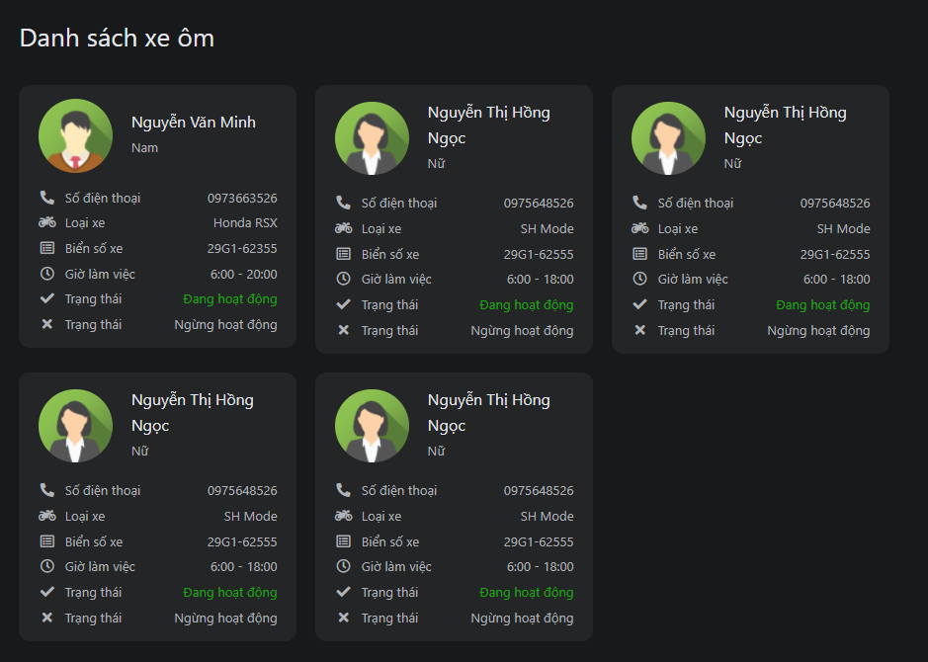

*Figure 3.18:List motorcycle taxi driver screen*

|  |  |  |  |
| --- | --- | --- | --- |
| ID and Name | UC-11 View list motorcycle taxi driver | | |
| Created By: | Nguyễn Hoàng Đức | Date Created: | 16/09/2021 |
| Primary Actor: | Guest | Secondary Actors: | Registered User |
| Description: | View list motorcycle taxi driver | | |
| Trigger: | The user wants to use view list motorcycle taxi driver | | |
| Pre-conditions: | N/A | | |
| Post-conditions: | N/A | | |
| Normal flow: | 1. Go to HomePage 2. Click button “Giao thông” 3. Click “Danh sách xe ôm” 4. System display list motorcycle taxi driver on the screen | | |
| Alternative Flows: | N/A | | |
| Exceptions: | The system displays an error message when:  1. Cannot connect to the server | | |
| Priority: | Normal | | |
| Frequency of Use: | Normal | | |
| Business Rules: | N/A | | |
| Other Information: | N/A | | |
| Assumptions: | N/A | | |

*Table 3.13 Use Case Specification – View list motorcycle taxi driver*

#### 2.2.2 Registered User

##### 2.2.2.1 UC-12 Sign in

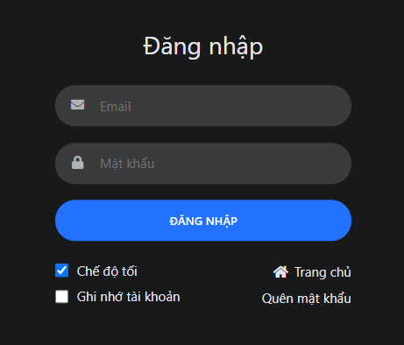

*Figure 3.19:Sign in screen*

|  |  |  |  |
| --- | --- | --- | --- |
| ID and Name | UC-12 Sign in | | |
| Created By: | Nguyễn Minh Tuấn | Date Created: | 17/09/2021 |
| Primary Actor: | Registered User | Secondary Actors: | N/A |
| Description: | Sign in to HolaLand System to use services from the system | | |
| Trigger: | The user wants to sign in to the application | | |
| Pre-conditions: | The user had an account on the HolaLand system. | | |
| Post-conditions: | When the normal flow completes successfully, the access token is saved on the client-side. | | |
| Normal flow: | 1. Go to HomePage 2. Click “Đăng nhập” 3. System display sign-in form 4. Input email and password 5. Click button “Đăng nhập” 6. System redirects to Home Page and displays user in the right of top header | | |
| Alternative Flows: | 1. Go to the “Sign up” Screen. 2. Click “Đăng nhập”. 3. Return to step 3 of normal flow | | |
| Exceptions: | The system displays an error message when:   1. Not input with correct username/email and password 2. Cannot connect to the server | | |
| Priority: | High | | |
| Frequency of Use: | High | | |
| Business Rules: | B13 | | |
| Other Information: | N/A | | |
| Assumptions: | N/A | | |

*Table 3.14 Use Case Specification – Sign in*

##### 2.2.2.2 UC-13 Sign out

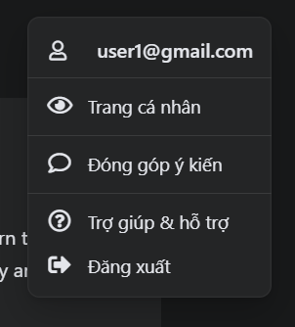

*Figure 3.20:Sign out screen*

|  |  |  |  |
| --- | --- | --- | --- |
| ID and Name | UC-13 Sign out | | |
| Created By: | Đoàn Quốc Việt | Date Created: | 17/09/2021 |
| Primary Actor: | Registered User | Secondary Actors: | N/A |
| Description: | Sign out the HolaLand website | | |
| Trigger: | The user wants to logout | | |
| Pre-conditions: | The account has been logged into the system | | |
| Post-conditions: | N/A | | |
| Normal flow: | 1. Login on system 2. Click button avatar user on the screen 3. Display the Combobox logout 4. Click “Logout” to confirm the logout 5. System redirect to login screen | | |
| Alternative Flows: | N/A | | |
| Exceptions: | The system displays an error message when:   1. Cannot connect to the server | | |
| Priority: | High | | |
| Frequency of Use: | Normal | | |
| Business Rules: | N/A | | |
| Other Information: | N/A | | |
| Assumptions: | N/A | | |

*Table 3.15 Use Case Specification – Sign out*

##### 2.2.2.3 UC-14 View profile info

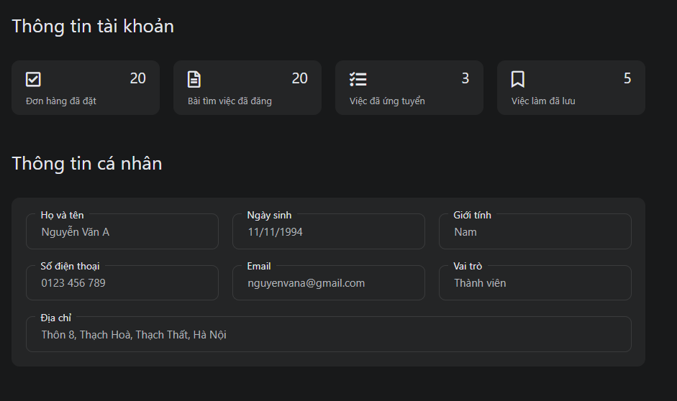

*Figure 3.21:Profile info screen*

|  |  |  |  |
| --- | --- | --- | --- |
| ID and Name | UC-14 View profile info | | |
| Created By: | Nguyễn Minh Tuấn | Date Created: | 17/09/2021 |
| Primary Actor: | Registered User | Secondary Actors: | N/A |
| Description: | View profile info | | |
| Trigger: | The user wants to view profile info | | |
| Pre-conditions: | The user has logged into HolaLand Website | | |
| Post-conditions: | N/A | | |
| Normal flow: | 1. Go to Profile Screen 2. Click “Trang cá nhân” in the menu on the left side of the screen 3. System displays profile info of user, including full name, date of birth, gender, phone number, email, role, address | | |
| Alternative Flows: | N/A | | |
| Exceptions: | The system displays an error message when:   1. Cannot connect to the server | | |
| Priority: | Medium | | |
| Frequency of Use: | High | | |
| Business Rules: | B08 | | |
| Other Information: | N/A | | |
| Assumptions: | N/A | | |

*Table 3.16 Use Case Specification – View profile info*

##### 2.2.2.4 UC-15 Change password

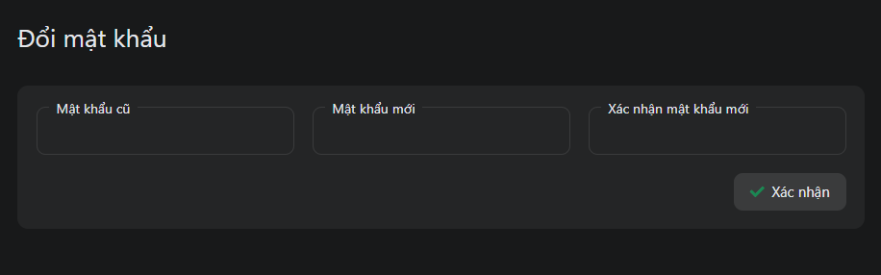

*Figure 3.22:Change password in the update profile screen*

|  |  |  |  |
| --- | --- | --- | --- |
| ID and Name | UC-15 Change password | | |
| Created By: | Nguyễn Minh Tuấn | Date Created: | 17/09/2021 |
| Primary Actor: | Registered User | Secondary Actors: | N/A |
| Description: | Change the password of an existing account on the system. | | |
| Trigger: | The user wants to change the password | | |
| Pre-conditions: | The user has logged into HolaLand Website. | | |
| Post-conditions: | When the normal flow completes successfully, the new password is set for the user’s account and saved to the database | | |
| Normal flow: | 1. Go to Profile Screen 2. Click “Chỉnh sửa thông tin” in the menu on the left side of the screen 3. User input current password, new password, confirm the new password in change password area. 4. Click “Cập nhật mật khẩu” button 5. 5. System displays toast success message | | |
| Alternative Flows: |  | | |
| Exceptions: | The system displays an error message when:   1. Not input with correct current password 2. New password is the same as the current password 3. Confirm password is not the same as new password   4. Cannot connect to the server | | |
| Priority: | Medium | | |
| Frequency of Use: | Low | | |
| Business Rules: | B02,B03,B04,B05,B06,B07 | | |
| Other Information: | N/A | | |
| Assumptions: | N/A | | |

*Table 3.17 Use Case Specification – Change password*

##### 2.2.2.5 UC-16 Update profile

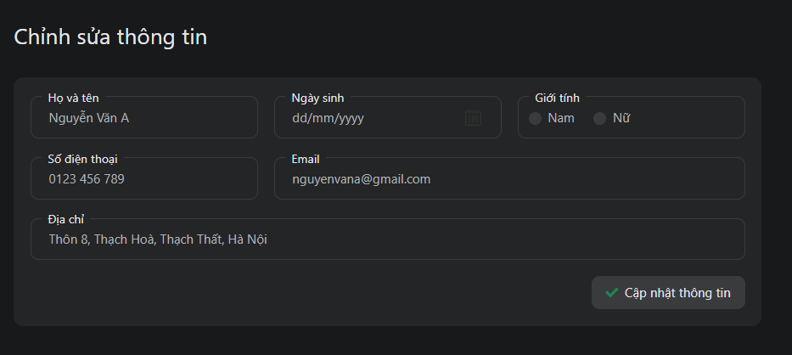

*Figure 3.23:Update profile in the update profile screen*

|  |  |  |  |
| --- | --- | --- | --- |
| ID and Name | UC-16 Update profile | | |
| Created By: | Nguyễn Minh Tuấn | Date Created: | 17/09/2021 |
| Primary Actor: | Registered User | Secondary Actors: | N/A |
| Description: | Update profile info | | |
| Trigger: | The user wants to update profile info | | |
| Pre-conditions: | The user has logged into HolaLand Website | | |
| Post-conditions: | When the normal flow completes successfully, the new profile info will be saved in a database | | |
| Normal flow: | 1. Go to Profile Screen  2. Click “Chỉnh sửa thông tin” in menu  3. System displays all profile info  4. User update full name, date of birth, gender, phone number  5. Click “Cập nhật thông tin” button  6. System displays toast success message  7. The new profile info is updated | | |
| Alternative Flows: | N/A | | |
| Exceptions: | The system displays an error message when:   1. Cannot connect to the server | | |
| Priority: | Low | | |
| Frequency of Use: | Low | | |
| Business Rules: | B06, B14 | | |
| Other Information: | N/A | | |
| Assumptions: | N/A | | |

*Table 3.18 Use Case Specification – Update profile*

##### 2.2.2.6 UC-17 Update address

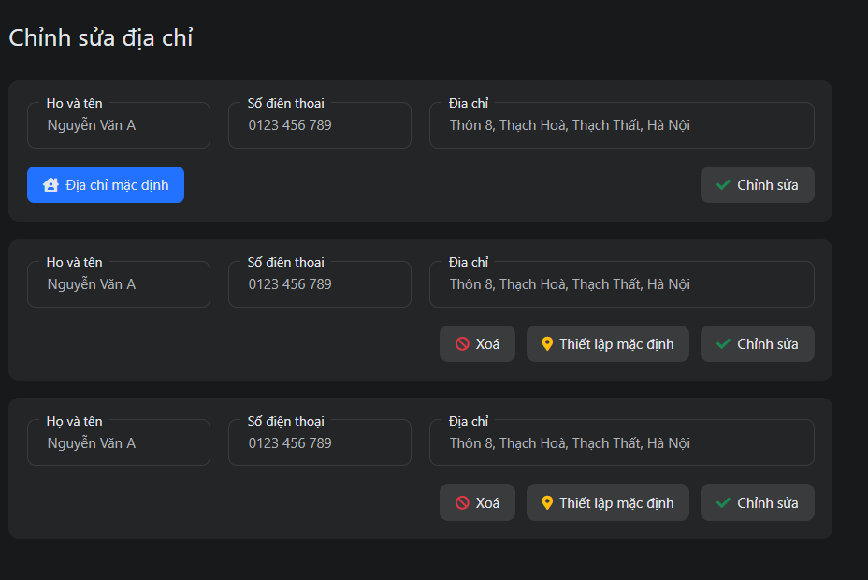

*Figure 3.24:Update address screen*

|  |  |  |  |
| --- | --- | --- | --- |
| ID and Name | UC-17 Update address | | |
| Created By: | Nguyễn Minh Tuấn | Date Created: | 18/09/2021 |
| Primary Actor: | Registered User | Secondary Actors: | N/A |
| Description: | Update address | | |
| Trigger: | The user wants to update the address | | |
| Pre-conditions: | The user has logged into HolaLand Website | | |
| Post-conditions: | When the normal flow completes successfully, the new address info will be saved in a database | | |
| Normal flow: | 1. Go to Profile Screen  2. Click “Chỉnh sửa địa chỉ” in menu  3. System displays all address info  4. User update full name, phone number, address  5. Click “Chỉnh sửa” button  6. System displays toast success message  7. The new address info is updated | | |
| Alternative Flows: | N/A | | |
| Exceptions: | The system displays an error message when:  1. Cannot connect to the server  2. Not input all field | | |
| Priority: | Low | | |
| Frequency of Use: | Low | | |
| Business Rules: | B14 | | |
| Other Information: | N/A | | |
| Assumptions: | N/A | | |

*Table 3.19 Use Case Specification – Update address*

##### 2.2.2.7 UC-18 View list order

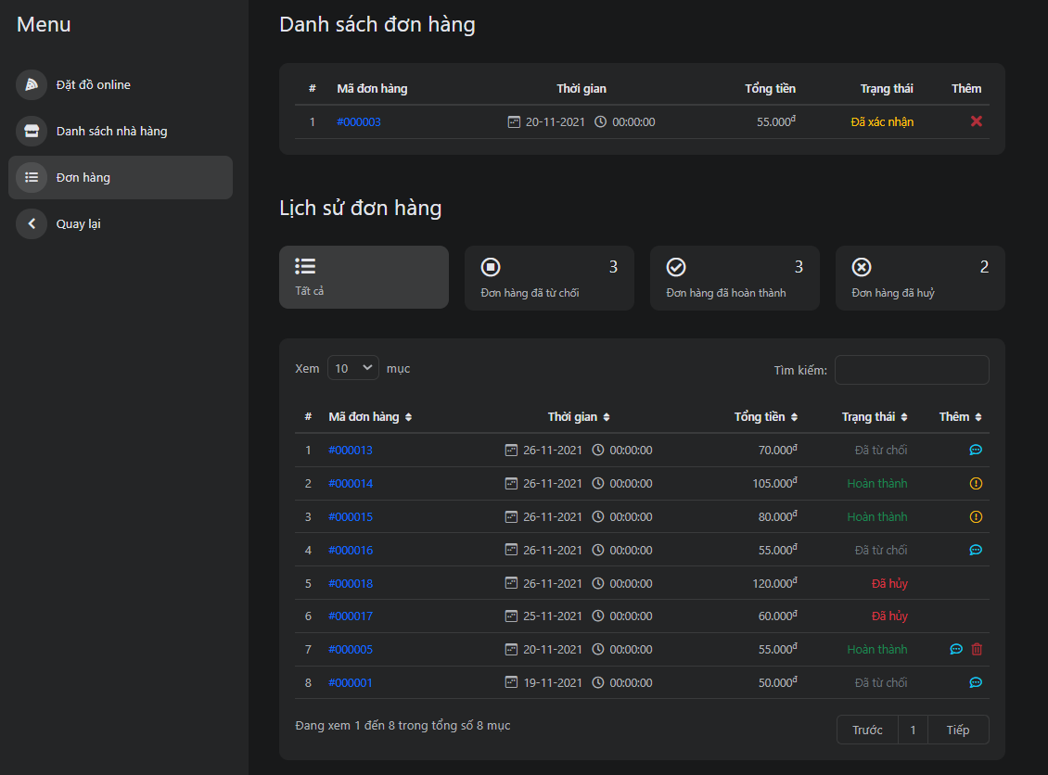

*Figure 3.25:List user order screen*

|  |  |  |  |
| --- | --- | --- | --- |
| ID and Name | UC-18 View list order | | |
| Created By: | Phạm Hữu Thọ | Date Created: | 18/09/2021 |
| Primary Actor: | Registered User | Secondary Actors: | N/A |
| Description: | View list order | | |
| Trigger: | Users want to view list order | | |
| Pre-conditions: | The user has logged into HolaLand Website | | |
| Post-conditions: | N/A | | |
| Normal flow: | 1. Go to Home Screen 2. Click module “Ăn-uống” 3. Click “Đơn hàng” in the menu 4. System display list order and list history order | | |
| Alternative Flows: | N/A | | |
| Exceptions: | The system displays an error message when:  1. Cannot connect to the server | | |
| Priority: | High | | |
| Frequency of Use: | High | | |
| Business Rules: |  | | |
| Other Information: | N/A | | |
| Assumptions: | N/A | | |

*Table 3.20 Use Case Specification – View list user order*

##### 2.2.2.8 UC-19 Cancel order

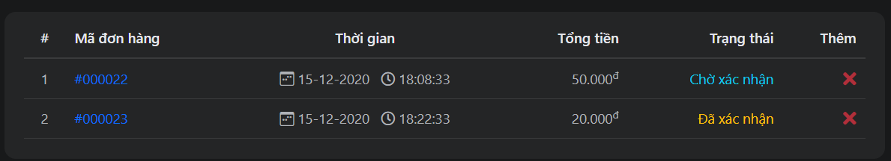

*Figure 3.26:Cancel order in list user order screen*

|  |  |  |  |
| --- | --- | --- | --- |
| ID and Name | UC-19 Cancel order | | |
| Created By: | Phạm Hữu Thọ | Date Created: | 18/09/2021 |
| Primary Actor: | Registered User | Secondary Actors: | N/A |
| Description: | Cancel order | | |
| Trigger: | The user wants to cancel the order | | |
| Pre-conditions: | The user has logged into HolaLand Website | | |
| Post-conditions: | User must place at least 1 order | | |
| Normal flow: | 1. Go to the Order screen 2. Click the “x” button on the right screen 3. System displays notification modal to confirm delete order 4. Click “Xác nhận” button 5. System displays toast success message | | |
| Alternative Flows: | N/A | | |
| Exceptions: | The system displays an error message when:  1. Cannot connect to the server | | |
| Priority: | High | | |
| Frequency of Use: | High | | |
| Business Rules: | B23 | | |
| Other Information: | N/A | | |
| Assumptions: | N/A | | |

*Table 3.21 Use Case Specification – Cancel order*

##### 2.2.2.9 UC-20 Report order

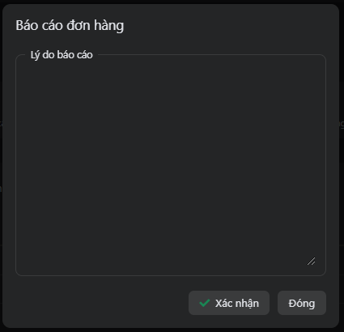

*Figure 3.27:Report order in the user order screen*

|  |  |  |  |
| --- | --- | --- | --- |
| ID and Name | UC-20 Report order | | |
| Created By: | Phạm Hữu Thọ | Date Created: | 18/09/2021 |
| Primary Actor: | Registered User | Secondary Actors: | N/A |
| Description: | Report order | | |
| Trigger: | Users want to report orders when the order status is complete | | |
| Pre-conditions: | The user has logged into HolaLand Website | | |
| Post-conditions: | User must place at least 1 order with status complete | | |
| Normal flow: | 1. Go to the Order screen  2. Click the “!” button on the right screen  3. System displays notification modal to report order  4. Input reason report  5.Click “Xác nhận” button  6. System displays toast success message | | |
| Alternative Flows: | N/A | | |
| Exceptions: | The system displays an error message when:  1. Cannot connect to the server | | |
| Priority: | Normal | | |
| Frequency of Use: | Normal | | |
| Business Rules: | B24 | | |
| Other Information: | N/A | | |
| Assumptions: | N/A | | |

*Table 3.22 Use Case Specification – Report order*

##### 2.2.2.10 UC-21 Order food

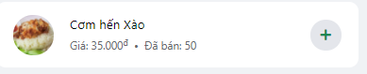

*Figure 3.27:Order food in detail store screen*

|  |  |  |  |
| --- | --- | --- | --- |
| ID and Name | UC-20 Order food | | |
| Created By: | Nguyễn Minh Tuấn | Date Created: | 19/09/2021 |
| Primary Actor: | Registered User | Secondary Actors: | N/A |
| Description: | Order food | | |
| Trigger: | User wants to order food | | |
| Pre-conditions: | The user has logged into HolaLand Website | | |
| Post-conditions: | N/A | | |
| Normal flow: | 1. Go to detail store screen 2. Click “+” button to order food items 3. System display message order successful | | |
| Alternative Flows: | N/A | | |
| Exceptions: | The system displays an error message when:  1. Cannot connect to the server | | |
| Priority: | High | | |
| Frequency of Use: | High | | |
| Business Rules: | B11 | | |
| Other Information: | N/A | | |
| Assumptions: | N/A | | |

*Table 3.23 Use Case Specification – Order food*

##### 2.2.2.11 UC-22 Rate and comment store

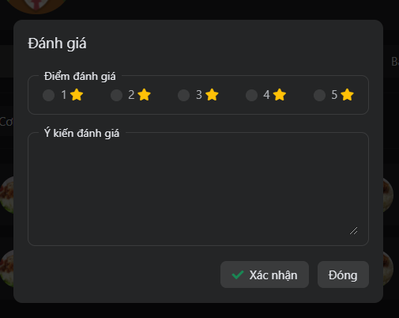

*Figure 3.28:Rate and comment store screen*

|  |  |  |  |
| --- | --- | --- | --- |
| ID and Name | UC-21 Rate and comment restaurant | | |
| Created By: | Nguyễn Minh Tuấn | Date Created: | 18/09/2021 |
| Primary Actor: | Registered User | Secondary Actors: | N/A |
| Description: | Rate and comment store | | |
| Trigger: | The user wants to rate and comment store | | |
| Pre-conditions: | The user has logged into HolaLand Website | | |
| Post-conditions: | User must place at least 1 order with status complete | | |
| Normal flow: | 1. Go to the “Ăn uống” module 2. Click any one store 3. Click “Đánh giá” 4. System displays modal rate and comment store 5. Select the number of stars to rate and fill in the comments 6. Click “Xác nhận” button 7. Rate and comment will be moved to the comment side | | |
| Alternative Flows: | N/A | | |
| Exceptions: | The system displays an error message when:  1. Cannot connect to the server | | |
| Priority: | High | | |
| Frequency of Use: | High | | |
| Business Rules: | B22 | | |
| Other Information: | N/A | | |
| Assumptions: | N/A | | |

*Table 3.24 Use Case Specification – Rate and comment store*

##### 2.2.2.12 UC-23 Search



*Figure 3.29:Search screen*

|  |  |  |  |
| --- | --- | --- | --- |
| ID and Name | UC-22 Rate and comment restaurant | | |
| Created By: | Phạm Hữu Thọ | Date Created: | 19/09/2021 |
| Primary Actor: | Registered User | Secondary Actors: | N/A |
| Description: | Search | | |
| Trigger: | Users want to search by any keyword | | |
| Pre-conditions: | The user has logged into HolaLand Website | | |
| Post-conditions: | N/A | | |
| Normal flow: | 1. Go to Home Page 2. Input keyword 3. Click the search button 4. System redirect to search screen with their keywork what they input 5. Screen displays result in search by keyword | | |
| Alternative Flows: | N/A | | |
| Exceptions: | The system displays an error message when:  1. Cannot connect to the server | | |
| Priority: | High | | |
| Frequency of Use: | High | | |
| Business Rules: | N/A | | |
| Other Information: | N/A | | |
| Assumptions: | N/A | | |

*Table 3.25 Use Case Specification – Search*

#### 2.2.3 Student

##### 2.2.3.1 UC-24 View list job hire

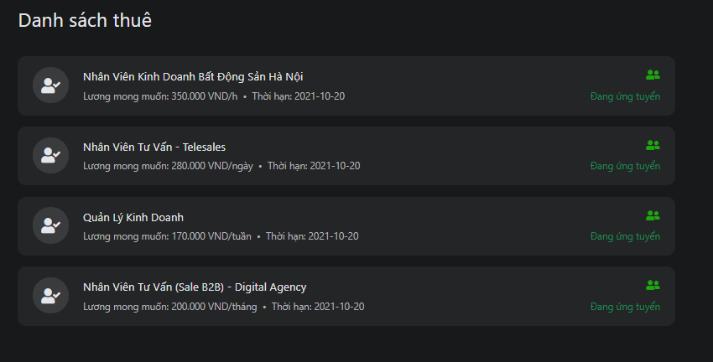

*Figure 3.30:List job hire screen*

|  |  |  |  |
| --- | --- | --- | --- |
| ID and Name | UC-23 View list job hire | | |
| Created By: | Phạm Hữu Thọ | Date Created: | 19/09/2021 |
| Primary Actor: | Student | Secondary Actors: | N/A |
| Description: | View list rental | | |
| Trigger: | The user wants to use view list rental | | |
| Pre-conditions: | The user has logged into HolaLand Website with the role is student | | |
| Post-conditions: | N/A | | |
| Normal flow: | 1. Go to HomePage 2. Click button “Công việc” 3. Click “Danh sách thuê” 4. System display list rental with the number of users who hire you | | |
| Alternative Flows: | N/A | | |
| Exceptions: | The system displays an error message when:   1. Cannot connect to the server | | |
| Priority: | High | | |
| Frequency of Use: | High | | |
| Business Rules: | B08 | | |
| Other Information: | N/A | | |
| Assumptions: | The account has logged into the system as a student | | |

*Table 3.26 Use Case Specification – View list job hire*

##### 2.2.3.2 UC-25 View list applied for a job

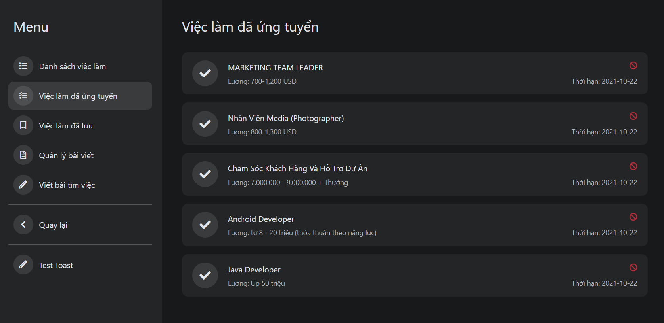

*Figure 3.31:List applied for a job screen*

|  |  |  |  |
| --- | --- | --- | --- |
| ID and Name | UC-24 View list applied for a job | | |
| Created By: | Đoàn Quốc Việt | Date Created: | 19/09/2021 |
| Primary Actor: | Student | Secondary Actors: | N/A |
| Description: | View applied for a job | | |
| Trigger: | The user wants to view the applied job | | |
| Pre-conditions: | The user has logged into HolaLand Website with the role is student | | |
| Post-conditions: | N/A | | |
| Normal flow: | 1. Go to HomePage 2. Click button “Công việc” 3. Click “Việc làm đã ứng tuyển” 4. System display list applied job | | |
| Alternative Flows: | N/A | | |
| Exceptions: | The system displays an error message when:   1. Cannot connect to the server | | |
| Priority: | High | | |
| Frequency of Use: | High | | |
| Business Rules: | B08 | | |
| Other Information: | N/A | | |
| Assumptions: | The account has logged into the system as a student | | |

*Table 3.27 Use Case Specification – View list applied for a job*

##### 2.2.3.3 UC-26 View list job save

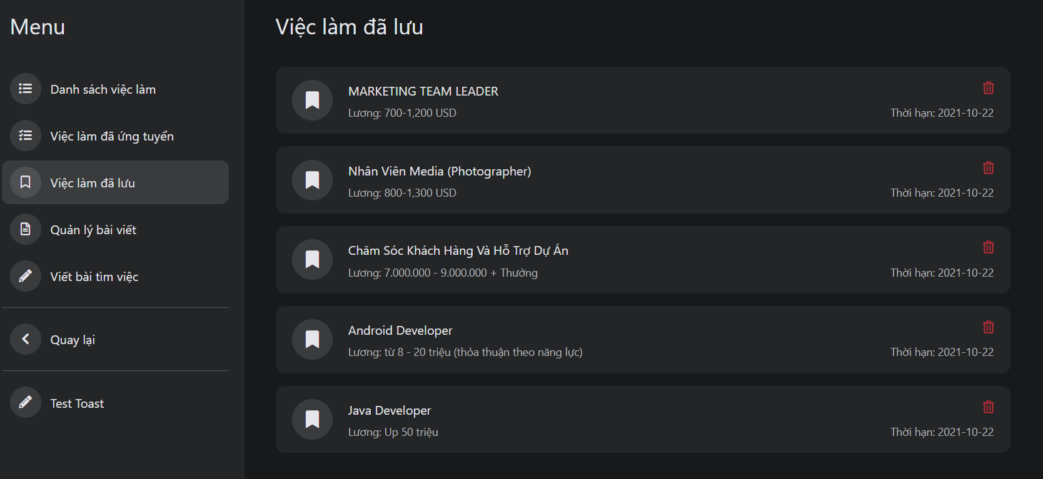

*Figure 3.32:List job save screen*

|  |  |  |  |
| --- | --- | --- | --- |
| ID and Name | UC-25 View list job save | | |
| Created By: | Phạm Hữu Thọ | Date Created: | 19/09/2021 |
| Primary Actor: | Student | Secondary Actors: | N/A |
| Description: | View saved job | | |
| Trigger: | The user wants to use view job save | | |
| Pre-conditions: | The user has logged into HolaLand Website with the role is student | | |
| Post-conditions: | N/A | | |
| Normal flow: | 1. Go to HomePage 2. Click button “Công việc” 3. Click “Việc làm đã lưu” 4. System display list job apply | | |
| Alternative Flows: | N/A | | |
| Exceptions: | The system displays an error message when:   1. Cannot connect to the server | | |
| Priority: | High | | |
| Frequency of Use: | High | | |
| Business Rules: | B08 | | |
| Other Information: | N/A | | |
| Assumptions: | The account has logged into the system as a student | | |

*Table 3.28 Use Case Specification – View list job save*

##### 2.2.3.4 UC-27 Create request find a job

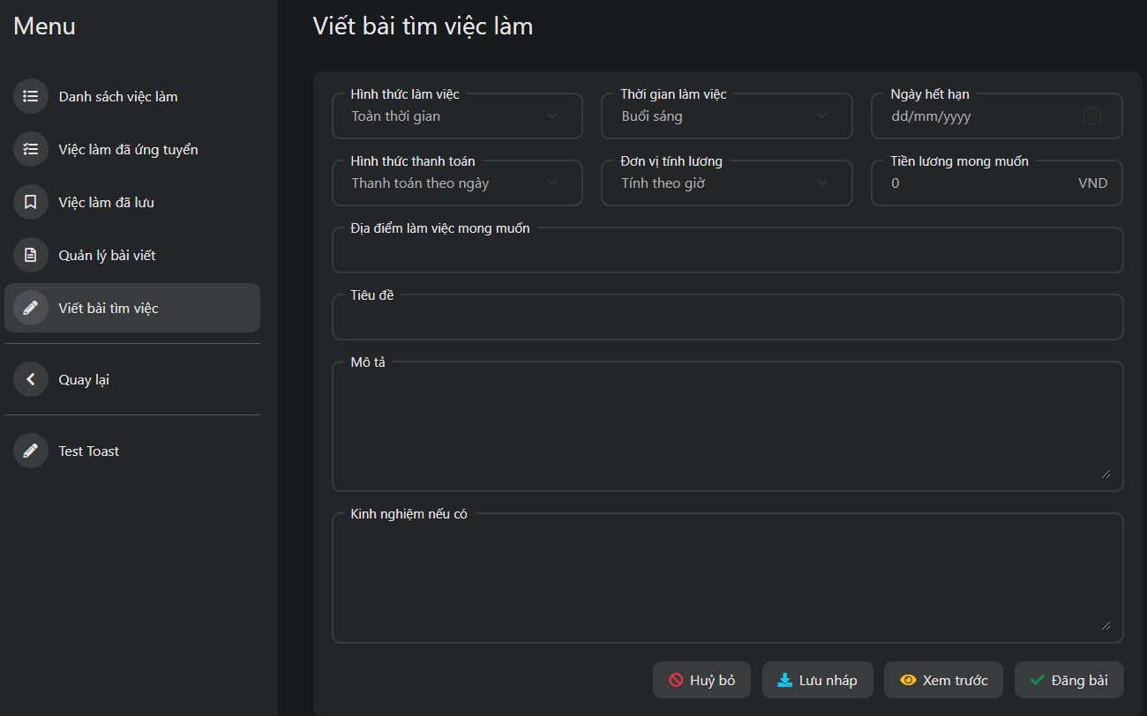

*Figure 3.33:Create request find job screen*

|  |  |  |  |
| --- | --- | --- | --- |
| ID and Name | UC-26 Create a request to find a job | | |
| Created By: | Nguyễn Minh Tuấn | Date Created: | 19/09/2021 |
| Primary Actor: | Student | Secondary Actors: | N/A |
| Description: | Allow member create post find a job | | |
| Trigger: | The user wants to create a post find a job | | |
| Pre-conditions: | 1. User account already created 2. User account has been authorized 3. User accounts already have a Student role 4. The user's device is already connected to the internet when logging in | | |
| Post-conditions: | N/A | | |
| Normal flow: | 1. Go to Home Page 2. Click button “Công việc” 3. Click “Viết bài tìm việc” 4. Fill in the information available in the form 5. Click “Đăng bài” button 6. System displays toast success message 7. System redirects to detail screen of that created request | | |
| Alternative Flows: | 1. Go to Home Page 2. Click button “Công việc” 3. Click “Viết bài tìm việc” 4. Fill in the information available in the form 5. Click “Lưu nháp” button 6. System displays toast success message 7. System redirects to detail screen of that created request 8. Click icon repost 9. System transfers the find job request to the status “Đang chờ duyệt” | | |
| Exceptions: | The system displays an error message when:   1. Cannot connect to the server | | |
| Priority: | High | | |
| Frequency of Use: | High | | |
| Business Rules: | B15,B16 | | |
| Other Information: | N/A | | |
| Assumptions: | The account has logged into the system as a student | | |

*Table 3.29 Use Case Specification – Create a request to find a job*

##### 2.2.3.5 UC-28 Update request find a job

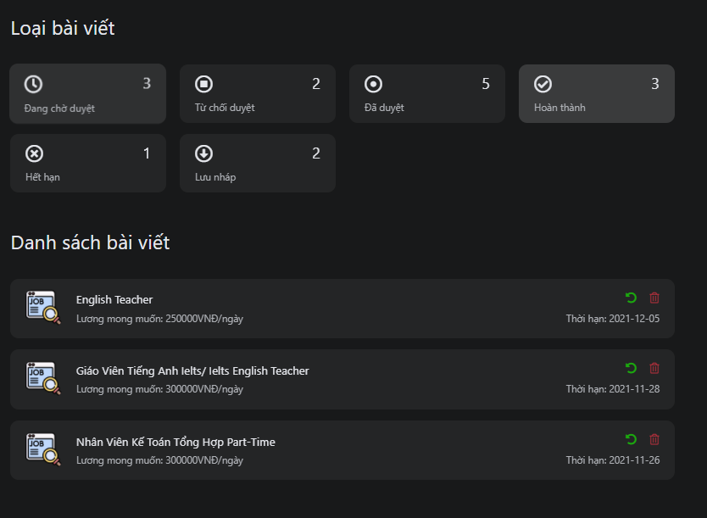

*Figure 3.34:Update request find a job in manage request find job screen*

|  |  |  |  |
| --- | --- | --- | --- |
| ID and Name | UC-27 Update request find a job | | |
| Created By: | Nguyễn Minh Tuấn | Date Created: | 20/09/2021 |
| Primary Actor: | Student | Secondary Actors: | N/A |
| Description: | Allow member update post find a job | | |
| Trigger: | Member wants to update post find a job | | |
| Pre-conditions: | 1. User account already created 2. User account has been authorized 3. User accounts already have a Student role 4. The user's device is already connected to the internet when logging in | | |
| Post-conditions: | The post is in “Hoàn Thành” or “Hết hạn” status | | |
| Normal flow: | 1. Go to Manage post find job screen 2. Click “Hoàn thành” or “Hết hạn” 3. Click the green button repost on the screen 4. System displays notification modal to confirm update post 5. Click “Xác nhận” button 6. System transfers the find job request to the status “Đang chờ duyệt” | | |
| Alternative Flows: | N/A | | |
| Exceptions: | The system displays an error message when:   1. Cannot connect to the server | | |
| Priority: | High | | |
| Frequency of Use: | Low | | |
| Business Rules: | B15,B16 | | |
| Other Information: | N/A | | |
| Assumptions: | The account has logged into the system as a student | | |

*Table 3.30 Use Case Specification – Update request find a job*

##### 2.2.3.6 UC-29 Delete request find a job

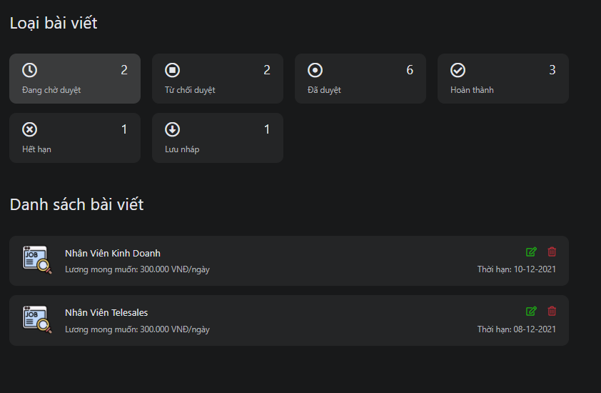

*Figure 3.35:Delete request find a job in manage request find job screen*

|  |  |  |  |
| --- | --- | --- | --- |
| ID and Name | Delete request find a job | | |
| Created By: | Nguyễn Minh Tuấn | Date Created: | 19/09/2021 |
| Primary Actor: | Student | Secondary Actors: | N/A |
| Description: | Delete request find a job | | |
| Trigger: | The user wants to delete the request find a job | | |
| Pre-conditions: | 1. User account already created 2. User account has been authorized 3. User accounts already have a Student role 4. The user's device is already connected to the internet when logging in | | |
| Post-conditions: | N/A | | |
| Normal flow: | 1. Go to Manage post find job screen 2. Click the red button delete in the screen 3. System displays notification modal to confirm delete post 4. Click “Xác nhận” button 5. System transfers the find job request to the status “Đang chờ duyệt” | | |
| Alternative Flows: | N/A | | |
| Exceptions: | The system displays an error message when:   1. Cannot connect to the server | | |
| Priority: | Low | | |
| Frequency of Use: | Low | | |
| Business Rules: | B21 | | |
| Other Information: | N/A | | |
| Assumptions: | The account has logged into the system as a student | | |

*Table 3.31 Use Case Specification – Delete request find a job*

##### 2.2.3.7 UC-30 View manage request find a job

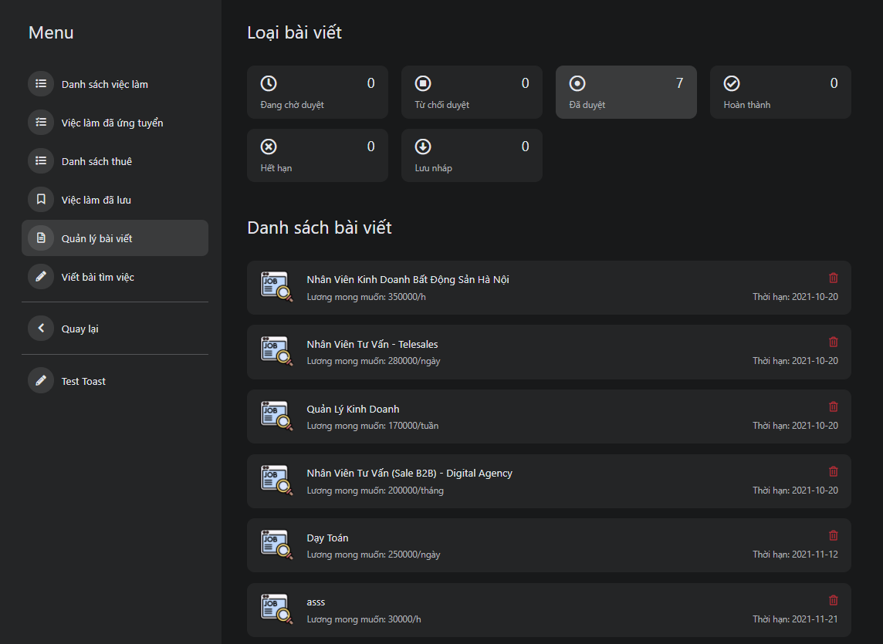

*Figure 3.36:Manage request find job screen*

|  |  |  |  |
| --- | --- | --- | --- |
| ID and Name | UC-29 View manage request find a job | | |
| Created By: | Phạm Hữu Thọ | Date Created: | 20/09/2021 |
| Primary Actor: | Student | Secondary Actors: | N/A |
| Description: | View manage post find a job | | |
| Trigger: | Member wants to view manage post find a job | | |
| Pre-conditions: | User has logged into HolaLand Website with the role is member | | |
| Post-conditions: | N/A | | |
| Normal flow: | 1. Go to HomePage 2. Click button “Công việc” 3. Click “Quản lý bài viết” 4. System display manage post find job screen | | |
| Alternative Flows: | N/A | | |
| Exceptions: | The system displays an error message when:   1. Cannot connect to the server | | |
| Priority: | High | | |
| Frequency of Use: | High | | |
| Business Rules: | B08,B11 | | |
| Other Information: | N/A | | |
| Assumptions: | N/A | | |

*Table 3.32 Use Case Specification – View manage request find a job*

##### 2.2.3.8 UC-31 Apply for a job

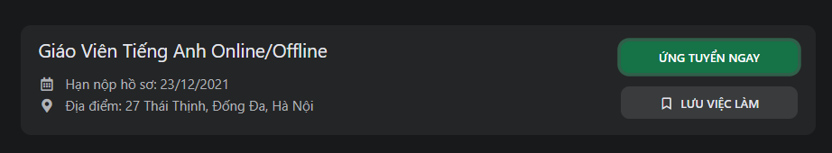

*Figure 3.37:Apply job in detail job screen*

|  |  |  |  |
| --- | --- | --- | --- |
| ID and Name | UC-30 Apply for a job | | |
| Created By: | Nguyễn Minh Tuấn | Date Created: | 20/09/2021 |
| Primary Actor: | Student | Secondary Actors: | N/A |
| Description: | Apply for a job | | |
| Trigger: | User wants to apply for a job | | |
| Pre-conditions: | User has logged into HolaLand Website with the role is member | | |
| Post-conditions: | N/A | | |
| Normal flow: | 1. Go to HomePage 2. Click “Công việc” button 3. Click one request recruitment 4. System display detail request 5. User click “ứng tuyển ngay” button 6. System display successful message | | |
| Alternative Flows: | N/A | | |
| Exceptions: | The system displays an error message when:   1. Cannot connect to the server | | |
| Priority: | High | | |
| Frequency of Use: | High | | |
| Business Rules: | N/A | | |
| Other Information: | N/A | | |
| Assumptions: | N/A | | |

*Table 3.33 Use Case Specification – Apply for job*

##### 2.2.3.9 UC-32 Save job



*Figure 3.38:Save job in detail job screen*

|  |  |  |  |
| --- | --- | --- | --- |
| ID and Name | UC-31 Save job | | |
| Created By: | Nguyễn Minh Tuấn | Date Created: | 20/09/2021 |
| Primary Actor: | Student | Secondary Actors: | N/A |
| Description: | Save job | | |
| Trigger: | User wants to save job | | |
| Pre-conditions: | User has logged into HolaLand Website with the role is member | | |
| Post-conditions: | N/A | | |
| Normal flow: | 1. Go to HomePage 2. Click “Công việc” button 3. Click one request recruitment 4. System display detail request 5. User click “lưu việc làm” button 6. System display successful message and change text “lưu việc làm” to “đã lưu” | | |
| Alternative Flows: | N/A | | |
| Exceptions: | The system displays an error message when:   1. Cannot connect to the server | | |
| Priority: | Normal | | |
| Frequency of Use: | Normal | | |
| Business Rules: | N/A | | |
| Other Information: | N/A | | |
| Assumptions: | N/A | | |

*Table 3.34 Use Case Specification – Save job*

#### 2.2.4 Recruiter

##### 2.2.4.1 UC-33 View list find a job

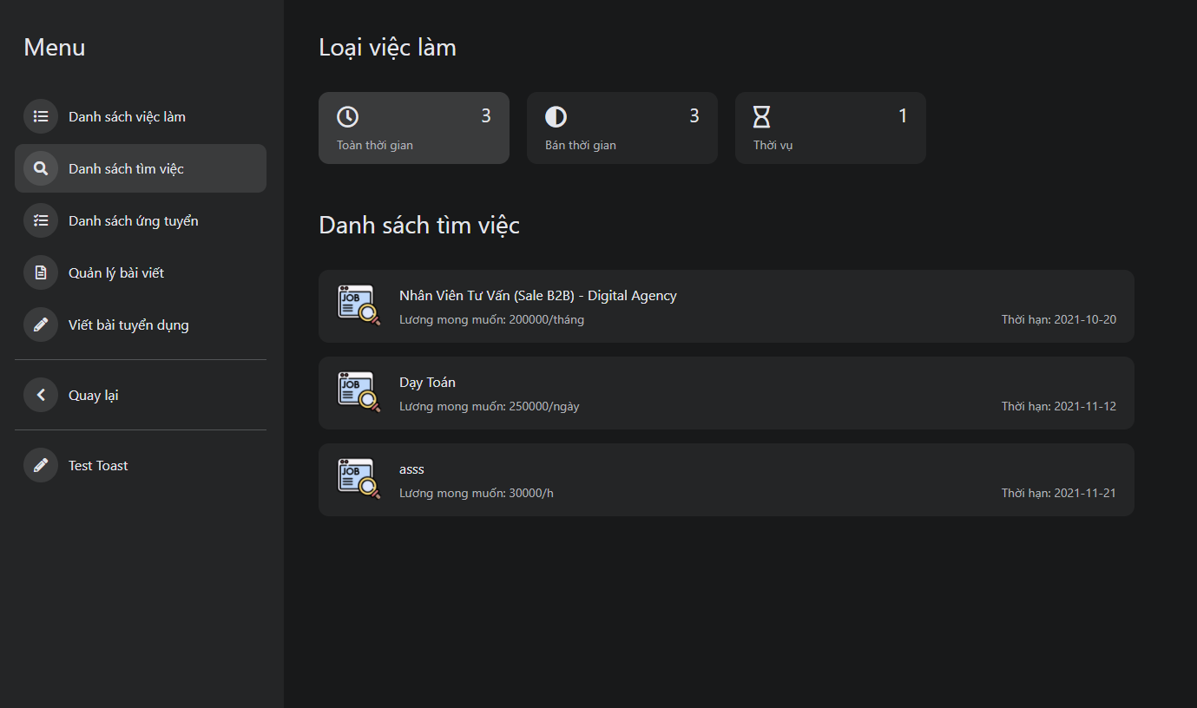

*Figure 3.39:List find job in “danh sách tìm việc” screen*

|  |  |  |  |
| --- | --- | --- | --- |
| ID and Name | UC-32 View list find a job | | |
| Created By: | Nguyễn Hoàng Đức | Date Created: | 20/09/2021 |
| Primary Actor: | Recruiter | Secondary Actors: | N/A |
| Description: | View list find a job | | |
| Trigger: | The user wants to use a view list to find a job | | |
| Pre-conditions: | The user has logged into HolaLand Website with the role is a recruiter | | |
| Post-conditions: | N/A | | |
| Normal flow: | 1. Go to Home Page 2. Click button “Công việc” 3. Click “Danh sách tìm việc” 4. System display list find a job | | |
| Alternative Flows: | N/A | | |
| Exceptions: | The system displays an error message when:   1. Cannot connect to the server | | |
| Priority: | High | | |
| Frequency of Use: | High | | |
| Business Rules: | B08 | | |
| Other Information: | N/A | | |
| Assumptions: | The account has logged into the system as a recruiter | | |

*Table 3.35 Use Case Specification – View list find a job*

##### 2.2.4.2 UC-34 View detail list find a job

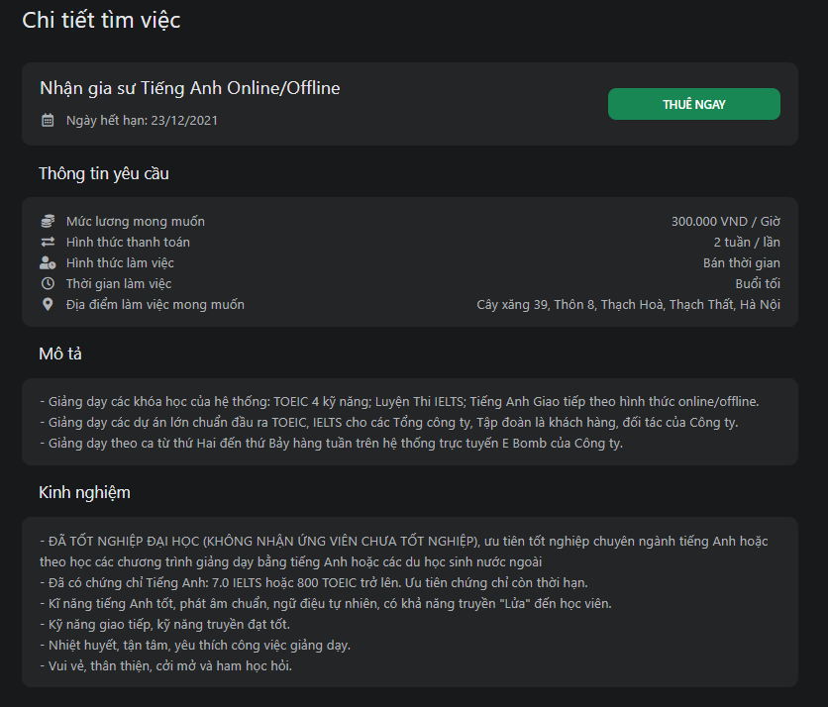

*Figure 3.40:Detail list find job screen*

|  |  |  |  |
| --- | --- | --- | --- |
| ID and Name | UC-33 View detail list find a job | | |
| Created By: | Phạm Thế Anh | Date Created: | 20/09/2021 |
| Primary Actor: | Recruiter | Secondary Actors: | N/A |
| Description: | View detail list find a job | | |
| Trigger: | Users want to view detail list find a job | | |
| Pre-conditions: | User has logged into HolaLand Website with the role is a recruiter | | |
| Post-conditions: | The system has at least 1 job on the screen | | |
| Normal flow: | 1. Go to Home Page 2. Click button “Công việc” 3. Click “Danh sách tìm việc” 4. Click any one job on the screen 5. System display one job detail that you click | | |
| Alternative Flows: | N/A | | |
| Exceptions: | The system displays an error message when:   1. Cannot connect to the server | | |
| Priority: | High | | |
| Frequency of Use: | High | | |
| Business Rules: | B08 | | |
| Other Information: | N/A | | |
| Assumptions: | N/A | | |

*Table 3.36 Use Case Specification – View detail list find a job*

##### 2.2.4.3 UC-35 Hire worker



*Figure 3.41:Hire worker in detail find job screen*

|  |  |  |  |
| --- | --- | --- | --- |
| ID and Name | UC-34 Hire worker | | |
| Created By: | Nguyễn Minh Tuấn | Date Created: | 20/09/2021 |
| Primary Actor: | Recruiter | Secondary Actors: | Guest |
| Description: | Hire worker | | |
| Trigger: | Recruiter wants to hire worker | | |
| Pre-conditions: | User has logged into HolaLand Website with the role is a recruiter | | |
| Post-conditions: | N/A | | |
| Normal flow: | 1. Go to module work screen 2. Click “Danh sách việc làm” in the left menu in the screen 3. Click one request find job 4. System display request find job 5. Click “thuê ngay” button 6. System display successful message | | |
| Alternative Flows: | N/A | | |
| Exceptions: | The system displays an error message when:   1. Cannot connect to the server | | |
| Priority: | High | | |
| Frequency of Use: | High | | |
| Business Rules: | N/A | | |
| Other Information: | N/A | | |
| Assumptions: | N/A | | |

*Table 3.37 Use Case Specification – Hire worker*

##### 2.2.4.4 UC-36 View list apply for a job

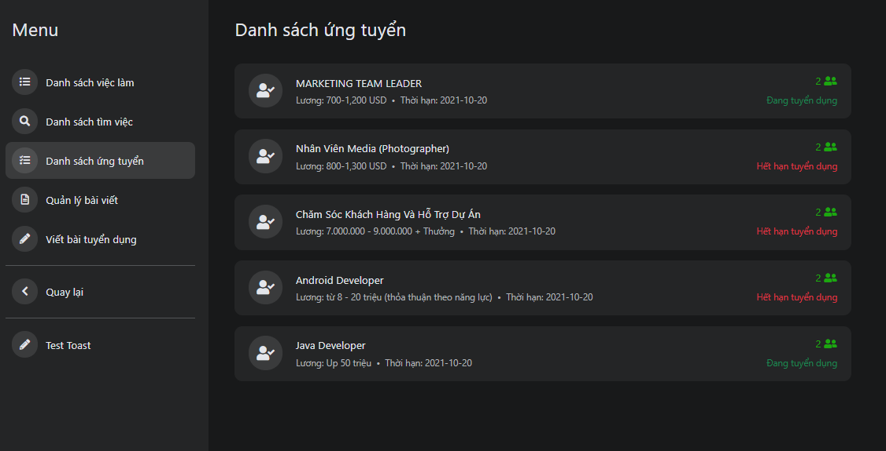

*Figure 3.42:List apply job screen*

|  |  |  |  |
| --- | --- | --- | --- |
| ID and Name | UC-35 View list apply for a job | | |
| Created By: | Phạm Thế Anh | Date Created: | 21/09/2021 |
| Primary Actor: | Recruiter | Secondary Actors: | N/A |
| Description: | Allow recruiter can view list job apply | | |
| Trigger: | Recruiter wants to view list job apply | | |
| Pre-conditions: | 1. User account already created 2. User account has been authorized 3. User accounts already have a Recruiter role 4. The user's device is already connected to the internet when logging in | | |
| Post-conditions: | N/A | | |
| Normal flow: | 1. Go to Home Page 2. Click button “Công việc” 3. Click “Danh sách ứng tuyển” 4. System display list job apply | | |
| Alternative Flows: | N/A | | |
| Exceptions: | The system displays an error message when:   1. Cannot connect to the server | | |
| Priority: | High | | |
| Frequency of Use: | Medium | | |
| Business Rules: | B08 | | |
| Other Information: | N/A | | |
| Assumptions: | The account has logged into the system as a recruiter | | |

*Table 3.38 Use Case Specification – View list apply for a job*

##### 2.2.4.5 UC-37 Create request recruitment

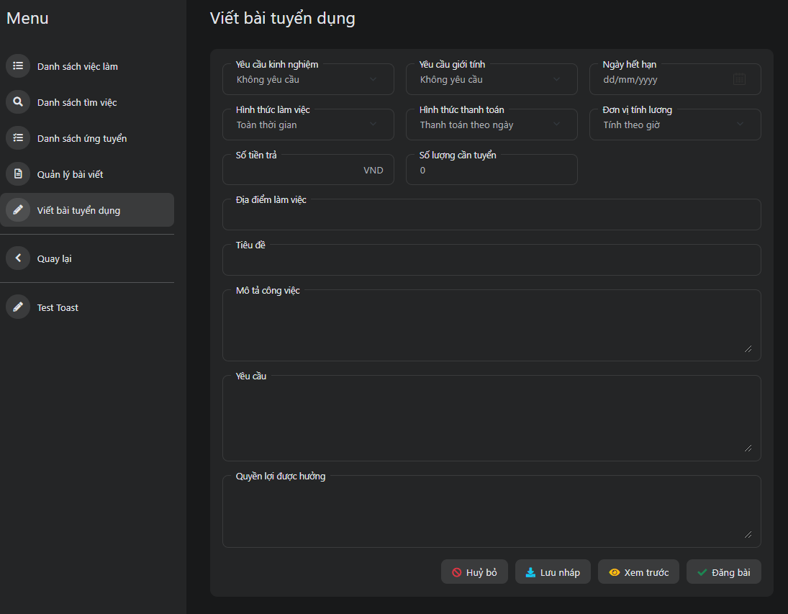

*Figure 3.43:Create request recruitment screen*

|  |  |  |  |
| --- | --- | --- | --- |
| ID and Name | UC-36 Create request recruitment | | |
| Created By: | Đoàn Quốc Việt | Date Created: | 21/09/2021 |
| Primary Actor: | Recruiter | Secondary Actors: | N/A |
| Description: | Create request recruitment | | |
| Trigger: | Recruitment want to Create a request for recruitment | | |
| Pre-conditions: | The user has logged into HolaLand Website with the role is a recruiter | | |
| Post-conditions: | N/A | | |
| Normal flow: | 1. Go to Home Page 2. Click button “Công việc” 3. Click “Viết bài tuyển dụng” 4. Fill in the information available in the form 5. Click “Đăng bài” button 6. System displays toast success message 7. System redirects to detail screen of that created request | | |
| Alternative Flows: | 1. Go to Home Page 2. Click button “Công việc” 3. Click “Viết bài tuyển dụng” 4. Fill in the information available in the form 5. Click “Lưu nháp” button 6. System displays toast success message 7. System redirects to detail screen of that created request 8. Click icon repost 9. System transfers the recruitment request to the item “Đang chờ duyệt” | | |
| Exceptions: | -System displays an error message when:   1. Cannot connect to the server   -System displays 404 screens when:   1. Fill in the missing information in the form | | |
| Priority: | High | | |
| Frequency of Use: | High | | |
| Business Rules: | B15,B16 | | |
| Other Information: | N/A | | |
| Assumptions: | N/A | | |

*Table 3.39 Use Case Specification – Create request recruitment*

##### 2.2.4.6 UC-38 Update request recruitment

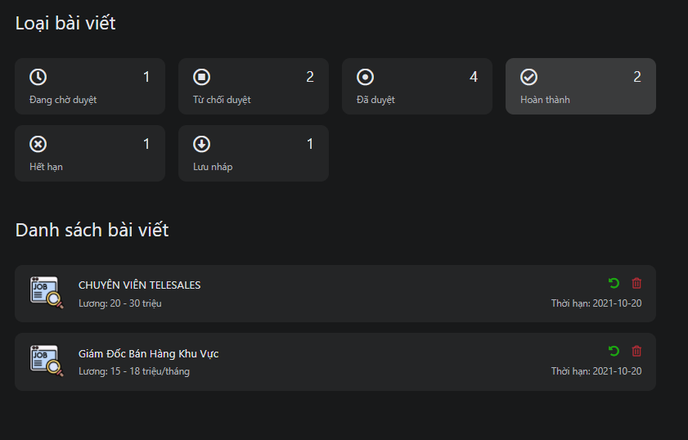

*Figure 3.44:Update request recruitment in manage request recruitment screen*

|  |  |  |  |
| --- | --- | --- | --- |
| ID and Name | UC-37 Update request recruitment | | |
| Created By: | Đoàn Quốc Việt | Date Created: | 21/09/2021 |
| Primary Actor: | Recruiter | Secondary Actors: | N/A |
| Description: | Allow recruiter update post recruitment | | |
| Trigger: | Recruiter wants to update post recruitment | | |
| Pre-conditions: | 1. User account already created 2. User account has been authorized 3. User accounts already have a Recruiter role 4. The user's device is already connected to the internet when logging in | | |
| Post-conditions: | The post is in “Hoàn Thành” or “Hết hạn” status | | |
| Normal flow: | 1. Go to Manage post recruitment screen 2. Click “Hoàn thành” or “Hết hạn” 3. Click the green button repost on the screen 4. System displays notification modal to confirm update post 5. Click “Xác nhận” button 6. System transfers the find job request to the item “Đang chờ duyệt” | | |
| Alternative Flows: | N/A | | |
| Exceptions: | The system displays an error message when:   1. Cannot connect to the server | | |
| Priority: | High | | |
| Frequency of Use: | Low | | |
| Business Rules: | B15,B16 | | |
| Other Information: | N/A | | |
| Assumptions: | The account has logged into the system as a recruiter | | |

*Table 3.40 Use Case Specification – Update request recruitment*

##### 2.2.4.7 UC-39 Delete request recruitment

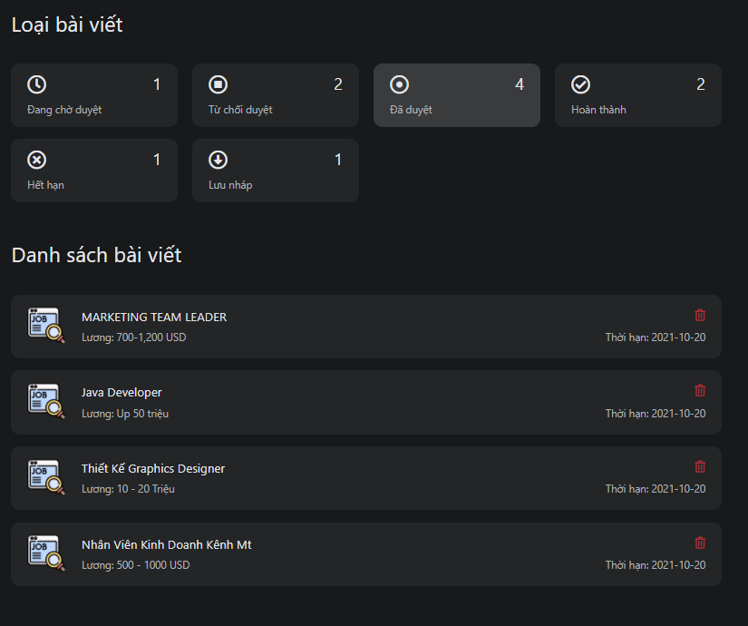

*Figure 3.45:Delete request recruitment in manage request recruitment screen*

|  |  |  |  |
| --- | --- | --- | --- |
| ID and Name | UC-38 Delete request recruitment | | |
| Created By: | Đoàn Quốc Việt | Date Created: | 21/09/2021 |
| Primary Actor: | Recruiter | Secondary Actors: | Guest |
| Description: | Delete request recruitment | | |
| Trigger: | The user wants to delete the request recruitment | | |
| Pre-conditions: | User has logged into HolaLand Website with the role is a recruiter | | |
| Post-conditions: | N/A | | |
| Normal flow: | 1. Go to Manage request recruitment screen 2. Click the red button delete in the screen 3. System displays notification modal to confirm delete post 4. Click “Xác nhận” button 5. System transfers the find job request to the status “Đang chờ duyệt” | | |
| Alternative Flows: | N/A | | |
| Exceptions: | The system displays an error message when:   1. Cannot connect to the server | | |
| Priority: | Low | | |
| Frequency of Use: | Medium | | |
| Business Rules: | B21 | | |
| Other Information: | N/A | | |
| Assumptions: | The account has logged into the system as a recruiter | | |

*Table 3.41 Use Case Specification – Delete request recruitment*

##### 2.2.4.8 UC-40 View manage request recruitment

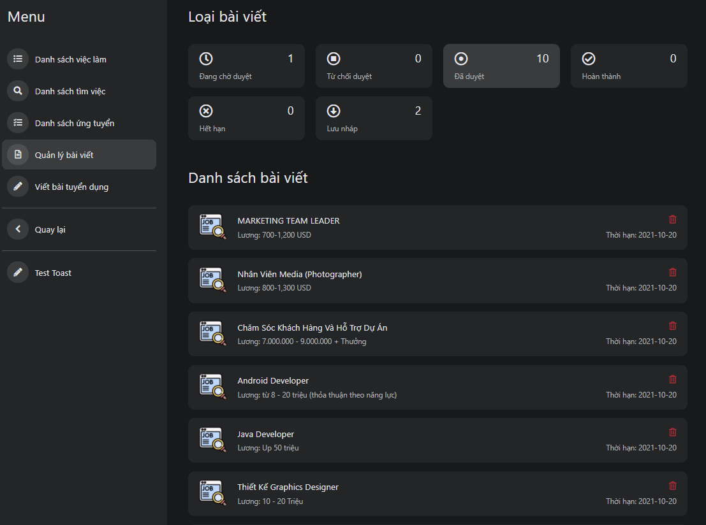

*Figure 3.46:Manage request recruitment screen*

|  |  |  |  |
| --- | --- | --- | --- |
| ID and Name | UC-39 View manage request recruitment | | |
| Created By: | Nguyễn Minh Tuấn | Date Created: | 21/09/2021 |
| Primary Actor: | Recruiter | Secondary Actors: | N/A |
| Description: | View manage post recruitment | | |
| Trigger: | Recruitment wants to view manage post recruitment | | |
| Pre-conditions: | User has logged into HolaLand Website with the role is a recruiter | | |
| Post-conditions: | N/A | | |
| Normal flow: | 1. Go to Home Page 2. Click button “Công việc” 3. Click “Quản lý bài viết” 4. System display manage post recuitment screen | | |
| Alternative Flows: | N/A | | |
| Exceptions: | The system displays an error message when:   1. Cannot connect to the server | | |
| Priority: | High | | |
| Frequency of Use: | High | | |
| Business Rules: | B08 | | |
| Other Information: | N/A | | |
| Assumptions: | N/A | | |

*Table 3.42 Use Case Specification – View manage request recruitment*

#### 2.2.5 Seller

##### 2.2.5.1 UC-41 Update shop information

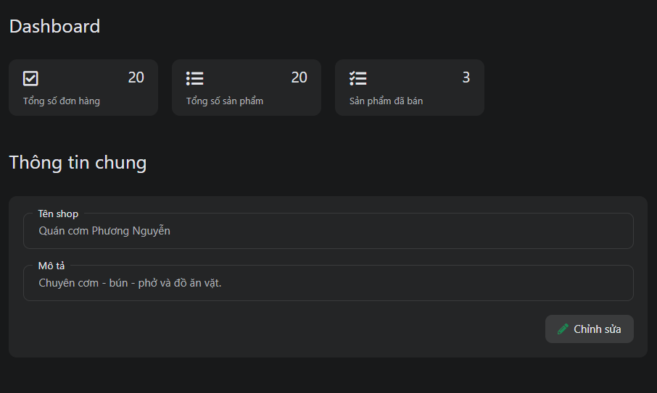

*Figure 3.47:Update shop information in store info screen*

|  |  |  |  |
| --- | --- | --- | --- |
| ID and Name | UC-43 Update shop information | | |
| Created By: | Đoàn Quốc Việt | Date Created: | 21/09/2021 |
| Primary Actor: | Seller | Secondary Actors: | N/A |
| Description: | Update shop information | | |
| Trigger: | The user wants to update shop information | | |
| Pre-conditions: | The user has logged into HolaLand Website | | |
| Post-conditions: | When the normal flow completes successfully, the new shop information will be saved in the database | | |
| Normal flow: | 1. Go to dashboard manage store Screen  2. Click “Thông tin shop” on the menu  3. System displays all shop info  4. User update full name, title  5. Click “Chỉnh sửa” button  6. System displays toast success message  7. The new shop info is updated | | |
| Alternative Flows: | N/A | | |
| Exceptions: | The system displays an error message when:   1. Cannot connect to the server | | |
| Priority: | Medium | | |
| Frequency of Use: | Medium | | |
| Business Rules: | B22 | | |
| Other Information: | N/A | | |
| Assumptions: | The account has logged into the system as a seller | | |

*Table 3.43 Use Case Specification – Update shop information*

##### 2.2.5.2 UC-42 Update tag of food

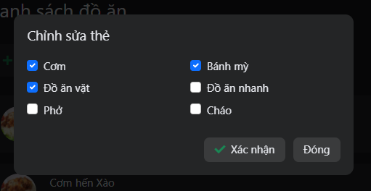

*Figure 3.48:Update tag of food screen*

|  |  |  |  |
| --- | --- | --- | --- |
| ID and Name | UC-44 Update tag of food | | |
| Created By: | Nguyễn Minh Tuấn | Date Created: | 22/09/2021 |
| Primary Actor: | Seller | Secondary Actors: | N/A |
| Description: | Update tag of food | | |
| Trigger: | The user wants to update the tag of the food | | |
| Pre-conditions: | The user has logged into HolaLand Website | | |
| Post-conditions: | When the normal flow completes successfully, the new tag of food will be saved in a database | | |
| Normal flow: | 1. Go to dashboard manage store Screen  2. Click “Quản lý thẻ-đồ ăn” in menu  3. System displays list tag of food  4. Click “Chỉnh sửa” button  5. User choose a tag to update  6. Click “Xác nhận” button  7. System displays toast success message  8. The new tag of food is updated | | |
| Alternative Flows: | N/A | | |
| Exceptions: | The system displays an error message when:   1. Cannot connect to the server | | |
| Priority: | Low | | |
| Frequency of Use: | Low | | |
| Business Rules: | B25 | | |
| Other Information: | N/A | | |
| Assumptions: | The account has logged into the system as a seller | | |

*Table 3.44 Use Case Specification – Update tag of food*

##### 2.2.5.3 UC-43 Add items to the shop

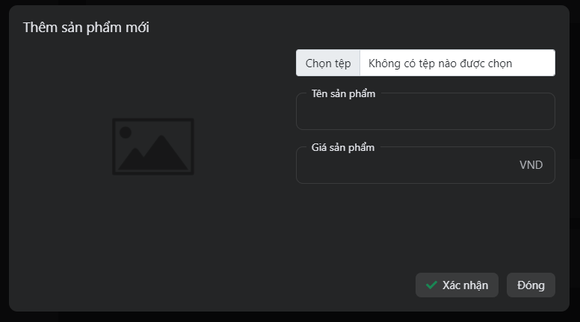

*Figure 3.49:Add food items screen*

|  |  |  |  |
| --- | --- | --- | --- |
| ID and Name | UC-45 Add items to shop | | |
| Created By: | Nguyễn Minh Tuấn | Date Created: | 22/09/2021 |
| Primary Actor: | Seller | Secondary Actors: | N/A |
| Description: | Add items to the shop | | |
| Trigger: | Seller wants to add items to shop | | |
| Pre-conditions: | User has logged into HolaLand Website with role “Seller” | | |
| Post-conditions: | When the normal flow completes successfully, the new items of the shop will be saved in a database | | |
| Normal flow: | 1. Go to Manage Store Screen 2. Click “Quản lý thẻ - đồ ăn” in the menu 3. Click “Thêm sản phẩm mới” button 4. System display modal add items 5. Seller add an image of food, input name items, and price 6. Click “Xác nhận” button 7. System displays toast success message 8. A new item is added | | |
| Alternative Flows: | N/A | | |
| Exceptions: | The system displays an error message when:  1. Cannot connect to the server | | |
| Priority: | High | | |
| Frequency of Use: | High | | |
| Business Rules: | B22 | | |
| Other Information: | N/A | | |
| Assumptions: | The account has logged into the system as a seller | | |

*Table 3.45 Use Case Specification – Add items to the shop*

##### 2.2.5.4 UC-44 Update items

*Figure 3.50:Update items screen*

|  |  |  |  |
| --- | --- | --- | --- |
| ID and Name | UC-46 Update items | | |
| Created By: | Phạm Thế Anh | Date Created: | 22/09/2021 |
| Primary Actor: | Seller | Secondary Actors: | N/A |
| Description: | Update items | | |
| Trigger: | Seller wants to update items of the shop | | |
| Pre-conditions: | User has logged into HolaLand Website with role “Seller” | | |
| Post-conditions: | When the normal flow completes successfully, the new items of the shop will be updated in the database | | |
| Normal flow: | 1. Go to Manage Store Screen 2. Click “Quản lý thẻ - đồ ăn” in the menu 3. Click the edit button on the right screen 4. System display modal edit items 5. Seller add a new image of food, inputs new name items, and new price 6. Click “Xác nhận” button 7. System displays toast success message 8. A new item is updated | | |
| Alternative Flows: | N/A | | |
| Exceptions: | The system displays an error message when:  1. Cannot connect to the server | | |
| Priority: | Normal | | |
| Frequency of Use: | Normal | | |
| Business Rules: | B22 | | |
| Other Information: | N/A | | |
| Assumptions: | The account has logged into the system as a seller | | |

*Table 3.46 Use Case Specification – Update items*

##### 2.2.5.5 UC-45 Delete items

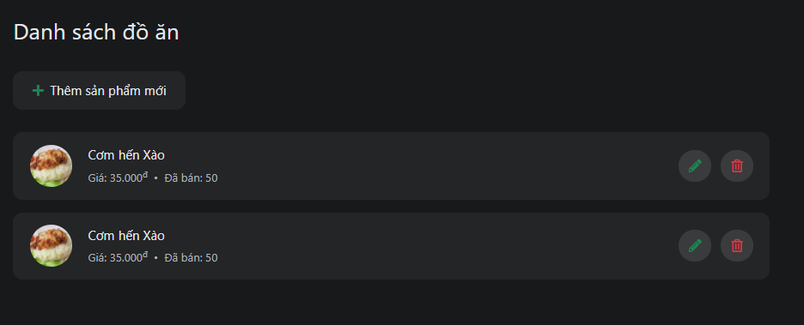

*Figure 3.51:Delete food items screen*

|  |  |  |  |
| --- | --- | --- | --- |
| ID and Name | UC-47 Delete items | | |
| Created By: | Nguyễn Minh Tuấn | Date Created: | 23/09/2021 |
| Primary Actor: | Seller | Secondary Actors: | N/A |
| Description: | Delete items of restaurant | | |
| Trigger: | The user wants to delete items | | |
| Pre-conditions: | The user has logged into HolaLand Website | | |
| Post-conditions: | N/A | | |
| Normal flow: | 1. Go to dashboard manage store Screen  2. Click “Quản lý thẻ-đồ ăn” in menu  3. System displays list food of the restaurant  4. Click the red button on the right of the food  5. System displays toast delete success message  6. The food is deleted | | |
| Alternative Flows: | N/A | | |
| Exceptions: | The system displays an error message when:  1. Cannot connect to the server | | |
| Priority: | High | | |
| Frequency of Use: | High | | |
| Business Rules: | N/A | | |
| Other Information: | N/A | | |
| Assumptions: | The account has logged into the system as a seller | | |

*Table 3.47 Use Case Specification – Delete items*

##### 2.2.5.6 UC-46 View list seller order

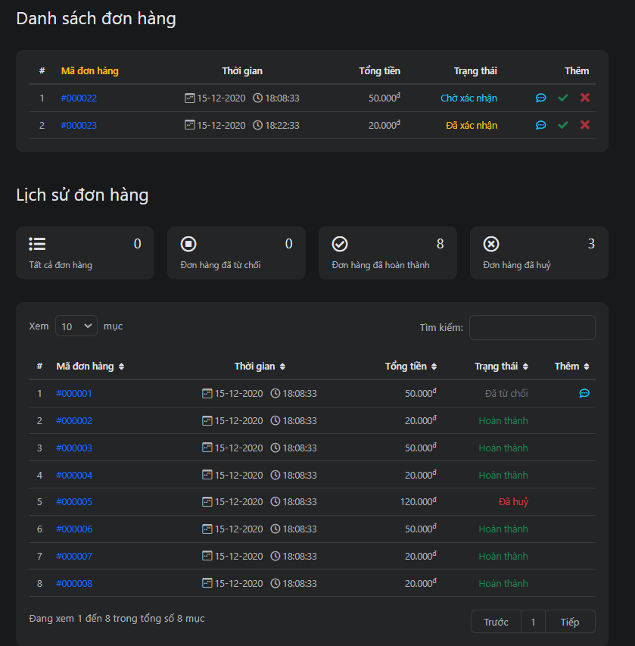

*Figure 3.52:Manage seller order screen*

|  |  |  |  |
| --- | --- | --- | --- |
| ID and Name | UC-48 View list seller order | | |
| Created By: | Nguyễn Minh Tuấn | Date Created: | 24/09/2021 |
| Primary Actor: | Seller | Secondary Actors: | N/A |
| Description: | View list seller order | | |
| Trigger: | Seller want to view list order | | |
| Pre-conditions: | User has logged into HolaLand Website with role seller | | |
| Post-conditions: | N/A | | |
| Normal flow: | 1. Go to Home Screen 2. Click module “Ăn-uống” 3. Click “Đơn hàng” in the menu 4. System display list order and list history order | | |
| Alternative Flows: | N/A | | |
| Exceptions: | The system displays an error message when:  1. Cannot connect to the server | | |
| Priority: | High | | |
| Frequency of Use: | High | | |
| Business Rules: | B11,B12 | | |
| Other Information: | N/A | | |
| Assumptions: | The account has logged into the system as a seller | | |

*Table 3.48 Use Case Specification – View manage seller order*

##### 2.2.5.7 UC-47 View detail order

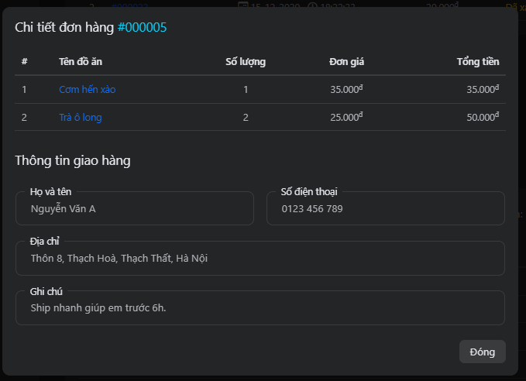

*Figure 3.53:Detail order screen*

|  |  |  |  |
| --- | --- | --- | --- |
| ID and Name | UC-49 View detail order | | |
| Created By: | Đoàn Quốc Việt | Date Created: | 24/09/2021 |
| Primary Actor: | Seller | Secondary Actors: | N/A |
| Description: | View detail order | | |
| Trigger: | Seller wants to view detail order | | |
| Pre-conditions: | User has logged into HolaLand Website with role seller | | |
| Post-conditions: | N/A | | |
| Normal flow: | 1. Go to Home Screen 2. Click module “Ăn-uống” 3. Click “Đơn hàng” in the menu 4. Click “Mã đơn hàng” 5. System displays detailed order | | |
| Alternative Flows: | N/A | | |
| Exceptions: | The system displays an error message when:  1. Cannot connect to the server | | |
| Priority: | Normal | | |
| Frequency of Use: | High | | |
| Business Rules: | B26 | | |
| Other Information: | N/A | | |
| Assumptions: | The account has logged into the system as a seller | | |

*Table 3.49 Use Case Specification – View detail order*

##### 2.2.5.8 UC-48 Approve the order

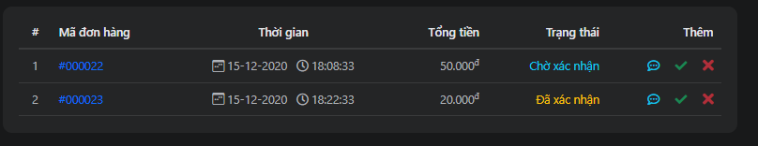

*Figure 3.54:Approve order in manage seller order screen*

|  |  |  |  |
| --- | --- | --- | --- |
| ID and Name | UC-50 Approve the order | | |
| Created By: | Phạm Hữu Thọ | Date Created: | 25/09/2021 |
| Primary Actor: | Seller | Secondary Actors: | N/A |
| Description: | Reject order | | |
| Trigger: | The seller wants to approve an order | | |
| Pre-conditions: | User has logged into HolaLand Website with role seller | | |
| Post-conditions: | User must place at least 1 order | | |
| Normal flow: | 1. Go to the Order screen 2. Click the “v” button on the right screen 3. System displays notification modal to confirm approve an order 4. Click “Xác nhận” button 5. System displays toast success message | | |
| Alternative Flows: | N/A | | |
| Exceptions: | The system displays an error message when:  1. Cannot connect to the server | | |
| Priority: | High | | |
| Frequency of Use: | High | | |
| Business Rules: | N/A | | |
| Other Information: | N/A | | |
| Assumptions: | N/A | | |

*Table 3.50 Use Case Specification – Approve the order*

##### 2.2.5.9 UC-49 Reject order



*Figure 3.55:Reject order in manage seller order screen*

|  |  |  |  |
| --- | --- | --- | --- |
| ID and Name | UC-51 Reject order | | |
| Created By: | Phạm Hữu Thọ | Date Created: | 25/09/2021 |
| Primary Actor: | Seller | Secondary Actors: | N/A |
| Description: | Reject order | | |
| Trigger: | The seller wants to reject an order | | |
| Pre-conditions: | User has logged into HolaLand Website with role seller | | |
| Post-conditions: | User must place at least 1 order | | |
| Normal flow: | 1. Go to the Order screen 2. Click the “x” button on the right screen 3. System displays notification modal to confirm reject an order 4. Seller input reason reject 5. Click “Xác nhận” button 6. System displays toast success message | | |
| Alternative Flows: | N/A | | |
| Exceptions: | The system displays an error message when:  1. Cannot connect to the server | | |
| Priority: | High | | |
| Frequency of Use: | High | | |
| Business Rules: | B27 | | |
| Other Information: | N/A | | |
| Assumptions: | N/A | | |

*Table 3.51 Use Case Specification – Reject order*

##### 2.2.5.10 UC-50 View data – statistics

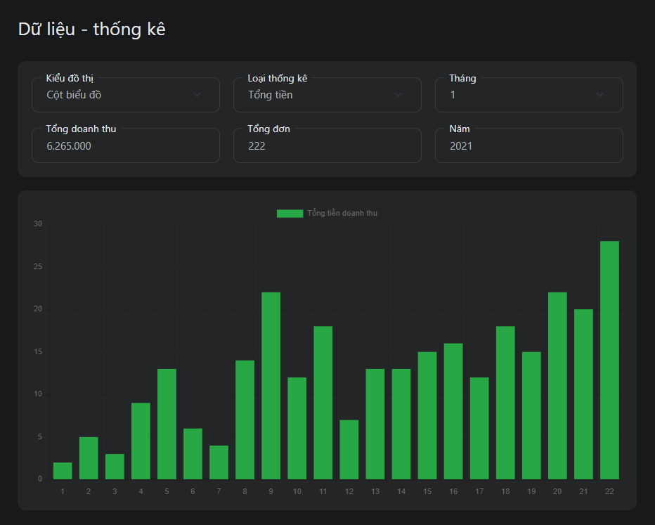

*Figure 3.56:Data – statistics screen*

|  |  |  |  |
| --- | --- | --- | --- |
| ID and Name | UC-52 View data – statistics | | |
| Created By: | Nguyễn Minh Tuấn | Date Created: | 26/09/2021 |
| Primary Actor: | Seller | Secondary Actors: | N/A |
| Description: | View data – statistics | | |
| Trigger: | Seller wants to view data – statistics | | |
| Pre-conditions: | User has logged into HolaLand Website with role seller | | |
| Post-conditions: | N/A | | |
| Normal flow: | 1. Go to manage store screen 2. Click “Dữ liệu thống kê” in the left menu in the screen 3. System displays statistics of total revenue according to the chart | | |
| Alternative Flows: | N/A | | |
| Exceptions: | The system displays an error message when:  1. Cannot connect to the server | | |
| Priority: | High | | |
| Frequency of Use: | High | | |
| Business Rules: | N/A | | |
| Other Information: | N/A | | |
| Assumptions: | N/A | | |

*Table 3.52 Use Case Specification – View data – statistics*

## 3. Functional Requirements

### 3.1 System Functional Overview

#### 3.1.1 Screen Flow

##### 3.1.1.1 HolaLand System

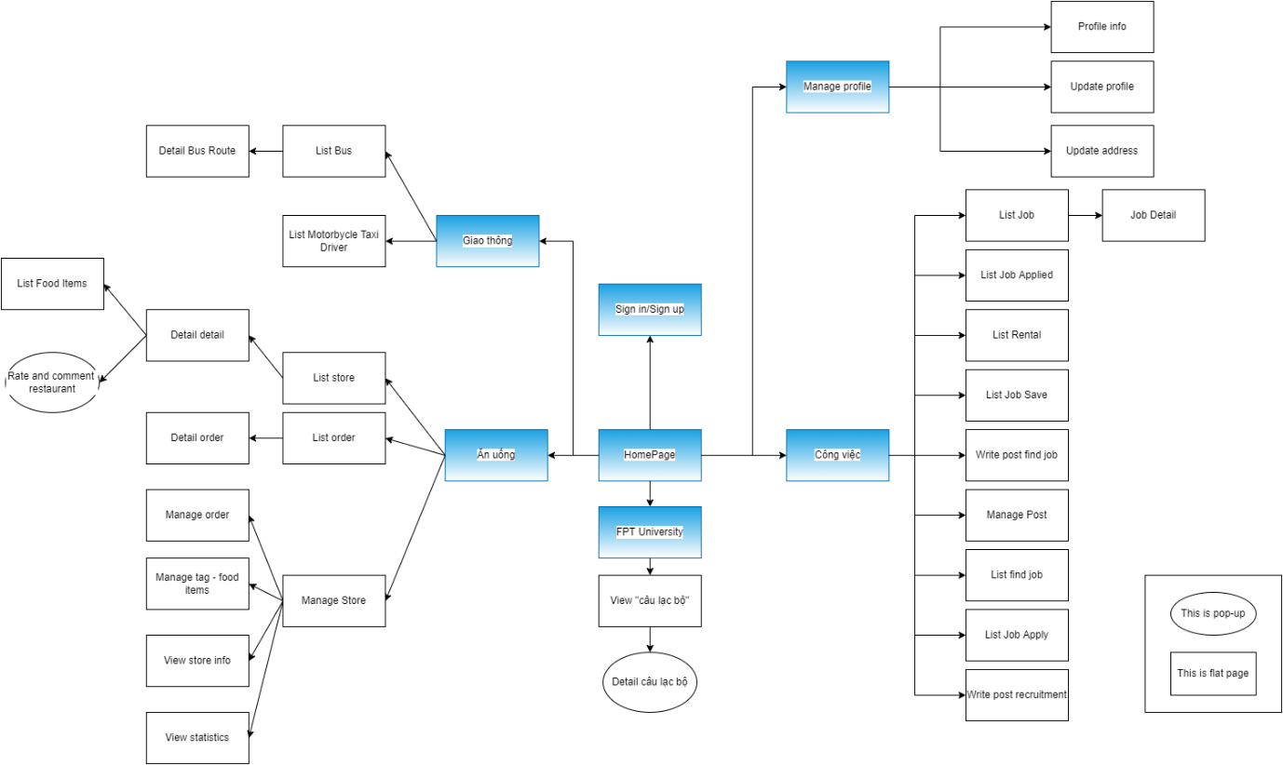

*Figure 3.57:Screen flow for HolaLand System*

##### 3.1.1.2 Dashboard admin

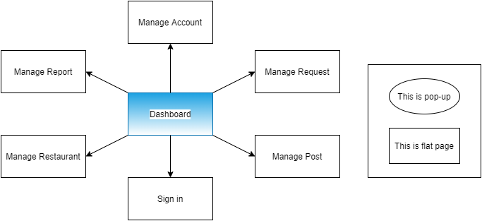

*Figure 3.58:Screen flow for Dashboard Admin*

#### 3.1.2 Screen Descriptions

|  |  |  |
| --- | --- | --- |
| **#** | **Product Owner** | **Description** |
|  | Home Page | The screen that shows general information of the website: “FPT University”, “Công việc”, “Ăn uống”, “Giải trí”, “Mua sắm”, “Giao thông”, “Thông tin khác”. |
|  | Sign in/Sign up | This screen uis sed to enter username and password by verifying email |
|  | List job | The screen that lists all job recruitment |
|  | List job applied | The screen that lists all jobs applied |
|  | List Rental | The screen that lists all job rental |
|  | List Job Save | The screen that lists all job save |
|  | Write post find a job | The screen where students can create requests find a job |
|  | Manage Post | The screen that user can update, delete request |
|  | List find job | The screen that lists all find job |
|  | List job apply | The screen that lists all apply |
|  | Write post recruitment | The screen where recruiters can create request recruitment |
|  | List store | The screen that lists all store |
|  | List order | The screen that lists all orders of user |
|  | Detail order | The screen that shows detail an order |
|  | Detail store | The screen that shows detail store |
|  | List food items | The screen that lists all food items of the store |
|  | Rate and comment restaurant | The popup for users to comment and rate store after  finishing order. |
|  | Manage order | The screen that allows seller can approve/reject order and view lists all order is finished |
|  | Manage tag – food items | The screen that allows sellers can update the tag of food and add, update, delete food items of their store |
|  | View store info | The screen that allows seller can views store info: name, description, and avatar of store |
|  | View statistics | The screen that allows sellers can view the total monthly sales statistics with the bar chart |
|  | List Bus | The screen that lists all bus |
|  | Detail Bus Routes | The screen that lists all bus routes |
|  | List Motorcycle Taxi Driver | The screen that lists all motorcycle taxi driver |
|  | Profile info | The screen that shows all information of users |
|  | Update profile | The screen where users update their profile. |
|  | Update address | The screen where users update their address. |
|  | View club | The screen that lists all club |
|  | Detail club | The screen that shows detail a club |

*Table 3.53 Screen Description*

#### 3.1.3 Screen Authorization

|  |  |  |  |  |
| --- | --- | --- | --- | --- |
| **Screen** | **Guest** | **Student** | **Recruiter** | **Seller** |
| Home | ✔ | ✔ | ✔ | ✔ |
| Sign In/Sign up | ✔ | ✔ | ✔ | ✔ |
| List Job | ✔ | ✔ | ✔ | ✔ |
| List Job Applied |  | ✔ |  |  |
| List Rental |  | ✔ |  |  |
| List Job Save |  | ✔ |  |  |
| Write post find a job |  | ✔ |  |  |
| Manage Post |  | ✔ | ✔ |  |
| List find job |  |  | ✔ |  |
| List job apply |  |  | ✔ |  |
| Write post recruitment |  |  | ✔ |  |
| List store | ✔ | ✔ | ✔ | ✔ |
| List order |  | ✔ | ✔ | ✔ |
| Detail order |  | ✔ | ✔ | ✔ |
| Detail store | ✔ | ✔ | ✔ | ✔ |
| List food | ✔ | ✔ | ✔ | ✔ |
| Rate and comment store |  | ✔ | ✔ | ✔ |
| Manage order |  |  |  | ✔ |
| Manage tag – food items |  |  |  | ✔ |
| View store info |  |  |  | ✔ |
| View statistics |  |  |  | ✔ |
| List bus | ✔ | ✔ | ✔ | ✔ |
| Detail bus routes | ✔ | ✔ | ✔ | ✔ |
| List motorcycle taxi driver | ✔ | ✔ | ✔ | ✔ |
| Profile info |  | ✔ | ✔ | ✔ |
| Edit profile |  | ✔ | ✔ | ✔ |
| Edit address |  | ✔ | ✔ | ✔ |
| View club | ✔ | ✔ | ✔ | ✔ |
| Detail club | ✔ | ✔ | ✔ | ✔ |

*Table 3.54 Screen Authorization*

#### 3.1.4 Screen Mockup

##### 3.1.4.1 Sign up

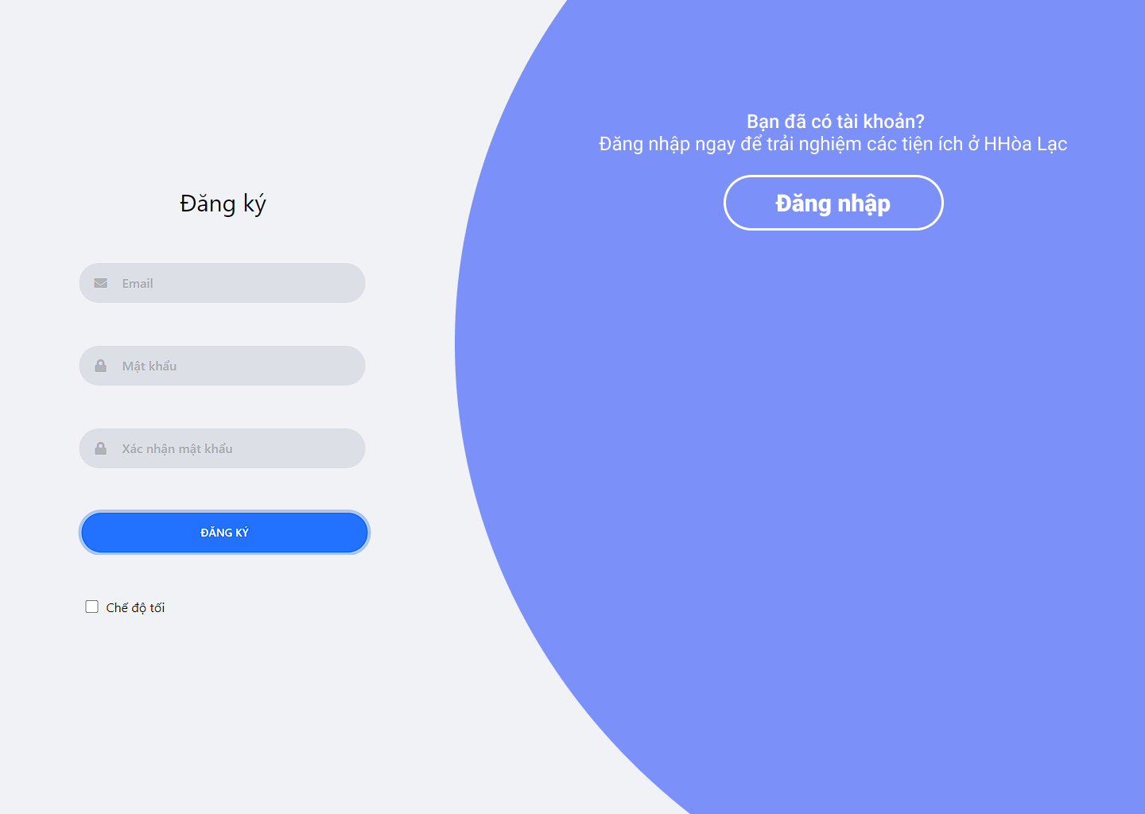

*Figure 3.57 Mockup – Sign in*

##### 3.1.4.2 Sign in

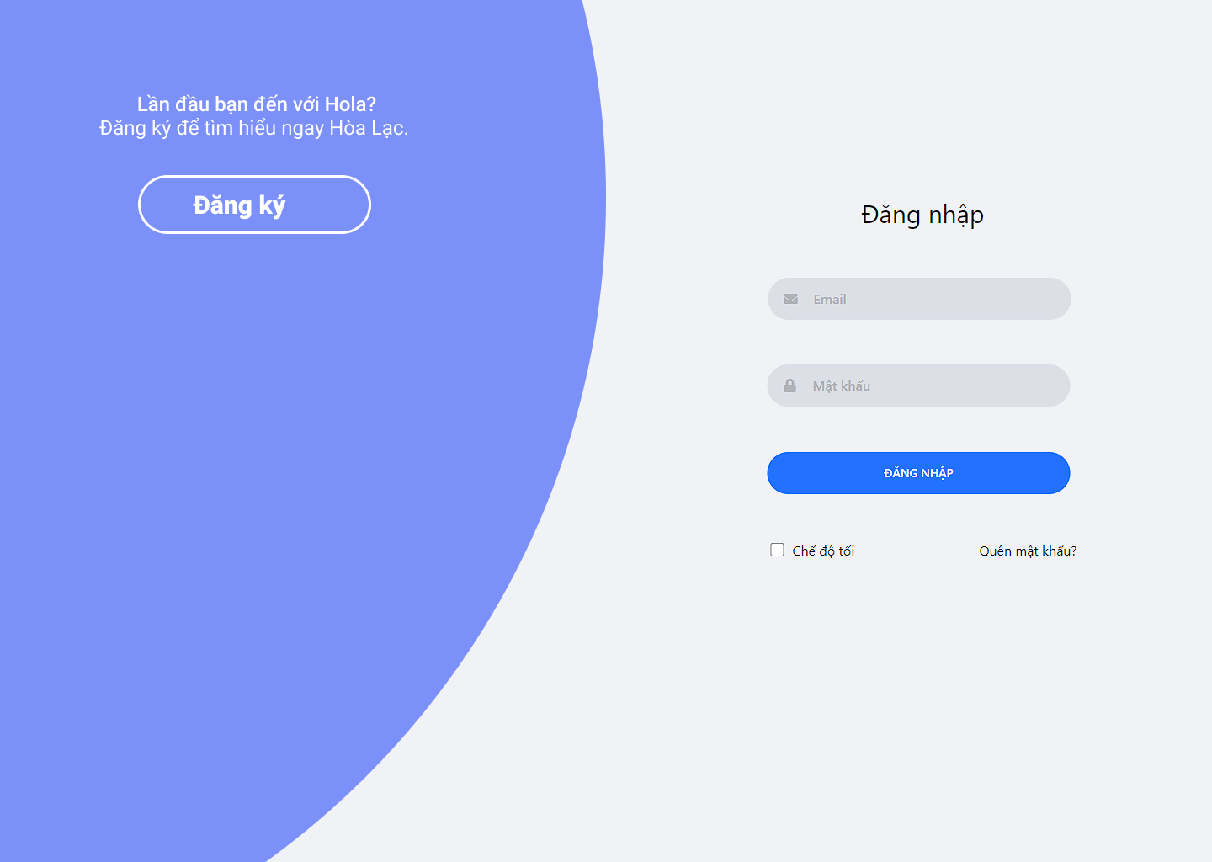

*Figure 3.58 Mockup – Sign in*

##### 3.1.4.3 Home Page

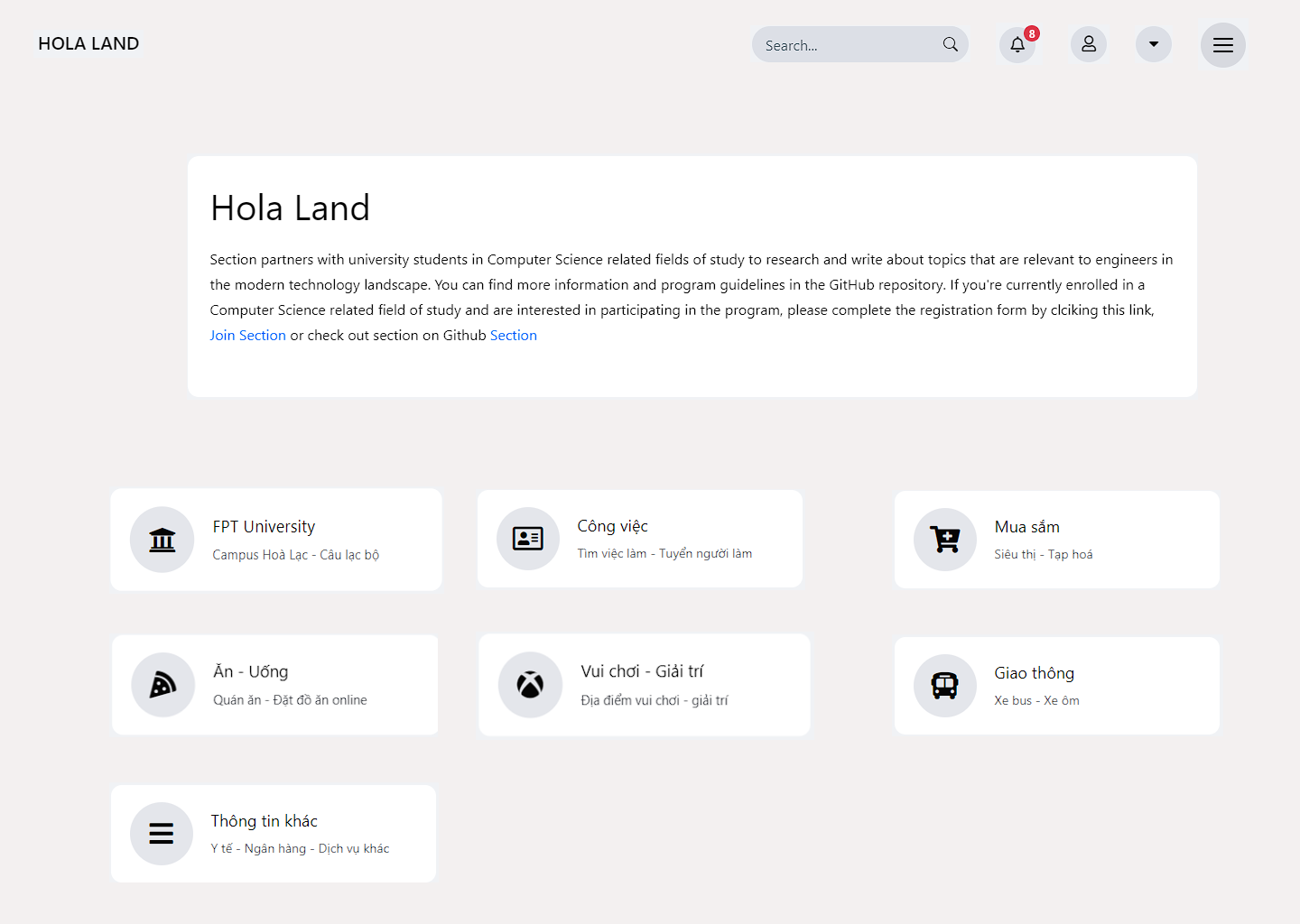

*Figure 3.59 Mockup – Home Page*

##### 3.1.4.4 FPT University – Campus

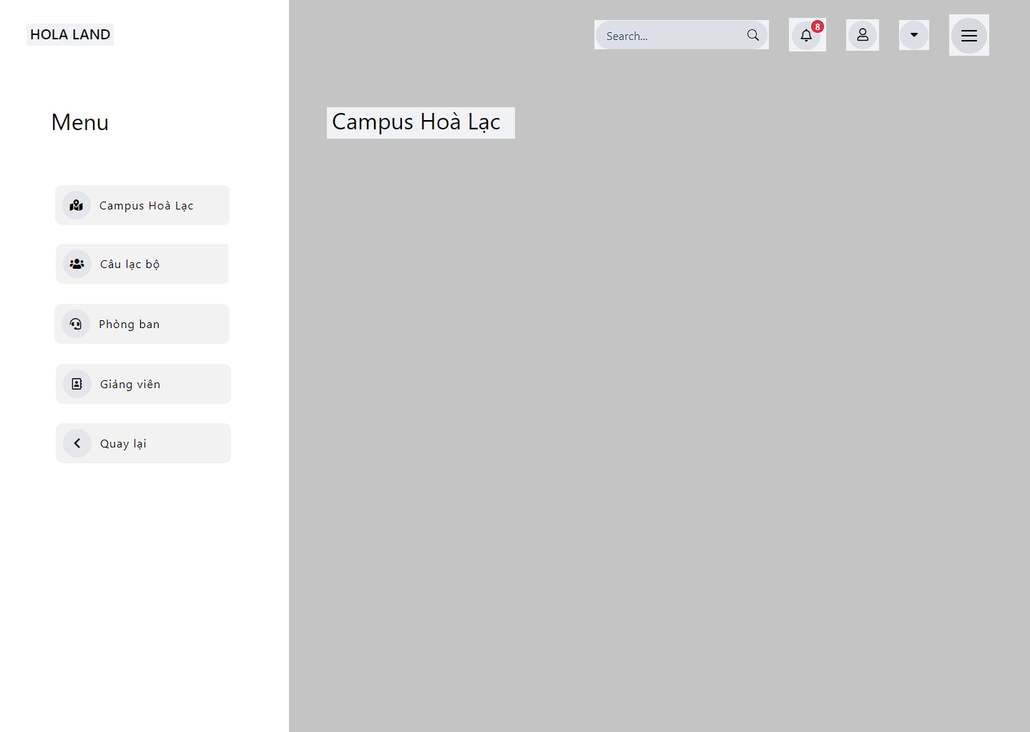

*Figure 3.60 Mockup – Campus Hòa Lạc*

##### 3.1.4.5 FPT University – Club

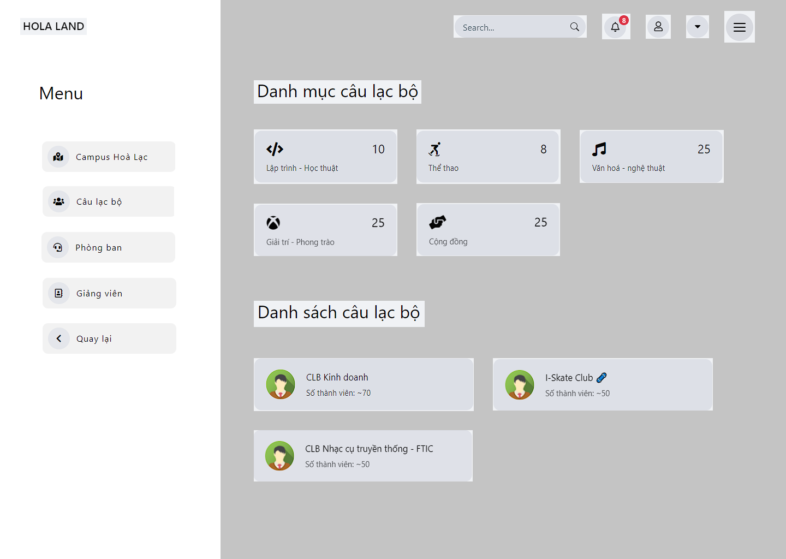

*Figure 3.61 Mockup – Club*

##### 3.1.4.6 FPT University – Club Detail

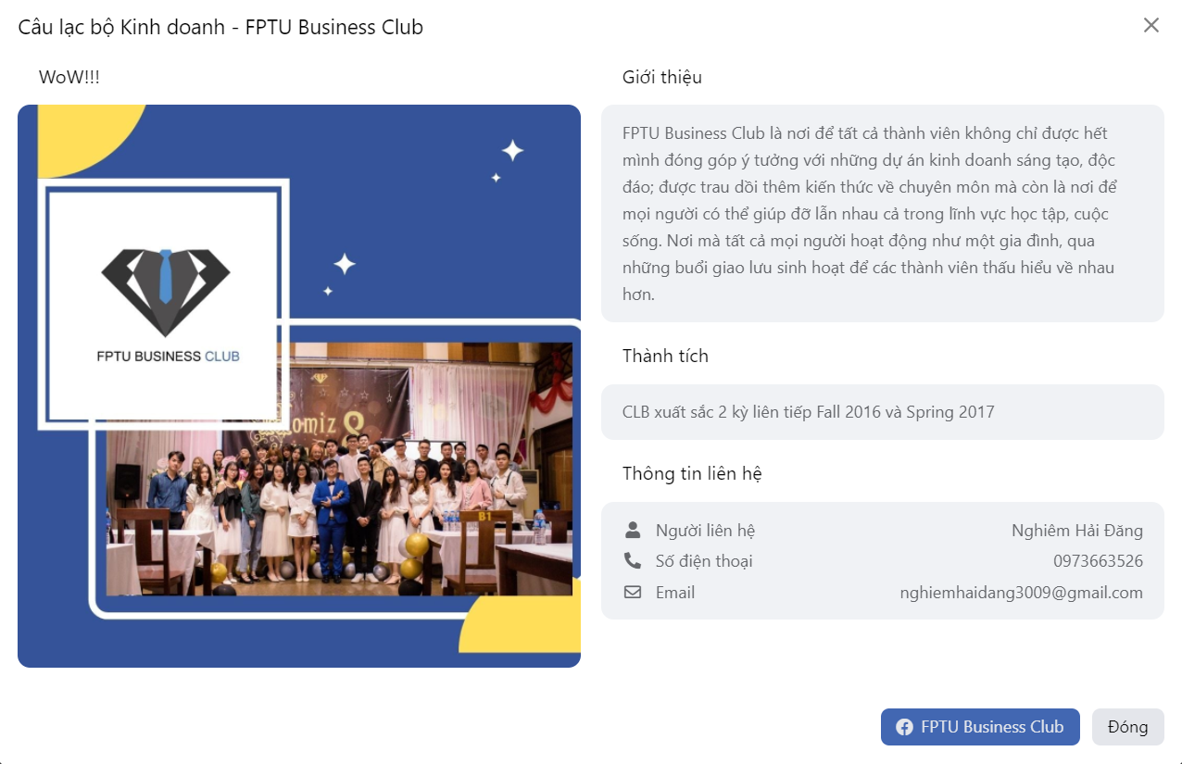

*Figure 3.62 Mockup – Detail club*

##### 3.1.4.7 Work – List Job

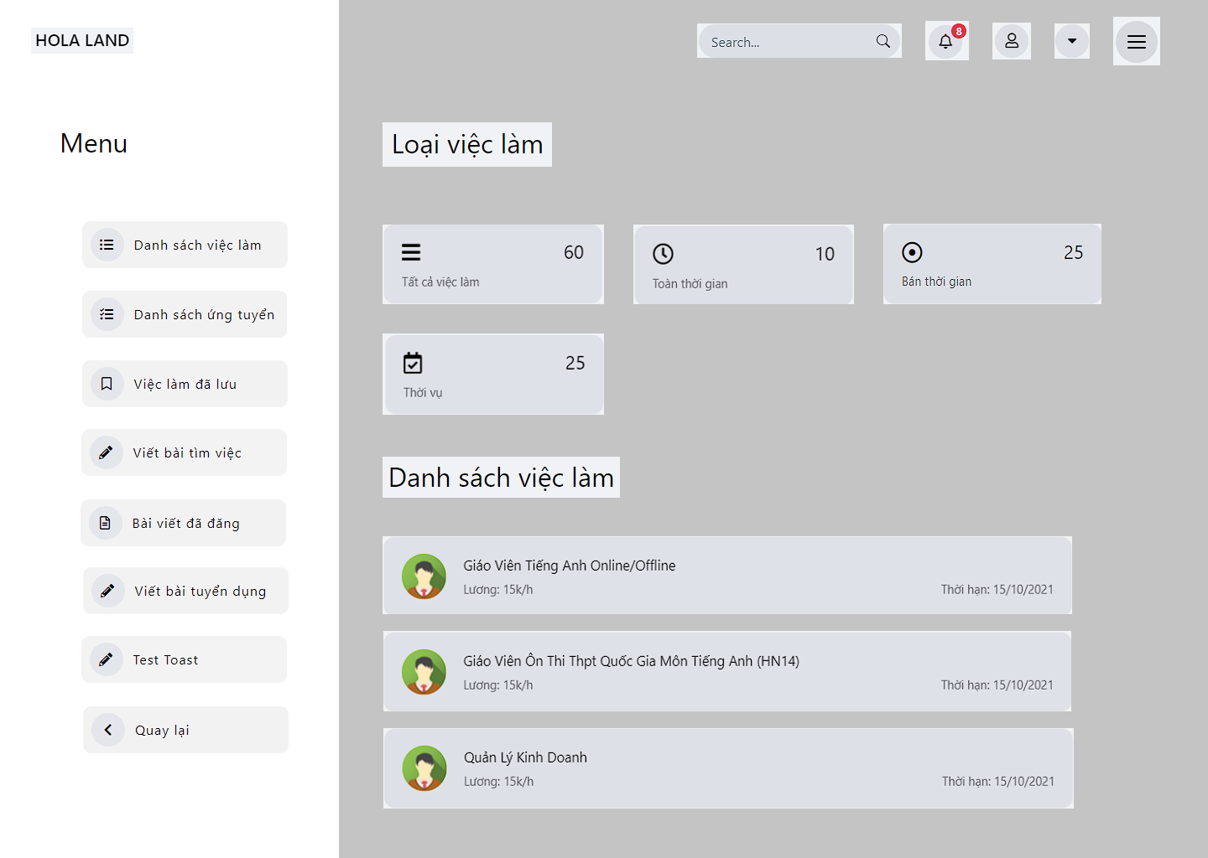

*Figure 3.63 Mockup – List job*

##### 3.1.4.8 Work – List Job Applied

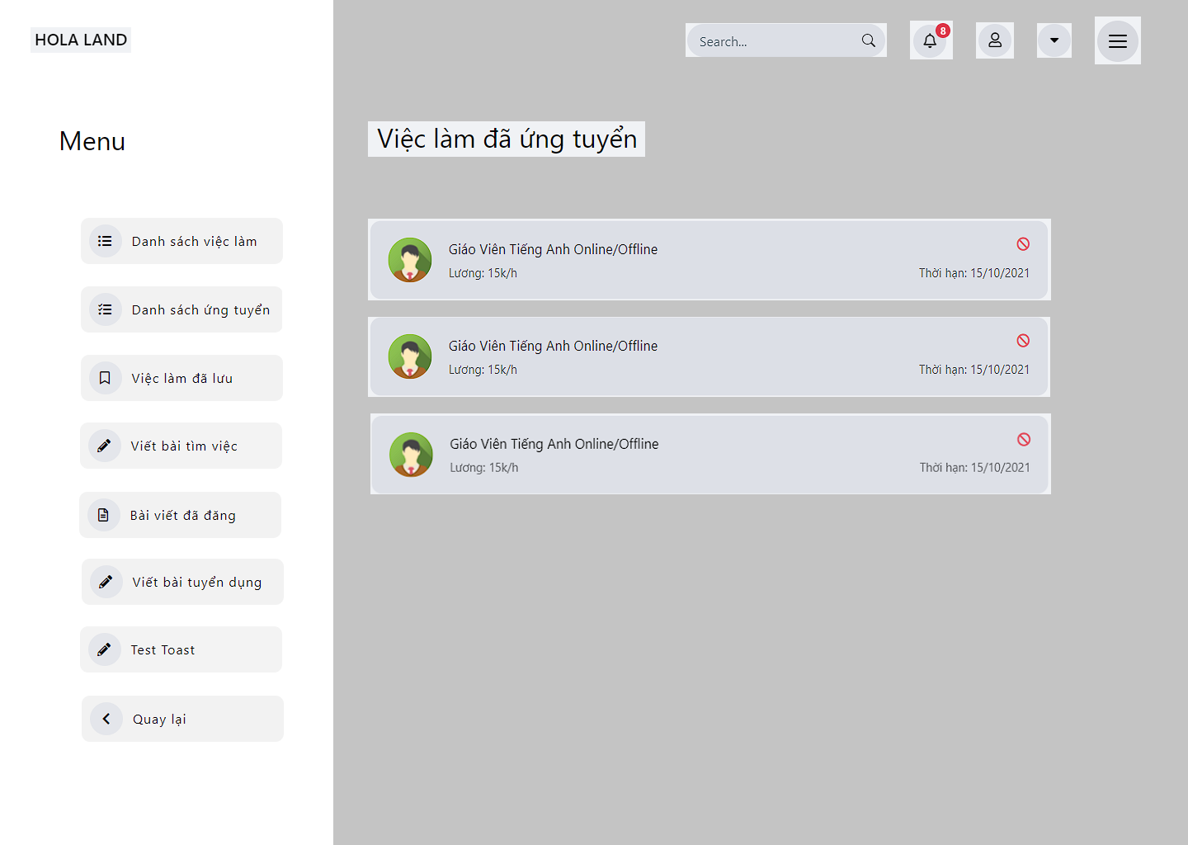

*Figure 3.64 Mockup – List job applied*

##### 3.1.4.9 Work – List Job Save

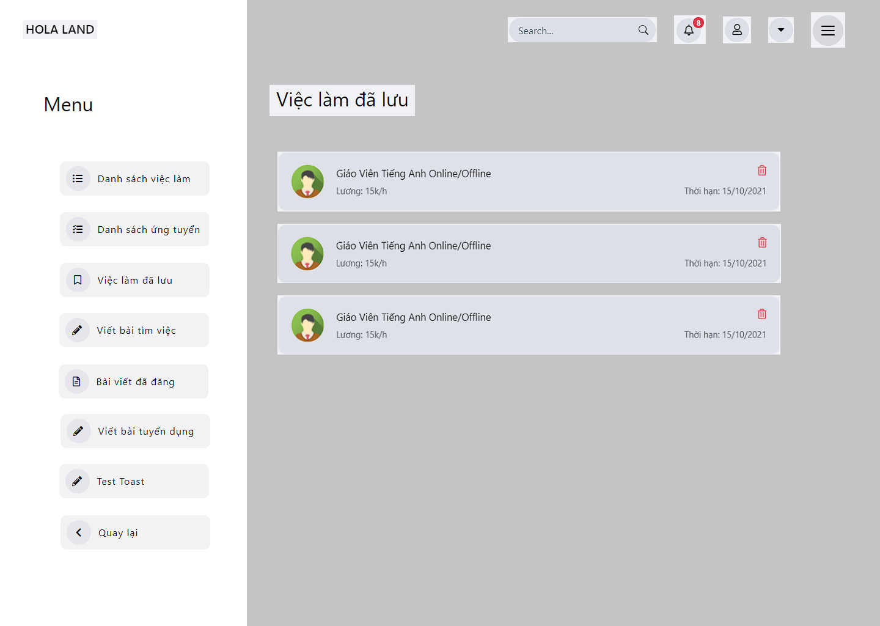

*Figure 3.65 Mockup – List job save*

##### 3.1.4.10 Work – Create request recruitment

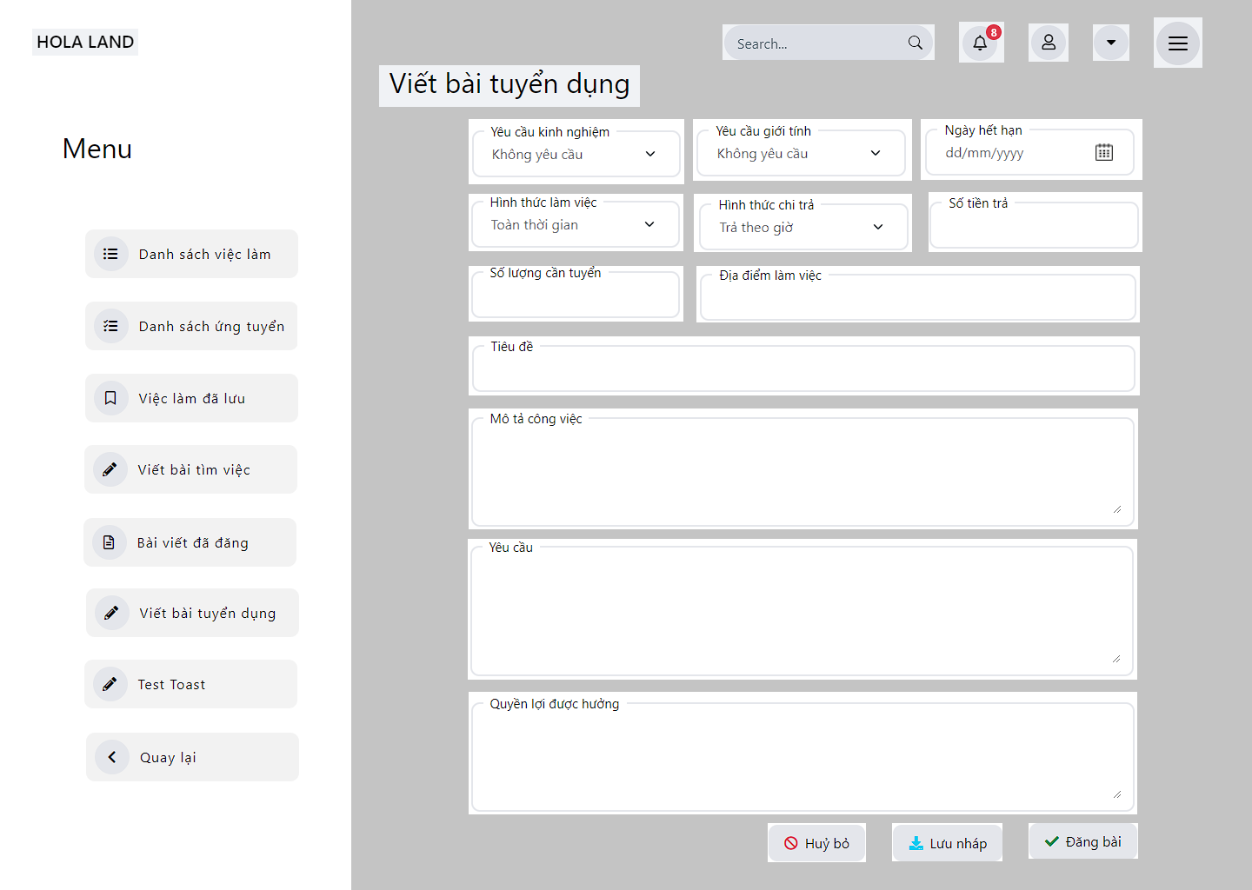

*Figure 3.66 Mockup – Create request recruitment*

##### 3.1.3.11 Work – Create a request to find a job

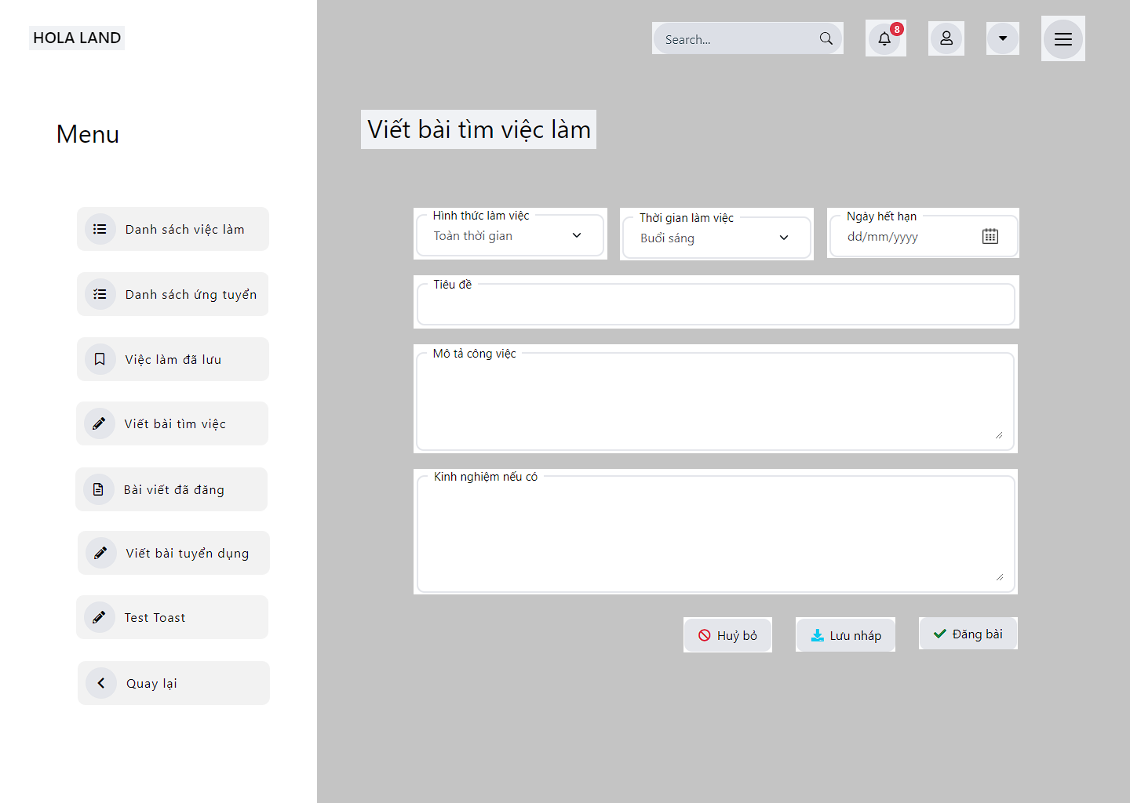

*Figure 3.67 Mockup – Create request find a job*

##### 3.1.3.12 Work – Job Detail

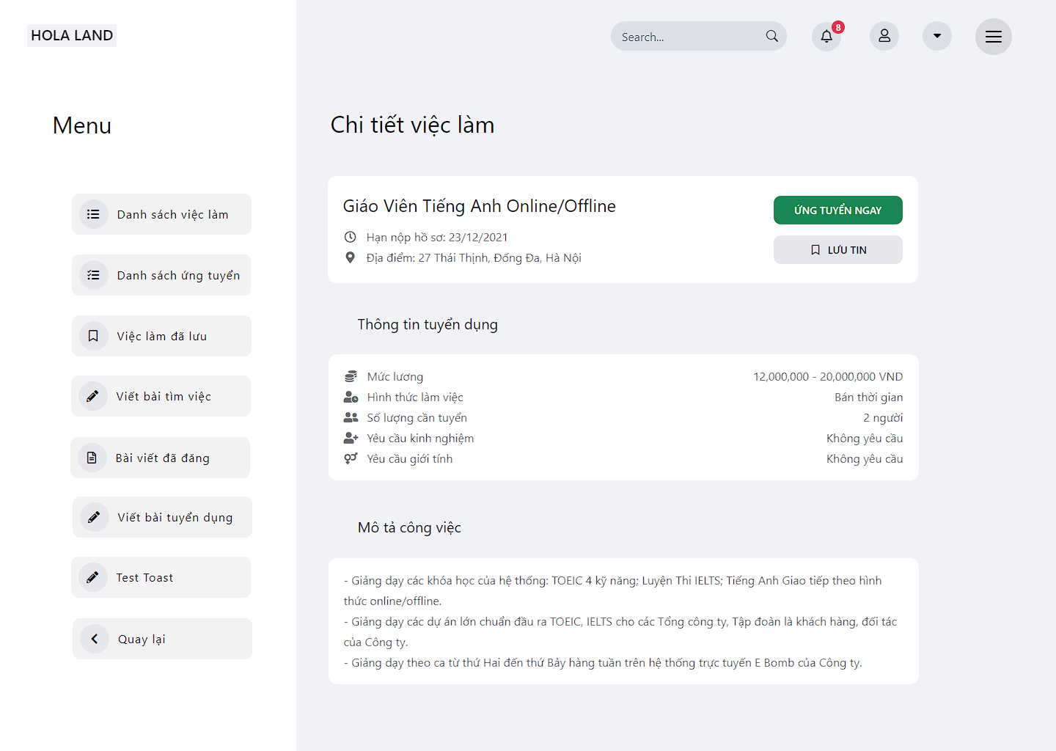

*Figure 3.68 Mockup – Job detail*

##### 3.1.3.13 Work – Apply for Job

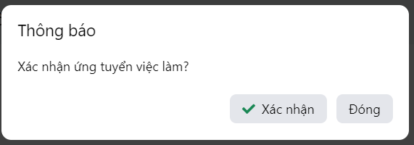

*Figure 3.69 Mockup – Apply for job*

##### 3.1.3.14 Work – Hire worker

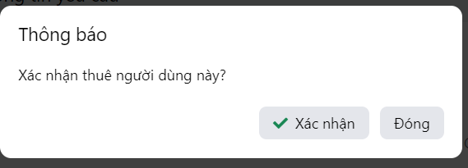

*Figure 3.70 Mockup – Hire worker*

##### 3.1.3.15 Work – Manage request

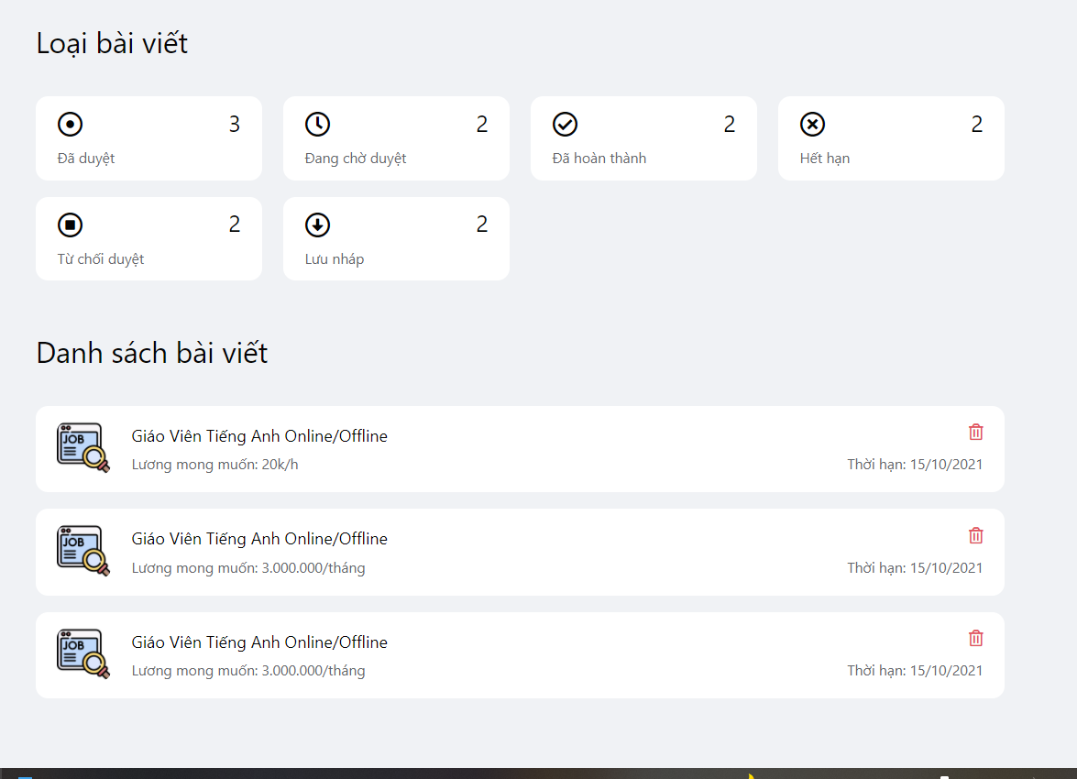

*Figure 3.71 Mockup – Manage request*

##### 3.1.3.16 Work – List find a job

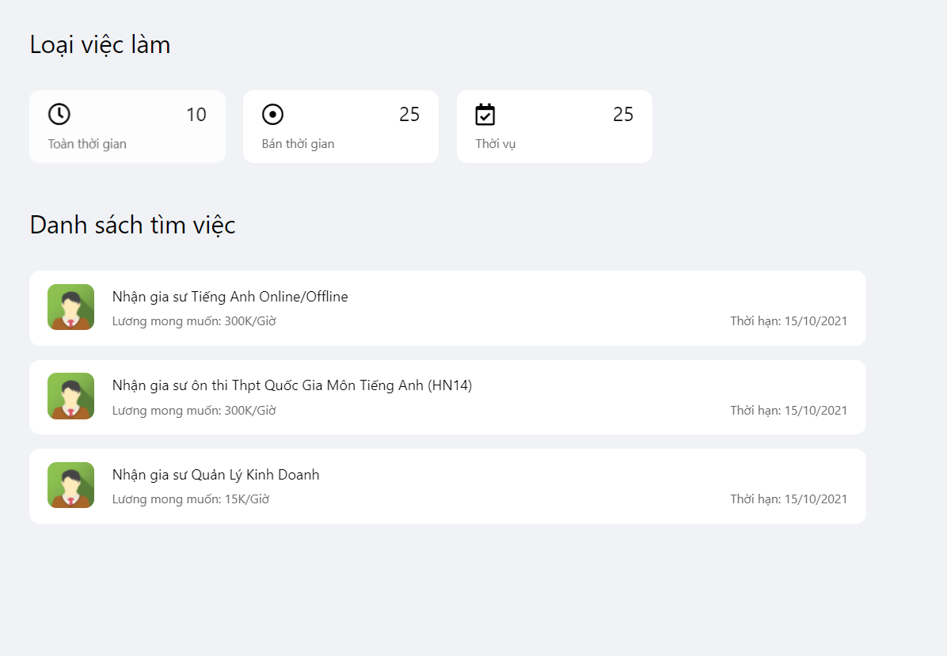

*Figure 3.72 Mockup – List find a job*

##### 3.1.3.17 Food – List store

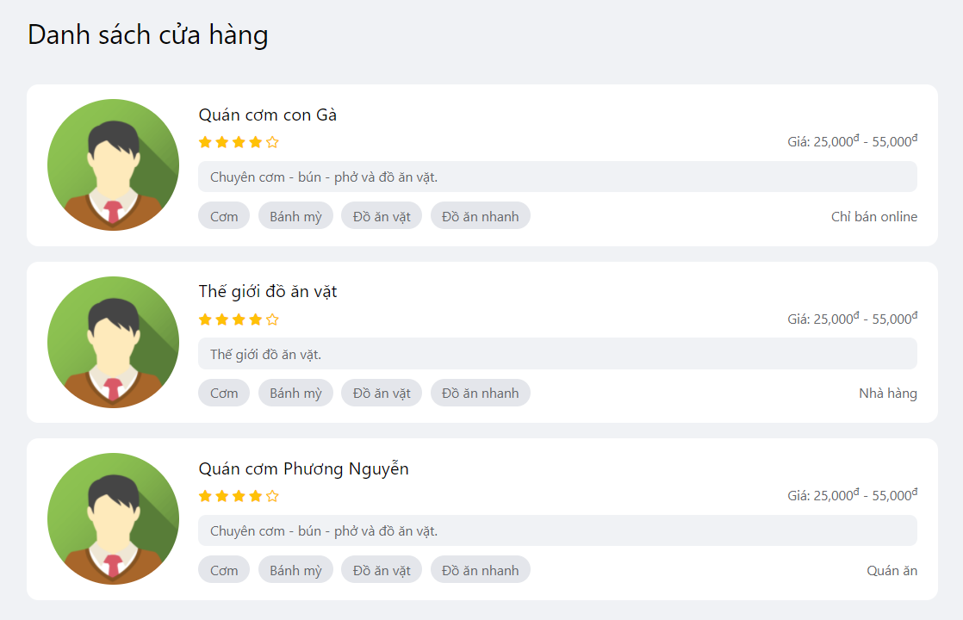

*Figure 3.73 Mockup – List store*

##### 3.1.3.18 Food – Detail store

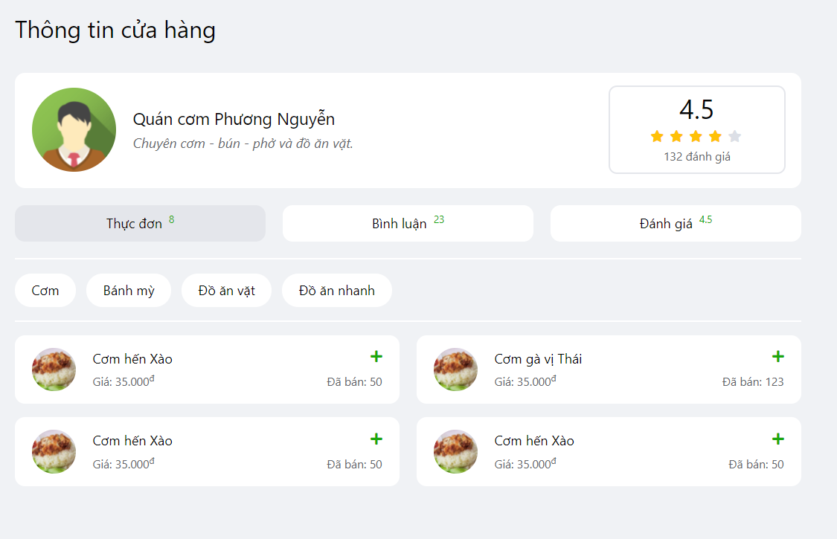

*Figure 3.74 Mock up – Detail store*

##### 3.1.3.19 Food – List Food Items

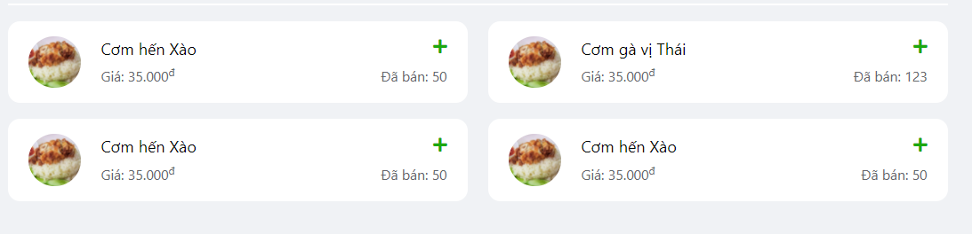

*Figure 3.75 Mock up – List food items*

##### 3.1.3.20 Food – Comment Store

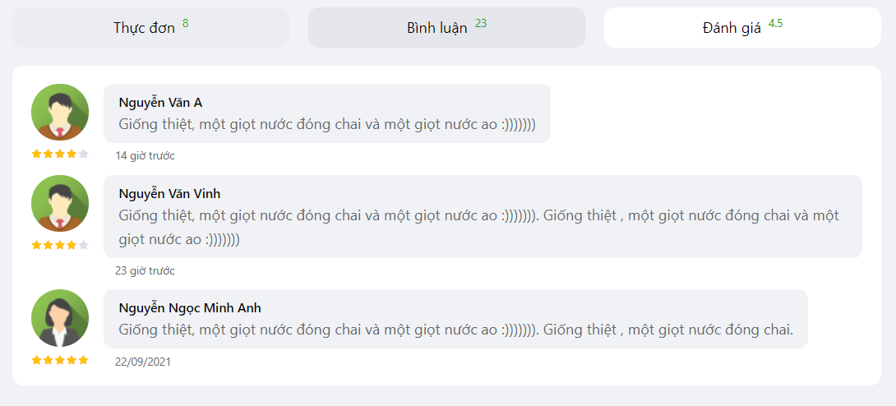

*Figure 3.76 Mock up – Comment Food*

##### 3.1.3.21 Food – Rate Store

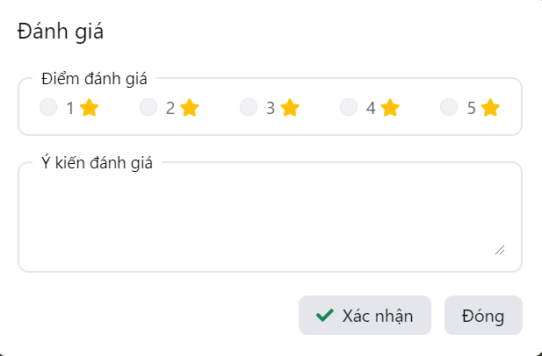

*Figure 3.77 Mock up – Rate Store*

##### 3.1.3.22 Food – Report food



*Figure 3.78 Mockup – Report food*

##### 3.1.3.23 Food – List users order

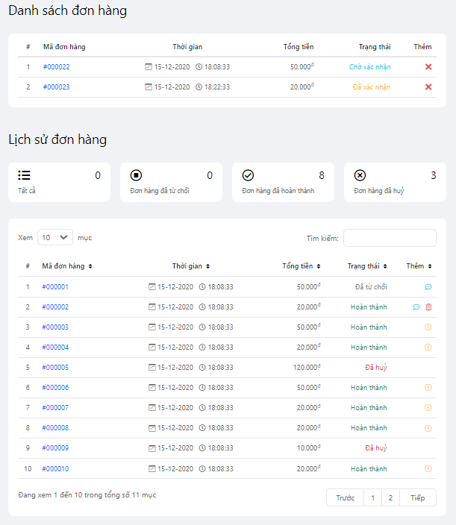

*Figure 3.79 Mock up – Manage user order*

##### 3.1.3.24 Food – Detail order

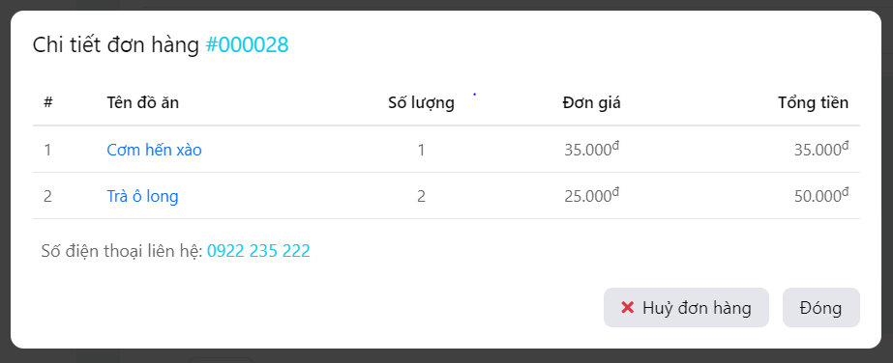

*Figure 3.80 Mock up – Detail order*

##### 3.1.3.25 Food – Manage Order Seller

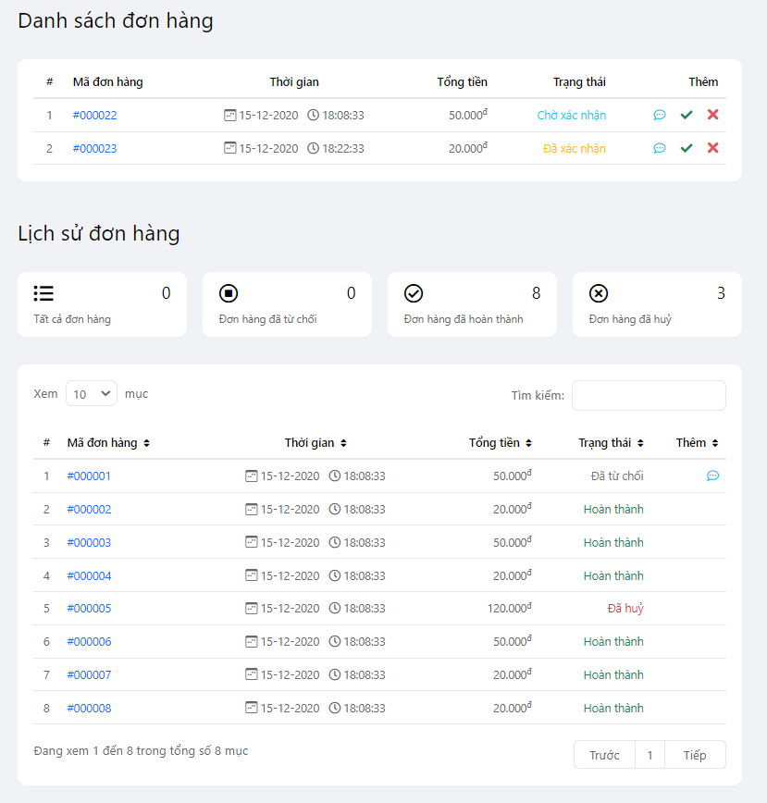

*Figure 3.81 Mock up – Manage order seller*

##### 3.1.3.26 Food – Manage tag – food items

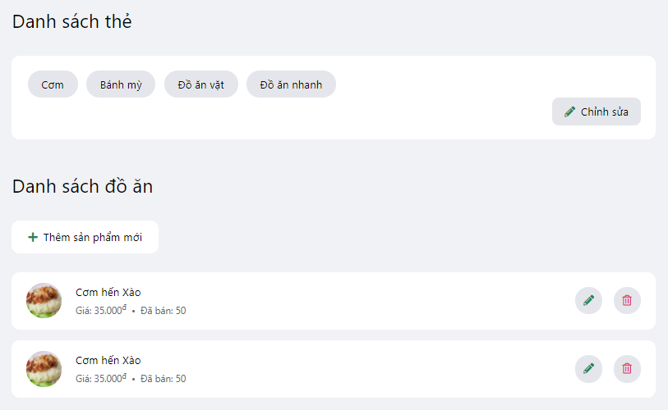

*Figure 3.82 Mockup – Manage tag – food items*

##### 3.1.3.27 Food – Store info

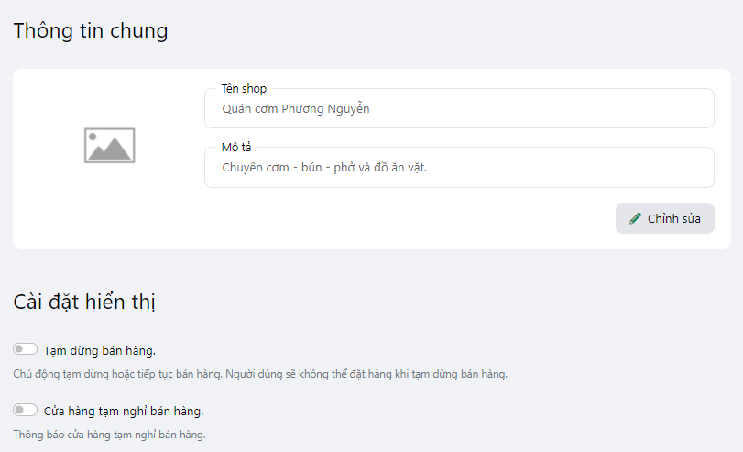

*Figure 3.83 Mockup – Store info*

##### 3.1.3.28 Food – Statistics

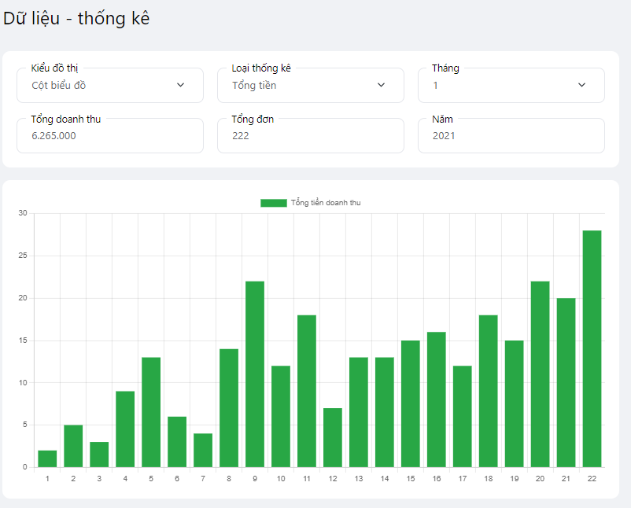

*Figure 3.84 Mockup – Statistics*

##### 3.1.3.29 Profile – View profile info

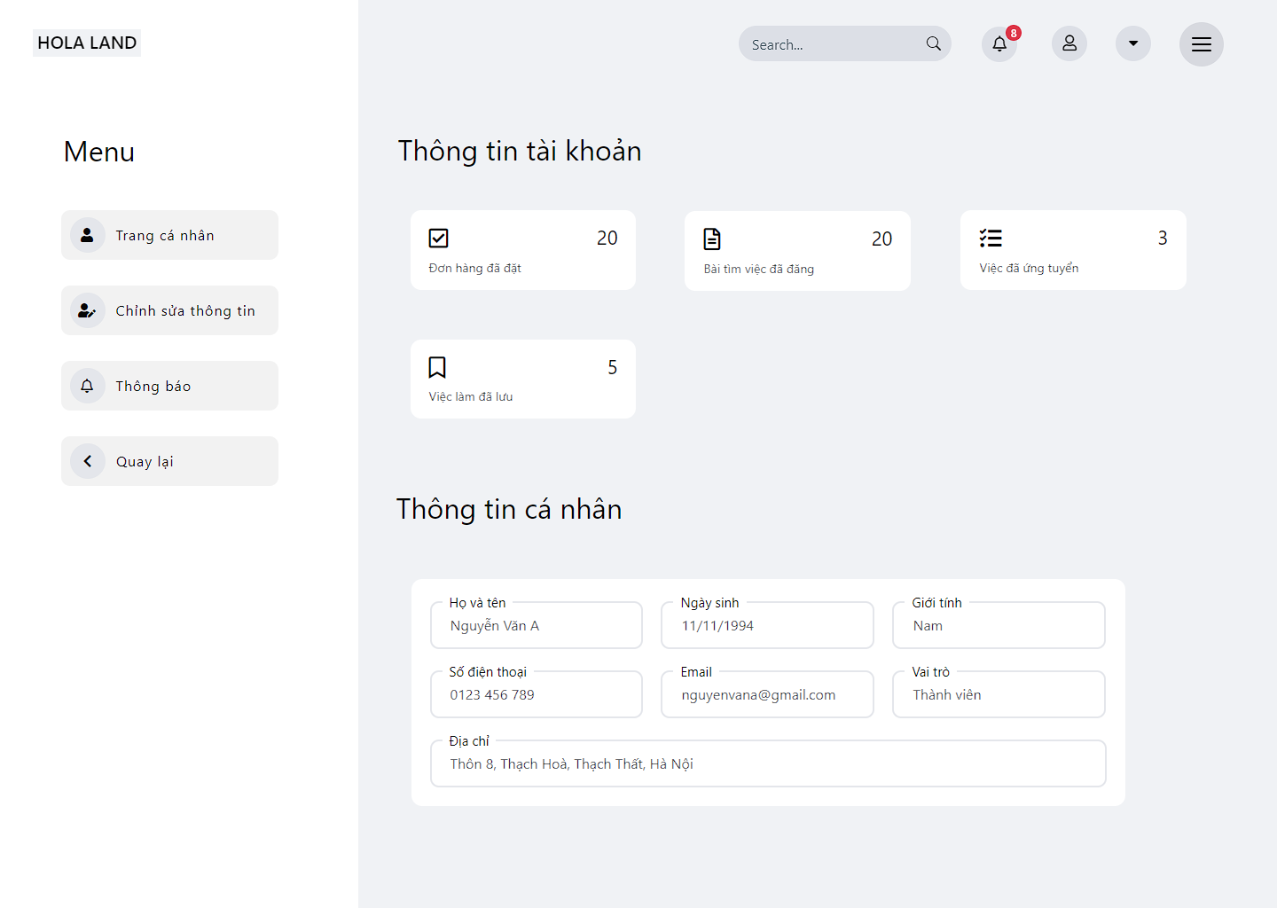

*Figure 3.85 Mockup – View profile info*

##### 3.1.3.30 Profile – Update profile

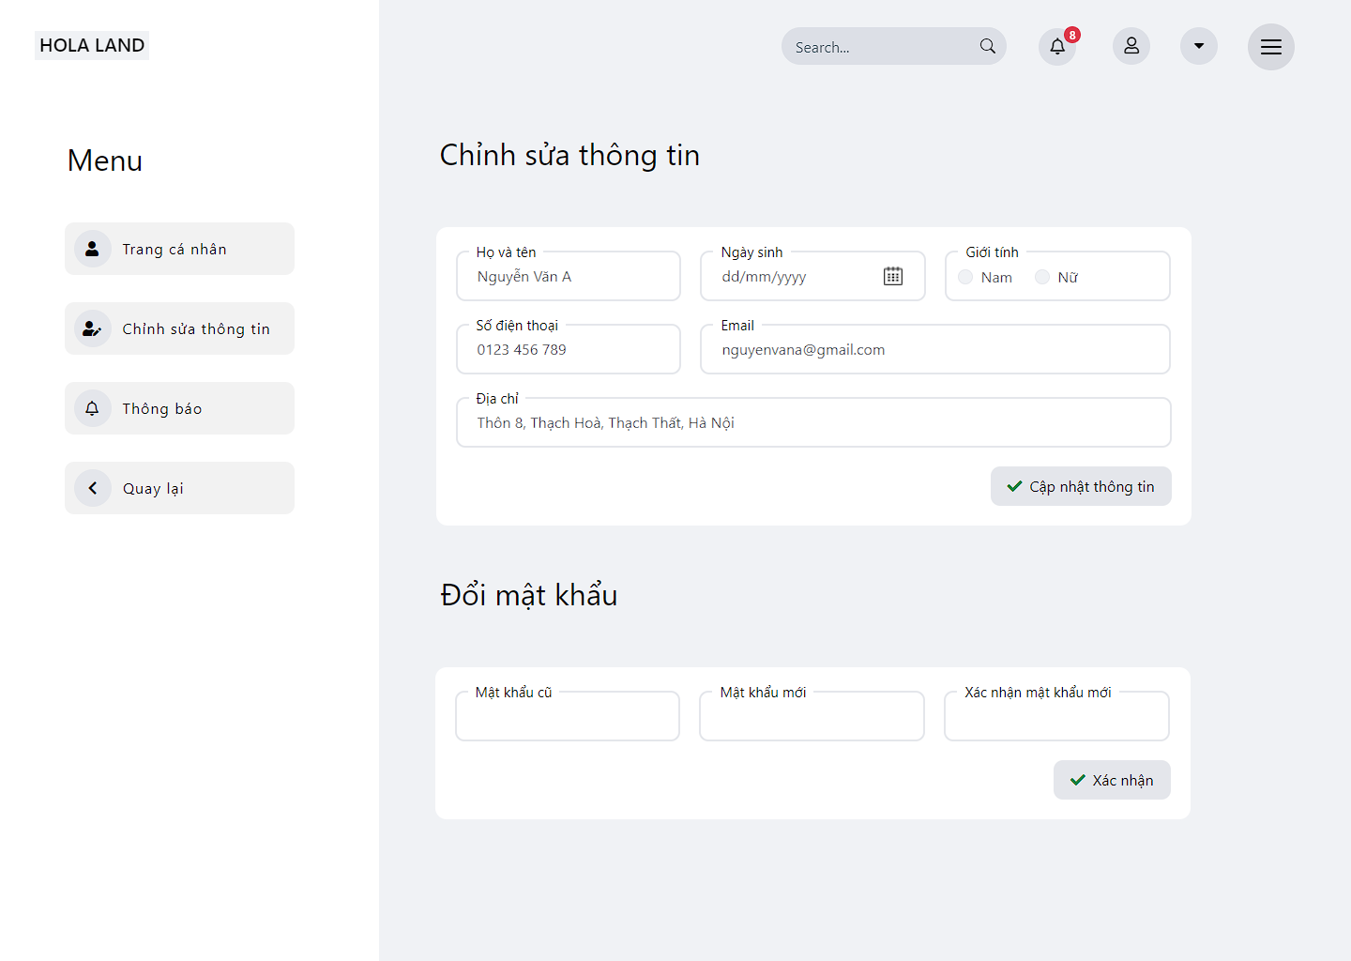

*Figure 3.86 Mockup – Update profile*

##### 3.1.3.31 Profile – Update address

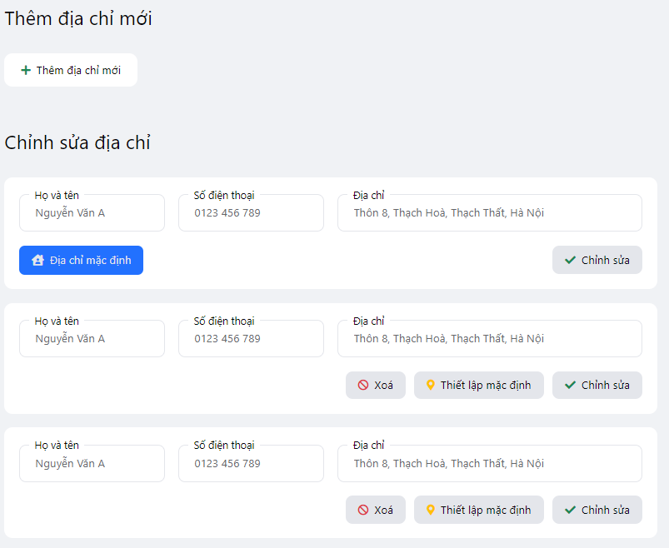

*Figure 3.87 Mockup – Update address*

#### 3.1.5 Entity Relationship Diagram

##### 3.1.5.1 Module Food

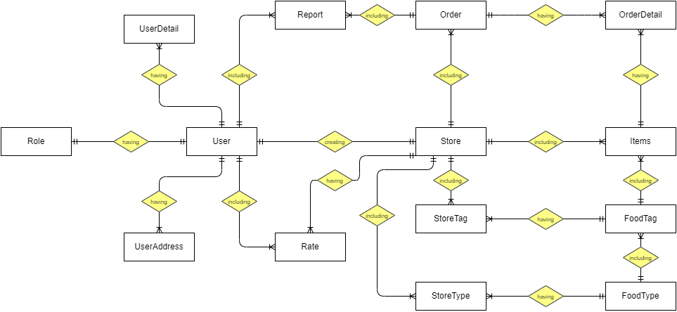

*Figure 3.88.1 Entity Relationship Diagram for module Food*

**Entities List**

|  |  |  |
| --- | --- | --- |
| **#** | **Entity** | **Description** |
|  | Role | The role of the user in the system. |
|  | User | Registered users on the system |
|  | UserDetail | Detail of registered users. |
|  | UserAddress | Address of registered users. |
|  | Report | Report order of user for food items |
|  | Order | Order food items of users |
|  | OrderDetail | Detail order of users |
|  | Store | The store was created by the seller and managed by the seller |
|  | Items | List food items of the store |
|  | Rate | User rating of the store |
|  | StoreTag | Tag of the store in the system |
|  | FoodTag | Tag of food in the system |
|  | StoreType | Type of store in the system |
|  | FoodType | Type of food in the system |

*Table 3.55 Entity Description for module Food*

##### 3.1.5.2 Module Work

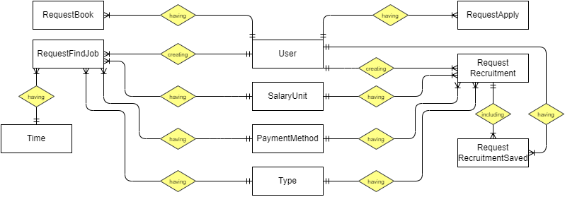

*Figure 3.88.2 Entity Relationship Diagram for module Work*

|  |  |  |
| --- | --- | --- |
| **#** | **Entity** | **Description** |
|  | User | Registered users on the system |
|  | RequestBook | List of find job requests booked by the recruiter |
|  | RequestApply | List of recruitments request applied by the student |
|  | RequestFindJob | List request find the job of student |
|  | Time | Working time such as morning shift, afternoon shift, evening shift |
|  | SalaryUnit | The currency unit of price |
|  | PaymentMethod | The payment method of job post |
|  | RequestRecruitmentSaved | List of recruitments request saved by the student |
|  | Type | Type of job |

*Table 3.56 Entity Description for module Work*

## 4. Non-Functional Requirements

### 4.1 External Interfaces

#### 4.1.1.User interfaces

**UI-1**: The web application display shall conform to the user and provide a friendly interface.

**UI-2**: The font size is easy to distinguish where is the title, where is the content.

**UI-3**: Consistent interface: font size, font, color, the logo must be in sync.

**UI-4**: The web application will support responsive screens on mobile, tablet, and desktop.

#### 4.1.2.Software interfaces

N/A

#### 4.1.3.Hardware interfaces

No hardware interfaces have been identified. Our system is aimed at building software systems, so the system has no hardware.

### 4.2 Quality Attributes

#### 4.2.1 Usability

**USA-1**: The steps and flows are short and easy to understand so that users can interact with the application without training.

**USA-2**: The user interface is clean, friendly, and consistent from the layout, component to the

button, text field.

**USA-3**: The input action is flexible with both keyboard and mouse.

**USA-4**: Error and warning messages are simple.

#### 4.2.2 Reliability

#### 4.2.3 Performance

* Reduce as less as possible query to database in loop
* Resource utilization: use very few computer resources such as ram, memory, CPU.

#### 4.2.4 Dependence

##### 4.2.4.1. Security

- Only the Admin account has access to system management.

- The system does not allow users who are not FPT University students to register for an account on the system but with other roles as recruiters and sellers.

- The recruiter role will not be able to sell and the seller role will not be able to post job vacancies.

- The system uses **spring security** to classify the user type for the system.

##### 4.2.4.2 Safety

- The password of the account is encrypted since creating a moment.

- The password should be hidden in the client.

#### 4.2.5 Supportability

- The account's password must be MD5 encrypted

- Named according to the Java Convention

- Project structure according to Spring MVC model

#### 4.2.6 Design Constraints

The back-end programming language is Java

Front-end programming language is Html5,Bootstrap,Thymleaf

Using Spring MVC

## 5. Other Requirements

### 5.1 Business Rules

|  |  |
| --- | --- |
| **ID** | **Description** |
|  | The email address must be valid |
|  | Password must be at least 8 characters in length |
|  | Password must be encrypted |
|  | When registering or changing a password, the user must enter the new password twice |
|  | A guest cannot register with a username and email that has already been registered |
|  | User cannot update their email once it has been registered |
|  | When changing a password, the new password must not be the same as the current password |
|  | Format of date must be “dd/mm/yyyy” |
|  | When an account is registered, the user must choose their roles |
|  | Email is unique and cannot be duplicated in the database |
|  | Format of money must be “10.000” |
|  | Format DateTime of comment restaurant must be “dd-MMM-yyyy HH:mm:ss” |
|  | User must provide their email and password when logging into the website |
|  | When updating the profile, the phone number is unique and cannot be duplicated in the database |
|  | The deadline of request when creating or updating must be in the future |
|  | After creating or re-opening a request to find a job or recruitment, the status of the request is PENDING |
|  | Students can repost a request find a job when the request’s status is COMPLETE or EXPIRED |
|  | A recruiter can repost request recruitment when the request’s status is COMPLETE or EXPIRED |
|  | Students can only apply for job postings when the job posting's status is APPROVED |
|  | A recruiter can only hire workers when the find job posting's status is APPROVED |
|  | When deleting posts that are not " APPROVED" status, the posts on the homepage are not deleted |
|  | When add, update or report, the blanks must be filled in completely. |
|  | The user cancels the order when the order is in the “Chờ xác nhận” status |
|  | The user cancels the order when the order is in the “Hoàn thành” status |
|  | When updating a tag of food, if the tag contains food, it cannot be deleted |
|  | The address in the displayed order details must be the default address |
|  | The seller reject order when the order is in the “Chờ xác nhận” status |

*Table 3.55 Business Rules*

### 5.2 Application Messages List

|  |  |  |  |  |
| --- | --- | --- | --- | --- |
| **#** | **Message code** | **Message Type** | **Context** | **Content** |
|  | MSG01 | In red, Toast Message | Wrong account | Email hoặc mật khẩu không chính xác. |
|  | MSG02 | In green, Toast Message | Logout success | Đăng xuất thành công. |
|  | MSG03 | Toast Message | Notify actions | Bạn phải hoàn thành ít nhất một đơn hàng trước khi đánh giá cửa hàng. |
|  | MSG04 | Toast Message | Notify actions | Không thẻ xóa thẻ này vì thẻ này đang được sử dụng. |
|  | MSG05 | Toast Message | Notify actions | Cập nhật mật khẩu mới thành công! |
|  | MSG06 | Toast Message | Notify actions | Có lỗi xảy ra. Vui lòng thử lại. |
|  | MSG07 | Toast Message | Notify actions | Mật khẩu cũ không đúng! |
|  | MSG08 | Toast Message | Notify actions | Mật khẩu xác nhận không giống với mật khẩu mới! |
|  | MSG09 | Toast Message | Notify actions | Cửa hàng hiện tại đang dừng bán hàng! |
|  | MSG10 | Toast Message | Notify actions | Cửa hàng hiện tại bắt đầu bán hàng trở lại! |
|  | MSG11 | Toast Message | Notify actions | Cửa hàng hiện tại đang tạm nghỉ! |
|  | MSG12 | Toast Message | Notify actions | Cửa hàng hiện tại đã hoạt động trở lại! |

*Table 3.56 Application Message List*

# IV. Software Design Description

## 1. Overall Description

### 1.1 Assumptions

This system is designed based on the following assumptions:

* My SQL (8.0)
* Bootstrap
* Spring boot (V2.5.6)

### 1.2 Design Constraints

This system should comply with the following items:

* End-user’s Environment: Any web browser that users have been installed in their devices like Google Chrome, Microsoft Edge, Safari.
* Support these languages: Vietnamese.
* Apply multi-layer architecture for back-end systems.
* Bootstrap is applied for the front-end system.
* User interfaces are easy to use, clear, and eye-catching.

## 2. System Architecture Design

### 2.1 Overall Architecture

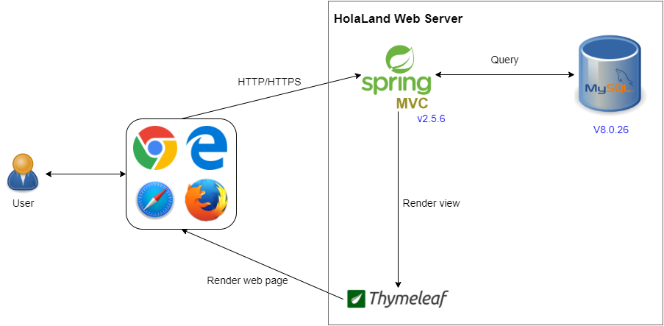

*Figure 4.1: Overall Architecture*

**a. Choice of System Architecture**

Hola Land system uses Client-Server architecture as a design pattern. This architecture is a distributed application structure composed of two types of components: clients and servers. Using this architecture, our system will ensure performance, speed, and also maintainability which is difficult to implement in other architectures.

The server component perpetually listens for requests from client components. When receiving a request, the server processes the request, and then sends a response back to the client.

**b. Component Explanation**

* **Spring MVC**:



**Spring MVC**: It is a web-based framework for doing web application development. It is one of the projects of the Spring Framework. As the name suggests, it is based on an MVC design pattern, which is Model, View, and Controller.

* **Thymeleaf**:



**Thymeleaf** is a modern server-side Java template engine for both web and standalone environments.Thymeleaf's main goal is to bring elegant natural templates to your development workflow — HTML that can be correctly displayed in browsers and also work as static prototypes, allowing for stronger collaboration in development teams.

* **Database**



**MySQL** is free and open-source software under the terms of the GNU General Public License and is also available under a variety of proprietary licenses. A relational database organizes data into one or more data tables in which data types may be related to each other; these relations help structure the data. SQL is a language programmers use to create, modify and extract data from the relational database, as well as control user access to the database. In addition to relational databases and SQL, an RDBMS like MySQL works with an operating system to implement a relational database in a computer's storage system, manages users, allows for network access, and facilitates testing database integrity and creation of backups. MySQL was owned and sponsored by the Swedish company MySQL AB, which was bought by Sun Microsystems (now Oracle Corporation). In 2010, when Oracle acquired Sun, Widenius forked the open-source MySQL project to create MariaDB.

### 2.2 System Architecture

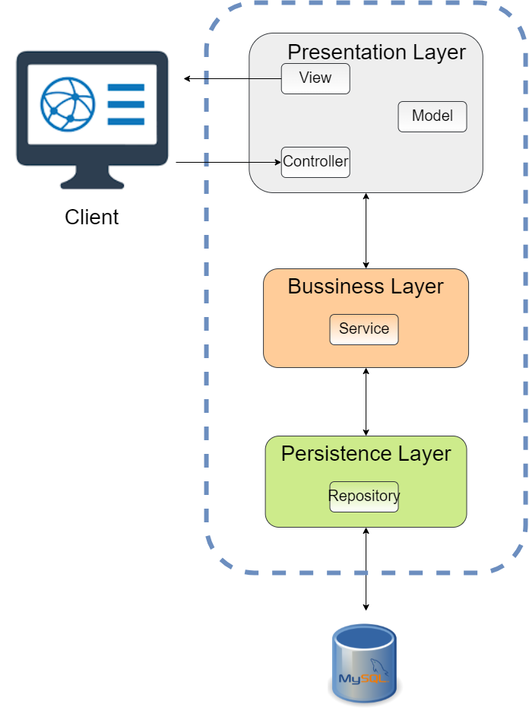

*Figure 4.2: System Architecture*

|  |  |  |
| --- | --- | --- |
| **No** | **Layer** | **Description** |
| 1 | Presentation | - Including controller, view, model component.  - This layer acts as a go-between for the business layer and the client, passing on different input requests to the business layer. |
| 2 | Business | - Including service class.  - This layer acts as a logic layer that receives passing on input requests from the presentation layer to the persistence layer. |
| 3 | Persistence | - Including repository class.  - This layer is used to connect and get data directly from the database, put it into the respective entities, and respond to the business layer. |

*Table 4.1: Layer explanation of HolaLand*

### 2.3 Package Diagram

#### 2.3.1 Diagram

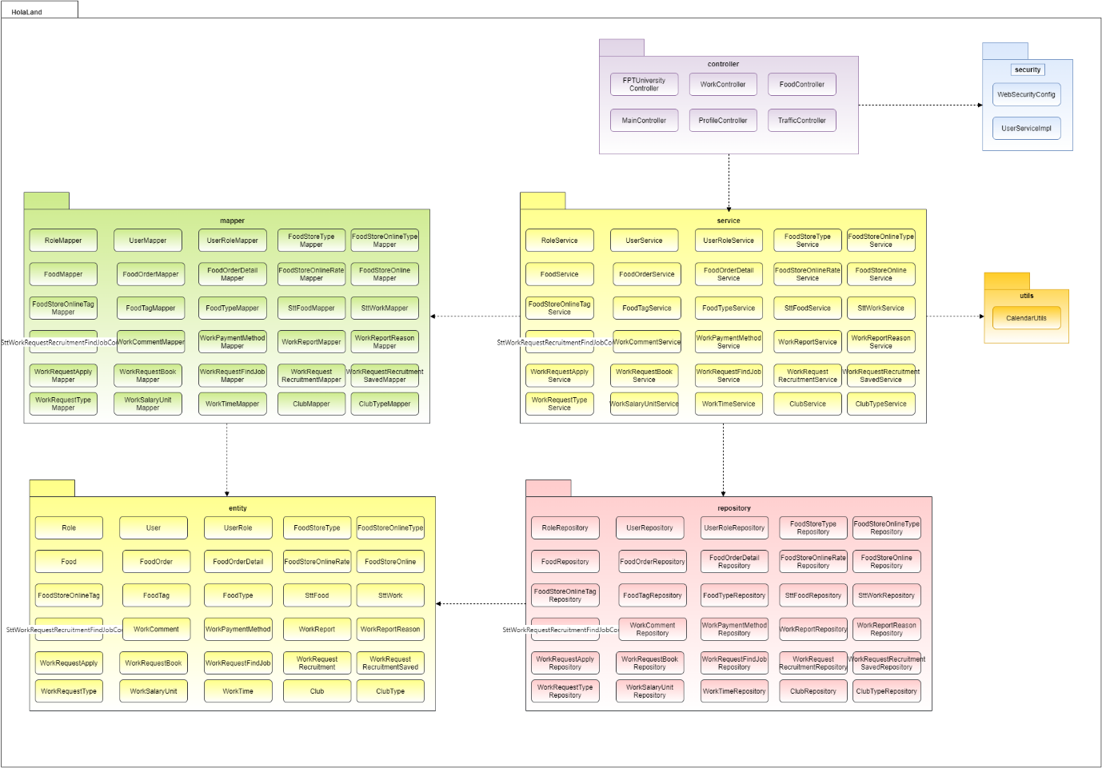

*Figure 4.3:Package Diagram*

#### 2.3.2 Package Explanation

|  |  |  |
| --- | --- | --- |
| **No** | **Package** | **Description** |
| 1 | Controller | Contain classes that are defined as controller, the main function is connected between client and server |
| 2 | Security | Containing classes help define the configuration for Spring Security. |
| 3 | Service | Contain classes that are defined as service, handle processing business logic, and work as a bridge between controller and repository. |
| 4 | Utils | Contain classes have, utility functions using handler common operations |
| 5 | Repository | Contain classes that are defined as a repository, handle getting data from the database |
| 6 | Mapper | Containing classes used as data transfer between layers. |
| 7 | Entity | Contain classes are used to keep data received from the database. |

*Table 4.2:Package explanation*

## 3. System Detailed Design

### 3.1 Guest

#### 3.1.2 View club

##### 3.1.2.1 Class diagram

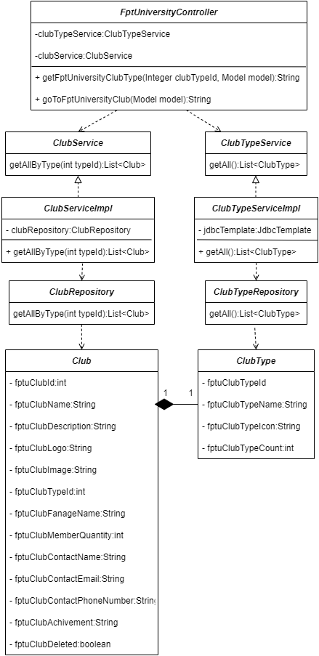

*Figure 4.4:View club – Class Diagram*

##### 3.1.2.2 Sequence diagram

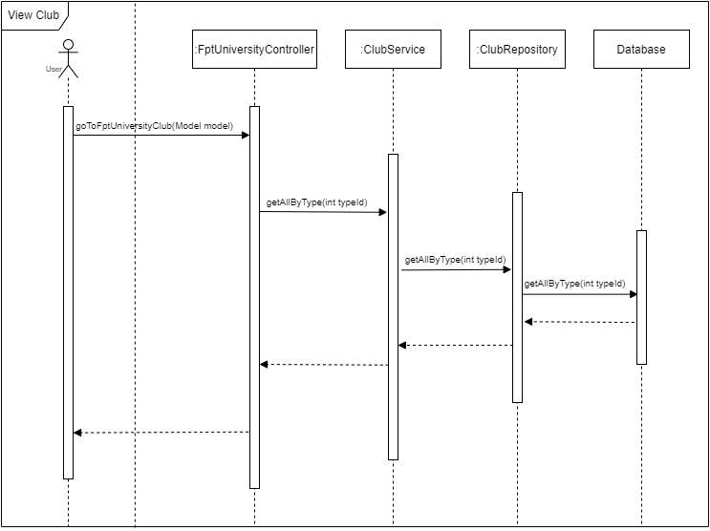

*Figure 4.5: View club – Sequence Diagram*

#### 3.1.3 View detail club

##### 3.1.3.1 Class diagram

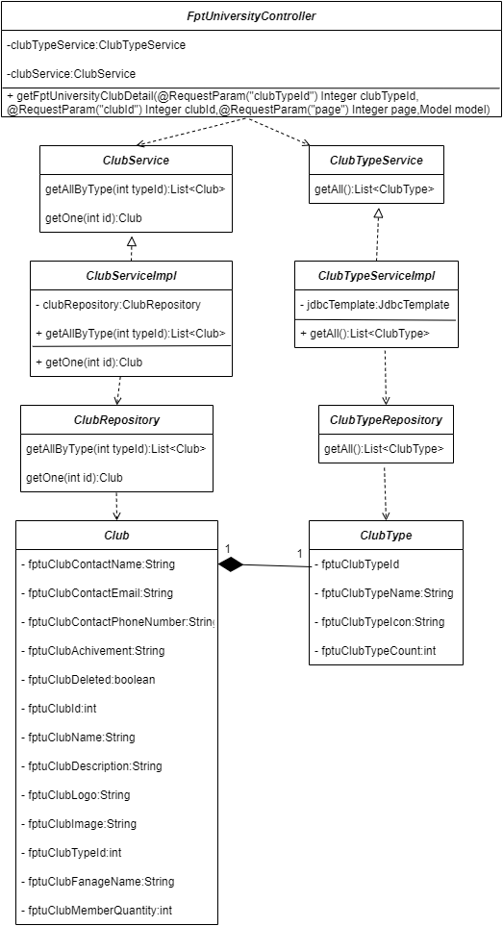

*Figure 4.6: View club detail – Class Diagram*

##### 3.1.3.2 Sequence diagram

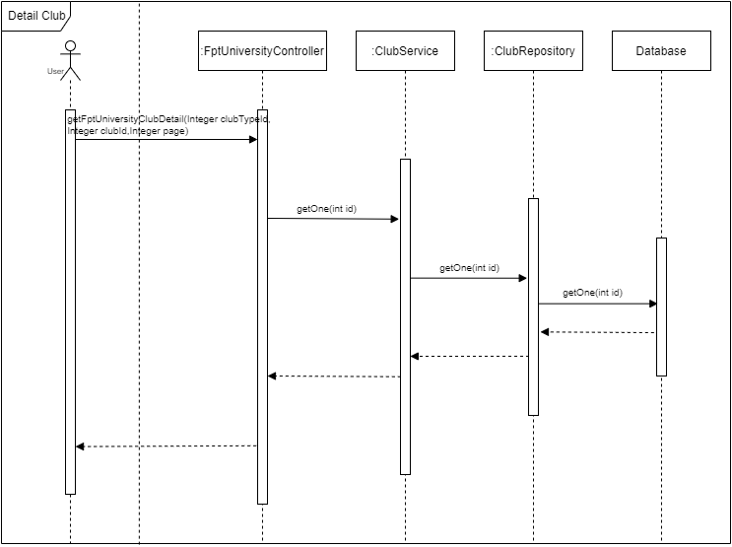

*Figure 4.7: View club detail – Sequence Diagram*

#### 3.1.4 View list job

##### 3.1.4.1 Class diagram

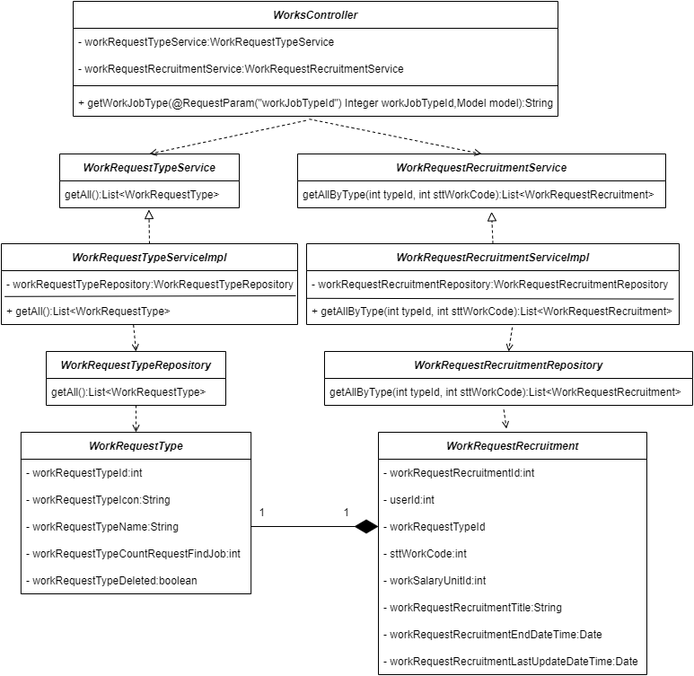

*Figure 4.8: View list job – Class Diagram*

##### 3.1.4.2 Sequence diagram

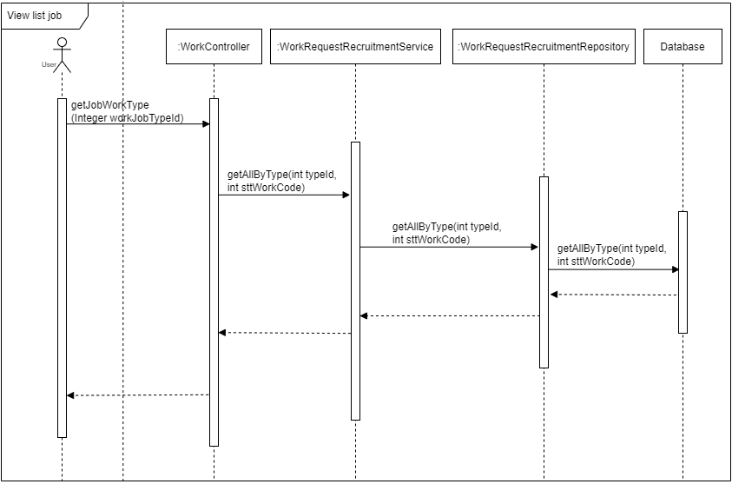

*Figure 4.9: View list job – Sequence Diagram*

#### 3.1.5 View detail job

##### 3.1.5.1 Class diagram

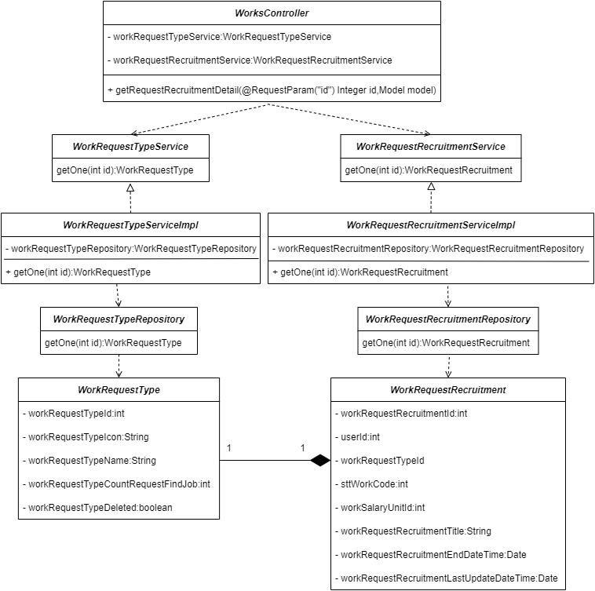

*Figure 4.10: View job detail – Class Diagram*

##### 3.1.5.2 Sequence diagram

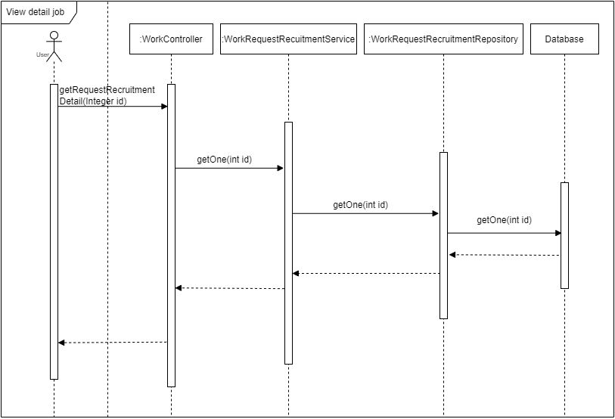

*Figure 4.11: View job detail – Sequence Diagram*

#### 3.1.6 View all store

##### 3.1.6.1 Class diagram

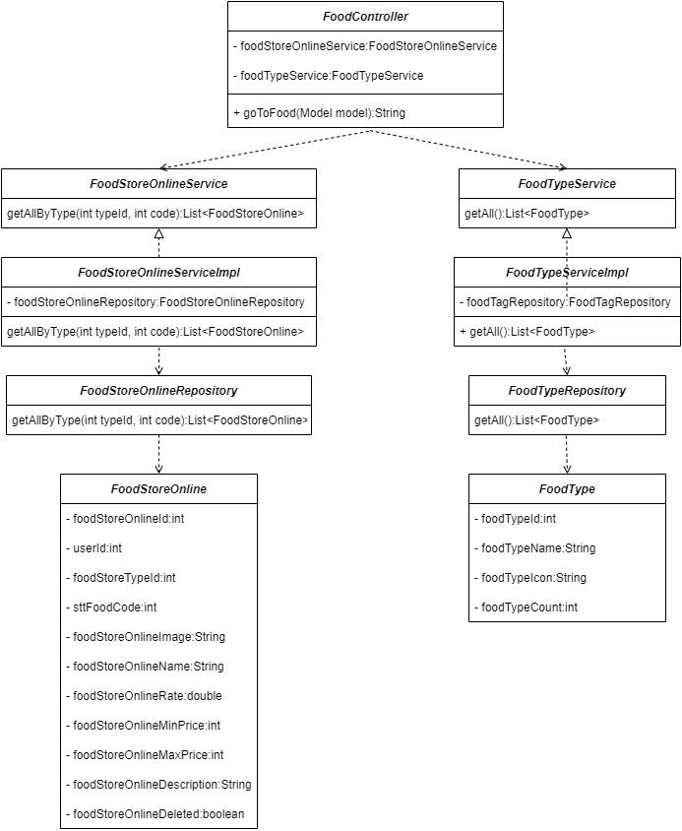

*Figure 4.12:View all stores – Class Diagram*

##### 3.1.6.2 Sequence diagram

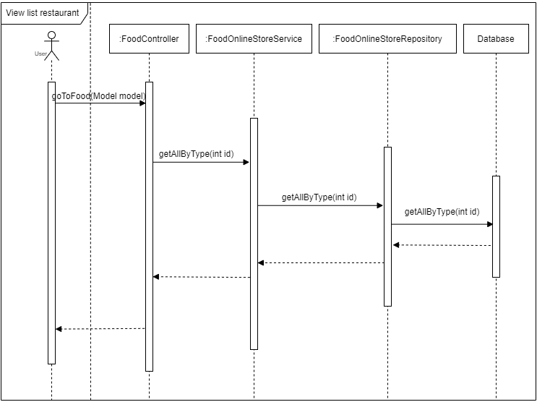

*Figure 4.13: View all stores– Sequence Diagram*

#### 3.1.7 View detail store

##### 3.1.7.1 Class diagram

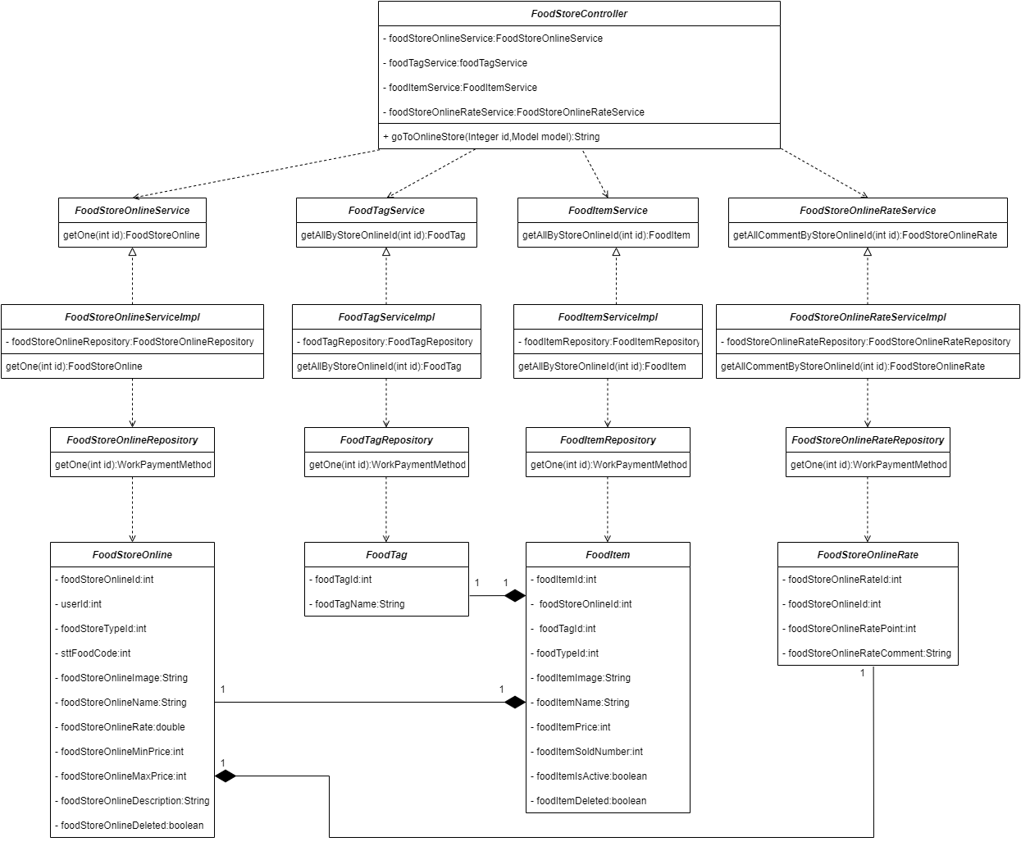

*Figure 4.14:View detail store – Class Diagram*

##### 3.1.7.2 Sequence diagram

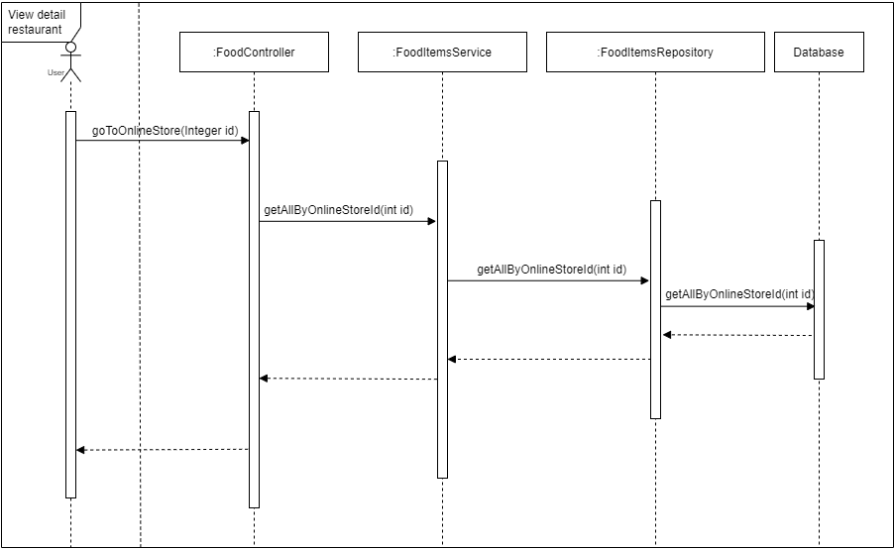

*Figure 4.15: View detail store– Sequence Diagram*

#### 3.1.8 View rating and comment

##### 3.1.8.1 Class diagram

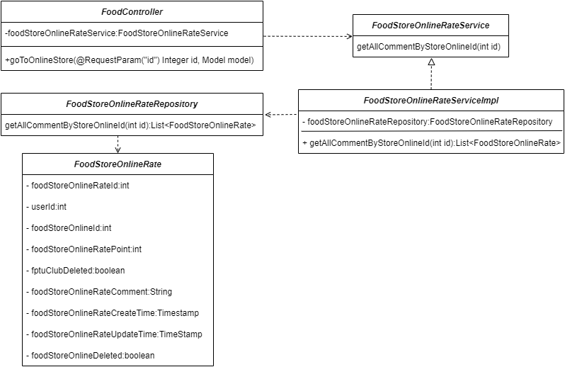

*Figure 4.16:View rating and comment – Class Diagram*

##### 3.1.8.2 Sequence diagram

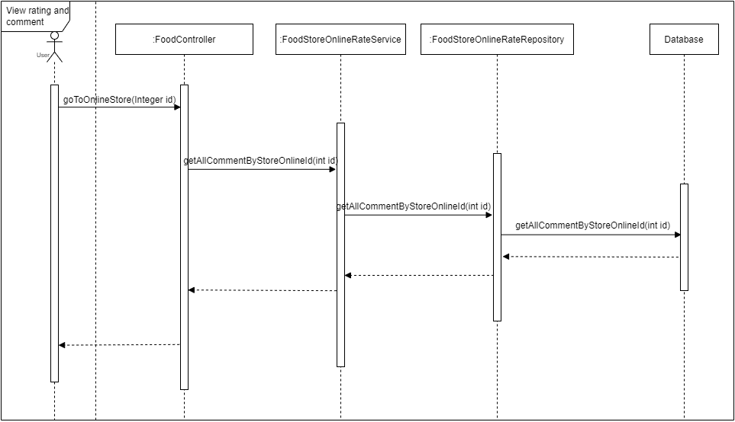

*Figure 4.17: View rating and comment– Sequence Diagram*

#### 3.1.9 View list bus

##### 3.1.9.1 Class diagram

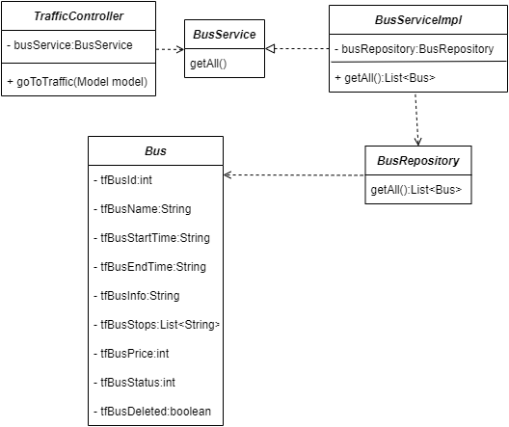

*Figure 4.18: View list bus – Class Diagram*

##### 3.1.9.2 Sequence diagram

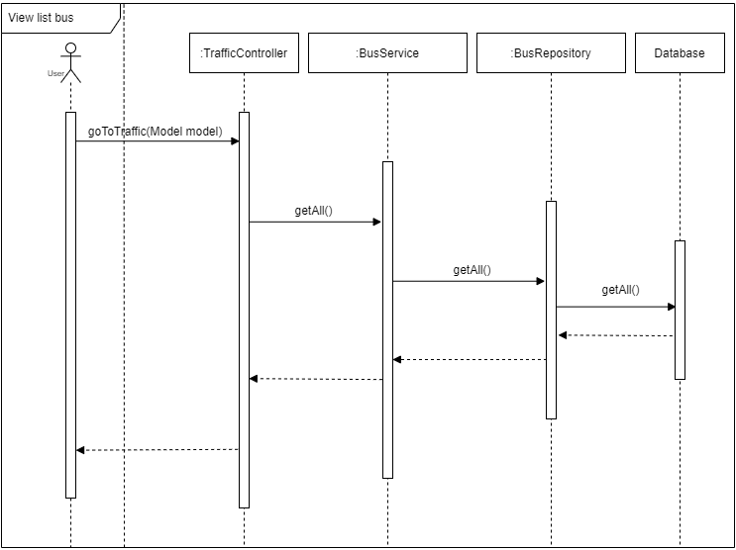

*Figure 4.19: View list bus– Sequence Diagram*

#### 3.1.10 View detail bus routes

##### 3.1.10.1 Class diagram

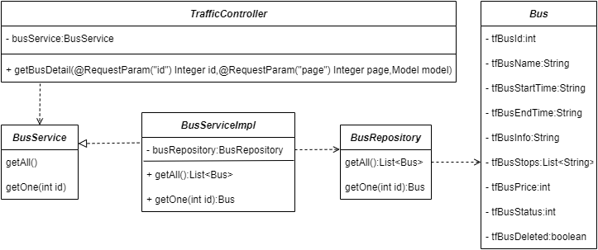

*Figure 4.20: View detail bus routes– Class Diagram*

##### 3.1.10.2 Sequence diagram

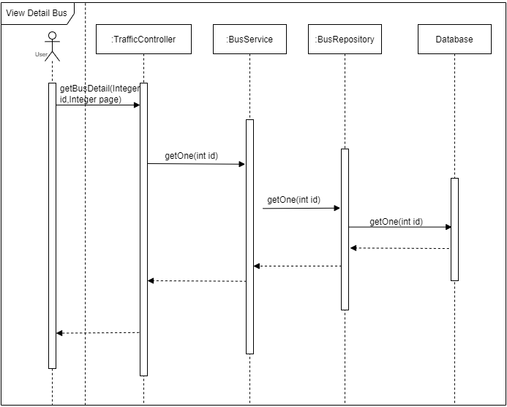

*Figure 4.21: View detail bus routes – Sequence Diagram*

#### 3.1.11 View list motorcycle taxi driver

##### 3.1.11.1 Class diagram

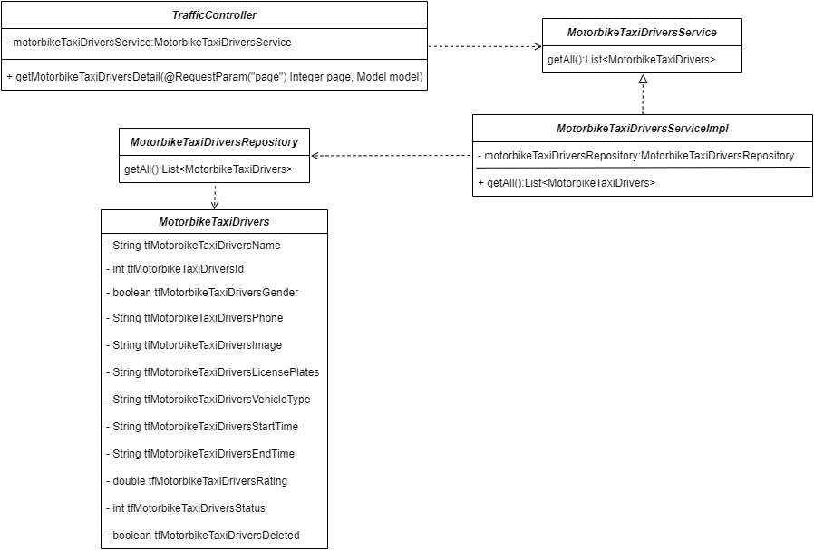

*Figure 4.22: View list motorcycle taxi driver – Class Diagram*

##### 3.1.11.2 Sequence diagram

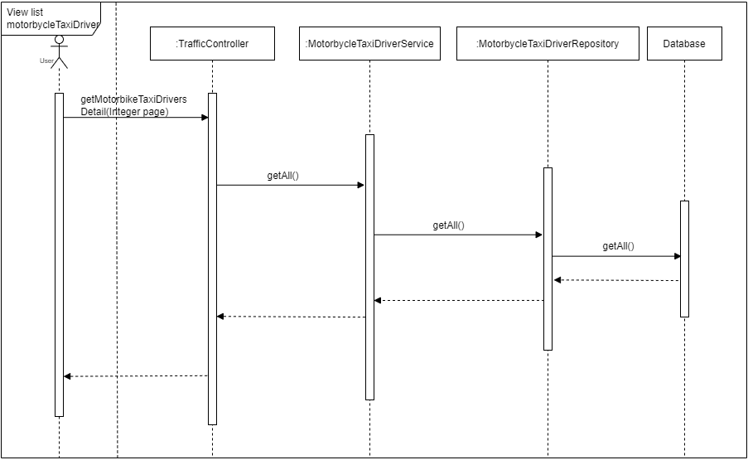

*Figure 4.23: View list motorcycle taxi driver – Sequence Diagram*

### 3.2 Registered User

#### 3.2.1 Sign in

##### 3.2.1.1 Class diagram

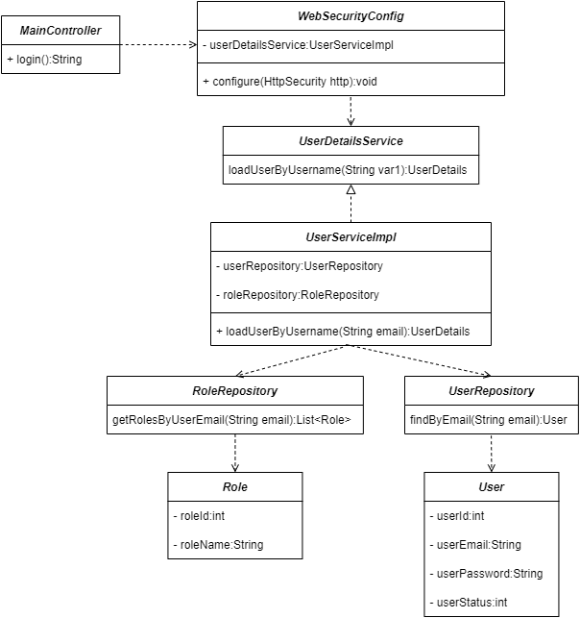

*Figure 4.24:Sign in – Class Diagram*

##### 3.2.1.2 Sequence diagram

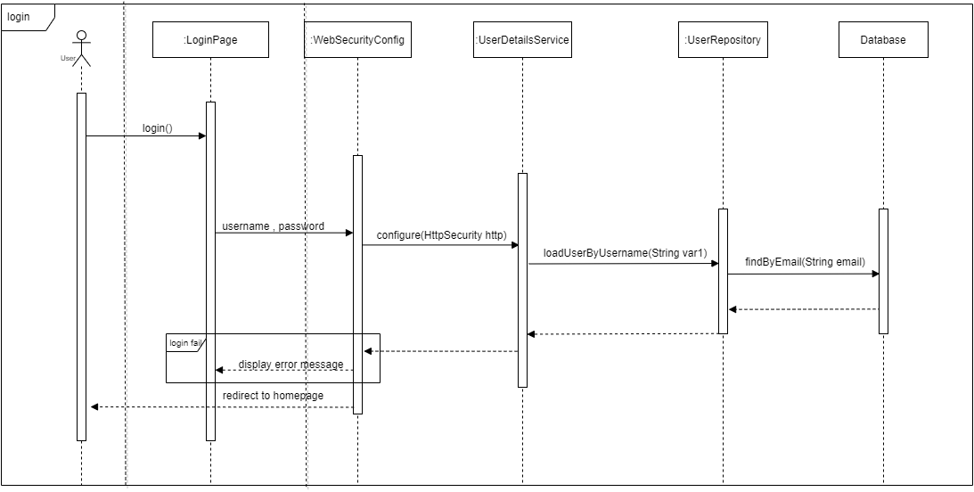

*Figure 4.25: Sign in – Sequence Diagram*

#### 3.2.2 View profile info

##### 3.2.2.1 Class diagram

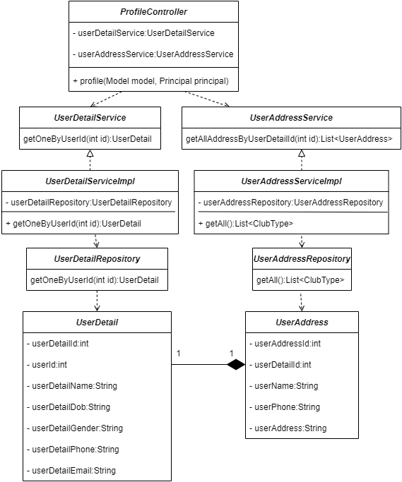

*Figure 4.26: View profile info – Class Diagram*

##### 3.2.2.2 Sequence diagram

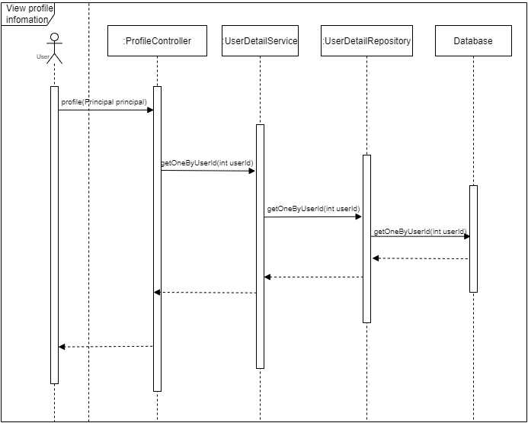

*Figure 4.27: View profile info – Sequence Diagram*

#### 3.2.3 Change password

##### 3.2.3.1 Class diagram

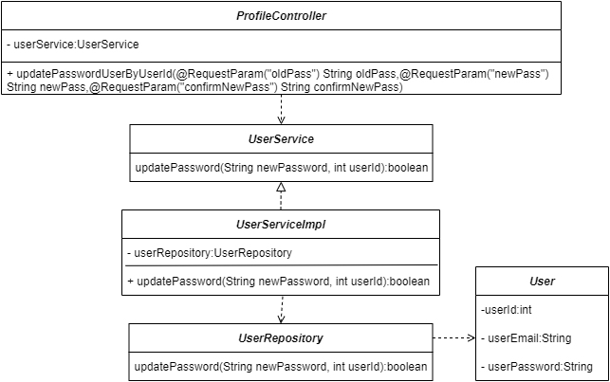

*Figure 4.28: Change password – Class Diagram*

##### 3.2.3.2 Sequence diagram

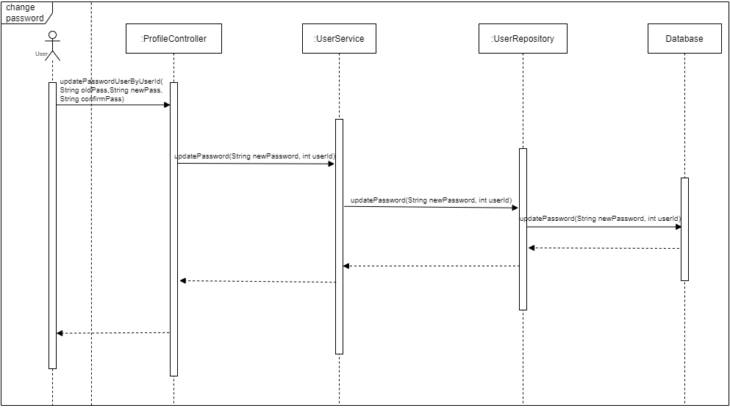

*Figure 4.29: Change password – Sequence Diagram*

#### 3.2.4 Update profile info

##### 3.2.4.1 Class diagram

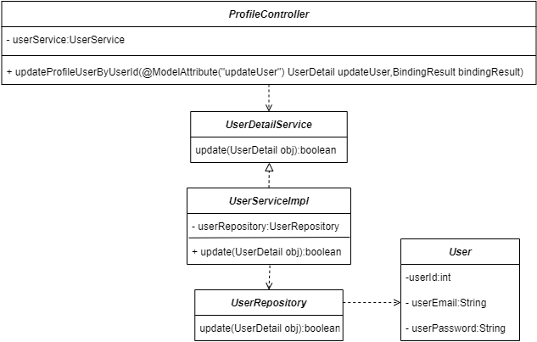

*Figure 4.30: Update profile info – Class Diagram*

##### 3.2.4.2 Sequence diagram

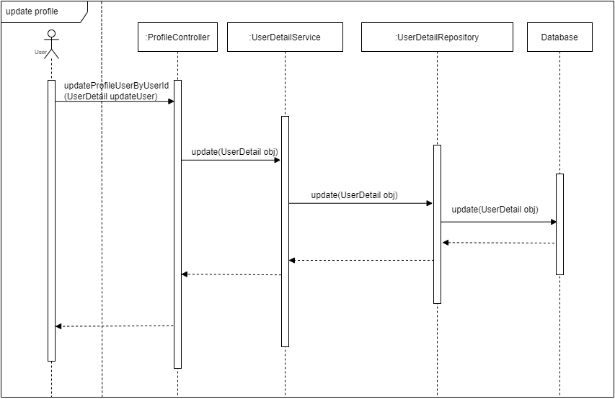

*Figure 4.31: Update profile info – Sequence Diagram*

#### 3.2.5 Update address

##### 3.2.5.1 Class diagram

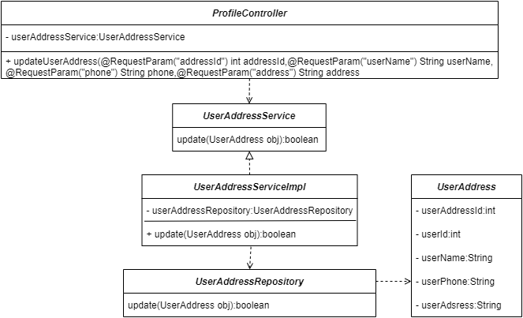

*Figure 4.32: Update address– Class Diagram*

##### 3.2.5.2 Sequence diagram

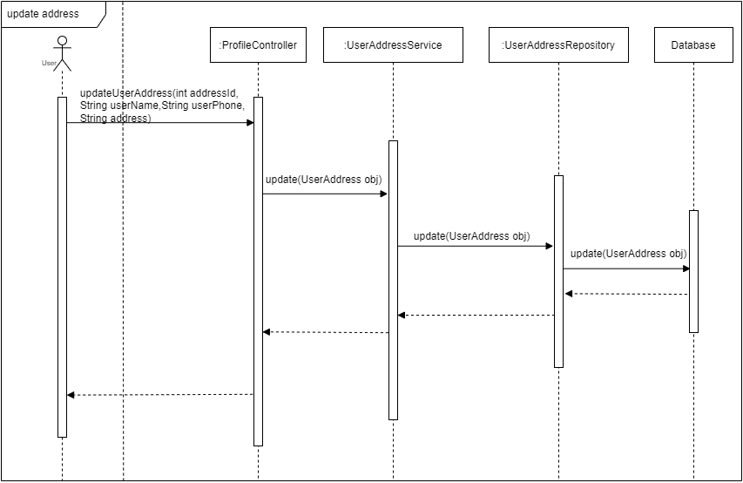

*Figure 4.33: Update address – Sequence Diagram*

#### 3.2.6 View list order

##### 3.2.6.1 Class diagram

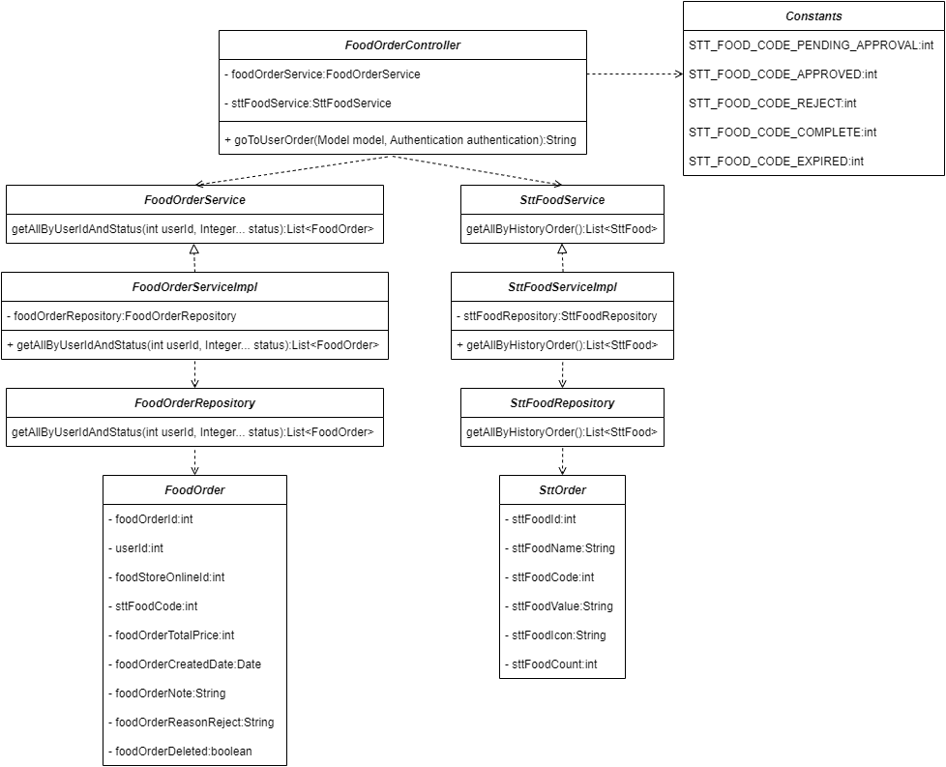

*Figure 4.34: View list order – Class Diagram*

##### 3.2.6.2 Sequence diagram

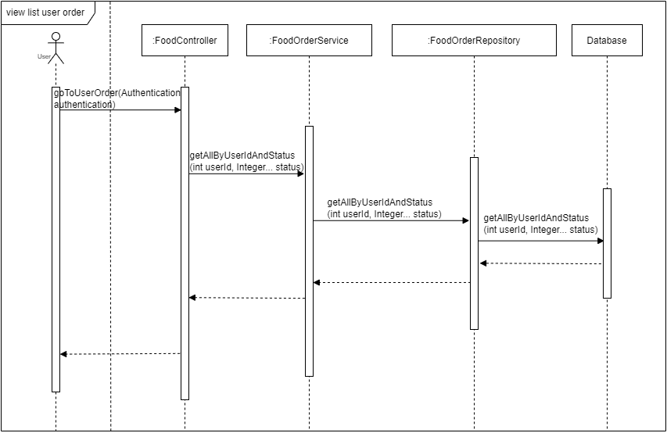

*Figure 4.35: View list order – Sequence Diagram*

#### 3.2.7 Cancel order

##### 3.2.7.1 Class diagram

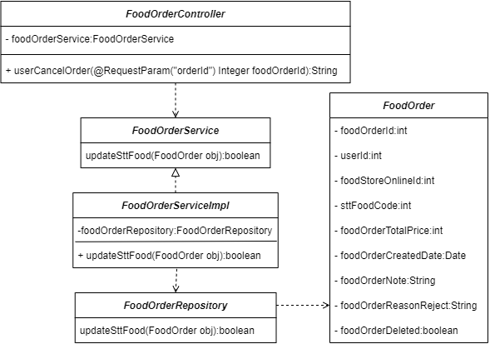

*Figure 4.36: Cancel order – Class Diagram*

##### 3.2.7.2 Sequence diagram

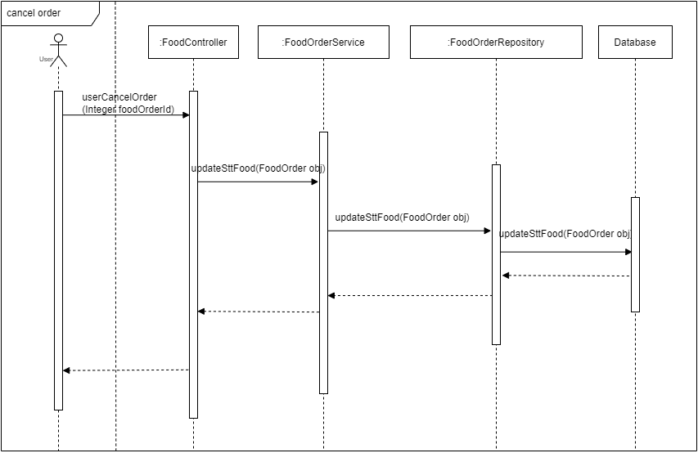

*Figure 4.37: Cancel order – Sequence Diagram*

#### 3.2.8 Order food

##### 3.2.8.1 Class diagram

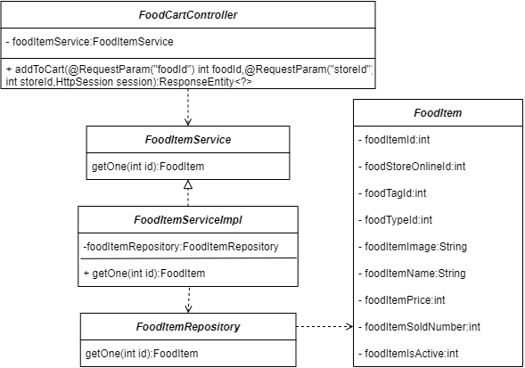

*Figure 4.38: Order food– Class Diagram*

##### 3.2.8.2 Sequence diagram

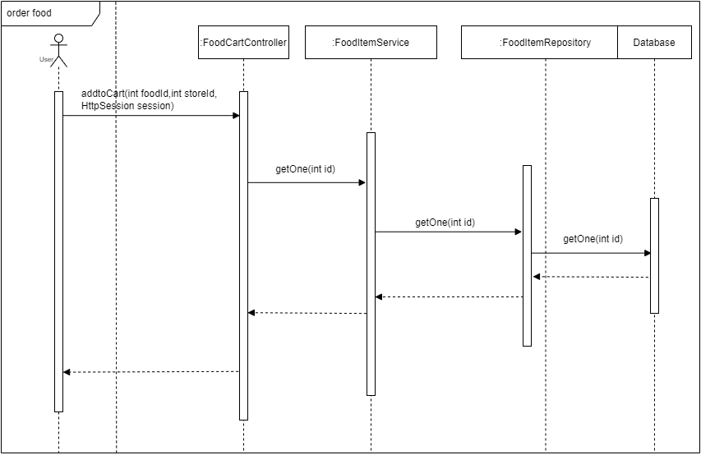

*Figure 4.39: Order food – Sequence Diagram*

#### 3.2.9 Rate and comment store

##### 3.2.9.1 Class diagram

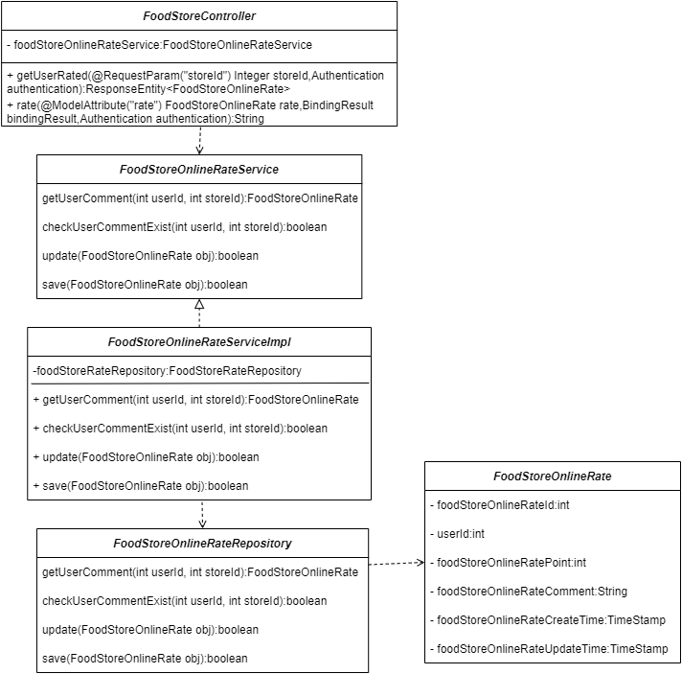

*Figure 4.40: Rate and comment store – Class Diagram*

##### 3.2.9.2 Sequence diagram

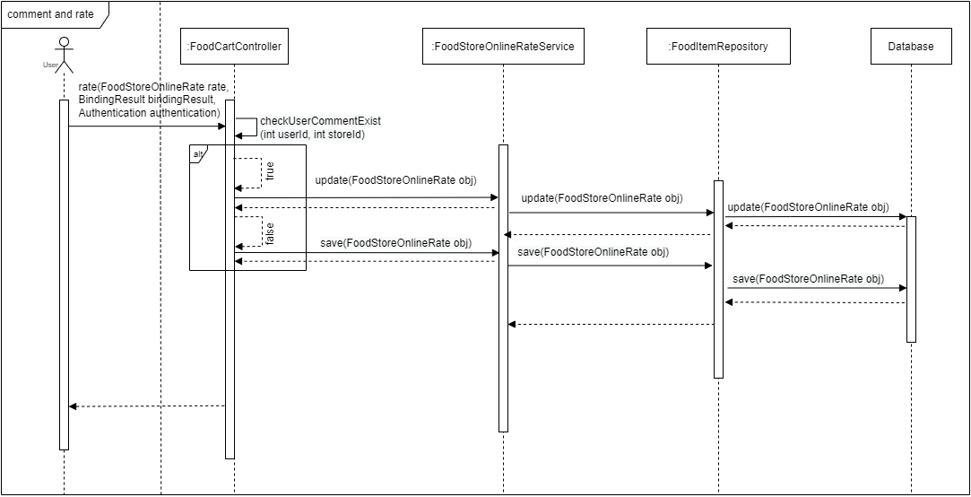

*Figure 4.41: Rate and comment store – Sequence Diagram*

#### 3.2.10 Report order

##### 3.2.10.1 Class diagram

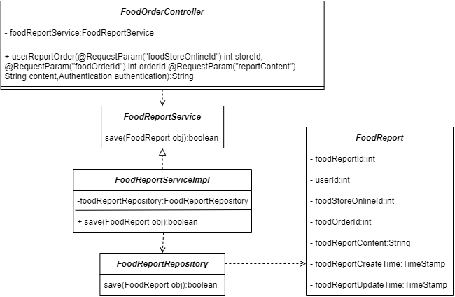

*Figure 4.42: Report order – Class Diagram*

##### 3.2.10.2 Sequence diagram

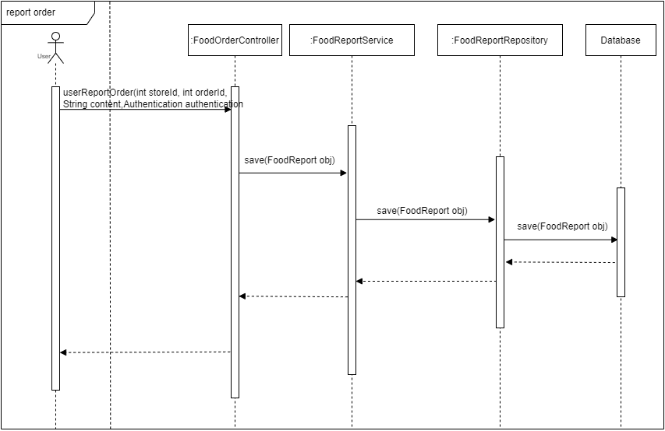

*Figure 4.43: Report order – Sequence Diagram*

#### 3.2.11 Search food

##### 3.2.11.1 Class diagram

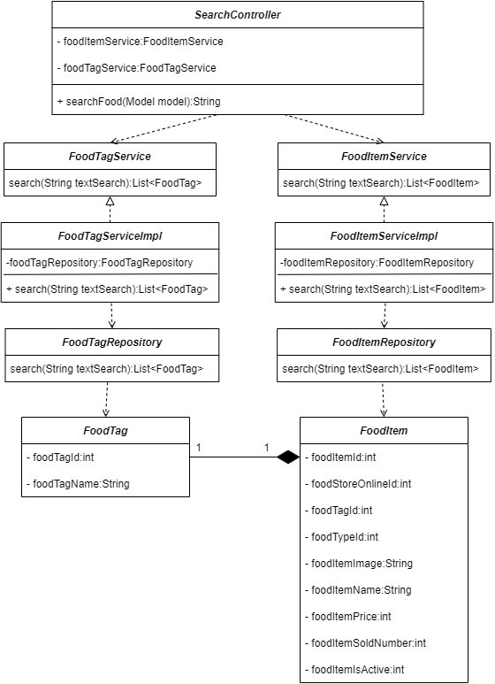

*Figure 4.44: Search food – Class Diagram*

##### 3.2.11.2 Sequence diagram

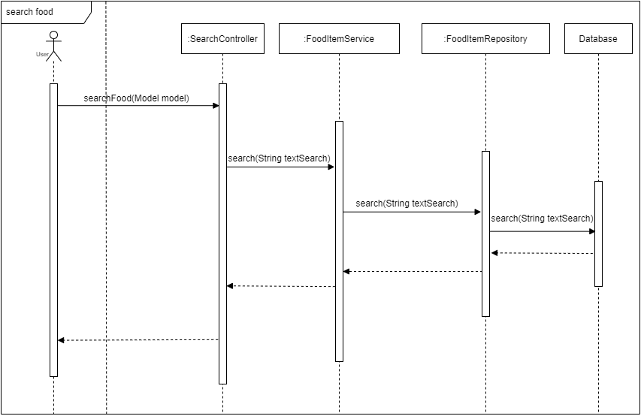

*Figure 4.45: Search – Sequence Diagram*

### 3.3 Student

#### 3.3.1 View list job hire

##### 3.3.1.1 Class diagram

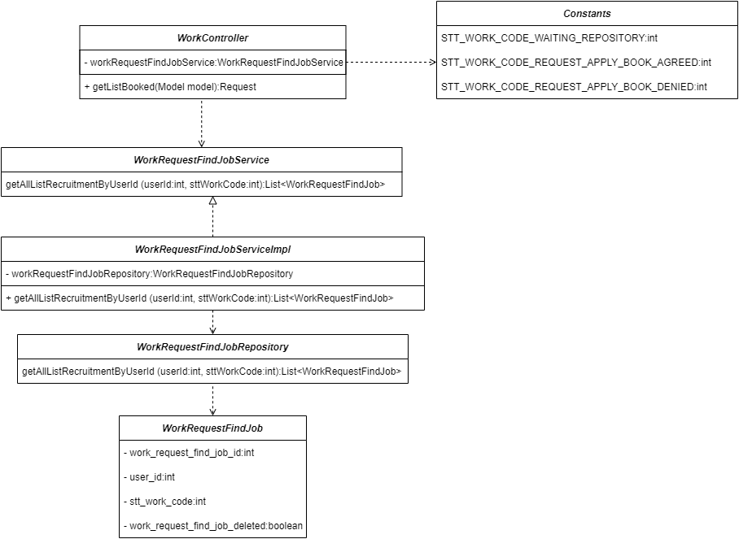

*Figure 4.46: View list job hire – Class Diagram*

##### 3.3.1.2 Sequence diagram

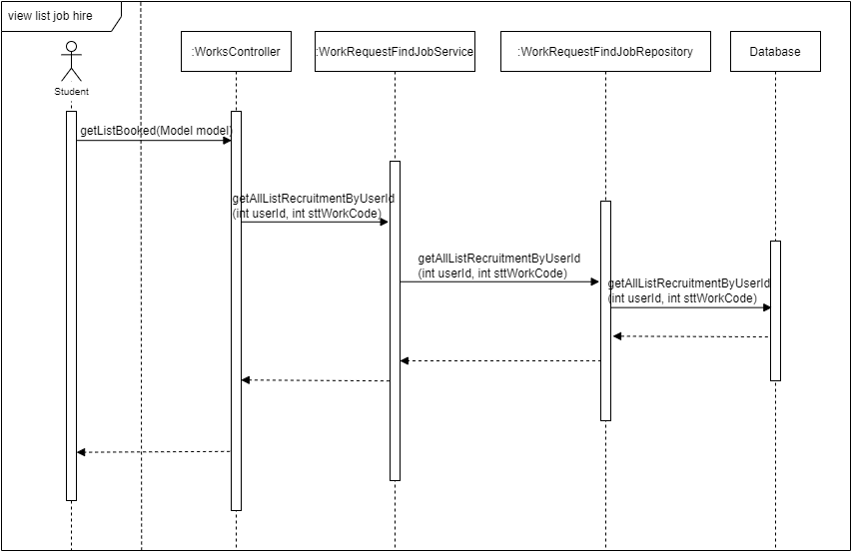

*Figure 4.47: View list job hire– Sequence Diagram*

#### 3.3.2 View list applied for a job

##### 3.3.2.1 Class diagram

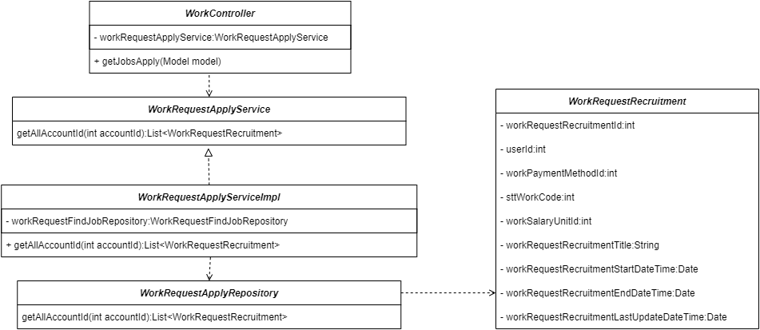

*Figure 4.48: View list applied for a job – Class Diagram*

##### 3.3.2.2 Sequence diagram

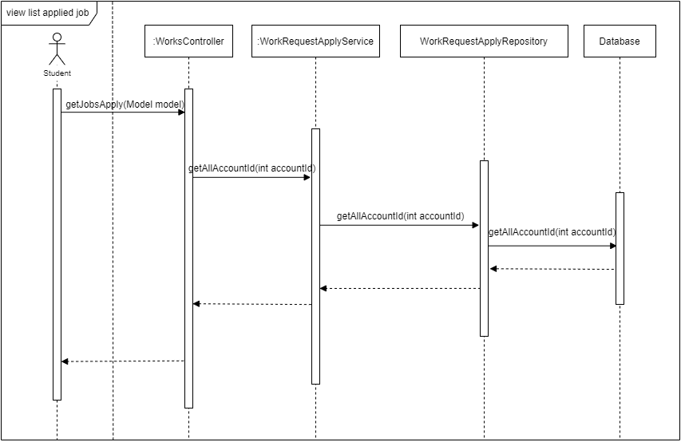

*Figure 4.49: View list applied for a job – Sequence Diagram*

#### 3.3.3 View list job save

##### 3.3.3.1 Class diagram

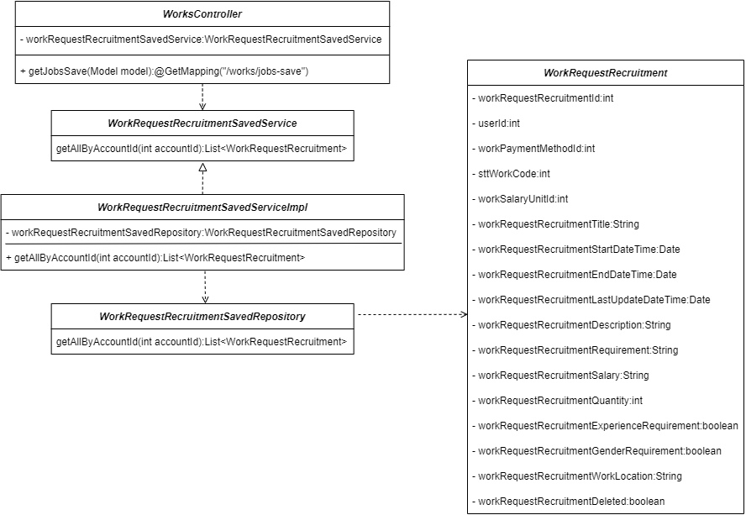

*Figure 4.50: View list job save – Class Diagram*

##### 3.3.3.2 Sequence diagram

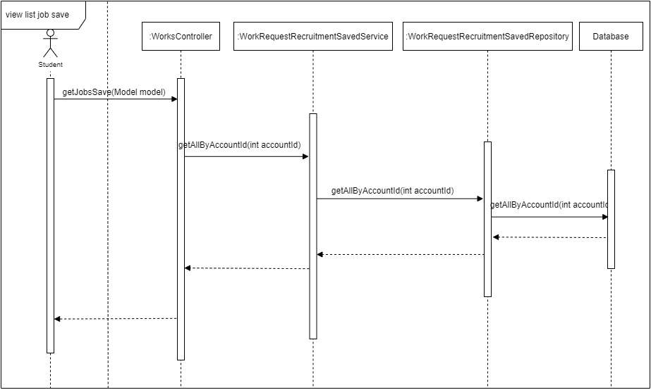

*Figure 4.51: View list job save – Sequence Diagram*

#### 3.3.4 Create a request to find a job

##### 3.3.4.1 Class diagram

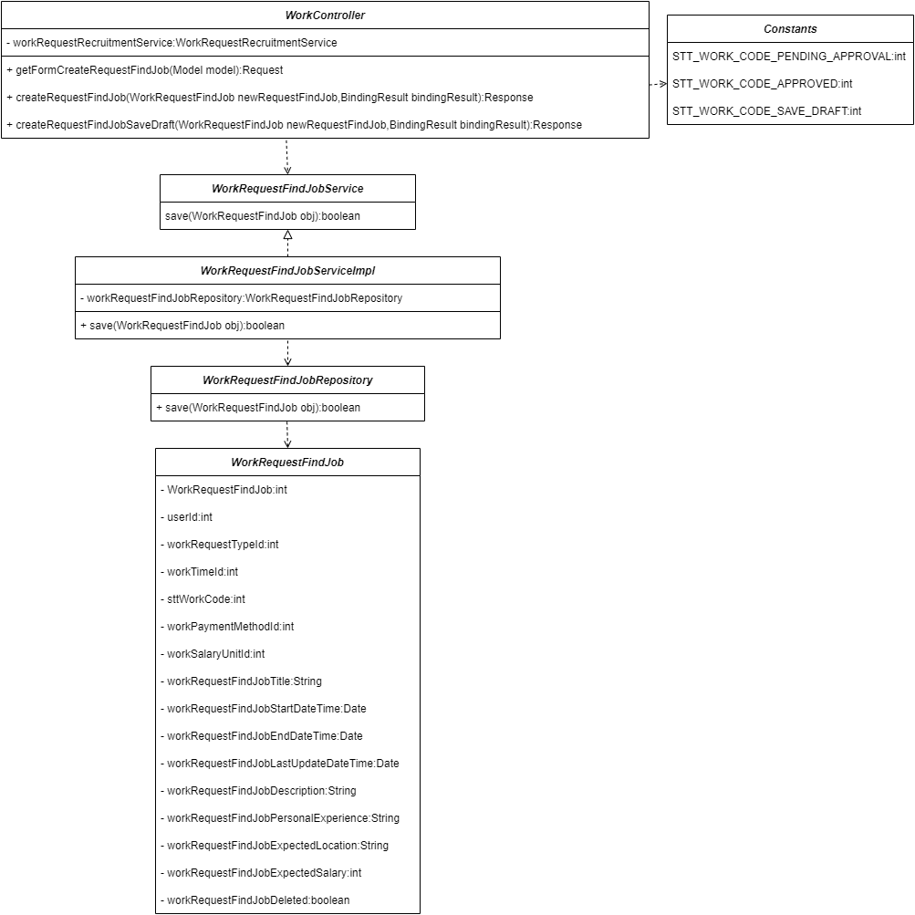

*Figure 4.52: Create request find a job – Class Diagram*

##### 3.3.4.2 Sequence diagram

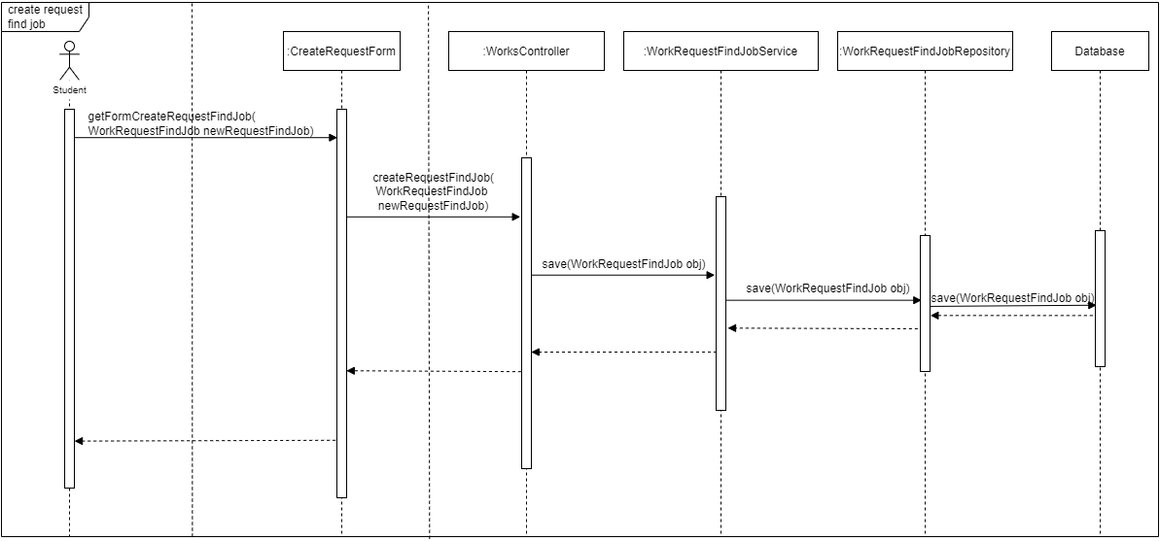

*Figure 4.53: Create request find a job – Sequence Diagram*

#### 3.3.5 Delete request find a job

##### 3.3.5.1 Class diagram

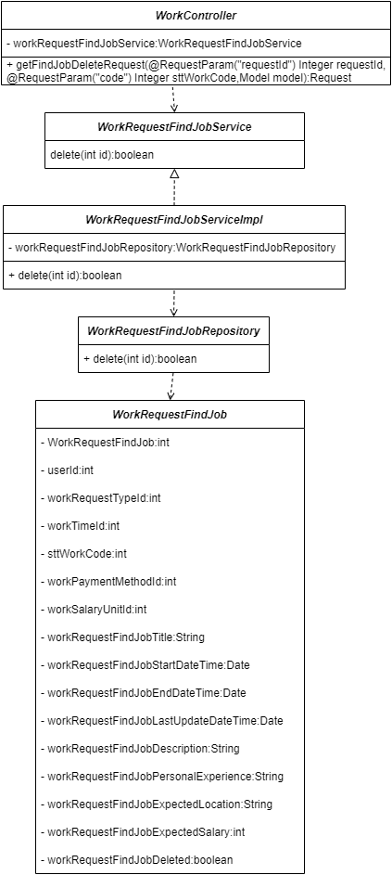

*Figure 4.54: Delete request find a job – Class Diagram*

##### 3.3.5.2 Sequence diagram

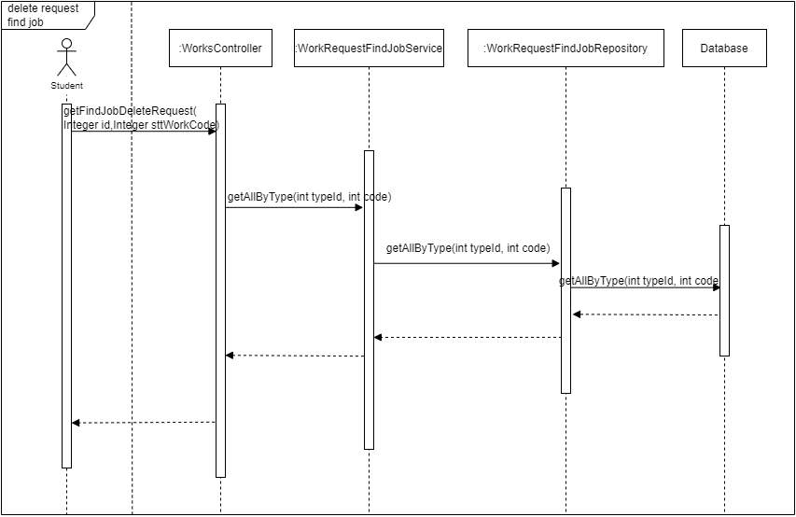

*Figure 4.55: Delete request find a job – Sequence Diagram*

#### 3.3.6 View manage request find a job

##### 3.3.6.1 Class diagram

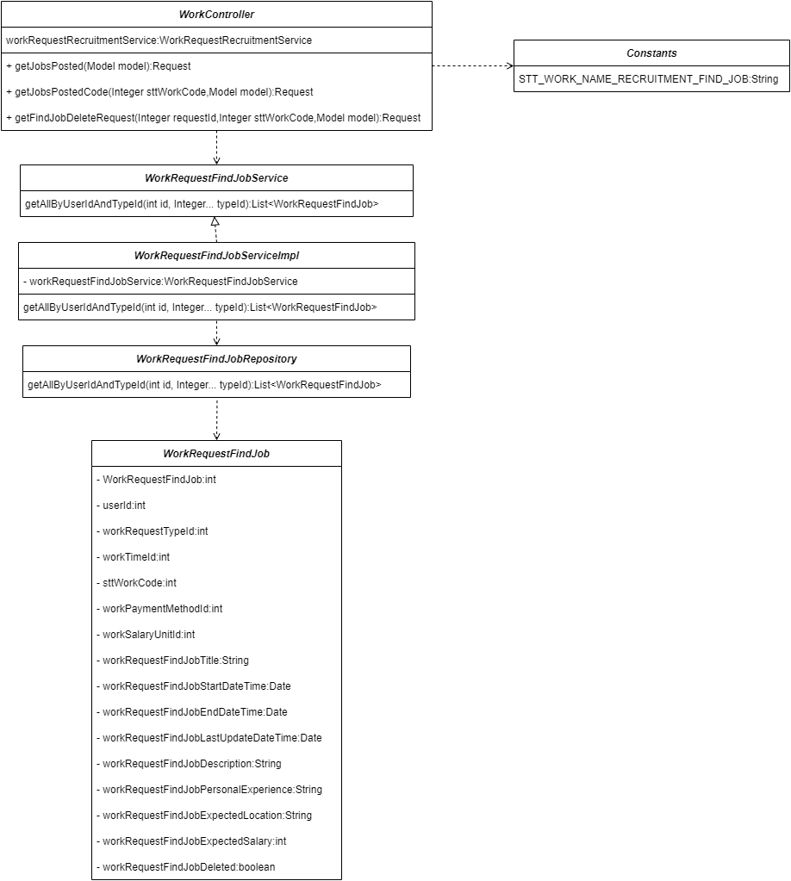

*Figure 4.56: View manage request find a job – Class Diagram*

##### 3.3.6.2 Sequence diagram

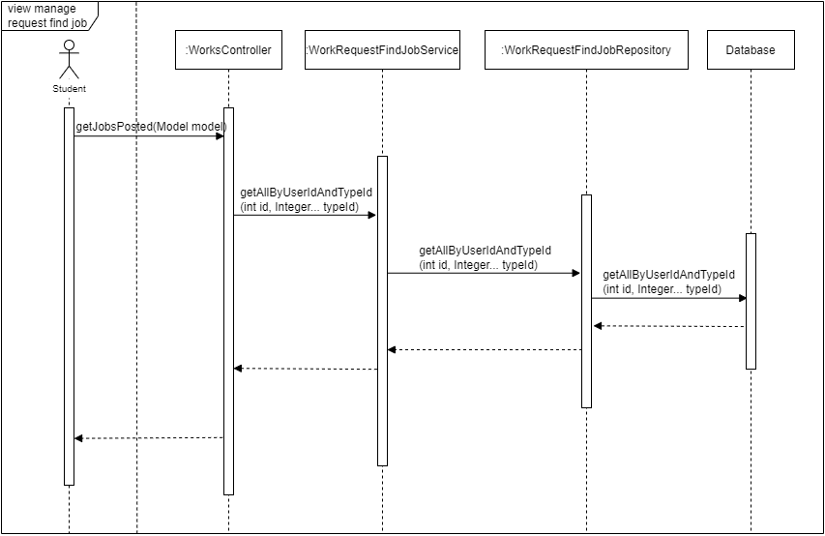

*Figure 4.57: View manage request find a job – Sequence Diagram*

#### 3.3.7 Apply for a job

##### 3.3.7.1 Class diagram

*Figure 4.58: Apply for a job – Class Diagram*

##### 3.3.7.2 Sequence diagram

*Figure 4.59: Apply for a job – Sequence Diagram*

#### 3.3.8 Save job

##### 3.3.8.1 Class diagram

*Figure 4.60: Save job – Class Diagram*

##### 3.3.8.2 Sequence diagram

*Figure 4.61: Save job – Sequence Diagram*

### 3.4 Recruiter

#### 3.4.1 View list find a job

##### 3.4.1.1 Class diagram

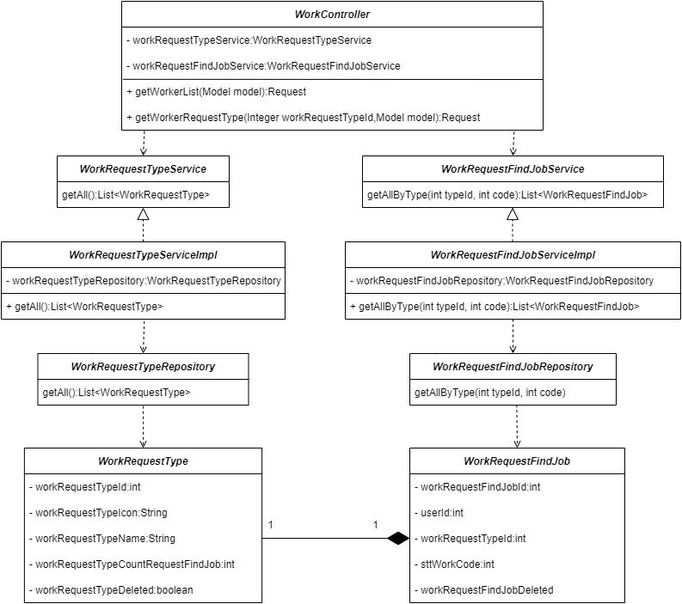

*Figure 4.62: View list find a job – Class Diagram*

##### 3.4.1.2 Sequence diagram

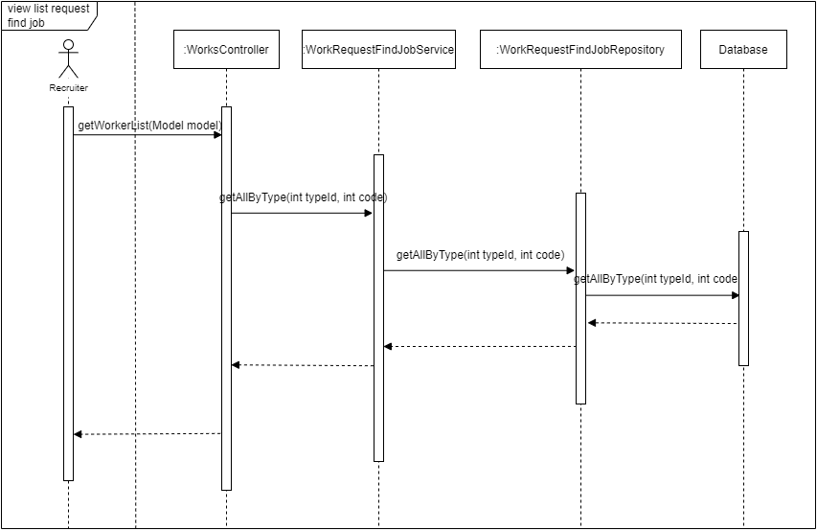

*Figure 4.63: View list find a job – Sequence Diagram*

#### 3.4.2 View detail request find a job

##### 3.4.2.1 Class diagram

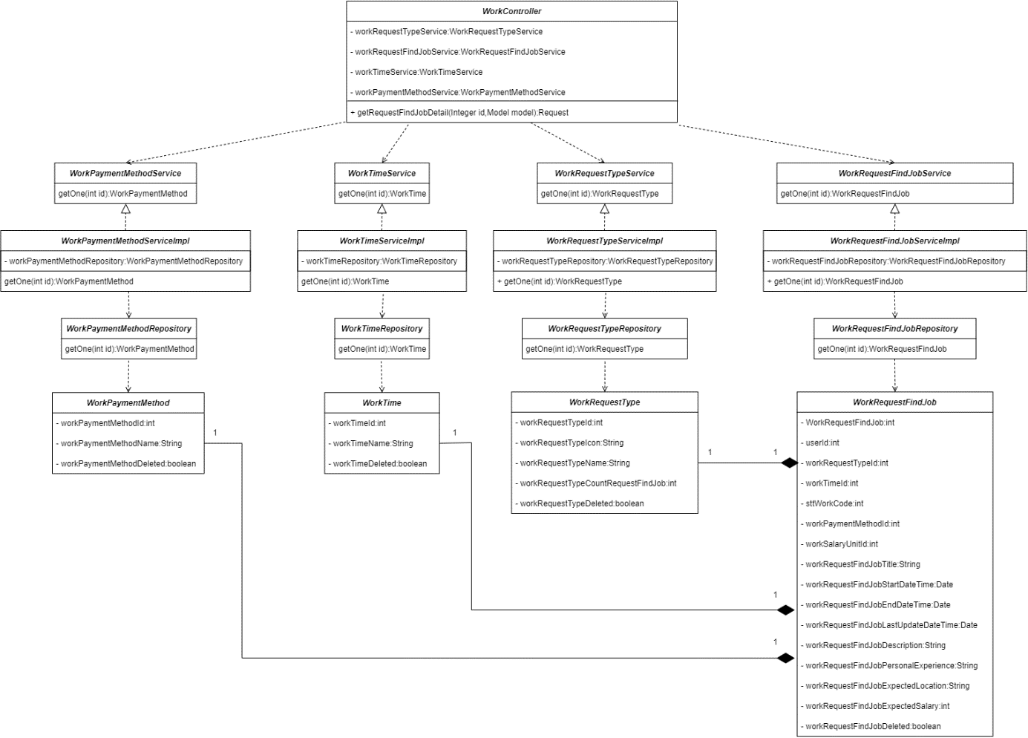

*Figure 4.64: View detail request find a job– Class Diagram*

##### 3.4.2.2 Sequence diagram

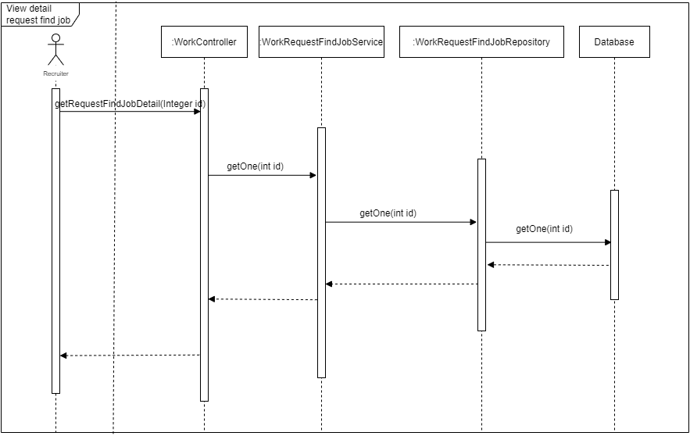

*Figure 4.65: View detail request find a job – Sequence Diagram*

#### 3.4.3 Hire worker

##### 3.4.3.1 Class diagram

*Figure 4.66: Hire worker – Class Diagram*

##### 3.4.3.2 Sequence diagram

*Figure 4.67: Hire worker – Sequence Diagram*

#### 3.4.4 View list apply for a job

##### 3.4.4.1 Class diagram

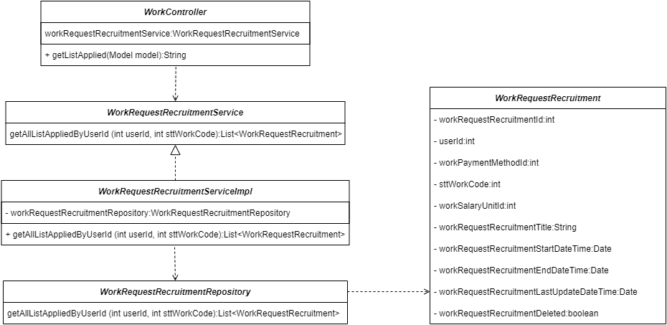

*Figure 4.68: View list apply for a job – Class Diagram*

##### 3.4.4.2 Sequence diagram

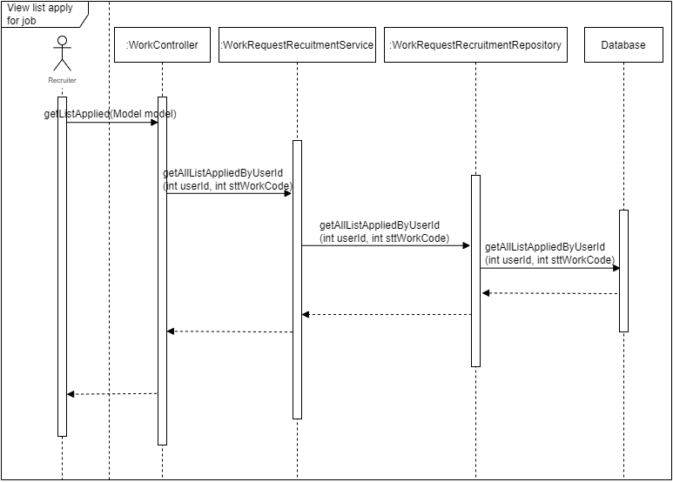

*Figure 4.69: View list apply for a job – Sequence Diagram*

#### 3.4.5 Create request recruitment

##### 3.4.5.1 Class diagram

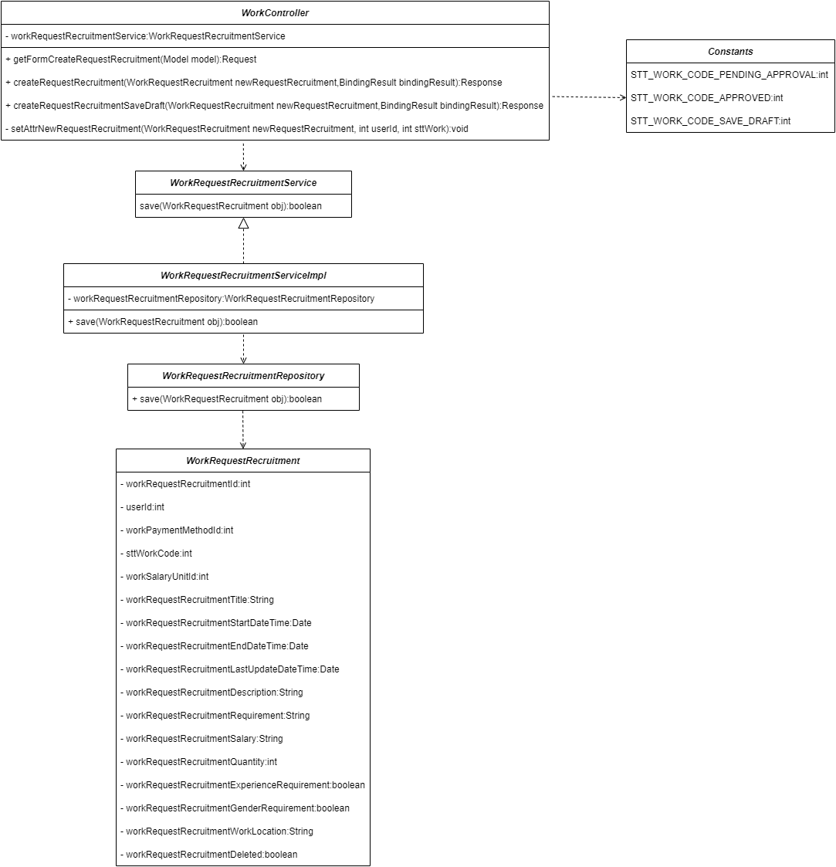

*Figure 4.70: Create request recruitment – Class Diagram*

##### 3.4.5.2 Sequence diagram

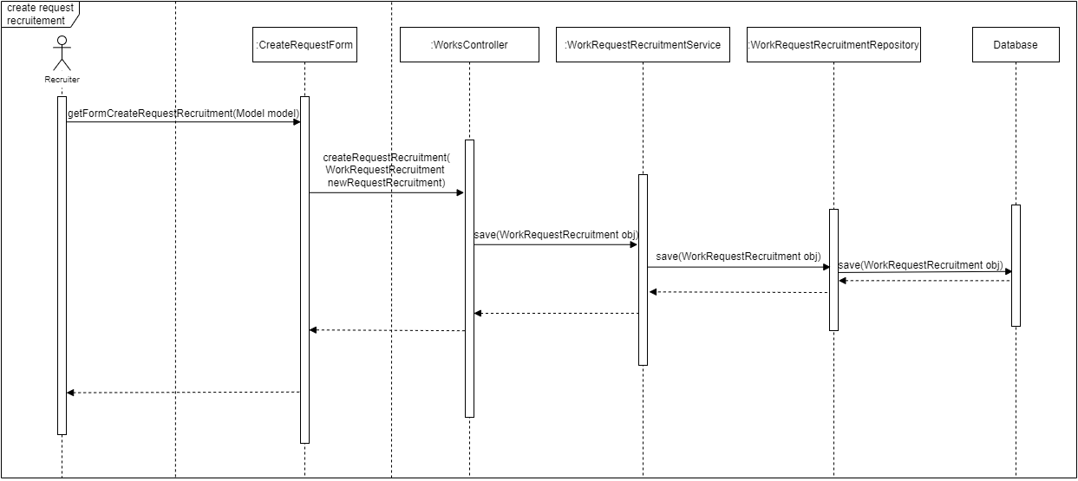

*Figure 4.71: Create request recruitment – Sequence Diagram*

#### 3.4.6 Delete request recruitment

##### 3.4.6.1 Class diagram

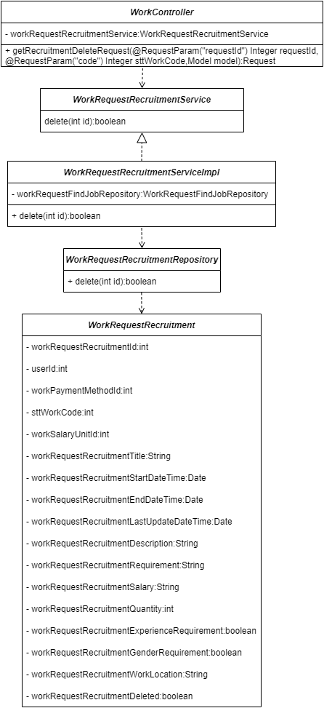

*Figure 4.72: Delete request recruitment – Class Diagram*

##### 3.4.6.2 Sequence diagram

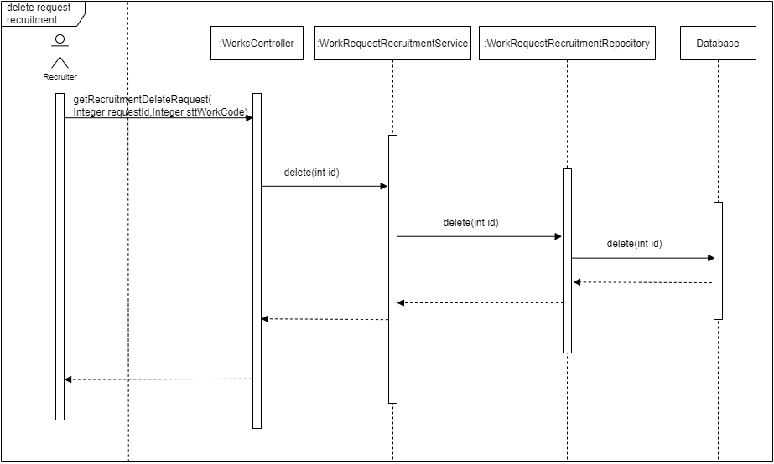

*Figure 4.73: Delete request recruitment – Sequence Diagram*

#### 3.4.7 View manage request recruitment

##### 3.4.7.1 Class diagram

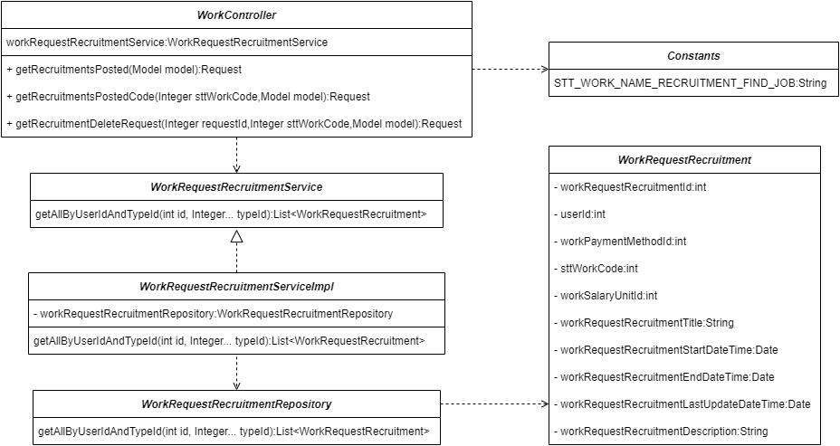

*Figure 4.74: View manage request recruitment – Class Diagram*

##### 3.4.7.2 Sequence diagram

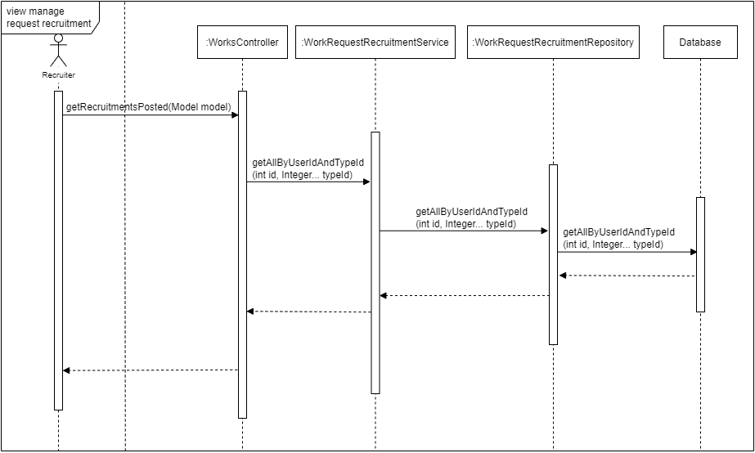

*Figure 4.75: View manage request recruitment – Sequence Diagram*

### 3.5 Seller

#### 3.5.1 Update shop information

##### 3.5.1.1 Class diagram

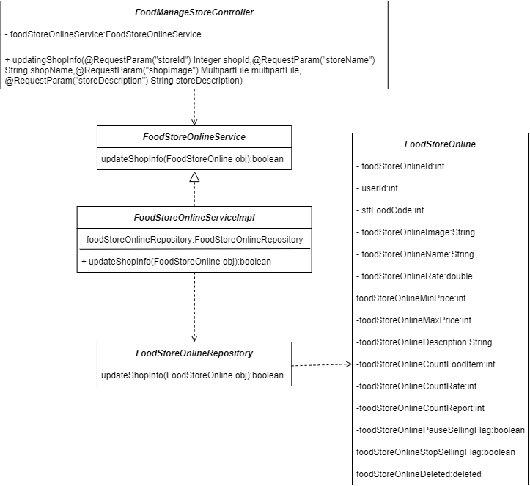

*Figure 4.76: Update shop information – Class Diagram*

##### 3.5.1.2 Sequence diagram

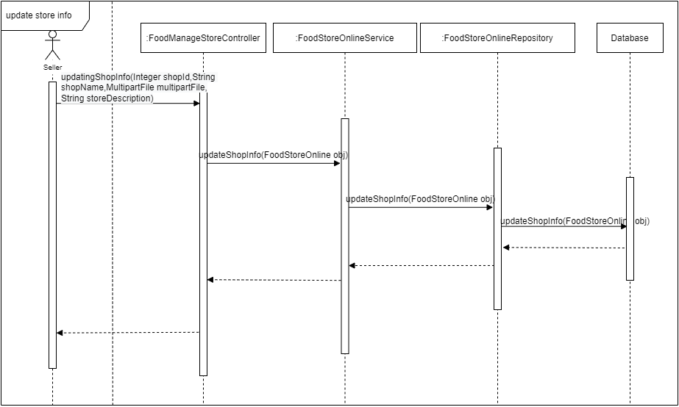

*Figure 4.77: Update shop information – Sequence Diagram*

#### 3.5.2 Update tag of food

##### 3.5.2.1 Class diagram

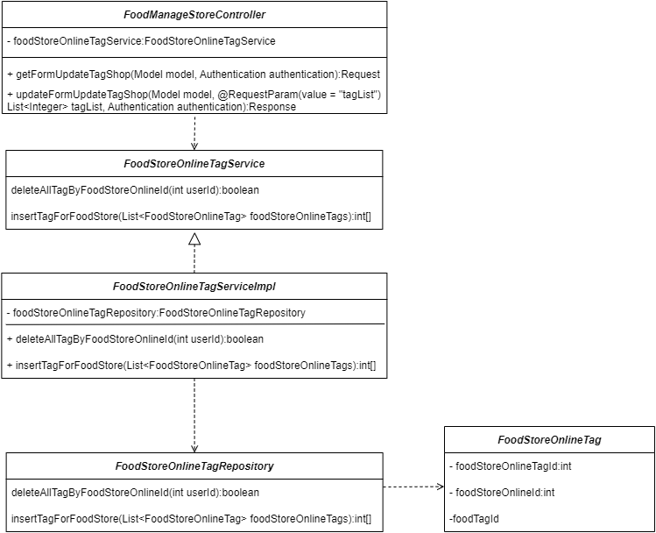

*Figure 4.78: Update tag of food – Class Diagram*

##### 3.5.2.2 Sequence diagram

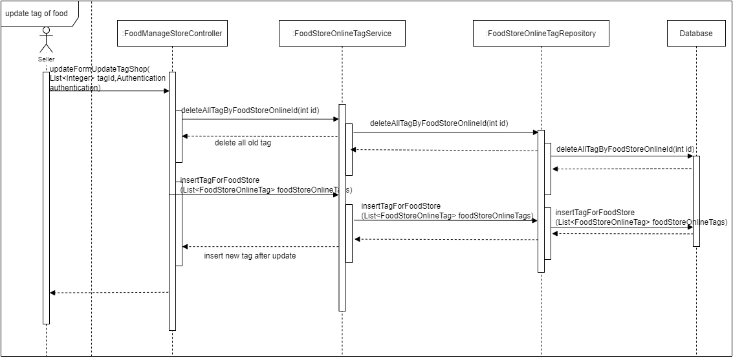

*Figure 4.79: Update tag of food – Sequence Diagram*

#### 3.5.3 Add items to the shop

##### 3.5.3.1 Class diagram

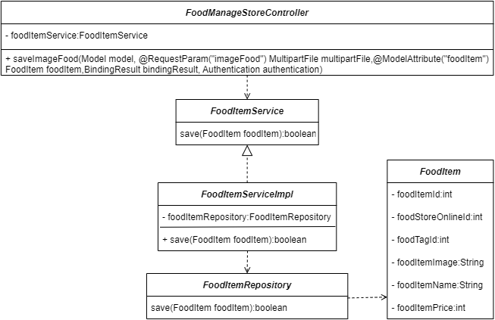

*Figure 4.80: Add items to the shop – Class Diagram*

##### 3.5.3.2 Sequence diagram

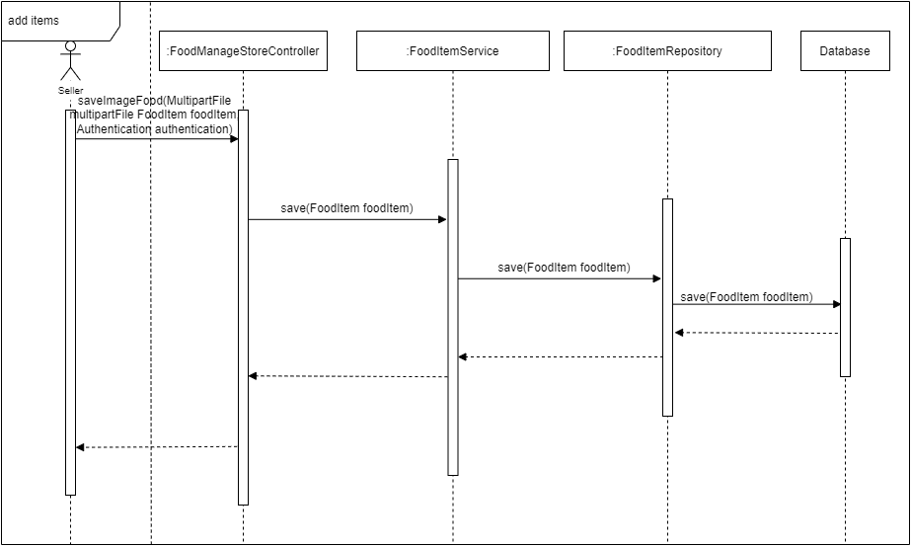

*Figure 4.81: Add items to the shop – Sequence Diagram*

#### 3.5.4 Update items

##### 3.5.4.1 Class diagram

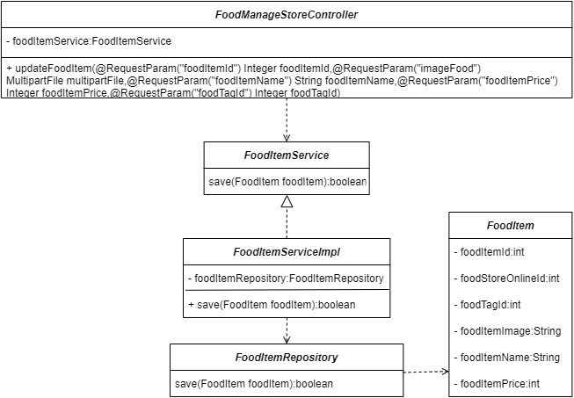

*Figure 4.82: Update items – Class Diagram*

##### 3.5.4.2 Sequence diagram

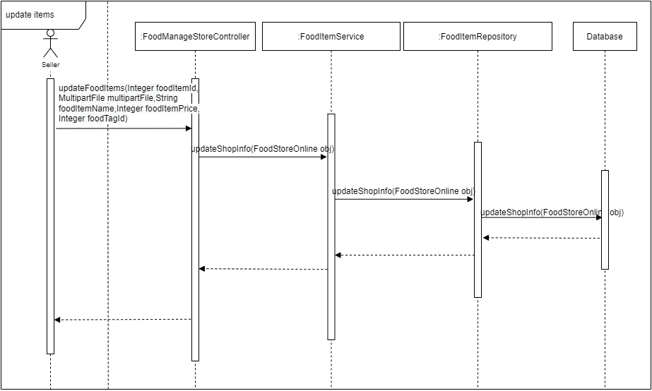

*Figure 4.83: Update items – Sequence Diagram*

#### 3.5.5 Delete items

##### 3.5.5.1 Class diagram

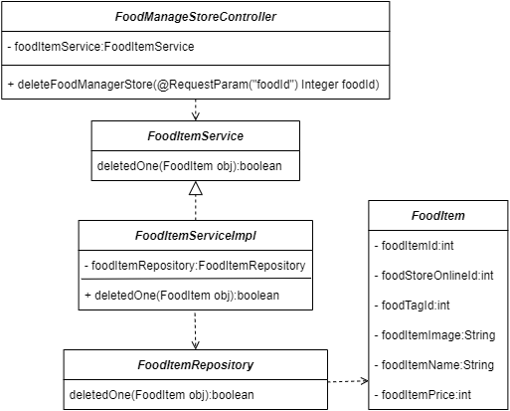

*Figure 4.84: Delete items – Class Diagram*

##### 3.5.5.2 Sequence diagram

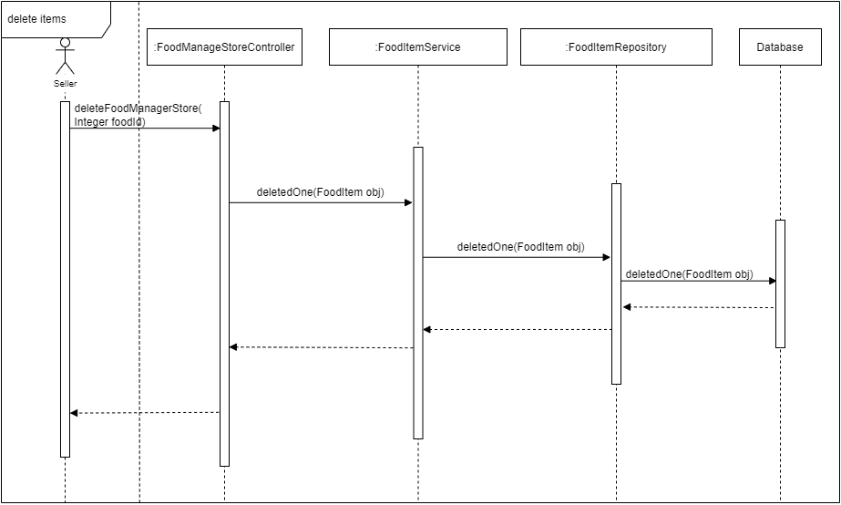

*Figure 4.85: Delete items – Sequence Diagram*

#### 3.5.6 View list seller order

##### 3.5.6.1 Class diagram

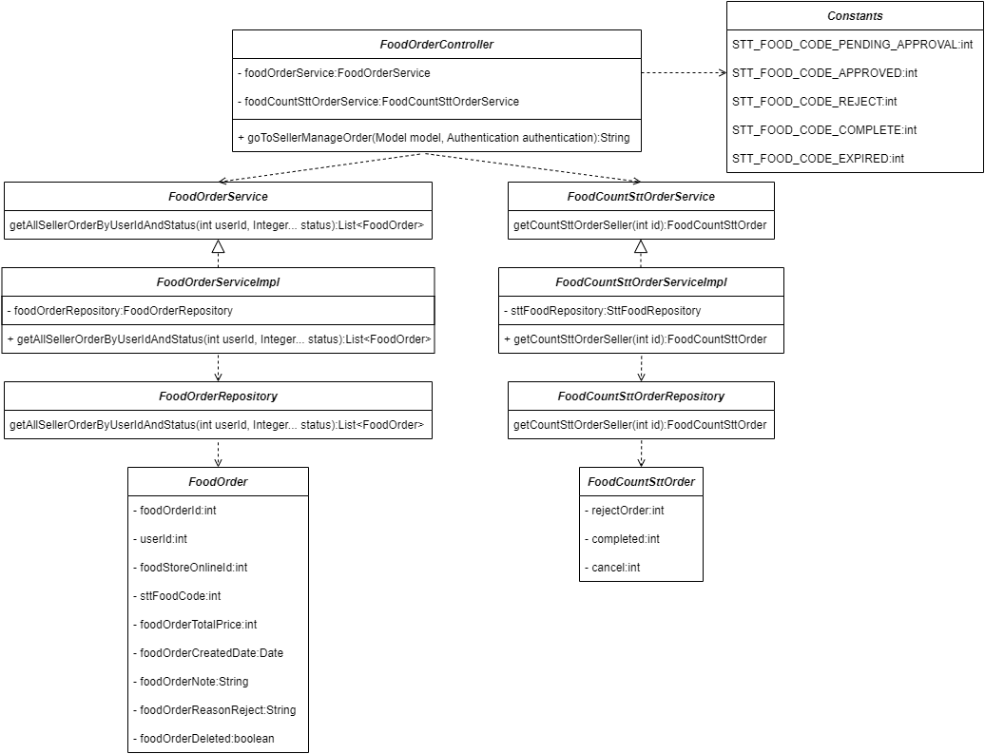

*Figure 4.86: View list seller order – Class Diagram*

##### 3.5.6.2 Sequence diagram

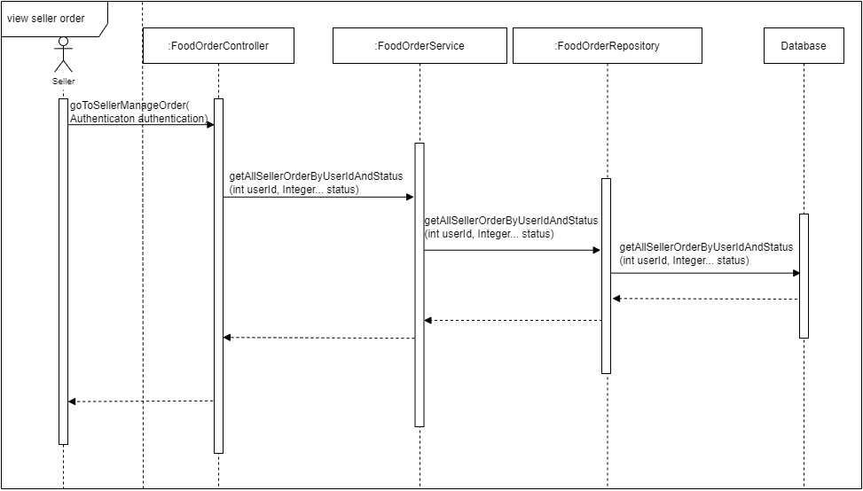

*Figure 4.87: View list seller order – Sequence Diagram*

#### 3.5.7 Reject order

##### 3.5.7.1 Class diagram

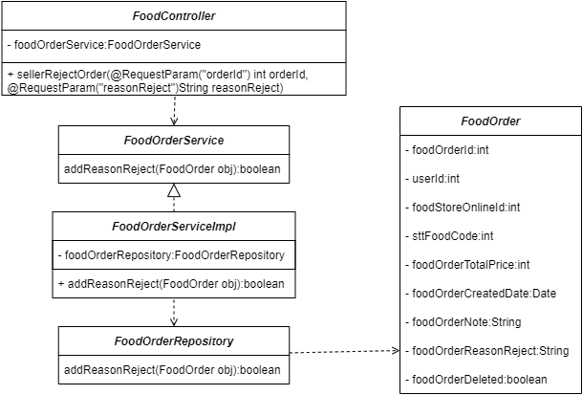

*Figure 4.88: Reject order – Class Diagram*

##### 3.5.7.2 Sequence diagram

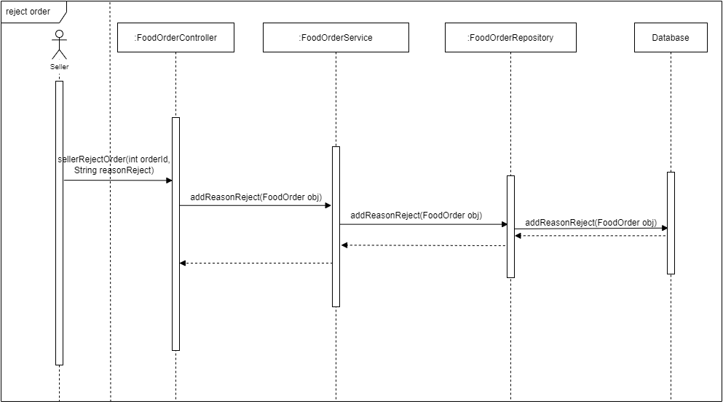

*Figure 4.89: Reject order – Sequence Diagram*

#### 3.5.8 View Data – Statistics

##### 3.5.8.1 Class diagram

*Figure 4.90: View data – statistics – Class Diagram*

##### 3.5.8.2 Sequence diagram

*Figure 4.91: View data – statistics – Sequence Diagram*

## 4. Class Specification

### 4.1 Controller

#### 4.1.1 FptUniversity Controller

##### 4.1.1.1 Class Attribute

|  |  |  |  |
| --- | --- | --- | --- |
| **No** | **Attribute** | **Data Type** | **Description** |
| 1 | clubTypeService | ClubTypeService | Using to call a method from ClubTypeService layer |
| 2 | clubService | ClubService | Using to call a method from ClubService layer |

*Table 4.3: Class Attribute – FptUniversity Controller*

##### 4.1.1.2 Class Method

|  |  |  |
| --- | --- | --- |
| **No** | **Method** | **Description** |
| 1 | goToFptUniversity(Model model) | Using to redirect FPT-university form |
| 2 | goToFptUniversityClub(Model model) | Using to get all list Club |
| 3 | getFptUniversityClubType(  @RequestParam("clubTypeId") Integer clubTypeId,Model model) | Using to get all list Club Type |
| 4 | String getFptUniversityClubDetail(  @RequestParam("clubTypeId") Integer clubTypeId,  @RequestParam("clubId") Integer clubId,  @RequestParam("page") Integer page,Model model) | Using to get Club Detail |
| 5 | setClubModel(Model model, int clubTypeId, List<ClubType> clubTypeList, List<Club> clubList, int page) | Set addtribute to model |

*Table 4.4: Class Method – FptUniversity Controller*

#### 4.1.2 Traffic Controller

##### 4.1.2.1 Class Attribute

|  |  |  |  |
| --- | --- | --- | --- |
| **No** | **Attribute** | **Data Type** | **Description** |
| 1 | busService | BusService | Using to call a method from BusService layer |
| 2 | motorbikeTaxiDriversService | MotorbikeTaxiDriversService | Using to call a method from motorbikeTaxiDriversService layer |

*Table 4.5: Class Attribute – Traffic Controller*

##### 4.1.2.2 Class Method

|  |  |  |
| --- | --- | --- |
| **No** | **Method** | **Description** |
| 1 | goToTraffic(Model model) | Using to redirect module-traffic form |
| 2 | getBusDetail() | Using to get detail of bus |
| 3 | getMotorbikeTaxiDriversDetail(@RequestParam("page") Integer page, Model model) | Using to get detail of motorbike taxi driver |
| 4 | setBusModel(Model model, List<Bus> busList, Bus busDetail, int page) | Set addtribute to model |

*Table 4.6: Class Method – Traffic Controller*

#### 4.1.3 Work Controller

##### 4.1.3.1 Class Attribute

|  |  |  |  |
| --- | --- | --- | --- |
| **No** | **Attribute** | **Data Type** | **Description** |
| 1 | workRequestRecruitment  Service | WorkRequestRecruitmentService | Using to call a method from BusService layer |
| 2 | workRequestTypeService | WorkRequestTypeService | Using to call a method from workRequestTypeService layer |
| 3 | workRequestApplyService | WorkRequestApplyService | Using to call a method from workRequestApplyService layer |
| 4 | workRequestRecruitmentSavedService | WorkRequestRecruitmentSavedService | Using to call a method from workRequestRecruitmentSavedService layer |
| 5 | workRequestFindJobService | WorkRequestFindJobService | Using to call a method from workRequestFindJobService layer |
| 6 | sttWorkService | SttWorkService | Using to call method from sttWorkService layer |

*Table 4.7: Class Attribute – Work Controller*

##### 4.1.3.2 Class Method

|  |  |  |
| --- | --- | --- |
| **No** | **Method** | **Description** |
| 1 | goToWorks(Model model) | Using to redirect module-works form |
| 2 | getWorkJobType() | Using to get list type of job |
| 3 | getJobsApply(Model model) | Using to get a list of students applying for each job |
| 4 | getJobsSave(Model model) | Using to get list job’s save of a student |
| 5 | deleteJobsApplyRequest(@RequestParam("requestId") Integer requestId, Model model) | Using to delete 1 job apply with given requestId |
| 6 | deleteJobsSaveRequest(@RequestParam("requestId") Integer requestId, Model model) | Using to delete 1 job save with given requestId |
| 7 | getWorkerList(Model model) | Using to get list worker |
| 8 | getWorkerRequestType(@RequestParam("workRequestTypeId") Integer workRequestTypeId,Model model) | Using to get list work request type |
| 9 | getJobsPosted(Model model) | Using to get list job posted |
| 10 | getJobsPostedStatus(@RequestParam("code") Integer sttWorkCode, Model model) | Using to get list status of job posted |
| 11 | getFindJobDeleteRequest(@RequestParam("requestId") Integer requestId, @RequestParam("code") Integer sttWorkCode, Model model) | Using to get list find job delete request |
| 12 | getRecruitmentsPosted(Model model) | Using to get list recruitments posted |
| 13 | getRecruitmentsPostedStatus(@RequestParam("code") Integer sttWorkCode, Model model) | Using to get list status of recruitments posted |
| 14 | getRecruitmentDeleteRequest(@RequestParam("requestId") Integer requestId, @RequestParam("code") Integer sttWorkCode, Model model) | Using to get list recruitments delete request |
| 15 | getSttCountMap(List<SttWork> sttWorkList, int userId) | Using to get count of status |
| 16 | getRequestRecruitmentDetail(@RequestParam("id") Integer id, Model model) | Using to get detail of request recruitment |
| 17 | getRequestFindJobDetail(@RequestParam("id") Integer id, Model model) | Using to get detail of request find a job |
| 18 | getFormCreateRequestFindJob(Model model) | Using to get the form to create a request find a job |
| 19 | createRequestFindJob(@ModelAttribute("newRequestFindJob") WorkRequestFindJob newRequestFindJob, BindingResult bindingResult) | Using to create request find job |
| 20 | createRequestFindJobSaveDraft( @ModelAttribute("newRequestFindJob") WorkRequestFindJob newRequestFindJob, BindingResult bindingResult) | Using to create request find job with save draft status |
| 21 | getFormCreateRequestRecruitment(Model model) | Using to get form create request recruitment |
| 22 | createRequestRecruitment(@ModelAttribute("newRequestRecruitment") WorkRequestRecruitment newRequestRecruitment, BindingResult bindingResult) | Using to create request recruitment |
| 23 | createRequestRecruitmentSaveDraft(@ModelAttribute("newRequestRecruitment") WorkRequestRecruitment newRequestRecruitment, BindingResult bindingResult) | Using to create request recruitments with save draft status |
| 24 | setAttrNewRequestRecruitment(WorkRequestRecruitment newRequestRecruitment, int userId, int sttWork) | Using to set attribute to model |
| 25 | getListApplied(Model model) | Using to get list applied |
| 26 | getListBooked(Model model) | Using to get list booked |
| 27 | getFormRepostRequestRecruitment(@RequestParam("requestId") Integer requestId, @RequestParam("code") Integer sttWorkCode, Model model) | Using to get form repost request recruitment |
| 28 | repostRequestRecruitment(  @RequestParam("endDate") Date endDate, @RequestParam("id") Integer id) | Using to repost request recruitment |
| 29 | getListUserBooked(@RequestParam("bookedId") Integer bookedId,  Model model) | Using to get list user booked |
| 30 | getListUserApplied(@RequestParam("appliedId") Integer appliedId,  Model model) | Using to get list user applied |
| 31 | getReasonRejectRecruitmentRequest(@RequestParam("requestId") Integer requestId, @RequestParam("code") Integer sttWorkCode, Model model) | Using to get reason reject recruitment request |

*Table 4.8: Class Method – Work Controller*

#### 4.1.4 Main Controller

##### 4.1.4.1 Class Attribute

|  |  |  |  |
| --- | --- | --- | --- |
| **No** | **Attribute** | **Data Type** | **Description** |
| 1 | userRepository | UserRepository | Using to call a method from UserRepository  layer |

*Table 4.9: Class Attribute – Main Controller*

##### 4.1.4.2 Class Method

|  |  |  |
| --- | --- | --- |
| **No** | **Method** | **Description** |
| 1 | logout(HttpServletRequest request, HttpServletResponse response) | Using to logout the system |

*Table 4.10: Class Method –* *Main Controller*

#### 4.1.5 Profile Controller

##### 4.1.5.1 Class Attribute

|  |  |  |  |
| --- | --- | --- | --- |
| **No** | **Attribute** | **Data Type** | **Description** |
|  | passwordEncoder | PasswordEncoder | Use method password encoder to encoder password |
|  | userRepository | UserRepository | Using to call a method from UserRepository  layer |
|  | roleRepository | RoleRepository | Using to call a method from RoleRepository  layer |
|  | userDetailService | userDetailService | Using to call a method from userDetailService  layer |
|  | userAddressService | UserAddressService | Using to call a method from UserAddressService  layer |

*Table 4.11: Class Attribute –* *Profile Controller*

##### 4.1.5.2 Class Method

|  |  |  |
| --- | --- | --- |
| **No** | **Method** | **Description** |
| 1 | profile(Model model, Authentication authentication) | Using to get all profile of User and return profile screen |
| 2 | profileUpdate(Model model, Authentication authentication) | Using to redirect to profile update screen |
| 3 | updateProfileUserByUserId(  @ModelAttribute("updateUser") UserDetail updateUser, BindingResult bindingResult, Authentication authentication) | Using to update profile of User by UserId |
| 4 | updatePasswordUserByUserId(@RequestParam("oldPass") String oldPass, @RequestParam("newPass") String newPass, @RequestParam("confirmNewPass") String confirmNewPass, Authentication authentication) | Using to update password by UserId |
| 5 | addressUpdate(Model model, Authentication authentication) | Using to redirect update address screen |
| 6 | updateUserAddress(@RequestParam("addressId") int addressId, @RequestParam("userName") String userName, @RequestParam("phone") String phone, @RequestParam("address") String address) | Using to update user address |
| 7 | addNewUserAddress(@RequestParam("newUserName") String newUserName, @RequestParam("newPhone") String newPhone, @RequestParam("newAddress") String newAddress, Authentication authentication) | Using to add new address |
| 8 | deleteUserAddress(@RequestParam("addressId") int addressId) | Using to delete address of user |
| 9 | changeUserAddressDefault(@RequestParam("addressId") int addressId, Authentication authentication) | Using to set address default |

*Table 4.12: Class Method – Profile Controller*

#### 4.1.6 Food Controller

##### 4.1.6.1 Class Attribute

|  |  |  |  |
| --- | --- | --- | --- |
| **No** | **Attribute** | **Data Type** | **Description** |
| 1 | foodStoreOnlineService | FoodStoreOnlineService | Using to call a method from FoodStoreOnlineService layer |
| 2 | foodTypeService | FoodTypeService | Using to call method from FoodTypeService layer |
| 3 | foodTagService | FoodTagService | Using to call method from FoodTagService layer |

*Table 4.13: Class Attribute – Food Controller*

##### 4.1.6.2 Class Method

|  |  |  |
| --- | --- | --- |
| **No** | **Method** | **Description** |
| 1 | goToFood(Model model) | Using to redirect module-food form |
| 2 | getFoodsByType(@RequestParam("typeId") Integer typeId, Model model) | Using to get all food items by typeId |
| 3 | goToOnlineStore(@RequestParam("id") Integer id, Model model) | Using to redirect module-food-store-online form |
| 4 | getFoodDetail(RequestParam("id") Integer id,@RequestParam("itemId") Integer itemId,@RequestParam("tagId") Integer tagId,Model model) | Using to get detail of food |
| 5 | addAttrStoreOnline(int id, int tagId, int page,Model model) | Using to set the attribute to the model |
| 6 | goToOfflineStore(Model model) | Using to redirect module-food-store-offline form |
| 7 | goToUserOrder(Model model) | Using to redirect module-food-user-order form |
| 8 | goToManageStore(Model model) | Using to redirect module-food-manage-store form |

*Table 4.14: Class Method – Food Controller*

#### 4.1.7 FoodCart Controller

##### 4.1.7.1 Class Attribute

|  |  |  |  |
| --- | --- | --- | --- |
| **No** | **Attribute** | **Data Type** | **Description** |
| 1 | foodItemService | FoodItemService | Using to call a method from FoodItemService  layer |

*Table 4.15: Class Attribute – FoodCart Controller*

##### 4.1.7.2 Class Method

|  |  |  |
| --- | --- | --- |
| **No** | **Method** | **Description** |
| 1 | goToCart(Model model) | Using to redirect add-to-cart screen |
| 2 | addToCart(RequestParam("foodId") int foodId, @RequestParam("storeId") int storeId, HttpSession session) | Using to add to cart when user add food items to buy it |
| 3 | countQuantity(List<FoodItemCart> listFoodOrder) | Using to count quantity of order |
| 4 | getTotalMoney(List<FoodItemCart> listFoodOrder) | Using to get total money of order |
| 5 | deleteCart(Model model, HttpSession session) | Using to delete cart |

*Table 4.16: Class Method – FoodCart Controller*

#### 4.1.8 FoodManageStore Controller

##### 4.1.8.1 Class Attribute

|  |  |  |  |
| --- | --- | --- | --- |
| **No** | **Attribute** | **Data Type** | **Description** |
| 1 | foodStoreOnlineService | FoodStoreOnlineService | Using to call a method from FoodStoreOnlineService  layer |
| 2 | foodTagService | FoodTagService | Using to call a method from FoodTagService  layer |
| 3 | foodItemService | FoodItemService | Using to call a method from FoodItemService  layer |
| 4 | foodStoreOnlineTagService | FoodStoreOnlineTagService | Using to call a method from FoodStoreOnlineTagService layer |

*Table 4.17: Class Attribute – FoodCart Controller*

##### 4.1.8.2 Class Method

|  |  |  |
| --- | --- | --- |
| **No** | **Method** | **Description** |
| 1 | getShopInfo(Model model, Authentication authentication) | Using to get store information |
| 2 | updatingShopInfo(@RequestParam("storeId") Integer shopId, @RequestParam("storeName") String shopName, @RequestParam("storeDescription") String storeDescription) | Using to update store information |
| 3 | manageFood(Model model, Authentication authentication) | Using to redirect to manage Food screen |
| 4 | getFormUpdateStoreTag(Model model, Authentication authentication) | Using to get form update store tag |
| 5 | updateStoreTag(Model model, @RequestParam(value = "tagList") List<Integer> tagList, Authentication authentication) | Using to update store tag |
| 6 | statistics(Model model) | Using to redirect data-statistics screen |
| 7 | saveImageFood(Model model, @RequestParam("imageFood") MultipartFile multipartFile, @ModelAttribute("foodItem") FoodItem foodItem, BindingResult bindingResult, Authentication authentication) | Using to add food item to store |
| 8 | updateFoodItem(@RequestParam("foodItemId") Integer foodItemId,  @RequestParam("imageFood") MultipartFile multipartFile, @RequestParam("foodItemName") String foodItemName, @RequestParam("foodItemPrice") Integer foodItemPrice, @RequestParam("foodTagId") Integer foodTagId) | Using to update food items |
| 9 | deleteFoodManagerStore(@RequestParam("foodId") Integer foodId) | Using to delete food items |

*Table 4.18: Class Method – FoodCart Controller*

#### 4.1.9 FoodOrder Controller

##### 4.1.9.1 Class Attribute

|  |  |  |  |
| --- | --- | --- | --- |
| **No** | **Attribute** | **Data Type** | **Description** |
| 1 | foodStoreOnlineService | FoodStoreOnlineService | Using to call a method from FoodStoreOnlineService  layer |
| 2 | foodCountSttOrderService | FoodCountSttOrderService | Using to call a method from FoodCountSttOrderService  layer |
| 3 | userAddressService | UserAddressService | Using to call a method from UserAddressService  layer |
| 4 | foodOrderService | FoodOrderService | Using to call a method from FoodOrderService  layer |
| 5 | foodOrderDetailService | FoodOrderDetailService | Using to call a method from FoodOrderDetailService  layer |
| 6 | foodReportService | FoodReportService | Using to call a method from FoodReportService  layer |

*Table 4.19: Class Attribute – FoodCart Controller*

##### 4.1.9.2 Class Method

|  |  |  |
| --- | --- | --- |
| **No** | **Method** | **Description** |
| 1 | goToUserOrder(Model model, Authentication authentication) | Using to redirect to user order screen |
| 2 | getUserOrderByType(@RequestParam("sttCode") Integer sttCode, Model model, Authentication authentication) | Using to get all order of user by type |
| 3 | getUserOrderDetail(RequestParam("orderId") Integer orderId, @RequestParam("sttCode") Integer sttCode, @RequestParam("orderStatus") Integer orderStatus, Model model, Authentication authentication) | Using to get detail of order |
| 4 | addAttrUserOrder(int sttCode, Model model, Authentication authentication) | Using to add attribute to user order screen |
| 5 | goToSellerManageOrder(Model model, Authentication authentication) | Using to redirect manage order screen of seller |
| 6 | getSellerOrderDetail(@RequestParam("orderId") Integer orderId, @RequestParam("sttCode") Integer sttCode, @RequestParam("orderStatus") Integer orderStatus, Model model, Authentication authentication) | Using to get detail order of manage order screen |
| 7 | addAttrSellerOrder(int sttCode, Model model, Authentication authentication) | Using to add attribute to seller order screen |
| 8 | userReportOrder(@RequestParam("foodStoreOnlineId") int storeId, @RequestParam("foodOrderId") int orderId, @RequestParam("reportContent") String content, Authentication authentication) | Using to report order |
| 9 | sellerRejectOrder(RequestParam("orderId") int orderId, @RequestParam("reasonReject") String reasonReject) | Using to reject order by seller |
| 10 | userDeleteReportOrder(@RequestParam("reportId") int reportId) | Using to delete report order |
| 11 | userCancelOrder(@RequestParam("orderId") Integer foodOrderId) | Using to cancel order by user |
| 12 | sellerConfirmOrder(@RequestParam("orderId") Integer orderId) | Using to confirm order by seller |
| 13 | sellerConfirmCompleteOrder(@RequestParam("orderId") Integer orderId) | Using to cofirm complete order by seller |

*Table 4.20: Class Method – FoodCart Controller*

#### 4.1.10 FoodStore Controller

##### 4.1.10.1 Class Attribute

|  |  |  |  |
| --- | --- | --- | --- |
| **No** | **Attribute** | **Data Type** | **Description** |
| 1 | foodStoreOnlineService | FoodStoreOnlineService | Using to call a method from FoodStoreOnlineService  layer |
| 2 | foodTagService | FoodTagService | Using to call a method from FoodTagService layer |
| 3 | foodItemService | FoodItemService | Using to call a method from FoodItemService  layer |
| 4 | foodOrderService | FoodOrderService | Using to call a method from FoodOrderService  layer |
| 5 | foodOrderDetailService | FoodOrderDetailService | Using to call a method from FoodOrderDetailService  layer |
| 6 | foodReportService | FoodReportService | Using to call a method from FoodReportService  layer |
| 7 | foodStoreOnlineRateService | FoodStoreOnlineRateService | Using to call a method from FoodStoreOnlineRateService  layer |
| 8 | userDetailService | UserDetailService | Using to call a method from UserDetailService  layer |

*Table 4.21: Class Attribute – FoodStore Controller*

##### 4.1.10.2 Class Method

|  |  |  |
| --- | --- | --- |
| **No** | **Method** | **Description** |
| 1 | goToOnlineStore(@RequestParam("id") Integer id, Model model) | Using to redirect store screen |
| 2 | isExitsOrder(@RequestParam("storeId") Integer storeId, Authentication authentication) | Using to check exit order |
| 3 | getUserRated(@RequestParam("storeId") Integer storeId, Authentication authentication) | Using to get rate of user |
| 4 | rate(@ModelAttribute("rate") FoodStoreOnlineRate rate, BindingResult bindingResult, Authentication authentication) | Using to rate store |
| 5 | getFoodOrderDetailReport(@RequestParam("orderId") Integer orderId, Model model) | Using to get report of detail order |
| 6 | getFoodOnlineStoreByTag(@RequestParam("storeId") Integer storeId, @RequestParam("tagId") Integer tagId, Model model) | Using to get list store by tagId |
| 7 | addAttrStoreOnline(FoodStoreOnline foodStoreOnline, int tagId, int page, Model model) | Using to add attribute to store screen |

*Table 4.22: Class Method – FoodStore Controller*

#### 4.1.11 Search Controller

##### 4.1.11.1 Class Attribute

|  |  |  |  |
| --- | --- | --- | --- |
| **No** | **Attribute** | **Data Type** | **Description** |
| 1 | foodItemService | FoodItemService | Using to call a method from FoodItemService  layer |
| 2 | foodTagService | FoodTagService | Using to call a method from FoodTagService  layer |

*Table 4.23: Class Attribute – Search Controller*

##### 4.1.11.2 Class Method

|  |  |  |
| --- | --- | --- |
| **No** | **Method** | **Description** |
| 1 | search(Model model, @RequestParam("textSearch") String textSearch) | Using to search by textSearch |
| 2 | searchFood(Model model) | Using to redirect search food screen |

*Table 4.24: Class Method – Search Controller*

### 4.2 Service

#### 4.2.1 Module Work

##### 4.2.1.1 SttWorkRequestRecruitmentFindJobCountService

|  |  |  |
| --- | --- | --- |
| **No** | **Method** | **Description** |
| 1 | getOneByUserId(int userId) | Using to get one count of status work request recruitment to find a job by userId from database |

*Table 4.25:SttWorkRequestRecruitmentFindJobCountService Class Specification*

##### 4.2.1.2 SttWorkService

|  |  |  |
| --- | --- | --- |
| **No** | **Method** | **Description** |
| 1 | getAll() | Using to get all status work from a database |
| 2 | getAllByName(String name) | Using to get one status work by name from the database |
| 3 | getOne(int id) | Using to get one status work by id from database |

*Table 4.26:* *SttWorkService Class Specification*

##### 4.2.1.3 WorkCommentService

|  |  |  |
| --- | --- | --- |
| **No** | **Method** | **Description** |
| 1 | getAll() | Using to get all work comments from the database |

*Table 4.27: WorkCommentService Class Specification*

##### 4.2.1.4 WorkPaymentMethodService

|  |  |  |
| --- | --- | --- |
| **No** | **Method** | **Description** |
| 1 | getAll() | Using to get all work payment methods from database |
| 2 | getOne(int id) | Using to get one work payment method by id from database |

*Table 4.28: WorkPaymentMethodService Class Specification*

##### 4.2.1.5 WorkReportReasonService

|  |  |  |
| --- | --- | --- |
| **No** | **Method** | **Description** |
| 1 | getAll() | Using to get all work report reason from database |
| 2 | getOne(int id) | Using to get one work report reason by id from database |

*Table 4.29:* *WorkReportReasonService Class Specification*

##### 4.2.1.6 WorkReportService

|  |  |  |
| --- | --- | --- |
| **No** | **Method** | **Description** |
| 1 | getAll() | Using to get all work report from database |

*Table 4.30: WorkReportService Class Specification*

##### 4.2.1.7 WorkRequestApplyService

|  |  |  |
| --- | --- | --- |
| **No** | **Method** | **Description** |
| 1 | getAll() | Using to get all work requests to applied from database |
| 2 | getAllAccountId(int accountId) | Using to get all accountId by accountId from database |
| 3 | getOne(int id) | Using to get one work request to apply by id from database |
| 4 | save(WorkRequestApply obj) | Using to update work request apply and save to database |
| 5 | delete(int id) | Using to delete work request apply with given Id |

*Table 4.31: WorkRequestApplyService Class Specification*

##### 4.2.1.8 WorkRequestBookService

|  |  |  |
| --- | --- | --- |
| **No** | **Method** | **Description** |
| 1 | getAll() | Using to get all work request book from a database |
| 2 | getOne(int id) | Using to get one work request book by id from database |
| 3 | save(WorkRequestBook obj) | Using to update work request apply and save to database |

*Table 4.32: WorkRequestBookService Class Specification*

##### 4.2.1.9 WorkRequestFindJobService

|  |  |  |
| --- | --- | --- |
| **No** | **Method** | **Description** |
| 1 | getAll() | Using to get all work requests to find job from database |
| 2 | getOne(int id) | Using to get one work request find a job by id from database |
| 3 | getAllByType(int typeId, int code) | Using to get all work requests to find a job by type from database |
| 4 | getAllByUserIdAndTypeId(int id, Integer... typeId) | Using to get all userId and typeId of work request find job from database |
| 5 | getAllListRecruitmentByUserId (int userId, int sttWorkCode) | Using to get all list recruitment by userId from database |
| 6 | save(WorkRequestFindJob obj) | Using to update work request find a job and save to database |
| 7 | delete(int id) | Using to delete work request find a job with given Id |

*Table 4.33:* *WorkRequestFindJobService Class Specification*

##### 4.2.1.10 WorkRequestRecruitmentSavedService

|  |  |  |
| --- | --- | --- |
| **No** | **Method** | **Description** |
| 1 | getAll() | Using to get all work request recruitment saved from the database |
| 2 | getAllAccountId(int accountId) | Using to get all userId of work requests to find a job by userId from database |
| 3 | getOne(int id) | Using to get one work request recruitment saved by id from database |
| 4 | save(WorkRequestApply obj) | Using to update work request recruitment saved and save to database |
| 5 | delete(int id) | Using to delete work request recruitment saved with given Id |

*Table 4.34:* *WorkRequestRecruitmentSavedService Class Specification*

##### 4.2.1.11 WorkRequestRecruitmentService

|  |  |  |
| --- | --- | --- |
| **No** | **Method** | **Description** |
| 1 | getAll() | Using to get all work request recruitment from database |
| 2 | getOne(int id) | Using to get one work request recruitment by id from database |
| 3 | getAllByType(int typeId, int code) | Using to get all work request recruitment by type from database |
| 4 | getAllByUserIdAndTypeId(int id, Integer... typeId) | Using to get all userId and typeId of work request recruitment from database |
| 5 | getAllListAppliedByUserId (int userId, int sttWorkCode) | Using to get all list applied by userId from database |
| 6 | save(WorkRequestFindJob obj) | Using to update work request recruitment and save to database |
| 7 | delete(int id) | Using to delete work request recruitment with given Id |

*Table 4.35: WorkRequestRecruitmentService Class Specification*

##### 4.2.1.12 WorkRequestTypeService

|  |  |  |
| --- | --- | --- |
| **No** | **Method** | **Description** |
| 1 | getAll() | Using to get all work request types from the database |
| 2 | getOne(int id) | Using to get one work request type by id from database |

*Table 4.36: WorkRequestTypeService Class Specification*

##### 4.2.1.13 WorkSalaryUnitService

|  |  |  |
| --- | --- | --- |
| **No** | **Method** | **Description** |
| 1 | getAll() | Using to get all work salary unit from database |
| 2 | getOne(int id) | Using to get one work salary unit by id from database |

*Table 4.37:* *WorkSalaryUnitService Class Specification*

##### 4.2.1.14 WorkTimeService

|  |  |  |
| --- | --- | --- |
| **No** | **Method** | **Description** |
| 1 | getAll() | Using to get all work time from the database |
| 2 | getOne(int id) | Using to get one work time by id from database |

*Table 4.38:* *WorkTimeService Class Specification*

#### 4.2.2 Module Food

##### 4.2.2.1 FoodItemService

|  |  |  |
| --- | --- | --- |
| **No** | **Method** | **Description** |
| 1 | getAll() | Using to get all food items from the database |
| 2 | getOne(int id) | Using to get one food item by id from database |

*Table 4.39: FoodItemService Class Specification*

##### 4.2.2.2 FoodOrderDetailService

|  |  |  |
| --- | --- | --- |
| **No** | **Method** | **Description** |
| 1 | getAll() | Using to get all detail order food from database |
| 2 | getOne(int id) | Using to get one detail order food by id from database |

*Table 4.40: FoodOrderDetailService Class Specification*

##### 4.2.2.3 FoodOrderService

|  |  |  |
| --- | --- | --- |
| **No** | **Method** | **Description** |
| 1 | getAll() | Using to get all food orders from the database |
| 2 | getOne(int id) | Using to get one food order by id from database |

*Table 4.41:* *FoodOrderService Class Specification*

##### 4.2.2.4 FoodStoreOnlineRateService

|  |  |  |
| --- | --- | --- |
| **No** | **Method** | **Description** |
| 1 | getAll() | Using to get all food store online rate from the database |
| 2 | getOne(int id) | Using to get one food store online rate by id from database |

*Table 4.42:* *FoodStoreOnlineRateService Class Specification*

##### 4.2.2.5 FoodStoreOnlineService

|  |  |  |
| --- | --- | --- |
| **No** | **Method** | **Description** |
| 1 | getAll() | Using to get all food store online from the database |
| 2 | getOne(int id) | Using to get one food store online by id from database |

*Table 4.43: FoodStoreOnlineService Class Specification*

##### 4.2.2.6 FoodStoreOnlineTagService

|  |  |  |
| --- | --- | --- |
| **No** | **Method** | **Description** |
| 1 | getAll() | Using to get all food store online tag from the database |
| 2 | getOne(int id) | Using to get one food store online tag by id from database |

*Table 4.44:* *FoodStoreOnlineTagService Class Specification*

##### 4.2.2.7 FoodStoreOnlineTypeService

|  |  |  |
| --- | --- | --- |
| **No** | **Method** | **Description** |
| 1 | getAll() | Using to get all food store online type from database |
| 2 | getOne(int id) | Using to get one food store online type by id from database |

*Table 4.45:* *FoodStoreOnlineTypeService Class Specification*

##### 4.2.2.8 FoodStoreTypeService

|  |  |  |
| --- | --- | --- |
| **No** | **Method** | **Description** |
| 1 | getAll() | Using to get all food store types from the database |
| 2 | getOne(int id) | Using to get one food store type by id from database |

*Table 4.46:* *FoodStoreTypeService Class Specification*

##### 4.2.2.9 FoodTagService

|  |  |  |
| --- | --- | --- |
| **No** | **Method** | **Description** |
| 1 | getAll() | Using to get all food from database |
| 2 | getOne(int id) | Using to get one food tag by id from database |

*Table 4.47:* *FoodTagService Class Specification*

##### 4.2.2.10 FoodTypeService

|  |  |  |
| --- | --- | --- |
| **No** | **Method** | **Description** |
| 1 | getAll() | Using to get all food types from the database |
| 2 | getOne(int id) | Using to get one food type by id from database |

*Table 4.48:* *FoodTypeService Class Specification*

##### 4.2.2.11 SttFoodService

|  |  |  |
| --- | --- | --- |
| **No** | **Method** | **Description** |
| 1 | getAll() | Using to get all status of food from database |
| 2 | getOne(int id) | Using to get one status of food by id from database |

*Table 4.49: SttFoodService Class Specification*

#### 4.2.3 Module FPT University

##### 4.2.3.1 ClubService

|  |  |  |
| --- | --- | --- |
| **No** | **Method** | **Description** |
| 1 | getAll() | Using to get all club from database |
| 2 | getOne(int id) | Using to get one club by id from database |

*Table 4.50:* *ClubService Class Specification*

##### 4.2.3.2 ClubTypeService

|  |  |  |
| --- | --- | --- |
| **No** | **Method** | **Description** |
| 1 | getAll() | Using to get all club types from the database |
| 2 | getOne(int id) | Using to get one club type by id from database |

*Table 4.51:* *ClubTypeService Class Specification*

#### 4.2.4 Module Traffic

##### 4.2.4.1 BusService

|  |  |  |
| --- | --- | --- |
| **No** | **Method** | **Description** |
| 1 | getAll() | Using to get all buses from database |
| 2 | getOne(int id) | Using to get one bus by id from database |

*Table 4.52: BusService Class Specification*

##### 4.2.4.2 MotorbikeTaxiDriversService

|  |  |  |
| --- | --- | --- |
| **No** | **Method** | **Description** |
| 1 | getAll() | Using to get all motorbike taxi driver from database |
| 2 | getOne(int id) | Using to get one motorbike taxi driver by id from database |

*Table 4.53:* *MotorbikeTaxiDriversService Class Specification*

### 4.3 Repository

#### 4.3.1 Module Work

##### 4.3.1.1 SttWorkRequestRecruitmentFindJobCountRepository

|  |  |  |
| --- | --- | --- |
| **No** | **Method** | **Description** |
| 1 | getOneByUserId(int userId) | Using to get one count of status work request recruitment to find a job by userId |

*Table 4.54: SttWorkRequestRecruitmentFindJobCountRepository Class Specification*

##### 4.3.1.2 SttWorkRepository

|  |  |  |
| --- | --- | --- |
| **No** | **Method** | **Description** |
| 1 | getAll() | Using to get all status work |
| 2 | getAllByName(String name) | Using to get one status work by name |
| 3 | getOne(int id) | Using to get one status work by id |

*Table 4.55:* *SttWorkRepository Class Specification*

##### 4.3.1.3 WorkCommentRepository

|  |  |  |
| --- | --- | --- |
| **No** | **Method** | **Description** |
| 1 | getAll() | Using to get all work comment |

*Table 4.56:* *WorkCommentRepository Class Specification*

##### 4.3.1.4 WorkPaymentMethodRepository

|  |  |  |
| --- | --- | --- |
| **No** | **Method** | **Description** |
| 1 | getAll() | Using to get all work payment method |
| 2 | getOne(int id) | Using to get one work payment method by id |

*Table 4.57: WorkPaymentMethodRepository Class Specification*

##### 4.3.1.5 WorkReportReasonRepository

|  |  |  |
| --- | --- | --- |
| **No** | **Method** | **Description** |
| 1 | getAll() | Using to get all work report reason |
| 2 | getOne(int id) | Using to get one work report reason by id |

*Table 4.58:* *WorkReportReasonRepository Class Specification*

##### 4.3.1.6 WorkReportRepository

|  |  |  |
| --- | --- | --- |
| **No** | **Method** | **Description** |
| 1 | getAll() | Using to get all work report |

*Table 4.59: WorkReportRepository Class Specification*

##### 4.3.1.7 WorkRequestApplyRepository

|  |  |  |
| --- | --- | --- |
| **No** | **Method** | **Description** |
| 1 | getAll() | Using to get all work requests to apply |
| 2 | getAllAccountId(int accountId) | Using to get all accountId by accountId |
| 3 | getOne(int id) | Using to get one work request to apply by id |
| 4 | save(WorkRequestApply obj) | Using to update work requests apply |
| 5 | delete(int id) | Using to delete work request apply with given Id |

*Table 4.60: WorkRequestApplyRepository Class Specification*

##### 4.3.1.8 WorkRequestBookRepository

|  |  |  |
| --- | --- | --- |
| **No** | **Method** | **Description** |
| 1 | getAll() | Using to get all work request book |
| 2 | getOne(int id) | Using to get one work request book by id |
| 3 | save(WorkRequestBook obj) | Using to update work requests apply |

*Table 4.61: WorkRequestBookRepository Class Specification*

##### 4.3.1.9 WorkRequestFindJobRepository

|  |  |  |
| --- | --- | --- |
| **No** | **Method** | **Description** |
| 1 | getAll() | Using to get all work requests to find a job |
| 2 | getOne(int id) | Using to get one work request find a job by id |
| 3 | getAllByType(int typeId, int code) | Using to get all work requests to find a job by type |
| 4 | getAllByUserIdAndTypeId(int id, Integer... typeId) | Using to get all userId and typeId of work request find job |
| 5 | getAllListRecruitmentByUserId (int userId, int sttWorkCode) | Using to get all list recruitment by userId |
| 6 | save(WorkRequestFindJob obj) | Using to update work request find a job |
| 7 | delete(int id) | Using to delete work request find a job with given Id |

*Table 4.62:* *WorkRequestFindJobRepository Class Specification*

##### 4.3.1.10 WorkRequestRecruitmentSavedRepository

|  |  |  |
| --- | --- | --- |
| **No** | **Method** | **Description** |
| 1 | getAll() | Using to get all work request recruitment saved |
| 2 | getAllAccountId(int accountId) | Using to get all userId of work request find a job by userId |
| 3 | getOne(int id) | Using to get one work request recruitment saved by id |
| 4 | save(WorkRequestApply obj) | Using to update work request recruitment saved |
| 5 | delete(int id) | Using to delete work request recruitment saved with given Id |

*Table 4.63: WorkRequestRecruitmentSavedRepository Class Specification*

##### 4.3.1.11 WorkRequestRecruitmentRepository

|  |  |  |
| --- | --- | --- |
| **No** | **Method** | **Description** |
| 1 | getAll() | Using to get all work request recruitment |
| 2 | getOne(int id) | Using to get one work request recruitment by id |
| 3 | getAllByType(int typeId, int code) | Using to get all work request recruitment by type |
| 4 | getAllByUserIdAndTypeId(int id, Integer... typeId) | Using to get all userId and typeId of work request recruitment |
| 5 | getAllListAppliedByUserId (int userId, int sttWorkCode) | Using to get all list applied by userId |
| 6 | save(WorkRequestFindJob obj) | Using to update work request recruitment |
| 7 | delete(int id) | Using to delete work request recruitment with given Id |

*Table 4.64: WorkRequestRecruitmentRepository Class Specification*

##### 4.3.1.12 WorkRequestTypeRepository

|  |  |  |
| --- | --- | --- |
| **No** | **Method** | **Description** |
| 1 | getAll() | Using to get all work request type |
| 2 | getOne(int id) | Using to get one work request type by id |

*Table 4.65: Class Specification*

##### 4.3.1.13 WorkSalaryUnitRepository

|  |  |  |
| --- | --- | --- |
| **No** | **Method** | **Description** |
| 1 | getAll() | Using to get all work salary unit |
| 2 | getOne(int id) | Using to get one work salary unit by id |

*Table 4.66:* *WorkRequestRecruitmentRepository Class Specification*

##### 4.3.1.14 WorkTimeRepository

|  |  |  |
| --- | --- | --- |
| **No** | **Method** | **Description** |
| 1 | getAll() | Using to get all work time |
| 2 | getOne(int id) | Using to get one work time by id |

*Table 4.67:* *WorkTimeRepository Class Specification*

#### 4.3.2 Module Food

##### 4.3.2.1 FoodItemRepository

|  |  |  |
| --- | --- | --- |
| **No** | **Method** | **Description** |
| 1 | getAll() | Using to get all food item |
| 2 | getOne(int id) | Using to get one food item by id |

*Table 4.68: FoodItemRepository Class Specification*

##### 4.3.2.2 FoodOrderDetailRepository

|  |  |  |
| --- | --- | --- |
| **No** | **Method** | **Description** |
| 1 | getAll() | Using to get all detail order food |
| 2 | getOne(int id) | Using to get one detail order food by id |

*Table 4.69:* *FoodOrderDetailRepository Class Specification*

##### 4.3.2.3 FoodOrderRepository

|  |  |  |
| --- | --- | --- |
| **No** | **Method** | **Description** |
| 1 | getAll() | Using to get all food orders |
| 2 | getOne(int id) | Using to get one food order by id |

*Table 4.70:* *FoodOrderRepository Class Specification*

##### 4.3.2.4 FoodStoreOnlineRateRepository

|  |  |  |
| --- | --- | --- |
| **No** | **Method** | **Description** |
| 1 | getAll() | Using to get all food store online rate |
| 2 | getOne(int id) | Using to get one food store online rate by id |

*Table 4.71: FoodStoreOnlineRateRepository Class Specification*

##### 4.3.2.5 FoodStoreOnlineRepository

|  |  |  |
| --- | --- | --- |
| **No** | **Method** | **Description** |
| 1 | getAll() | Using to get all food stores online |
| 2 | getOne(int id) | Using to get one food store online by id |

*Table 4.72:* *FoodStoreOnlineRepository Class Specification*

##### 4.3.2.6 FoodStoreOnlineTagRepository

|  |  |  |
| --- | --- | --- |
| **No** | **Method** | **Description** |
| 1 | getAll() | Using to get all food store online tag |
| 2 | getOne(int id) | Using to get one food store online tag by id |

*Table 4.73: FoodStoreOnlineTagRepository Class Specification*

##### 4.3.2.7 FoodStoreOnlineTypeRepository

|  |  |  |
| --- | --- | --- |
| **No** | **Method** | **Description** |
| 1 | getAll() | Using to get all food store online type |
| 2 | getOne(int id) | Using to get one food store online type by id |

*Table 4.74:* *FoodStoreOnlineTypeRepository Class Specification*

##### 4.3.2.8 FoodStoreTypeRepository

|  |  |  |
| --- | --- | --- |
| **No** | **Method** | **Description** |
| 1 | getAll() | Using to get all food store type |
| 2 | getOne(int id) | Using to get one food store type by id |

*Table 4.75:* *FoodStoreTypeRepository Class Specification*

##### 4.3.2.9 FoodTagRepository

|  |  |  |
| --- | --- | --- |
| **No** | **Method** | **Description** |
| 1 | getAll() | Using to get all food |
| 2 | getOne(int id) | Using to get one food tag by id |

*Table 4.76:* *FoodTagRepository Class Specification*

##### 4.3.2.10 FoodTypeRepository

|  |  |  |
| --- | --- | --- |
| **No** | **Method** | **Description** |
| 1 | getAll() | Using to get all food type |
| 2 | getOne(int id) | Using to get one food type by id |

*Table 4.77:* *FoodTypeRepository Class Specification*

##### 4.3.2.11 SttFoodRepository

|  |  |  |
| --- | --- | --- |
| **No** | **Method** | **Description** |
| 1 | getAll() | Using to get all status of food |
| 2 | getOne(int id) | Using to get one status of food by id |

*Table 4.78: SttFoodRepository Class Specification*

#### 4.3.3 Module FPT University

##### 4.3.3.1 ClubRepository

|  |  |  |
| --- | --- | --- |
| **No** | **Method** | **Description** |
| 1 | getAll() | Using to get all club |
| 2 | getOne(int id) | Using to get one club by id |

*Table 4.79: ClubRepository Class Specification*

##### 4.3.3.2 ClubTypeRepository

|  |  |  |
| --- | --- | --- |
| **No** | **Method** | **Description** |
| 1 | getAll() | Using to get all club type |
| 2 | getOne(int id) | Using to get one club type by id |

*Table 4.80: ClubTypeRepository Class Specification*

#### 4.3.4 Module Traffic

##### 4.3.4.1 BusRepository

|  |  |  |
| --- | --- | --- |
| **No** | **Method** | **Description** |
| 1 | getAll() | Using to get all bus |
| 2 | getOne(int id) | Using to get one bus by id |

*Table 4.81: BusRepository Class Specification*

##### 4.3.4.2 MotorbikeTaxiDriversRepository

|  |  |  |
| --- | --- | --- |
| **No** | **Method** | **Description** |
| 1 | getAll() | Using to get all motorbike taxi driver |
| 2 | getOne(int id) | Using to get one motorbike taxi driver by id |

*Table 4.82: MotorbikeTaxiDriversRepository Class Specification*

### 4.4 Entity

#### 4.4.1 Module Work

##### 4.4.1.1 SttWork

|  |  |  |  |
| --- | --- | --- | --- |
| **No** | **Attribute** | **Data Type** | **Description** |
| 1 | sttWorkId | Int | Id of status work |
| 2 | sttWorkName | String | Name of status work |
| 3 | sttWorkCode | Int | Code of status work |
| 4 | sttWorkValue | String | Info of status work |
| 5 | sttWorkIcon | String | Icon of status work format by awesome font |

*Table 4.83: SttWork Class Specification*

##### 4.4.1.2 SttWorkRequestRecruitmentFindJobCount

|  |  |  |  |
| --- | --- | --- | --- |
| **No** | **Attribute** | **Data Type** | **Description** |
| 1 | sttWorkRequestRecruitmentFindJobCountId | Int | Id of status work request recruitment find job count |
| 2 | userId | Int | Id of user |
| 3 | sttWorkRequestRecruitmentFindJobCount  Pending | Int | Value pending of status work request recruitment find job count |
| 4 | sttWorkRequestRecruitmentFindJobCountReject | Int | Value reject of status work request recruitment find job count |
| 5 | sttWorkRequestRecruitmentFindJobCountApproved | Int | Value approved of status work request recruitment find job count |
| 6 | sttWorkRequestRecruitmentFindJobCountComplete | Int | Value complete of status work request recruitment find job count |
| 7 | sttWorkRequestRecruitmentFindJobCountExpired | Int | Value expired of status work request recruitment find job count |
| 8 | sttWorkRequestRecruitmentFindJobCountSaveDraft | Int | Value save a draft of status work request recruitment find job count |

*Table 4.84:* *SttWorkRequestRecruitmentFindJobCount Class Specification*

##### 4.4.1.3 WorkComment

|  |  |  |  |
| --- | --- | --- | --- |
| **No** | **Attribute** | **Data Type** | **Description** |
| 1 | workCommentId | Int | Id of work comment |
| 2 | workRequestRecruitmentId | Int | Id of work request recruitment |
| 3 | userId | Int | Id of user |
| 4 | workCommentContent | String | Detail infor of comment |
| 5 | workCommentDeleted | Boolean | Check work comment has been deleted or not |

*Table 4.85:* *WorkComment Class Specification*

##### 4.4.1.4 WorkPaymentMethod

|  |  |  |  |
| --- | --- | --- | --- |
| **No** | **Attribute** | **Data Type** | **Description** |
| 1 | workPaymentMethodId | Int | Id of work payment method |
| 2 | workPaymentMethodName | String | Name of work payment method |
| 3 | workPaymentMethodDeleted | Boolean | Check work payment method has been deleted or not |

*Table 4.86:* *WorkPaymentMethod Class Specification*

##### 4.4.1.5 WorkReport

|  |  |  |  |
| --- | --- | --- | --- |
| **No** | **Attribute** | **Data Type** | **Description** |
| 1 | workReportId | Int | Id of work report |
| 2 | sttWorkCode | Int | Code of status work |
| 3 | workReportReasonId | Int | Id of work report reason |
| 4 | workReportDescription | String | Description of work report |
| 5 | workReportDeleted | Boolean | Check work report has been deleted or not |

*Table 4.87: WorkReport Class Specification*

##### 4.4.1.6 WorkReportReason

|  |  |  |  |
| --- | --- | --- | --- |
| **No** | **Attribute** | **Data Type** | **Description** |
| 1 | workReportReasonId | Int | Id of work report reason |
| 2 | workReportReasonName | String | Name of work report reason |

*Table 4.88:* *WorkReportReason Class Specification*

##### 4.4.1.7 WorkRequestApply

|  |  |  |  |
| --- | --- | --- | --- |
| **No** | **Attribute** | **Data Type** | **Description** |
| 1 | workRequestApplyId | Int | Id of work request apply |
| 2 | userId | Int | Id of user |
| 3 | workRequestRecruitmentId | Int | Id of work request recruitment |
| 4 | sttWorkCode | Int | Code of status work |
| 5 | workRequestApplyDeleted | Boolean | Check work request apply has been deleted or not |

*Table 4.89:* *WorkRequestApply Class Specification*

##### 4.4.1.8 WorkRequestBook

|  |  |  |  |
| --- | --- | --- | --- |
| **No** | **Attribute** | **Data Type** | **Description** |
| 1 | workRequestBookId | Int | Id of work request book |
| 2 | userId | Int | Id of user |
| 3 | workRequestFindId | Int | Id of work request find a job |
| 4 | sttWorkCode | Int | Code of status work |
| 5 | workRequestBookDeleted | Boolean | Check work request book has been deleted or not |

*Table 4.90: WorkRequestBook Class Specification*

##### 4.4.1.9 WorkRequestFindJob

|  |  |  |  |
| --- | --- | --- | --- |
| **No** | **Attribute** | **Data Type** | **Description** |
| 1 | workRequestFindJobId | Int | Id of work request find a job |
| 2 | userId | Int | Id of user |
| 3 | workRequestTypeId | Int | Id of work request type |
| 4 | workTimeId | Int | Id of work time |
| 5 | sttWorkCode | Int | Code of status work |
| 6 | workPaymentMethodId | Int | Id of work payment method |
| 7 | workSalaryUnitId | Int | Id of work salary unit |
| 8 | workRequestFindJobTitle | String | Title of work request find a job |
| 9 | workRequestFindJobStartDateTime | Date | Start date-time of work request find a job |
| 10 | workRequestFindJobEndDateTime | Date | End date time of work request find a job |
| 11 | workRequestFindJobLastUpdateDateTime | Date | Last update date time of work request find a job |
| 12 | workRequestFindJobDescription | String | Description of work request find a job |
| 13 | workRequestFindJobPersonalExperience | String | Personal experience of work request find a job |
| 14 | workRequestFindJobExpectedLocation | String | Expected location of work request find a job |
| 15 | workRequestFindJobExpectedSalary | Int | The expected salary of work request find a job |
| 16 | workRequestFindJobDeleted | Boolean | Check work requests to find a job has been deleted or not |

*Table 4.91: WorkRequestFindJob Class Specification*

##### 4.4.1.10 WorkRequestRecruitment

|  |  |  |  |
| --- | --- | --- | --- |
| **No** | **Attribute** | **Data Type** | **Description** |
| 1 | workRequestRecruitmentId | Int | Id of work request recruitment |
| 2 | userId | Int | Id of user |
| 3 | workPaymentMethodId | Int | Id of work payment method |
| 4 | workRequestTypeId | Int | Id of work request type |
| 5 | sttWorkCode | Int | Code of status work |
| 6 | workSalaryUnitId | Int | Id of work salary unit |
| 7 | workRequestRecruitmentTitle | String | Title of work request recruitment |
| 8 | workRequestRecruitmentStartDateTime | Date | Start date-time of work request recruitment |
| 9 | workRequestRecruitmentEndDateTime | Date | End date time of work request recruitment |
| 10 | workRequestRecruitment LastUpdateDateTime | Date | Last update date time of work request recruitment |
| 11 | workRequestRecruitmentDescription | String | Description of work request recruitment |
| 12 | workRequestRecruitmentRequirement | String | Requirement of work request recruitment |
| 13 | workRequestRecruitmentBenefit | String | The benefit of work request recruitment |
| 14 | workRequestRecruitmentSalary | String | Salary of work request recruitment |
| 15 | workRequestRecruitmentQuatity | Int | Quantity of work request recruitment |
| 16 | workRequestRecruitmentExperienceRequirement | String | Experience requirement of work request recruitment |
| 17 | workRequestRecruitmentGenderRequirement | String | Gender requirement of work request recruitment |
| 18 | workRequestRecruitmentWorkLocation | String | Work location of work request recruitment |
| 19 | workRequestRecruitmentDeleted | Boolean | Check work request recruitment has been deleted or not |

*Table 4.92:* *WorkRequestRecruitment Class Specification*

##### 4.4.1.11 WorkRequestRecruitmentSaved

|  |  |  |  |
| --- | --- | --- | --- |
| **No** | **Attribute** | **Data Type** | **Description** |
| 1 | workRequestRecruitmentSavedId | Int | Id of work request recruitment save |
| 2 | userId | Int | Id of user |
| 3 | workRequestRecruitmentId | Int | Id of work request recruitment save |
| 4 | workRequestRecruitmentSavedDeleted | Boolean | Check work request recruitment save has been deleted or not |

*Table 4.93: WorkRequestRecruitmentSaved Class Specification*

##### 4.4.1.12 WorkRequestType

|  |  |  |  |
| --- | --- | --- | --- |
| **No** | **Attribute** | **Data Type** | **Description** |
| 1 | workRequestTypeId | Int | Id of work request type |
| 2 | workRequestTypeIcon | String | Icon of work request type |
| 3 | workRequestTypeName | String | Name of work request type |
| 4 | workRequestTypeCountRequestRecruitment | Int | Id of work request type count request recruitment |
| 5 | workRequestTypeCountFindJob | Int | Id of work request type count find a job |
| 6 | workRequestTypeDeleted | Boolean | Check work request type has been deleted or not |

*Table 4.94: WorkRequestType Class Specification*

##### 4.4.1.13 WorkSalaryUnit

|  |  |  |  |
| --- | --- | --- | --- |
| **No** | **Attribute** | **Data Type** | **Description** |
| 1 | workSalaryUnitId | Int | Id of work salary unit |
| 2 | workSalaryUnitName | String | Name of work salary unit |

*Table 4.95: WorkSalaryUnit Class Specification*

##### 4.4.1.14 WorkTime

|  |  |  |  |
| --- | --- | --- | --- |
| **No** | **Attribute** | **Data Type** | **Description** |
| 1 | workTimeId | Int | Id of work time |
| 2 | workTimeName | String | Name of work time |
| 3 | workTimeDeleted | Boolean | Check work time has been deleted or not |

*Table 4.96:* *WorkTime Class Specification*

#### 4.4.2 Module Food

##### 4.4.2.1 FoodItem

|  |  |  |  |
| --- | --- | --- | --- |
| **No** | **Attribute** | **Data Type** | **Description** |
| 1 | foodItemId | Int | Id of food item |
| 2 | foodStoreOnlineId | Int | Id of food store online |
| 3 | foodTagId | Int | Id of food tag |
| 4 | foodTypeId | Int | Id of food type |
| 5 | foodItemImage | String | Image of food item |
| 6 | foodItemName | String | Name of food item |
| 7 | foodItemPrice | Int | Price of food item |
| 8 | foodItemSoldNumber | Int | Sold number of food item |
| 9 | foodItemIsActive | Boolean | Check food item has been activated or not |
| 10 | foodItemDeleted | Boolean | Check food item has been deleted or not |

*Table 4.97: FoodItem Class Specification*

##### 4.4.2.2 FoodOrder

|  |  |  |  |
| --- | --- | --- | --- |
| **No** | **Attribute** | **Data Type** | **Description** |
| 1 | foodOrderId | Int | Id of food order |
| 2 | userId | Int | Id of user |
| 3 | foodStoreOnlineId | Int | Id of food store online |
| 4 | sttFoodCode | Int | Code of status food |
| 5 | foodOrderTotalPrice | Int | Total Price of food order |
| 6 | foodOrderCreatedDate | Date | Created date of food order |
| 7 | foodOrderNote | String | Note of food order |
| 8 | foodOrderDeleted | Boolean | Check food order has been deleted or not |

*Table 4.98: FoodOrder Class Specification*

##### 4.4.2.3 FoodOrderDetail

|  |  |  |  |
| --- | --- | --- | --- |
| **No** | **Attribute** | **Data Type** | **Description** |
| 1 | foodOrderDetailId | Int | Id of food order detail |
| 2 | foodOrderId | Int | Id of food order |
| 3 | foodItemId | Int | Id of food item |
| 4 | foodItemName | String | Name of food order detail |
| 5 | foodItemPrice | Int | Price of food order detail |
| 6 | foodItemQuantity | Int | Quantity of food order detail |

*Table 4.99:* *FoodOrderDetail Class Specification*

##### 4.4.2.4 FoodStoreOnline

|  |  |  |  |
| --- | --- | --- | --- |
| **No** | **Attribute** | **Data Type** | **Description** |
| 1 | foodStoreOnlineId | Int | Id of food store online |
| 2 | userId | Int | Id of user |
| 3 | foodStoreTypeId | Int | Id of food store type |
| 4 | sttFoodCode | Int | Code of status food |
| 5 | foodStoreOnlineImage | String | Image of food store online |
| 6 | foodStoreOnlineName | String | Name of food store online |
| 7 | foodStoreOnlineRate | Double | Rate of food store online |
| 8 | foodStoreOnlineMinPrice | Int | Min price of food store online |
| 9 | foodStoreOnlineMaxPrice | Int | Max price of food store online |
| 10 | foodStoreOnlineDescription | String | Description of food store online |
| 11 | foodStoreOnlineDeleted | Boolean | Check food store online has been deleted or not |

*Table 4.100:* *FoodStoreOnline Class Specification*

##### 4.4.2.5 FoodStoreOnlineRate

|  |  |  |  |
| --- | --- | --- | --- |
| **No** | **Attribute** | **Data Type** | **Description** |
| 1 | foodStoreOnlineRateId | Int | Id of food store online rate |
| 2 | foodStoreOnlineId | Int | Id of food store online |
| 3 | foodStoreOnlineRatePoint | Int | Point of food store online rate |
| 4 | foodStoreOnlineRateComment | String | Comment of food store online rate |

*Table 4.101: FoodStoreOnlineRate Class Specification*

##### 4.4.2.6 FoodStoreOnlineTag

|  |  |  |  |
| --- | --- | --- | --- |
| **No** | **Attribute** | **Data Type** | **Description** |
| 1 | foodStoreOnlineTagId | Int | Id of food store online tag |
| 2 | foodStoreOnlineId | Int | Id of food store online |
| 3 | foodTagId | Int | Id of food tag |

*Table 4.102:* *FoodStoreOnlineTag Class Specification*

##### 4.4.2.7 FoodStoreOnlineType

|  |  |  |  |
| --- | --- | --- | --- |
| **No** | **Attribute** | **Data Type** | **Description** |
| 1 | foodStoreOnlineTypeId | Int | Id of food store online type |
| 2 | foodStoreOnlineId | Int | Id of food store online rate |
| 3 | foodTypeId | Int | Id of food type |

*Table 4.103:* *FoodStoreOnlineType Class Specification*

##### 4.4.2.8 FoodStoreType

|  |  |  |  |
| --- | --- | --- | --- |
| **No** | **Attribute** | **Data Type** | **Description** |
| 1 | foodStoreTypeId | Int | Id of food store type |
| 2 | foodStoreTypeName | String | Name of food store type |

*Table 4.104: FoodStoreType Class Specification*

##### 4.4.2.9 FoodTag

|  |  |  |  |
| --- | --- | --- | --- |
| **No** | **Attribute** | **Data Type** | **Description** |
| 1 | foodTagId | Int | Id of food tag |
| 2 | foodTagName | String | Name of food tag |

*Table 4.105: FoodTag Class Specification*

##### 4.4.2.10 FoodType

|  |  |  |  |
| --- | --- | --- | --- |
| **No** | **Attribute** | **Data Type** | **Description** |
| 1 | foodTypeId | Int | Id of food type |
| 2 | foodTypeIcon | String | Icon of food type |
| 3 | foodTypeName | String | Name of food type |
| 4 | foodTypeCount | Int | Count of food type |
| 5 | foodTypeDeleted | Boolean | Check food type has been deleted or not |

*Table 4.106: FoodType Class Specification*

##### 4.4.2.11 SttFood

|  |  |  |  |
| --- | --- | --- | --- |
| **No** | **Attribute** | **Data Type** | **Description** |
| 1 | sttFoodId | Int | Id of status food |
| 2 | sttFoodName | String | Name of status food |
| 3 | sttFoodCode | Int | Code of status food |
| 4 | sttFoodValue | String | Value of status food |
| 5 | sttFoodIcon | String | Icon of status food |
| 6 | sttFoodCount | Int | Count of status food |

*Table 4.107:* *SttFood Class Specification*

#### 4.4.3 Module FPT University

##### 4.4.3.1 Club

|  |  |  |  |
| --- | --- | --- | --- |
| **No** | **Attribute** | **Data Type** | **Description** |
| 1 | fptuClubId | Int | Id of club fpt university |
| 2 | fptuClubName | String | Name of club fpt university |
| 3 | fptuClubNameEn | String | Name en of club fpt university |
| 4 | fptuClubDescription | String | Description of club fpt university |
| 5 | fptuClubLogo | String | Logo of club fpt university |
| 6 | fptuClubImage | String | Image of club fpt university |
| 7 | fptuClubTypeId | Int | Id of FPT club type |
| 8 | fptuClubFanpageName | String | Fanpage name of club fpt university |
| 9 | fptuClubFanpage | String | Fanpage of club fpt university |
| 10 | fptuClubMemberQuantity | Int | Member quantity of club fpt university |
| 11 | fptuClubContactName | String | Contact name of club fpt university |
| 12 | fptuClubContactEmail | String | Contact email of club fpt university |
| 13 | fptuClubContactPhoneNumber | String | Contact phone number of club fpt university |
| 14 | fptuClubClubAchievements | String | Club achievements of club fpt university |
| 15 | fptuClubStatus | String | Status of club fpt university |
| 16 | fptuClubDeleted | Boolean | Check fpt club has been deleted or not |

*Table 4.108: Club Class Specification*

##### 4.4.3.2 Club Type

|  |  |  |  |
| --- | --- | --- | --- |
| **No** | **Attribute** | **Data Type** | **Description** |
|  | fptuClubTypeId | Int | Id of club type |
|  | fptuClubTypeName | String | Name of club type |
|  | fptuClubTypeIcon | String | Icon of club type |
|  | fptuClubTypeCount | Int | Count of club type |
|  | fptuClubTypeDeleted | Boolean | Check club type has been deleted or not |

*Table 4.109:* *Club Type Class Specification*

#### 4.4.4 Module Traffic

##### 4.4.4.1 Bus

|  |  |  |  |
| --- | --- | --- | --- |
| **No** | **Attribute** | **Data**  **Type** | **Description** |
| 1 | tfBusId | Int | If of bus |
| 2 | tfBusName | String | Name of bus |
| 3 | tfBusStartTime | String | Start time of the bus |
| 4 | tfBusEndTime | String | End time of the bus |
| 5 | tfBusInfo | String | Info of bus |
| 6 | tfBusStops | List  <String> | Stops of bus |
| 7 | tfBusPrice | Int | Price of bus |
| 8 | tfBusStatus | Int | Status of bus |
| 9 | tfBusDeleted | Boolean | Check bus has been deleted or not |

*Table 4.110: Bus Class Specification*

##### 4.4.4.2 MotorbikeTaxiDriver

|  |  |  |  |
| --- | --- | --- | --- |
| **No** | **Attribute** | **Data Type** | **Description** |
| 1 | tfMotorbikeTaxiDriversId | Int | Id of a motorbike taxi driver |
| 2 | tfMotorbikeTaxiDriversName | String | Name of a motorbike taxi driver |
| 3 | tfMotorbikeTaxiDriversGender | Boolean | Gender of a motorbike taxi driver |
| 4 | tfMotorbikeTaxiDriversPhone | String | Phone of a motorbike taxi driver |
| 5 | tfMotorbikeTaxiDriversImage | String | Image of a motorbike taxi driver |
| 6 | tfMotorbikeTaxiDriversLicensePlates | String | License plates of a motorbike taxi driver |
| 7 | tfMotorbikeTaxiDriversVehicleType | String | Vehicle type of motorbike taxi driver |
| 8 | tfMotorbikeTaxiDriversStartTime | String | Start time of motorbike taxi driver |
| 9 | tfMotorbikeTaxiDriversEndTime | String | End time of motorbike taxi driver |
| 10 | tfMotorbikeTaxiDriversRating | Double | Rating of a motorbike taxi driver |
| 11 | tfMotorbikeTaxiDriversStatus | Int | Status of a motorbike taxi driver |
| 12 | tfMotorbikeTaxiDriversDeleted | Boolean | Check motorbike taxi driver has been deleted or not |

*Table 4.111: MotorbikeTaxiDriver Class Specification*

## 5. Data & Database Design

### 5.1 Database Design

#### 5.1.1 Module Work

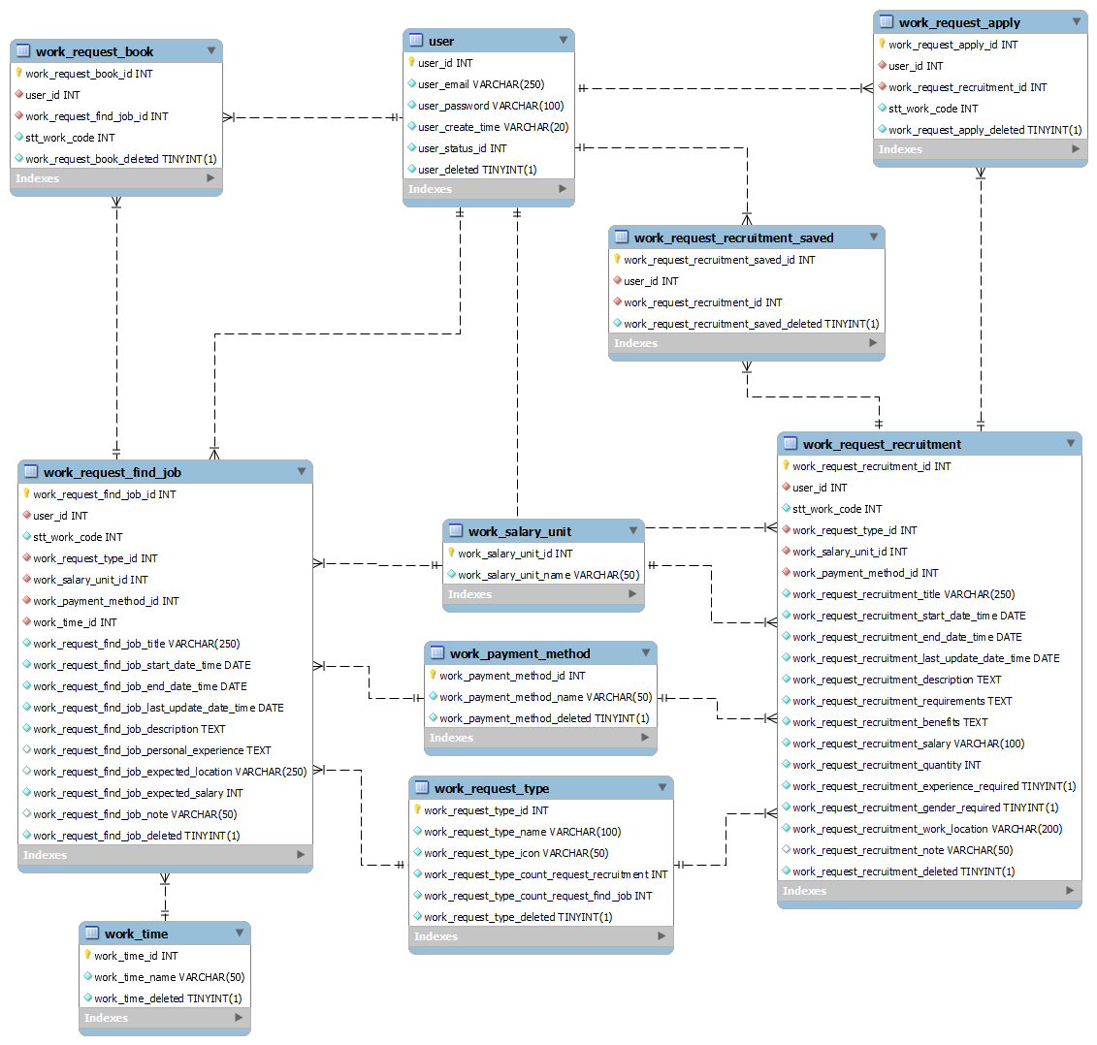

*Figure 4.92:Database design module Work*

#### 5.1.2 Module Food

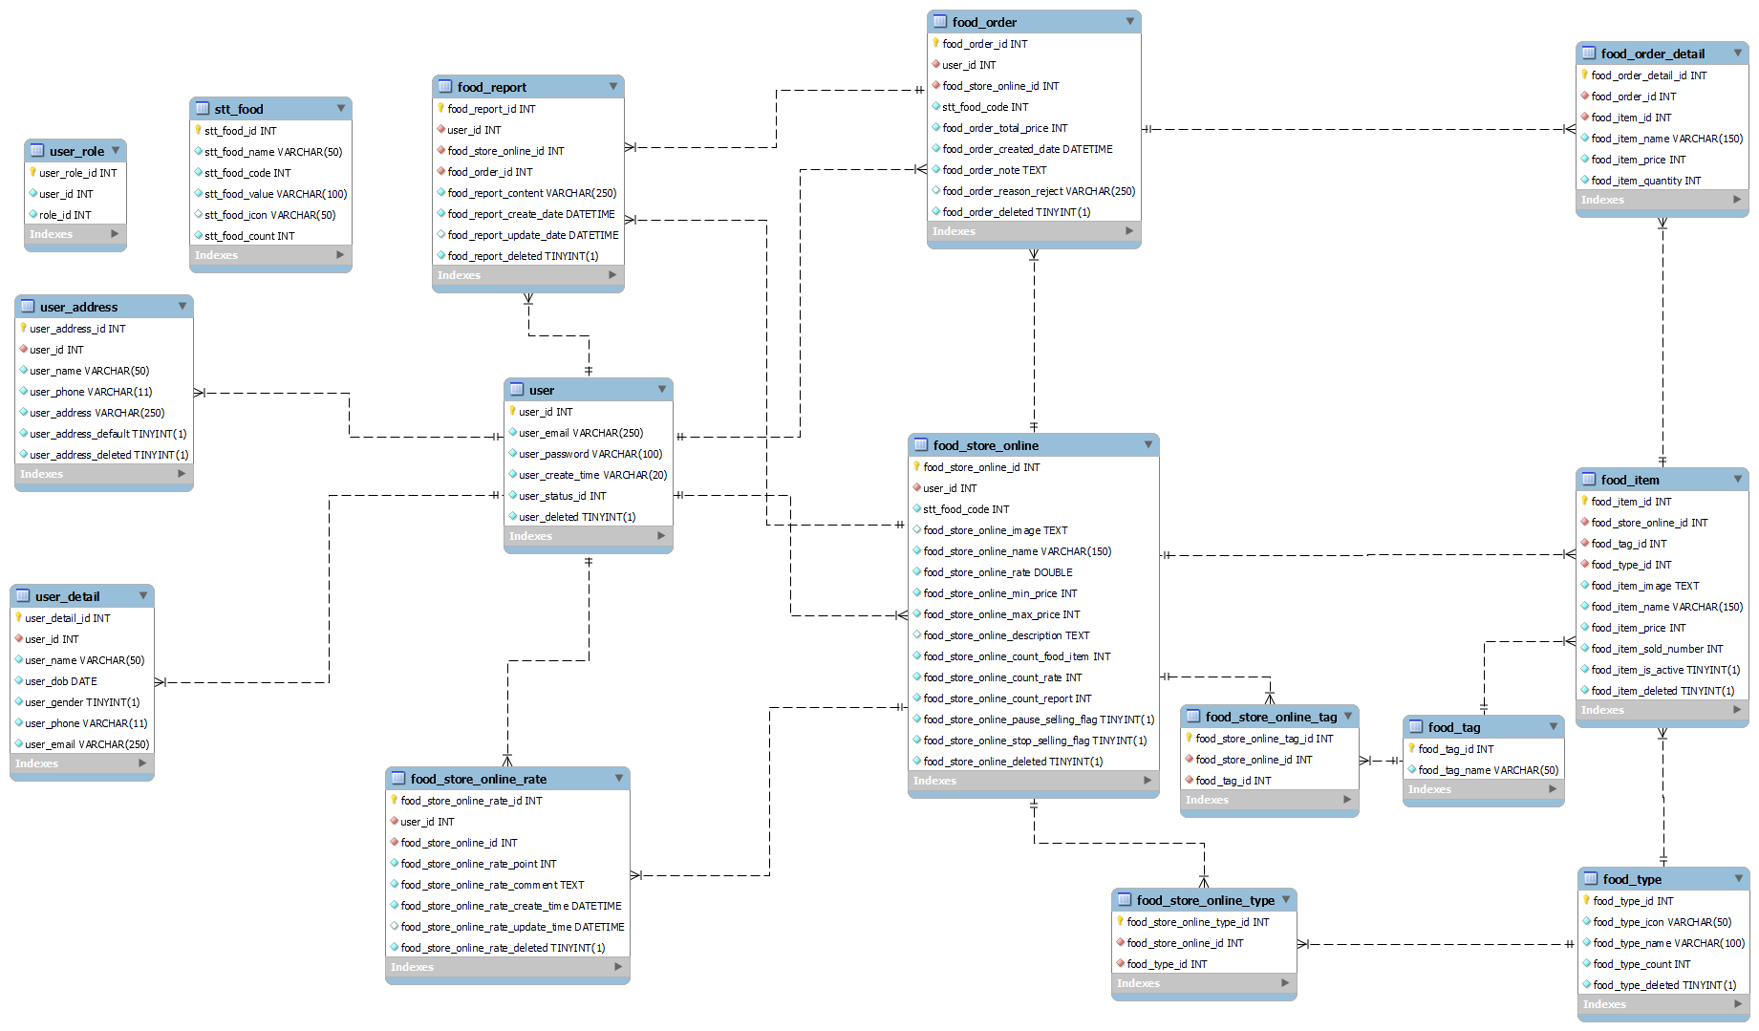

*Figure 4.93:Database design module Food*

#### 5.1.3 Module FPT University & Module Traffic

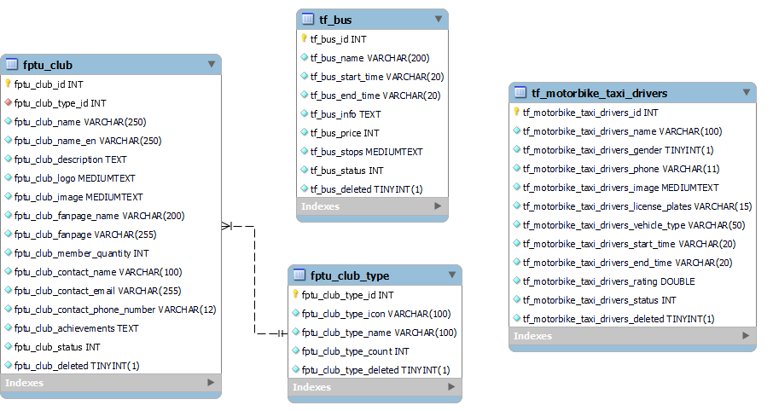

*Figure 4.94:Database design module FPT University & module Traffic*

### 5.2 Data File Design

#### 5.2.1 Module Work

##### 5.2.1.1 work_request_find_job

|  |  |  |  |  |  |  |  |
| --- | --- | --- | --- | --- | --- | --- | --- |
| # | Field name | Type | Size | Unique | Not null | PK/PK | Notes |
|  | work_request_find_job_  id | int |  | T | T | PK | auto_increment |
|  | user_id | int |  | N | T | FK |  |
|  | stt_work_code | int |  | N | T |  |  |
|  | work_request_type_id | int |  | N | F | FK |  |
|  | work_salary_unit_id | int |  | N | T | FK |  |
|  | work_payment_method_id | int |  | N | T | FK |  |
|  | work_time_id | int |  | N | T | FK |  |
|  | work_request_find_job_  title | nvarchar | 250 | N | T |  | charset utf8mb4 |
|  | work_request_find_job_  start_date_time | nvarchar | 20 | N | T |  | charset utf8mb4 |
|  | work_request_find_job_end_date_time | nvarchar | 20 | N | T |  | charset utf8mb4 |
|  | work_request_find_job_  last_update_date_time | nvarchar | 20 | N | T |  | charset utf8mb4 |
|  | work_request_find_job_description | text |  | N | T |  | charset utf8mb4 |
|  | work_request_find_job_personal_experience | text |  | N | F |  | charset utf8mb4 |
|  | work_request_find_job_expected_location | nvarchar | 250 | N | F |  | charset utf8mb4 |
|  | work_request_find_job_expected_salary | int |  | N | T |  |  |
|  | work_request_find_job_note | nvarchar | 50 | N | F |  | charset utf8mb4 |
|  | work_request_find_job_deleted | boolean |  | N | T |  |  |

*Table 4.112:* *work_request_find_job table*

##### 5.2.1.2 work_request_recruitment

|  |  |  |  |  |  |  |  |
| --- | --- | --- | --- | --- | --- | --- | --- |
| # | Field name | Type | Size | Unique | Not null | PK/PK | Notes |
| 1 | work_request_recruitment _id | int |  | T | T | PK | auto_increment |
| 2 | user_id | int |  | N | T | FK |  |
| 3 | stt_work_code | int |  | N | T |  |  |
| 4 | work_request_type_id | int |  | N | T | FK |  |
| 5 | work_salary_unit_id | int |  | N | T | FK |  |
| 6 | work_payment_method_id | int |  | N | T | FK |  |
| 7 | work_request_recruitment_title | nvarchar | 250 | N | T |  | charset utf8mb4 |
| 8 | work_request_recruitment_start_date_time | nvarchar | 20 | N | T |  | charset utf8mb4 |
| 9 | work_request_recruitment_end_date_time | nvarchar | 20 | N | T |  | charset utf8mb4 |
| 10 | work_request_recruitment_  last_update_date_time | nvarchar | 20 | N | T |  | charset utf8mb4 |
| 11 | work_request_recruitment_  description | text |  | N | T |  | charset utf8mb4 |
| 12 | work_request_recruitment_  requirements | text |  | N | T |  | charset utf8mb4 |
| 13 | work_request_recruitment_  benefits | text |  | N | T |  | charset utf8mb4 |
| 14 | work_request_recruitment_  salary | nvarchar | 100 | N | T |  | charset utf8mb4 |
| 15 | work_request_recruitment_  quantity | int |  | N | T |  |  |
| 16 | work_request_recruitment_  experience_required | boolean |  | N | T |  |  |
| 17 | work_request_recruitment_  gender_required | boolean |  | N | T |  |  |
| 18 | work_request_recruitment_  work_location | nvarchar | 200 | N | T |  | charset utf8mb4 |
| 19 | work_request_recruitment_note | nvarchar | 50 | N | T |  | charset utf8mb4 |
| 20 | work_request_recruitment_deleted | boolean |  | N | T |  |  |

*Table 4.113:* *work_request_recruitment table*

##### 5.2.1.3 work_request_apply

|  |  |  |  |  |  |  |  |
| --- | --- | --- | --- | --- | --- | --- | --- |
| # | Field name | Type | Size | Unique | Not null | PK/PK | Notes |
| 1 | work_request_apply_id | int |  | T | T | PK | auto_increment |
| 2 | user_id | int |  | N | T | FK |  |
| 3 | work_request_recruitment_id | int |  | N | T | FK |  |
| 4 | stt_work_code | int |  | N | T |  |  |
| 5 | work_request_apply_  deleted | boolean |  | N | T |  |  |

*Table 4.114:* *work_request_apply table*

##### 5.2.1.4 work_request_book

|  |  |  |  |  |  |  |  |
| --- | --- | --- | --- | --- | --- | --- | --- |
| # | Field name | Type | Size | Unique | Not null | PK/PK | Notes |
| 1 | work_request_book_id | int |  | T | T | PK | auto_increment |
| 2 | user_id | int |  | N | T | FK |  |
| 3 | work_request_find_job_id | int |  | N | T | FK |  |
| 4 | stt_work_code | int |  | N | T |  |  |
| 5 | work_request_book_  deleted | boolean |  | N | T |  |  |

*Table 4.115: work_request_book table*

##### 5.2.1.5 work_request_recruitment_saved

|  |  |  |  |  |  |  |  |
| --- | --- | --- | --- | --- | --- | --- | --- |
| # | Field name | Type | Size | Unique | Not null | PK/PK | Notes |
| 1 | work_request_recruitment_  saved_id | int |  | T | T | PK | auto_increment |
| 2 | user_id | int |  | N | T | FK |  |
| 3 | work_request_recruitment _id | int |  | N | T | FK |  |
| 4 | work_request_recruitment_  saved_deleted | boolean |  | N | T |  |  |

*Table 4.116:* *work_request_recruitment_saved table*

##### 5.2.1.6 stt_work

|  |  |  |  |  |  |  |  |
| --- | --- | --- | --- | --- | --- | --- | --- |
| # | Field name | Type | Size | Unique | Not null | PK/PK | Notes |
| 1 | stt_work_id | int |  | T | T | PK | auto_increment |
| 2 | stt_work_name | nvarchar | 50 | N | T |  | charset utf8mb4 |
| 3 | stt_work_code | int |  | N | T |  |  |
| 4 | stt_work_value | nvarchar | 100 | N | T |  | charset utf8mb4 |
| 5 | stt_work_icon | nvarchar | 50 | N | T |  | charset utf8mb4 |

*Table 4.117:* *stt_work table*

##### 5.2.1.7 stt_work_request_recruitment_find_job_count

|  |  |  |  |  |  |  |  |
| --- | --- | --- | --- | --- | --- | --- | --- |
| # | Field name | Type | Size | Unique | Not null | PK/PK | Notes |
| 1 | stt_work_request_recruitment_find_job_count_id | int |  | T | T | PK | auto_increment |
| 2 | user_id | int |  | N | T | FK |  |
| 3 | stt_work_request_recruitment_find_job_count_pending | int |  | N | T |  |  |
| 4 | stt_work_request_recruitment_find_job_count_reject | int |  | N | T |  |  |
| 5 | stt_work_request_recruitment_find_job_count_approved | int |  | N | T |  |  |
| 6 | stt_work_request_recruitment_find_job_count_complete | int |  | N | T |  |  |
| 7 | stt_work_request_recruitment_find_job_count_expired | int |  | N | T |  |  |
| 8 | stt_work_request_recruitment_find_job_count_save_draft | int |  | N | T |  |  |

*Table 4.118: stt_work_request_recruitment_find_job_count table*

##### 5.2.1.8 work_report

|  |  |  |  |  |  |  |  |
| --- | --- | --- | --- | --- | --- | --- | --- |
| # | Field name | Type | Size | Unique | Not null | PK/PK | Notes |
| 1 | work_report_id | int |  | T | T | PK | auto_increment |
| 2 | stt_work_code | int |  | N | T |  |  |
| 3 | work_report_reason_id | int |  | N | T |  |  |
| 4 | work_report_  description | text |  | N | T |  | charset utf8mb4 |
| 5 | work_report_  deleted | boolean |  | N | T |  |  |

*Table 4.119: work_report table*

##### 5.2.1.9 work_request_type

|  |  |  |  |  |  |  |  |
| --- | --- | --- | --- | --- | --- | --- | --- |
| # | Field name | Type | Size | Unique | Not null | PK/PK | Notes |
| 1 | work_request_type_id | int |  | T | T | PK | auto_increment |
| 2 | work_request_type_name | nvarchar | 100 | N | T |  | charset utf8mb4 |
| 3 | work_request_type_icon | nvarchar | 50 | N | T |  | charset utf8mb4 |
| 4 | work_request_type_count | int |  | N | T |  |  |
| 5 | work_request_type_count_request_recruitment | int |  | N | T |  |  |
| 6 | work_request_type_count_request_find_job | int |  | N | T |  |  |
| 7 | work_request_type_deleted | boolean |  | N | T |  |  |

*Table 4.120: work_request_type table*

##### 5.2.1.10 work_time

|  |  |  |  |  |  |  |  |
| --- | --- | --- | --- | --- | --- | --- | --- |
| # | Field name | Type | Size | Unique | Not null | PK/PK | Notes |
| 1 | work_time_id | int |  | T | T | PK | auto_increment |
| 2 | work_time_name | nvarchar | 50 | N | T |  | charset utf8mb4 |
| 3 | work_time_deleted | boolean |  | N | T |  |  |

*Table 4.121:* *work_time table*

##### 5.2.1.11 work_comment

|  |  |  |  |  |  |  |  |
| --- | --- | --- | --- | --- | --- | --- | --- |
| # | Field name | Type | Size | Unique | Not null | PK/PK | Notes |
| 1 | work_comment_id | int |  | T | T | PK | auto_increment |
| 2 | work_request_  recruitment _id | int |  | N | T | FK |  |
| 3 | user_id | int |  | N | T | FK |  |
| 4 | work_comment_  content | text |  | N | T |  | charset utf8mb4 |
| 5 | work_comment_  deleted | boolean |  | N | T |  |  |

*Table 4.122:* *work_comment table*

##### 5.2.1.12 work_report_reason

|  |  |  |  |  |  |  |  |
| --- | --- | --- | --- | --- | --- | --- | --- |
| # | Field name | Type | Size | Unique | Not null | PK/PK | Notes |
| 1 | work_report_reason_id | int |  | T | T | PK | auto_increment |
| 2 | work_report_reason_name | nvarchar | 200 | N | T |  | charset utf8mb4 |

*Table 4.123: work_report_reason table*

5.2.1.13 work_salary_unit

|  |  |  |  |  |  |  |  |
| --- | --- | --- | --- | --- | --- | --- | --- |
| # | Field name | Type | Size | Unique | Not null | PK/PK | Notes |
| 1 | work_salary_unit_id | int |  | T | T | PK | auto_increment |
| 2 | work_salary_unit_name | nvarchar | 50 | N | T |  | charset utf8mb4 |

*Table 4.124: work_salary_unit table*

##### 5.2.1.14 work_payment_method

|  |  |  |  |  |  |  |  |
| --- | --- | --- | --- | --- | --- | --- | --- |
| # | Field name | Type | Size | Unique | Not null | PK/PK | Notes |
| 1 | work_payment_method_id | int |  | T | T | PK | auto_increment |
| 2 | work_payment_method_name | nvarchar | 50 | N | T |  | charset utf8mb4 |
| 3 | work_payment_method_deleted | boolean |  | N | T |  |  |

*Table 4.125:* *work_payment_method table*

#### 5.2.2 Module Food

##### 5.2.2.1 food_item

|  |  |  |  |  |  |  |  |
| --- | --- | --- | --- | --- | --- | --- | --- |
| # | Field name | Type | Size | Unique | Not null | PK/PK | Notes |
| 1 | food_item_id | int |  | T | T | PK | auto_increment |
| 2 | food_store_online_id | int |  | N | T | FK |  |
| 3 | food_tag_id | int |  | N | T | FK |  |
| 4 | food_type_id | int |  | N | T | FK |  |
| 5 | food_item_image | text |  | N | T |  | charset utf8mb4 |
| 6 | food_item_name | nvarchar | 150 | N | T |  | charset utf8mb4 |
| 7 | food_item_price | int |  | N | T |  |  |
| 8 | food_item_sold_number | int |  | N | T |  |  |
| 9 | food_item_is_active | boolean |  | N | T |  |  |
| 10 | food_item_deleted | boolean |  | N | T |  |  |

*Table 4.126: food_item table*

##### 5.2.2.2 food_order

|  |  |  |  |  |  |  |  |
| --- | --- | --- | --- | --- | --- | --- | --- |
| # | Field name | Type | Size | Unique | Not null | PK/PK | Notes |
| 1 | food_order_id | int |  | T | T | PK | auto_increment |
| 2 | user_id | int |  | N | T | FK |  |
| 3 | food_store_online_id | int |  | N | T | FK |  |
| 4 | stt_food_code | int |  | N | T |  |  |
| 5 | food_order_total_price | int |  | N | T |  |  |
| 6 | food_order_created_date | date |  | N | T |  |  |
| 7 | food_order_note | text |  | N | T |  | charset utf8mb4 |
| 8 | food_order_deleted | boolean |  | N | T |  |  |

*Table 4.127:* *food_order table*

##### 5.2.2.3 food_order_detail

|  |  |  |  |  |  |  |  |
| --- | --- | --- | --- | --- | --- | --- | --- |
| # | Field name | Type | Size | Unique | Not null | PK/PK | Notes |
| 1 | food_order_detail_id | int |  | T | T | PK |  |
| 2 | food_order_id | int |  | N | T | FK |  |
| 3 | food_item_id | int |  | N | T | FK |  |
| 4 | food_item_name | nvarchar | 150 | N | T |  | charset utf8mb4 |
| 5 | food_item_price | int |  | N | T |  |  |
| 6 | food_item_quantity | int |  | N | T |  |  |

*Table 4.128: food_order_detail table*

##### 5.2.2.4 food_report

|  |  |  |  |  |  |  |  |
| --- | --- | --- | --- | --- | --- | --- | --- |
| # | Field name | Type | Size | Unique | Not null | PK/PK | Notes |
| 1 | food_report_id | int |  | T | T | PK |  |
| 2 | user_id | int |  | N | T | FK |  |
| 3 | food_order_id | int |  | N | T | FK |  |
| 4 | food_report_content | nvarchar | 250 | N | T |  | charset utf8mb4 |
| 5 | food_report_create_date | datetime |  | N | T |  |  |
| 6 | food_report_update_date | datetime |  | N | T |  |  |
| 7 | food_report_delete | boolean |  | N | T |  |  |

*Table 4.129:* *food_report table*

##### 5.2.2.5 food_store_online

|  |  |  |  |  |  |  |  |
| --- | --- | --- | --- | --- | --- | --- | --- |
| # | Field name | Type | Size | Unique | Not null | PK/PK | Notes |
| 1 | food_store_online_id | int |  | T | T | PK |  |
| 2 | user_id | int |  | N | T | FK |  |
| 3 | food_store_type_id | int |  | N | T | FK |  |
| 4 | stt_food_code | int |  | N | T |  |  |
| 5 | food_store_online_image | text |  | N | T |  | charset utf8mb4 |
| 6 | food_store_online_name | nvarchar | 150 | N | T |  | charset utf8mb4 |
| 7 | food_store_online_rate | double |  | N | T |  |  |
| 8 | food_store_online_min_price | int |  | N | T |  |  |
| 9 | food_store_online_max_price | int |  | N | T |  |  |
| 10 | food_store_online_  description | text |  | N | T |  | charset utf8mb4 |
| 11 | food_store_online_deleted | boolean |  | N | T |  |  |

*Table 4.130:* *food_store_online table*

##### 5.2.2.6 food_store_online_rate

|  |  |  |  |  |  |  |  |
| --- | --- | --- | --- | --- | --- | --- | --- |
| # | Field name | Type | Size | Unique | Not null | PK/PK | Notes |
| 1 | food_store_online_rate_id | int |  | T | T | PK |  |
| 2 | food_store_online_id | int |  | N | T | FK |  |
| 3 | food_store_online_rate_point | int |  | N | T |  |  |
| 4 | food_store_online_rate_  comment | text |  | N | T |  | charset utf8mb4 |
| 5 | user_id | int |  | N | T | FK |  |
| 6 | food_store_online_rate_  create_time | datetime |  | N | T |  |  |
| 7 | food_store_online_rate_  update_time | datetime |  | N | T |  |  |
| 8 | food_store_online_rate_  deleted | boolean |  | N | T |  |  |

*Table 4.131: food_store_online_rate table*

##### 5.2.2.7 food_store_online_tag

|  |  |  |  |  |  |  |  |
| --- | --- | --- | --- | --- | --- | --- | --- |
| # | Field name | Type | Size | Unique | Not null | PK/PK | Notes |
| 1 | food_store_online_tag_id | int |  | T | T | PK |  |
| 2 | food_store_online_id | int |  | N | T | FK |  |
| 3 | food_tag_id | int |  | N | T | FK |  |

*Table 4.132: food_store_online_tag table*

##### 5.2.2.8 food_store_online_type

|  |  |  |  |  |  |  |  |
| --- | --- | --- | --- | --- | --- | --- | --- |
| # | Field name | Type | Size | Unique | Not null | PK/PK | Notes |
| 1 | food_store_online_type_id | int |  | T | T | PK |  |
| 2 | food_store_online_id | int |  | N | T | FK |  |
| 3 | food_type_id | int |  | N | T | FK |  |

*Table 4.133:* *food_store_online_type table*

##### 5.2.2.9 food_store_type

|  |  |  |  |  |  |  |  |
| --- | --- | --- | --- | --- | --- | --- | --- |
| # | Field name | Type | Size | Unique | Not null | PK/PK | Notes |
| 1 | food_store_type_id | int |  | T | T | PK |  |
| 2 | food_store_type_name | nvarchar | 50 | N | T |  | charset utf8mb4 |

*Table 4.134:* *food_store_type table*

##### 5.2.2.10 food_tag

|  |  |  |  |  |  |  |  |
| --- | --- | --- | --- | --- | --- | --- | --- |
| # | Field name | Type | Size | Unique | Not null | PK/PK | Notes |
| 1 | food_tag_id | int |  | T | T | PK |  |
| 2 | food_tag_name | nvarchar | 50 | N | T |  | charset utf8mb4 |

*Table 4.135:* *food_tag table*

##### 5.2.2.11 food_type

|  |  |  |  |  |  |  |  |
| --- | --- | --- | --- | --- | --- | --- | --- |
| # | Field name | Type | Size | Unique | Not null | PK/PK | Notes |
| 1 | food_type_id | int |  | T | T | PK |  |
| 2 | food_type_icon | nvarchar | 50 | N | T |  | charset utf8mb4 |
| 3 | food_type_name | nvarchar | 100 | N | T |  | charset utf8mb4 |
| 4 | food_type_count | int |  | N | T |  |  |
| 5 | food_type_deleted | boolean |  | N | T |  |  |

*Table 4.136:* *food_type table*

#### 5.2.3 Module FPT-University

##### 5.2.3.1 fptu_club

|  |  |  |  |  |  |  |  |
| --- | --- | --- | --- | --- | --- | --- | --- |
| # | Field name | Type | Size | Unique | Not null | PK/PK | Notes |
| 1 | fptu_club_id | int |  | T | T | PK | auto_increment |
| 2 | fptu_club_type_id | Int |  | N | T | FK |  |
| 3 | fptu_club_name | nvarchar | 250 | N | T |  | charset utf8mb4 |
| 4 | fptu_club_name_en | nvarchar | 250 | N | T |  | charset utf8mb4 |
| 5 | fptu_club_description | text |  | N | T |  | charset utf8mb4 |
| 6 | fptu_club_logo | text | 15 | N | T |  | charset utf8mb4 |
| 7 | fptu_club_image | text | 50 | N | T |  | charset utf8mb4 |
| 8 | fptu_club_fanpage_name | nvarchar | 200 | N | T |  | charset utf8mb4 |
| 9 | fptu_club_fanpage | nvarchar | 255 | N | T |  | charset utf8mb4 |
| 10 | fptu_club_member_quantity | double |  | N | T |  |  |
| 11 | fptu_club_contact_name | nvarchar | 100 | N | T |  | charset utf8mb4 |
| 12 | fptu_club_contact_email | nvarchar | 255 | N | T |  | charset utf8mb4 |
| 13 | fptu_club_contact_phone_  number | nvarchar | 12 | N | T |  | charset utf8mb4 |
| 14 | fptu_club_achievements | text |  | N | T |  | charset utf8mb4 |
| 15 | fptu_club_status | int |  | N | T |  |  |
| 16 | fptu_club_deleted | boolean |  | N | T |  |  |

*Table 4.137:* *fptu_club table*

##### 5.2.3.2 fpt_club_type

|  |  |  |  |  |  |  |  |
| --- | --- | --- | --- | --- | --- | --- | --- |
| # | Field name | Type | Size | Unique | Not null | PK/PK | Notes |
| 1 | fptu_club_type_id | int |  | T | T | PK | auto_increment |
| 2 | fptu_club_type_icon | nvarchar | 100 | N | T | FK | charset utf8mb4 |
| 3 | fptu_club_type_name | nvarchar | 100 | N | T |  | charset utf8mb4 |
| 4 | fptu_club_type_count | int |  | N | T |  |  |
| 5 | fptu_club_type_deleted | boolean |  | N | T |  |  |

*Table 4.138: fpt_club_type table*

#### 5.2.4 Module Traffic

##### 5.2.4.1 tf_bus

|  |  |  |  |  |  |  |  |
| --- | --- | --- | --- | --- | --- | --- | --- |
| # | Field name | Type | Size | Unique | Not null | PK/PK | Notes |
| 1 | tf_bus_id | int |  | T | T | PK | auto_increment |
| 2 | tf_bus_name | nvarchar | 200 | N | T |  | charset utf8mb4 |
| 3 | tf_bus_start_time | nvarchar | 20 | N | T |  | charset utf8mb4 |
| 4 | tf_bus_end_time | nvarchar | 20 | N | T |  | charset utf8mb4 |
| 5 | tf_bus_info | text |  | N | T |  | charset utf8mb4 |
| 6 | tf_bus_price | int |  | N | T |  |  |
| 7 | tf_bus_stops | text |  | N | T |  | charset utf8mb4 |
| 8 | tf_bus_status | int |  | N | T |  |  |
| 9 | tf_bus_deleted | boolean |  | N | T |  |  |

*Table 4.139: tf_bus table*

##### 5.2.4.2 tf_motorbike_taxi_driver

|  |  |  |  |  |  |  |  |
| --- | --- | --- | --- | --- | --- | --- | --- |
| # | Field name | Type | Size | Unique | Not null | PK/PK | Notes |
| 1 | tf_motorbike_taxi_drivers_id | int |  | T | T | PK | auto_increment |
| 2 | tf_motorbike_taxi_drivers_name | nvarchar | 100 | N | T |  | charset utf8mb4 |
| 3 | tf_motorbike_taxi_drivers_  gender | boolean |  | N | T |  |  |
| 4 | tf_motorbike_taxi_drivers_  phone | nvarchar | 11 | N | T |  | charset utf8mb4 |
| 5 | tf_motorbike_taxi_drivers_  image | text |  | N | T |  | charset utf8mb4 |
| 6 | tf_motorbike_taxi_drivers_  license_plates | nvarchar | 15 | N | T |  | charset utf8mb4 |
| 7 | tf_motorbike_taxi_drivers_  vehicle_type | nvarchar | 50 | N | T |  | charset utf8mb4 |
| 8 | tf_motorbike_taxi_drivers_start_time | nvarchar | 20 | N | T |  | charset utf8mb4 |
| 9 | tf_motorbike_taxi_drivers_end_  time | nvarchar | 20 | N | T |  | charset utf8mb4 |
| 10 | tf_motorbike_taxi_drivers_rating | double |  | N | T |  |  |
| 11 | tf_motorbike_taxi_drivers_status | int |  | N | T |  |  |
| 12 | tf_motorbike_taxi_drivers_  deleted | boolean |  | N | T |  |  |

*Table 4.140: tf_motorbike_taxi_driver table*

# V. Software Testing Documentation

## 1. Overall Description

### 1.1 Test Model

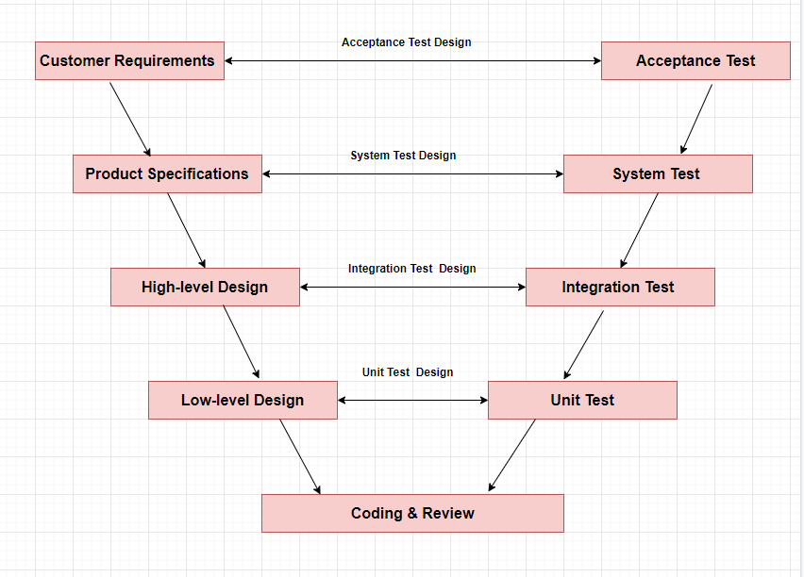

*Figure 5.1:V-Model for testing*

We choose V-Model to implement the testing process. With V-Model, software development is separated into two appropriate phase groups: development and testing. In this model, the verification and validation will be done side by side. It emphasizes the strict process flow to develop a quality product. The errors occurring in any phase will be corrected in that phase. Proactive defect tracking defects, which are found at early stages even, maybe in the development phase before the application is tested.

Specifically, Hola Land is divided into 2 sub-systems: Hola Land Back-end and Hola Land Front-end. In each phase of the process, we use a specific process for each sub-system team to fit the requirement, the characteristic, and the human resource of each team.

### 1.2 Testing Levels

There are 4 phases in Testing Process: Unit testing, Integration testing, System testing and Acceptance testing.

|  |  |  |
| --- | --- | --- |
| **ID** | **Test Stages** | **Description** |
| **1** | **Unit testing** | The main aim of this endeavor is to determine whether the application functions as designed. In this phase, a unit can refer to a function, individual program or even a procedure, and a White-box Testing method is usually used to get the job done. |
| **2** | **Integration testing** | Integration testing allows individuals the opportunity to combine all of the units within a program and test them as a group. This testing level is designed to find interface defects between the modules/functions. This is particularly beneficial because it determines how efficiently the units are running together. |
| **3** | **System testing** | System testing is the first level in which the complete application is tested as a whole. The goal at this level is to evaluate whether the system has complied with all of the outlined requirements and to see that it meets Quality Standards. |
| **4** | **Acceptance testing** | Acceptance testing (or User Acceptance Testing), is conducted to determine whether the system is ready for release. During this phase, the tester and some alpha test user will test the system to find out whether the application meets their business’ needs. |

*Table 5.1: Testing Levels*

### 1.3 Testing Types

|  |  |  |
| --- | --- | --- |
| **No** | **Testing Types** | **Description** |
| **1** | **Functional Testing** | - Testing all individual implemented methods, functions of model class or library class.  - Test case will have to cover all logic branch that function or method could execute with difference data input. |
| **2** | **Algorithm Testing** | Algorithm testing is used to test about the speed and accuracy of algorithm with different similarity measures and difference input data to evaluate the performance of algorithm |
| **3** | **UI/UX Testing** | -UI/UX testing verifies a user’s interaction with the software. The goal of UI/UX testing is to ensure that the UI/UX provides the user with an appropriate access and navigation through the functions of the target-oftest. In addition, UI/UX testing ensures that the objects within the UI/UX function as expected and conform to requirement.  - UI/UX test will be performed fully on all screens.  - UI/UX test targets to cover the verification of the overall look and feel  of the system including initial position, font, text size, color, focus, initial button, tab order, label, screen sizes, sentences width and animation.  - Check all the UI elements for color, size, position, width, length and acceptance of characters or numbers. |
| **4** | **Regression Testing** | Regression Testing confirms that the bug was removed including the extent of the impact, when developers fix bug, developers and testers will confirm with each other what is the impacts of fix bug modification, after that all impact unit or function will be retested by developers then testers after that |

*Table 5.2: Testing Types*

## 2. Test Plan

### 2.1 Test Stages

| **Type of Tests** | **Test Level** | | | |
| --- | --- | --- | --- | --- |
| **Unit** | **Integration** | **System** | **Acceptance** |
| Functional Testing | X | X | X | X |
| Algorithm Testing | X | X |  |  |
| UI/UX Testing |  | X |  | X |
| Regression Testing | X | X | X |  |

*Table 5.3: Test Levels*

### 2.2 Resources

#### 2.2.1 Human Resources

|  |  |  |
| --- | --- | --- |
| **No** | **Resources** | **Specific Responsibilities/Comments** |
| 1 | Project Manager | * Responsible for project schedule and overall success of the project. * Review test cases and reports. |
| 2 | Tester | * Performing the actual system testing * Manage test resources and assign test task * Create test plan. * Create test cases. * Create test report. * Execute test. * Test log report. |
| 3 | Developer | * Fix bugs * Create unit test and integration test scripts. |

*Table 5.4: Human Resources*

#### 2.2.2 Tools and Environment

##### 2.2.2.1 Tools

* **Github**: Manage issues
* **Google Sheets, Microsoft Excel**: Manage test cases
* **Chrome DevTools**: View logs, inspect element front-end
* **Mockito**: Generate unit tests in back-end

##### 2.2.2.2 Evironment

|  |  |  |  |
| --- | --- | --- | --- |
| **Purpose** | **Tool** | **Provider** | **Version** |
| Integration Testing, System Testing & Acceptance Testing |  |  |  |
|  |  |  |  |
|  |  |  |  |
|  |  |  |  |
|  |  |  |  |

*Table 5.5: Testing Evironment*

### 2.3 Test Milestones

|  |  |  |
| --- | --- | --- |
| **Milestone Task** | **Start Date** | **End Date** |
| **Iteration 1** | **21/09/2021** | **1/11/2021** |
| Create test plan | 21/09/2021 | 22/09/2021 |
| Review and update test plan | 23/09/2021 | 30/09/2021 |
| Create integration and system test | 12/10/2021 | 20/10/2021 |
| Execute unit test | 13/10/2021 | 28/10/2021 |
| Execute integration and system test | 14/10/2021 | 1/11/2021 |
| **Iteration 2** | **3/11/2021** | **30/11/2021** |
| Create test plan | 03/11/2021 | 04/11/2021 |
| Review and update test plan | 04/11/2021 | 11/11/2021 |
| Create integration and system test | 12/11/2021 | 13/11/2021 |
| Execute unit test | 13/11/2021 | 28/11/2021 |
| Execute integration and system test | 14/11/2021 | 30/11/2021 |
| **Iteration 3** | **1/12/2021** | **19/12/2021** |
| Create test plan | 01/12/2021 | 02/12/2021 |
| Review and update test plan | 02/12/2021 | 10/12/2021 |
| Create integration and system test | 03/12/2021 | 04/12/2021 |
| Execute unit test | 04/12/2021 | 18/12/2021 |
| Execute integration and system test | 05/12/2021 | 19/12/2021 |

*Table 5.6: Testing Milestones*

### 2.4 Deliverables

|  |  |  |  |  |
| --- | --- | --- | --- | --- |
| **Deliverables** | **Responsibilities** | **Complete date** | | |
| **Iteration 1** | **Iteration 2** | **Iteration 3** |
| Test Plan | Tester | 21/09/2021 | 03/11/2021 | 01/12/2021 |
| Test Cases | Tester | 22/09/2021 | 05/11/2021 | 02/12/2021 |
| Test case review | Tester + PM | 23/09/2021 | 06/11/2021 | 03/12/2021 |
| Defect report | All members | 01/11/2021 | 30/11/2021 | 10/12/2021 |
| Final test Summary report | PM | 19/12/2021 | | |

*Table 5.7: Testing Deliverables*

## 3. Test Cases

### 3.1 Unit Test

All unit tests are located in the folder **src/test** in source code. Here is an example of unit test cases:

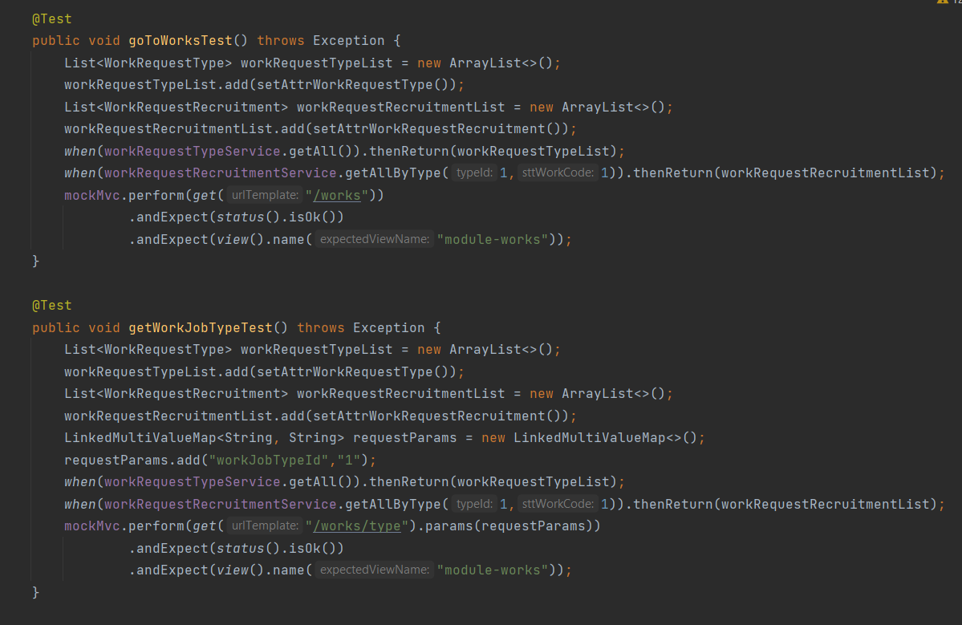

*Figure 5.2: Unit Test Example*

### 3.2 Integration Testing & System Testing

Detailed test cases of these types of testing are described in 2 files: **IntegrationTest.xlsx** (for  
Integration Testing) and **SystemTest.xlsx** (for System Testing).  
As a standard definition, Anest Project defines that a test case is:

* A set of test data and test programs (test scripts) and their expected results. A test case validates one or more system requirements and generates a pass or fail.
* A good test case should follow two basic aspects, the content and the style. Test cases for functional testing are derived from the target of test's use cases. Test cases should be developed for each use case scenario. The use case scenarios are identified by describing the paths through the use case that traverse the basic flow and alternate flows start to finish through the use case.

Integration testing and system testing are done by testers to ensure that each high-level module and the whole system work properly. In integration testing, testers test each module function follow each screen in the system and in system testing, testers follow the use case list to do testing process. If having any bugs or defects, testers are responsible to create issue in Gihub and report to developers to fix as soon as possible.

**Test case examples:**

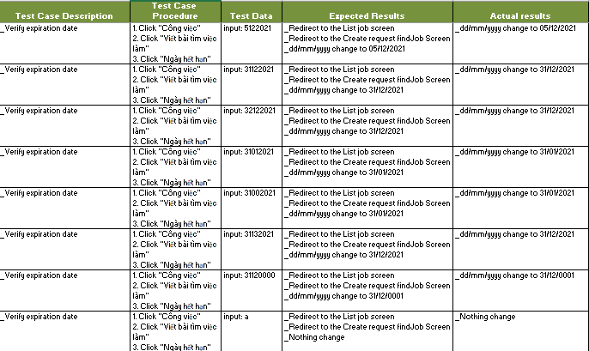

*Figure 5.3: Integration Test Case Example*

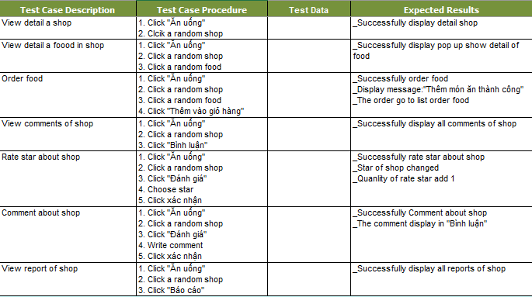

*Figure 5.4: System Test Case Example*

### 3.3 Acceptance Testing

Acceptance testing is a level of the software testing process where a system is tested for acceptability.  
The purpose of this test is to evaluate the system’s compliance with the business requirements and assess whether it is acceptable for delivery. But our project will use the checklist as a substitute for acceptance testing. Detailed checklists are described in **AcceptanceTestCase.xlxs** file.

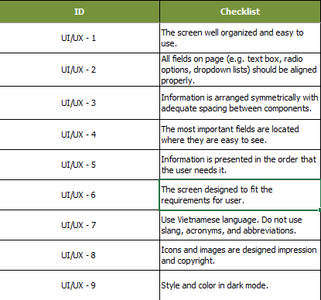

*Figure 5.5: UAT Checklist Example*

### 3.4 Issue log

Log issues in Github, that makes it easy for developers and testers to view and take part in activities like fix issues, re-test and close issues. Issues will be logged by testers or developers during the development progress.

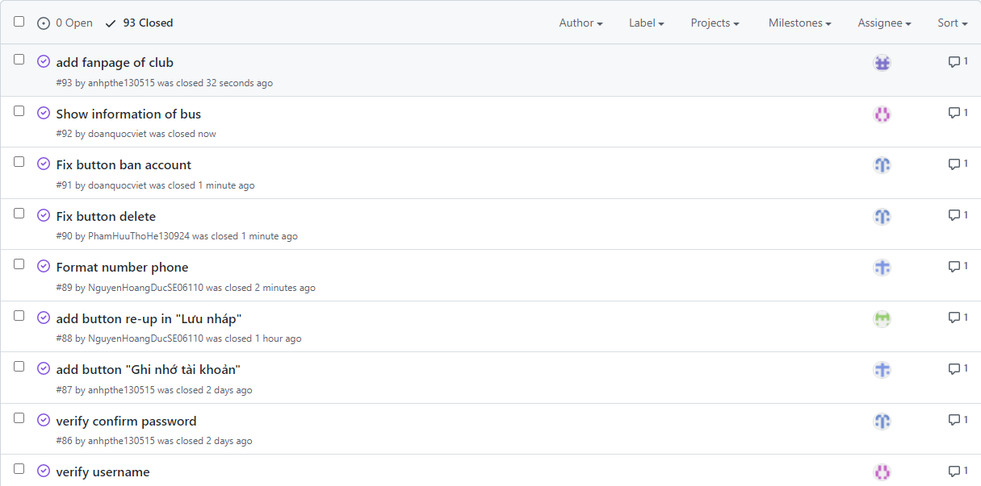

*Figure 5.6: Issue Log in Github*

## 4. Test Reports

### 4.1 Unit Test Report

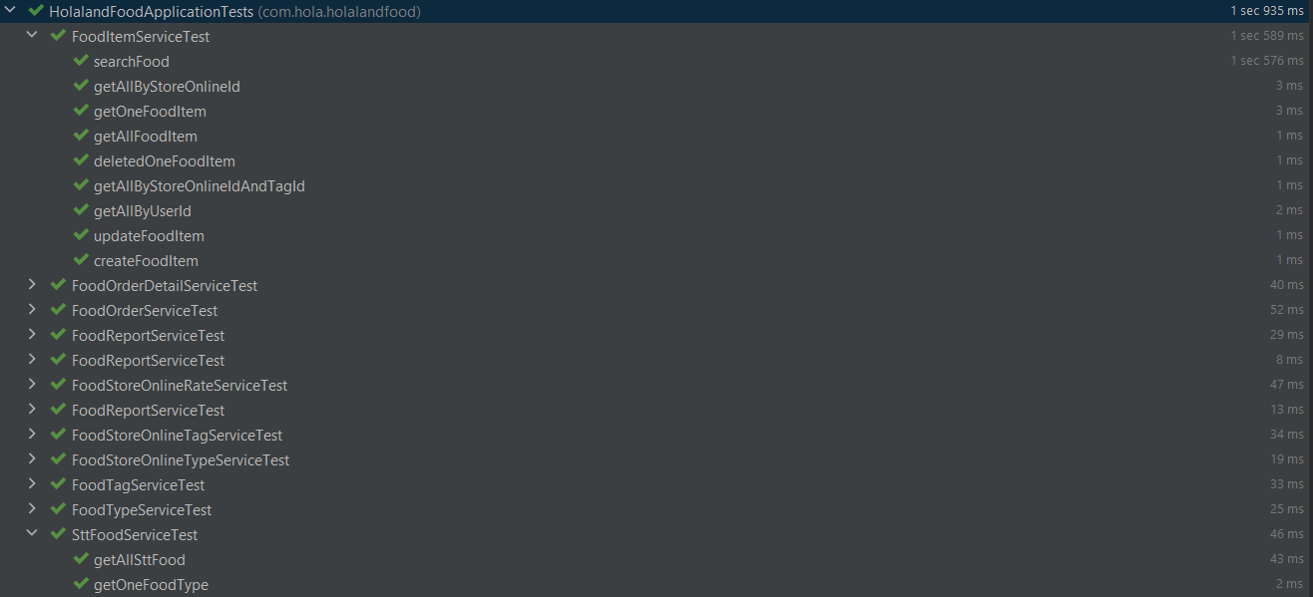

*Figure 5.7: Unit Test Report*

### 4.2 Integration Test Report

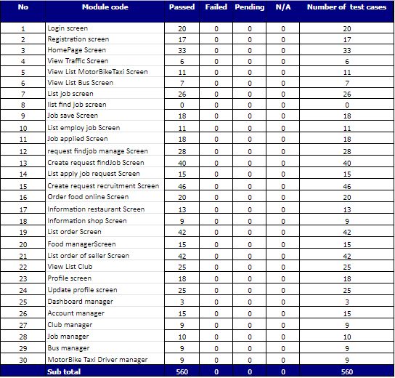

*Figure 5.8: Integration Test Report*

### 4.3 System Test Report

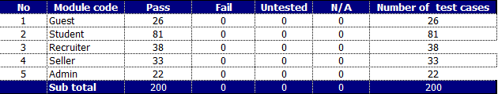

*Figure 5.9: System Test Report*

### 4.4 Acceptance Test Report

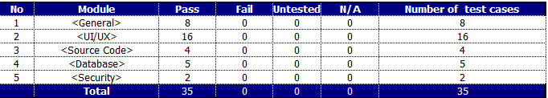

*Figure 5.10: Acceptance Test Report*

# VI. Release Package & User Guides

## 1. Deliverable Package

### 1.1 Source codes & documents

|  |  |  |  |  |
| --- | --- | --- | --- | --- |
| **No** | **Items** | **Sub-Items** | **Type** | **Version** |
| ***Code Package*** | | | | |
| 1 | Source Code | HolaLand_SourceCode.zip | New | 1.0 |
| ***Documents*** | | | | |
| 1 | Final Report | HolaLand_KLTN.pdf | New | 1.0 |
| ***Slide*** | | | | |
| 1 | Slide | HolaLand_Slide.ppt | New | 1.0 |
| ***Testing*** | | | | |
| 1 | Integration test | Integration-Testing.xlsx | New | 1.0 |
| 2 | System test | SystemTestCase.xlsx | New | 1.0 |
| 3 |  |  |  |  |

*Table 6.1 Source codes & documents*

### 1.2 Known Issues, Limitations & Restrictions

N/A

## 2. Installation Guides

### 2.1 System Requirements

* Windows 10 Professional 64 bit, Intel® Core™ i5, RAM 8.00GB:
* JDK v11.0.12
* IntelliJ IDEA Utimate v2021.2.1
* MySQL v8.0
* DataGrip v2021.2.2
* Visual Studio Code v1.51

### 2.2 Installation Instruction

#### 2.2.1 Install HolaLand project

* Install JDK version 11.0.12 by following the instruction at:

<https://www.oracle.com/java/technologies/javase/jdk11-archive-downloads.html>

* Install IntelliJ IDEA Ultimate v2021.2.1 by following the instruction at:

<https://www.jetbrains.com/help/idea/installation-guide.html#standalone>

* Download and install MySQL version 8.0 at:

<https://dev.mysql.com/downloads/mysql/>

* Install DataGrip v2021.2.2 by following the instruction:

[https://www.jetbrains.com/help/datagrip/installation-guide.html#standalone](https://www.jetbrains.com/help/datagrip/installation-guide.html%23standalone)

* Open HolaLand project with IntelliJ IDEA
* Create a database in MySQL
* Go to file holaland-web/src/main/resources/application.properties and rename database name with the created database, username & password with username & password of MySQL

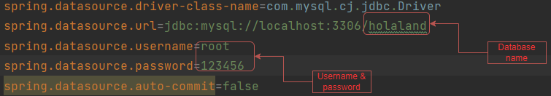

*Figure 6.1: Database config guideline*

* Click run project

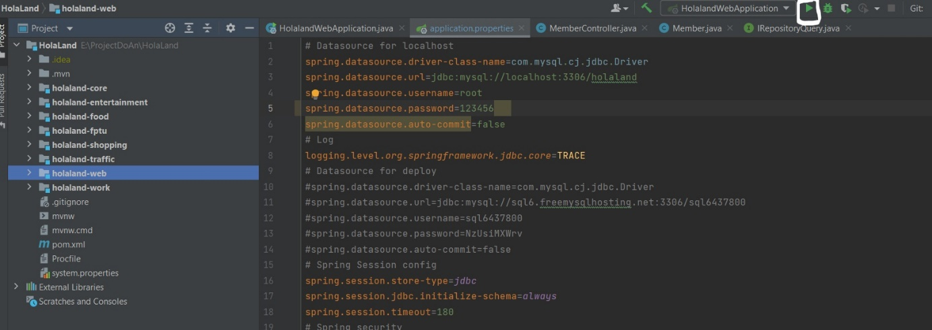

*Figure 6.2: Run HolaLand project guideline*

## 3. User Manual

### 3.1 Terms and definitions

N/A

### 3.2 System requirements

* Windows 10 Professional 64 bit, Intel® Core™ i5, RAM 8.00GB:
* JDK v11.0.12
* IntelliJ IDEA Utimate v2021.2.1
* MySQL v8.0
* DataGrip v2021.2.2
* Visual Studio Code v1.51

### 3.3 Application Usage

#### 3.3.1 Guest

##### 3.3.1.1 View HomePage

* Step 1:Access homepage
* Step 2:User can view all modules on the HolaLand website

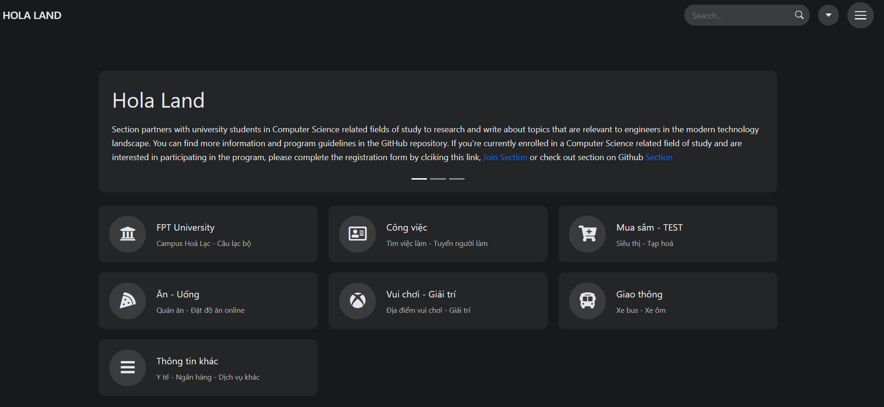

*Figure 6.3:HomePage Screen*

##### 3.3.1.2 Sign up

* Step 1:Access homepage.
* Step 2:Click “Đăng kí tài khoản” on the top right of website.

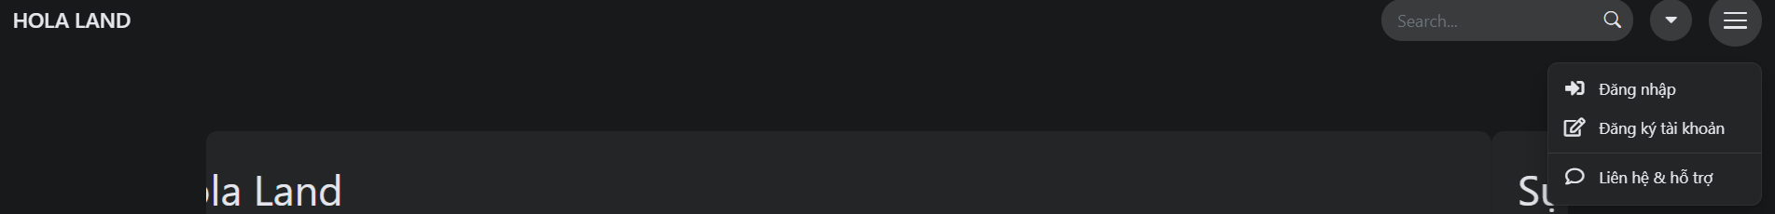

*Figure 6.4:Combobox HomePage*

* Step 3: Input all the information and click the “Đăng ký” button.

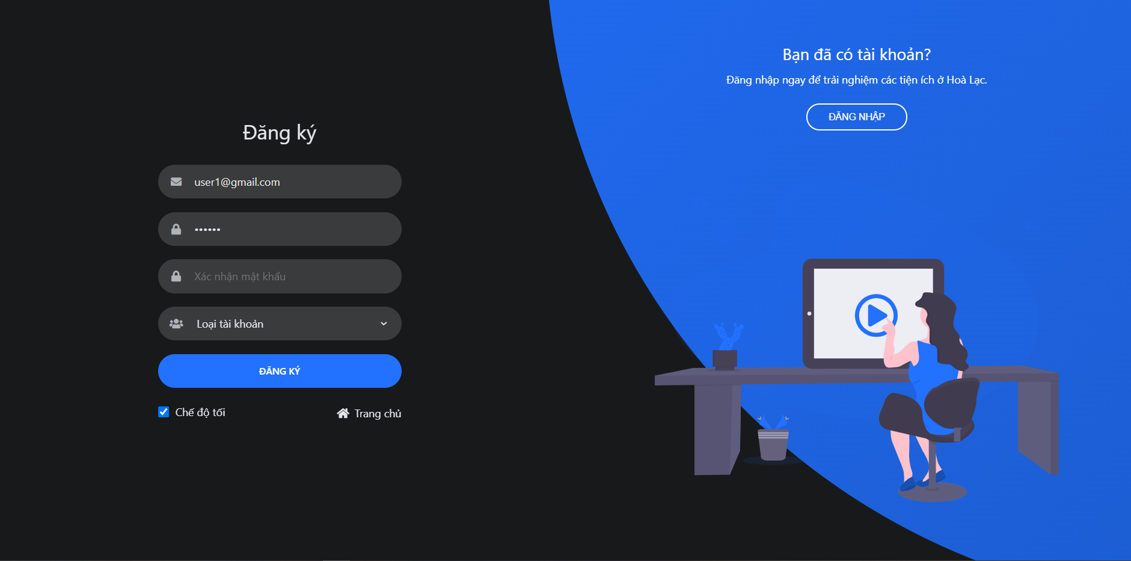

*Figure 6.5:Sign up Screen*

##### 3.3.1.3 View module FPT University

* Step 1:Access homepage
* Step 2:Click “FPT University”
* Step 3:User can view all clubs in university and the detail of each club

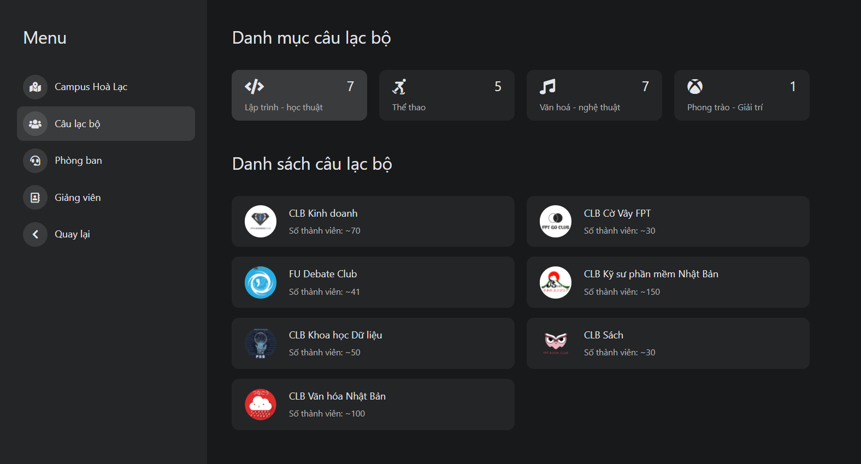

*Figure 6.6:List club Screen*

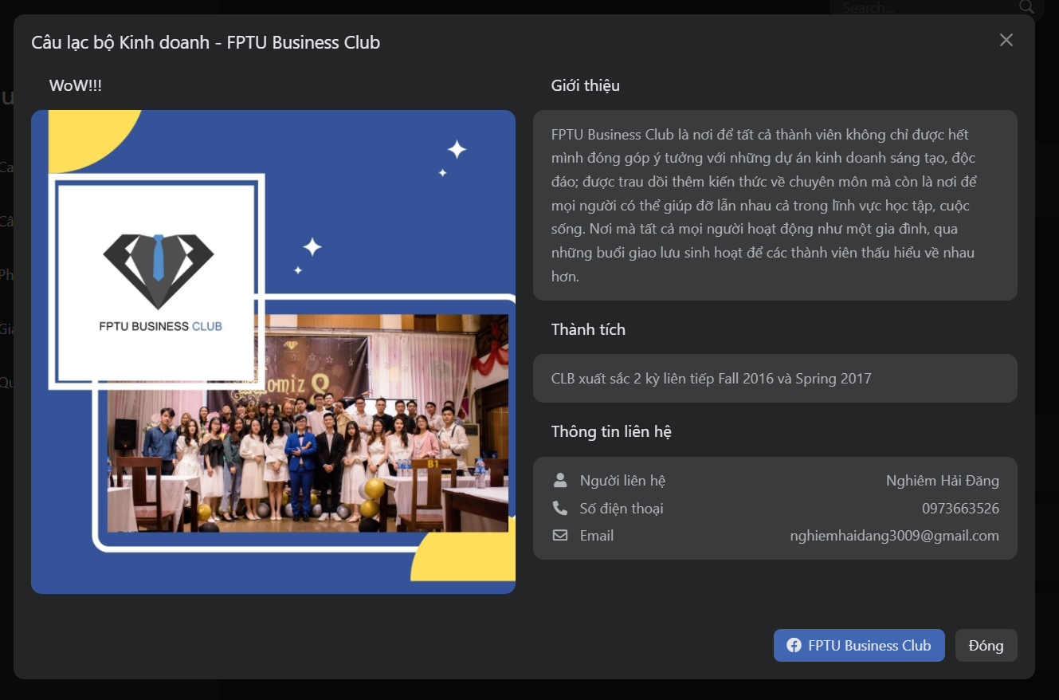

*Figure 6.7:Detail club Screen*

##### 3.3.1.4 View module “Công việc”

* Step 1:Access homepage
* Step 2:Click “Công việc”
* Step 3:Click “Danh sách việc làm”.User can view all request recruitment of recruiter and detail request

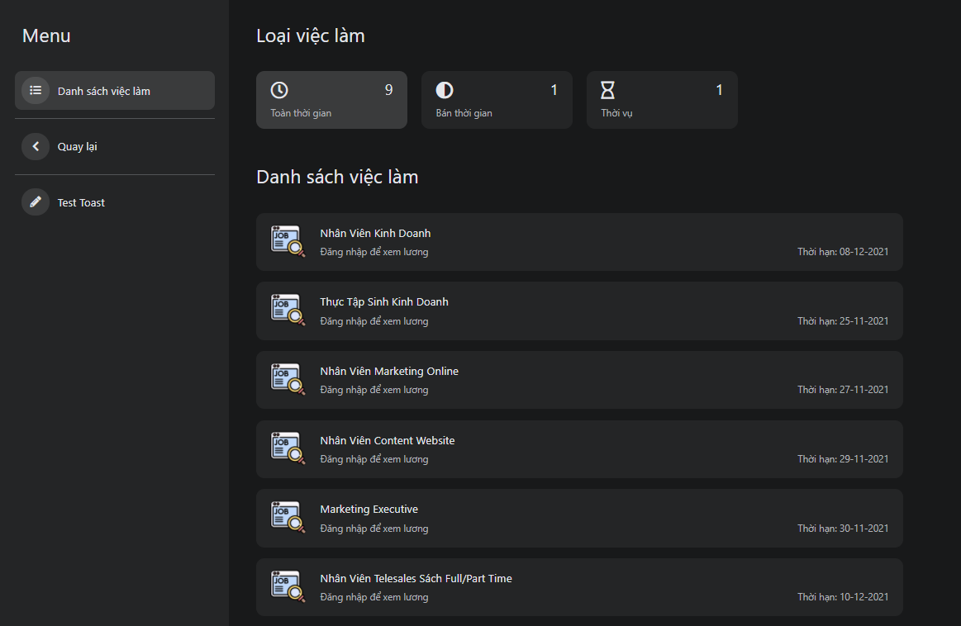

*Figure 6.8:List job Screen*

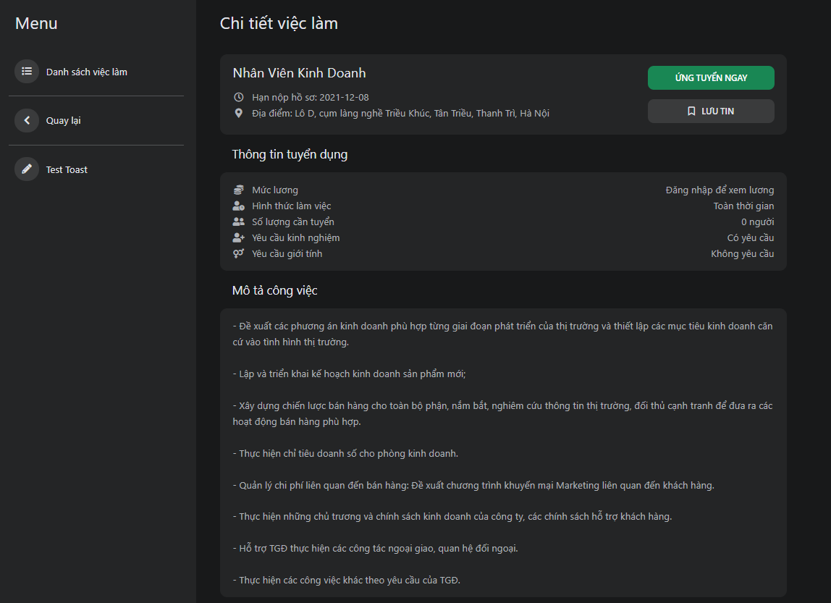

*Figure 6.9:Detail job Screen*

##### 3.3.1.5 View module “Ăn-uống”

* Step 1:Access homepage
* Step 2:Click “Ăn uống”
* Step 3: Click “Đặt đồ online” user can view a list of all list stores is selling food

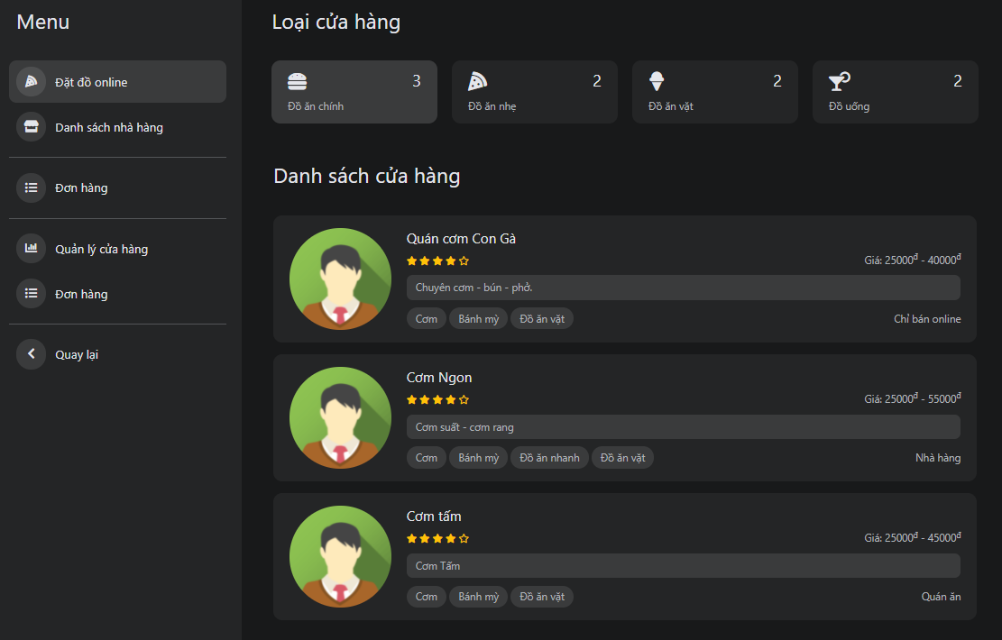

*Figure 6.10:List store Screen*

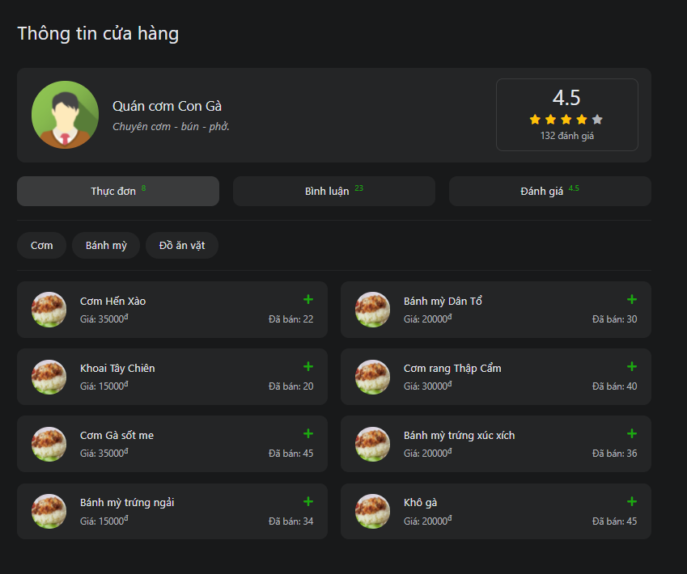

*Figure 6.11:Detail Store Screen*

##### 3.3.1.6 View module “Giao thông”

* Step 1:Access homepage
* Step 2:Click “Giao thông”
* Step 3:User can view all bus, detail bus routes, and list motorcycle taxi driver

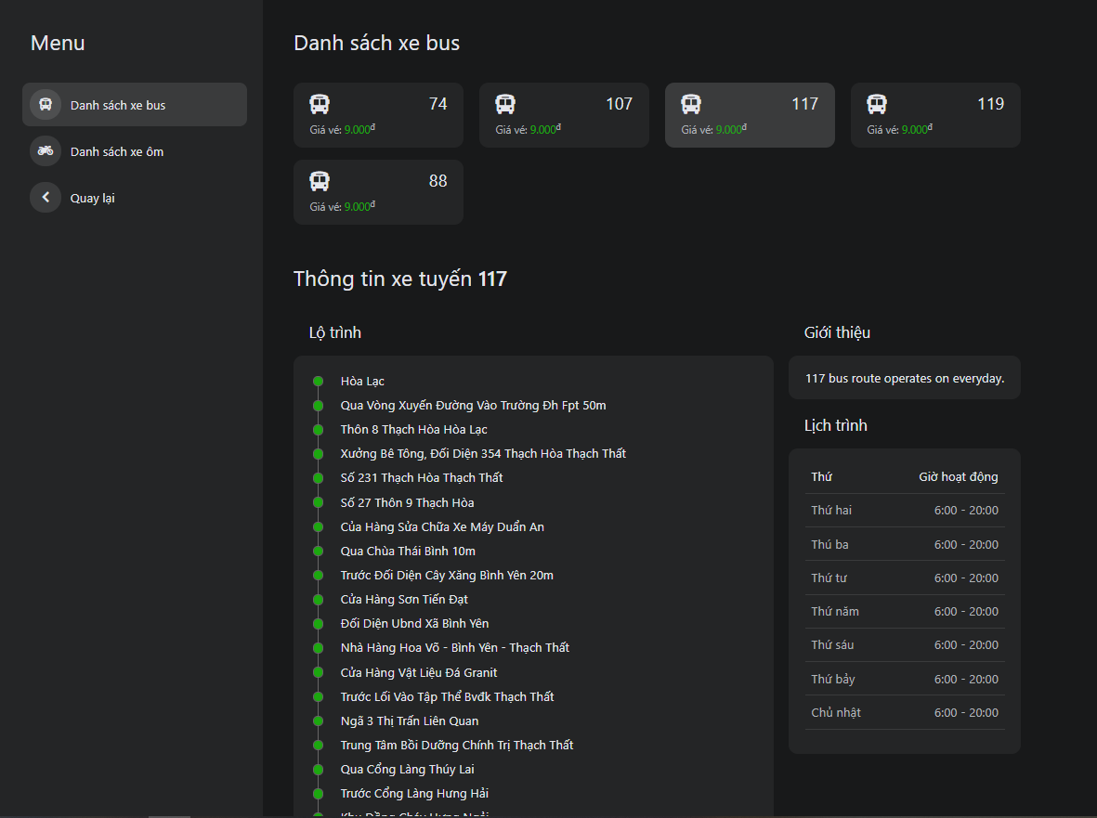

*Figure 6.13:List bus Screen*

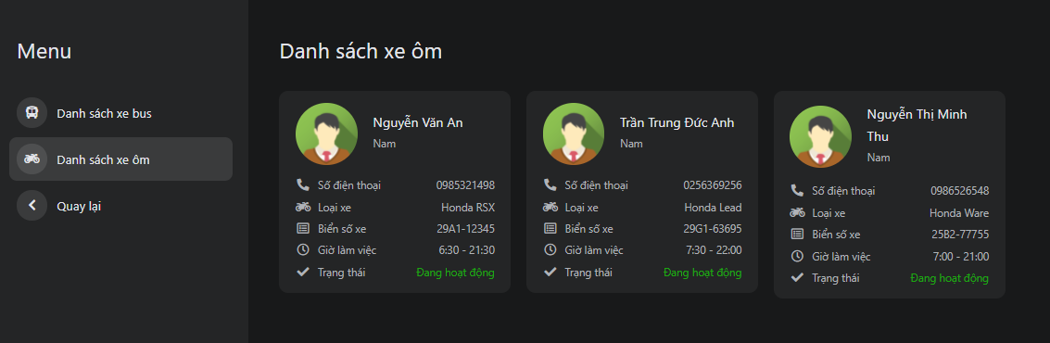

*Figure 6.14:List motorcycle taxi driver Screen*

##### 3.3.1.7 View detail store

* Step 1:Access homepage
* Step 2:Click “Ăn -uống”
* Step 3:Click any store what you want to view detail
* Step 4:User can view a list of food items, comment, and rate the food of another user

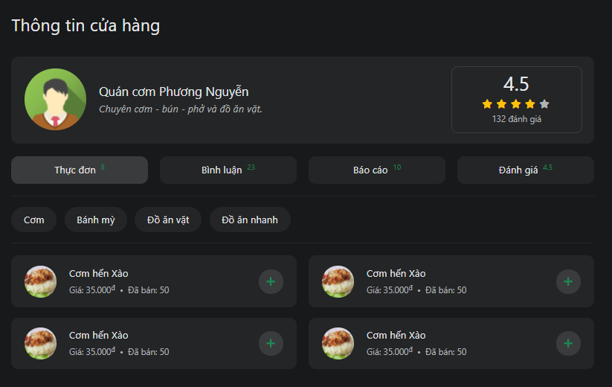

*Figure 6.15:Detail store Screen*

#### 3.3.2 Registered User

##### 3.3.2.1 Sign in

* Step 1:Access homepage.
* Step 2:Click “Đăng nhập” on the top right of the website.

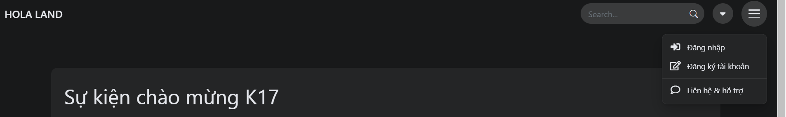

*Figure 6.16:Combobox HomePage*

* Step 3: Input email and password and click “Đăng nhập” button

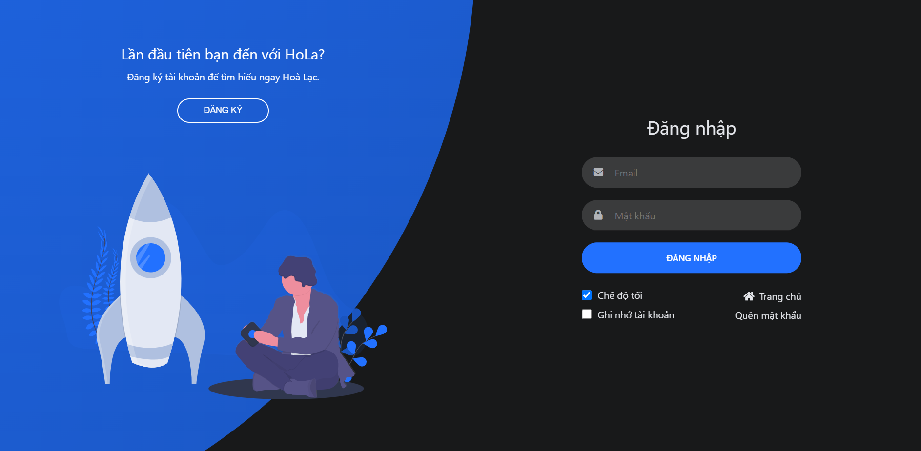

*Figure 6.17:Sign in Screen*

##### 3.3.2.2 Sign out

* Step 1:Access homepage.
* Step 2:Click the icon user in the top right of the website.
* Step 3:Click “Đăng xuất”



*Figure 6.18:Combobox HomePage*

##### 3.3.2.3 View profile info

* Step 1:Access homepage
* Step 2:Click icon user in the top right of the website
* Step 3:Click “Trang cá nhân”

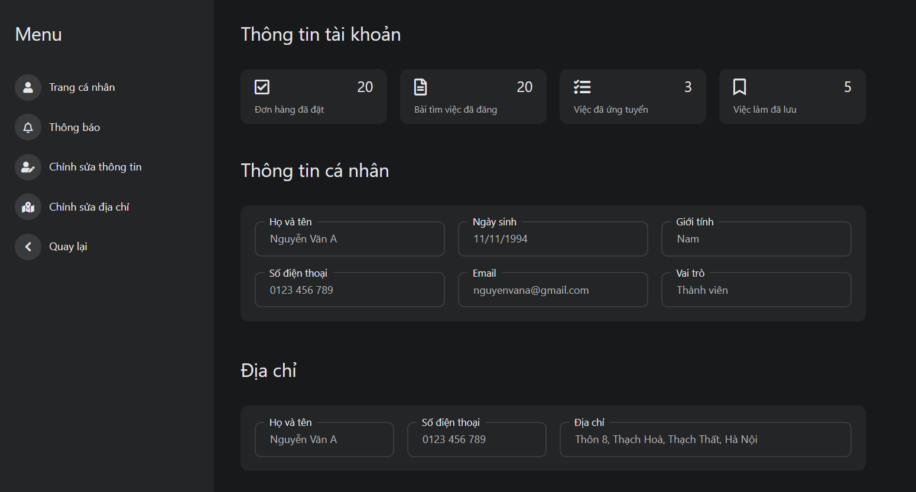

*Figure 6.19:Profile info Screen*

##### 3.3.2.4 Update profile, change password

* Step 1:Go to profile screen
* Step 2:Click “Chỉnh sửa thông tin” in the menu

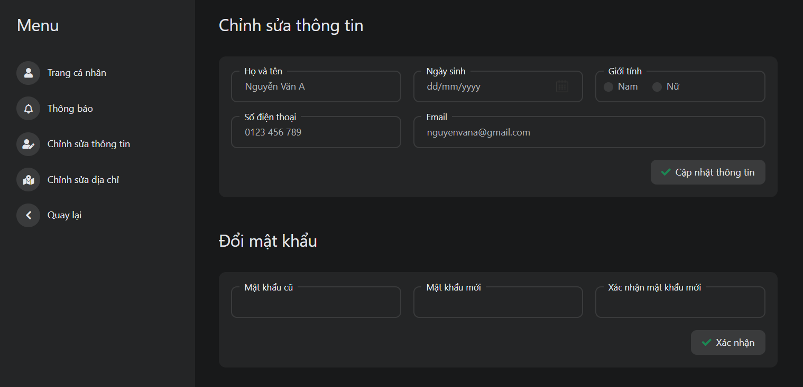

*Figure 6.20:Update profile Screen*

* Step 3:User can update profile or change password

##### 3.3.2.5 Edit address

* Step 1:Go to profile screen
* Step 2:Click “Chỉnh sửa địa chỉ” in the menu
* Step 3:User can edit the name, phone number, address and set the default address

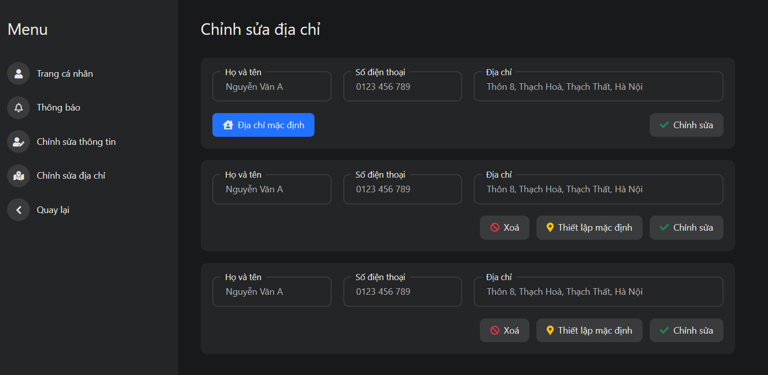

*Figure 6.21:Update address Screen*

* Step 4:Click “Chỉnh sửa” button

##### 3.3.2.6 View list order

* Step 1:Access module “Ăn uống”
* Step 2:Click “Đơn hàng”
* Step 3:User can view list order with another status as “Chờ xác nhận”, “Đã xác nhận”, “Hoàn thành” và “Đã từ chối”

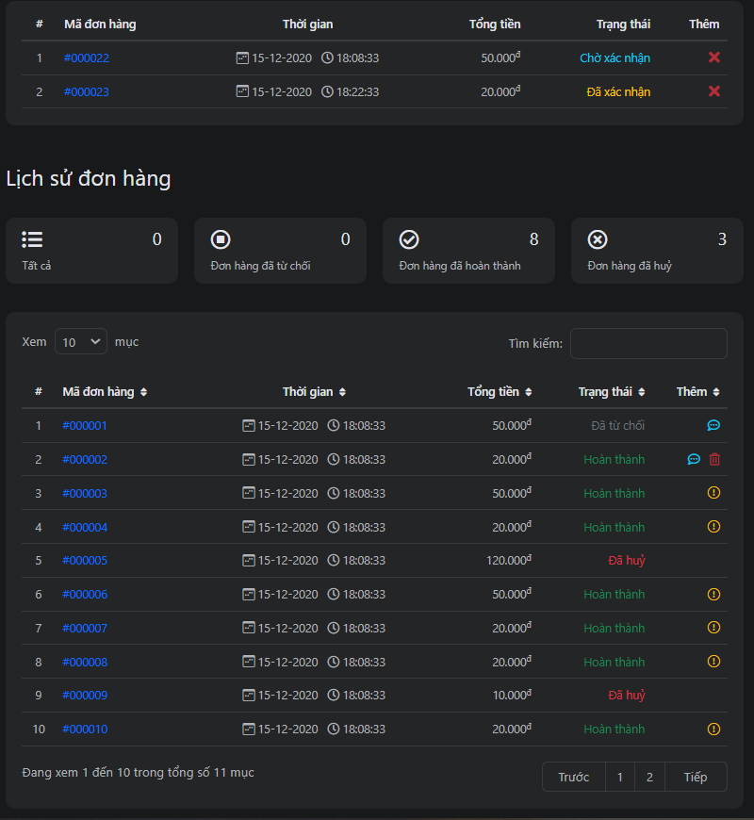

*Figure 6.22:List user order Screen*

##### 3.3.2.7 Cancel order/Report order

* Step 1:Access order screen
* Step 2:If order is in status “Chờ xác nhận” => User can cancel an order, If an order is in status “Hoàn thành” => User can report order

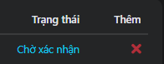

*Figure 6.23:Cancel order in list user order Screen*

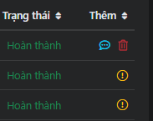

*Figure 6.24:Report order in list user order Screen*

##### 3.3.2.8 Order food

* Step 1:Access detail store screen
* Step 2:Click “+” button to order food items

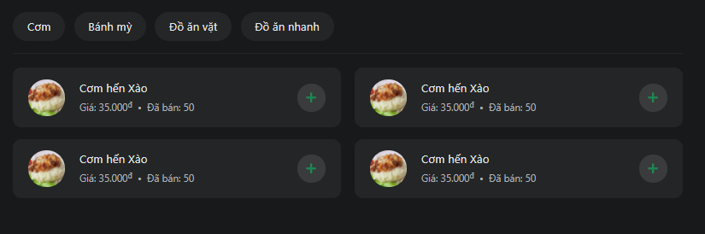

*Figure 6.25:List food Screen*

* Step 3:Click “giỏ hàng”



*Figure 6.26:Task bar in “Ăn-uống” module Screen*

* Step 4:In “giỏ hàng” screen, the user can increase thenumbery of items, delete an item, cancel the order and confirm the order

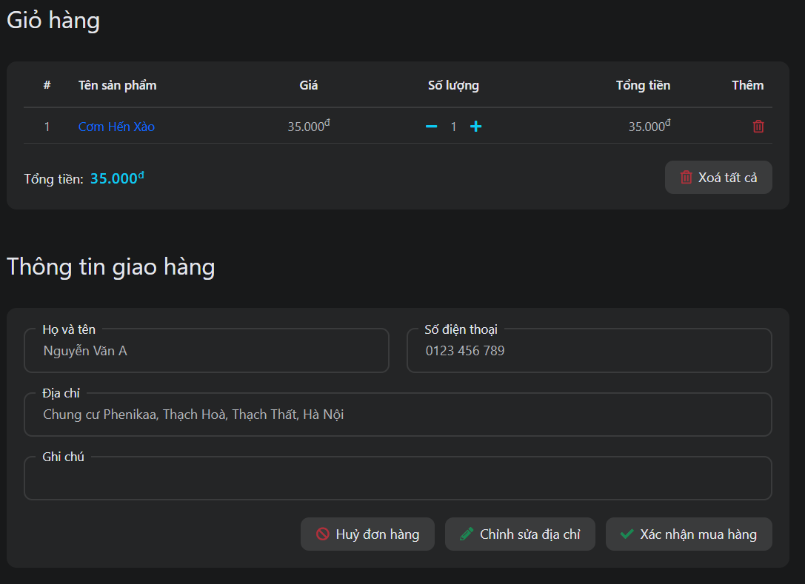

*Figure 6.27:Add to cart Screen*

##### 3.3.2.9 Rate and comment restaurant

* Step 1:Access detail store screen
* Step 2:Click “Đánh giá”
* Step 3:User select star and input comment

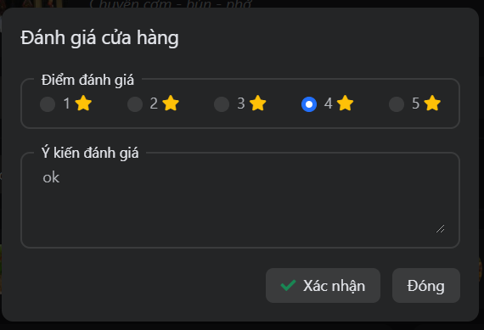

*Figure 6.28:Modal rate and comment store Screen*

* Step 4:Click “xác nhận”. All information will be moved to the comment section

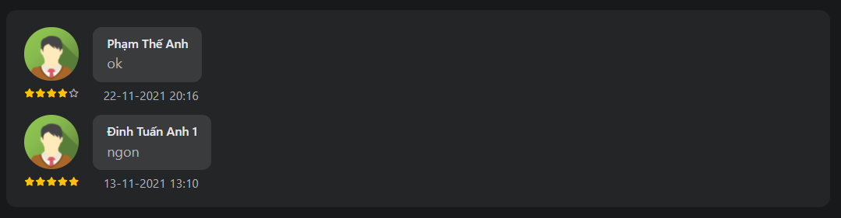

*Figure 6.29:Comment Screen*

##### 3.3.2.10 Search

* Step 1:Access to HomePage
* Step 2:Enter the word you need to search in the search bar



*Figure 6.30:Search bar Screen*

* Step 3:System redirect to the search screen. Users can select the module youtheynt to search

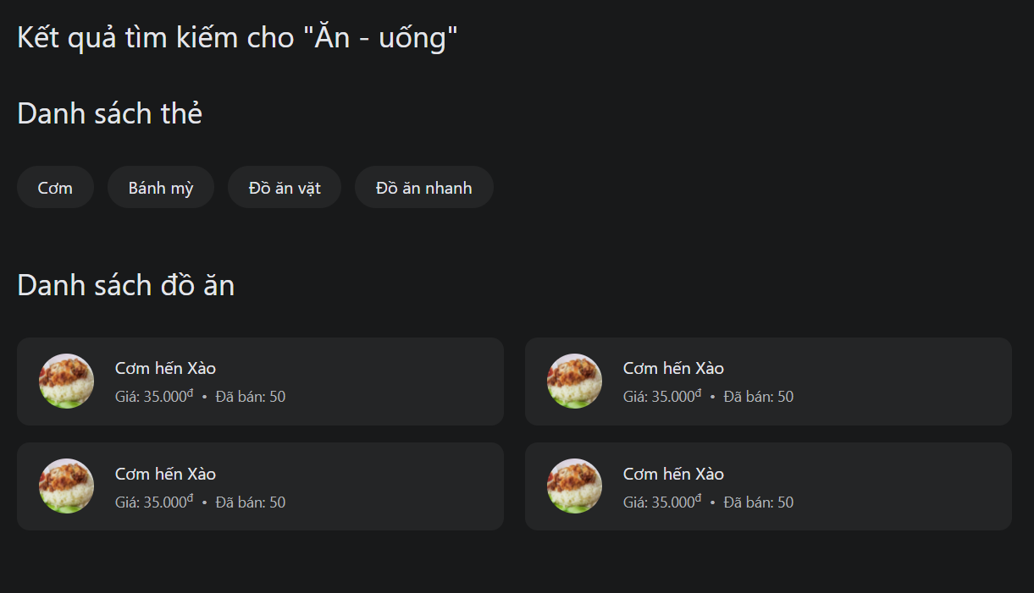

*Figure 6.31:Search Screen in module food*

#### 3.3.3 Student

##### 3.3.3.1 View “Danh sách thuê”

* Step 1:Go to the homepage
* Step 2:Click “Công việc”
* Step 3: Click “danh sách thuê”.User with role student can view list hire

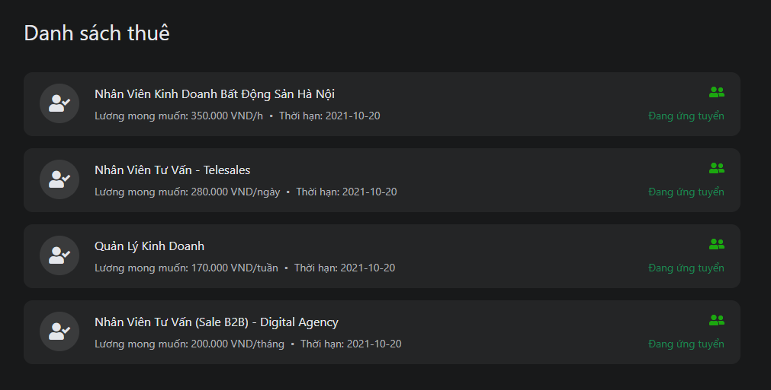

*Figure 6.32:List job hire screen*

##### 3.3.3.2 View “việc làm đã ứng tuyển”

* Step 1:Go to the homepage
* Step 2:Click “Công việc”
* Step 3: Click “việc làm đã ứng tuyển”.Users with role students can view a list of jobs applied

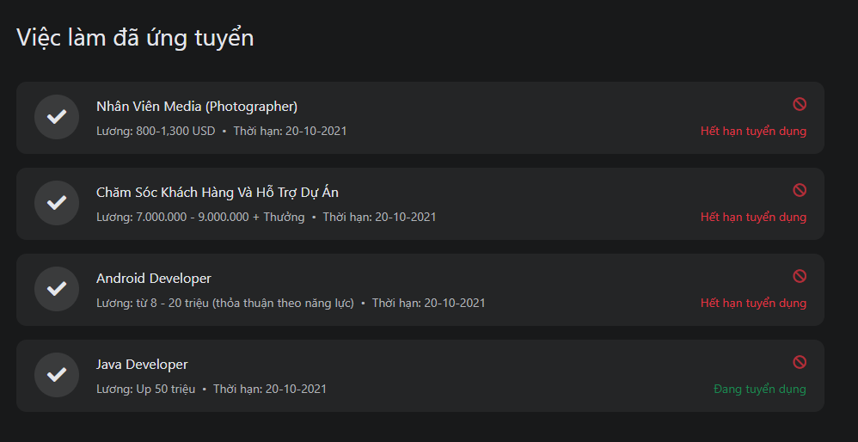

*Figure 6.33:List applied job screen*

##### 3.3.3.3 View “việc làm đã lưu”

* Step 1:Go to the homepage
* Step 2:Click “Công việc”
* Step 3: Click “việc làm đã lưu”.Users with role students can view a list of jobs saved

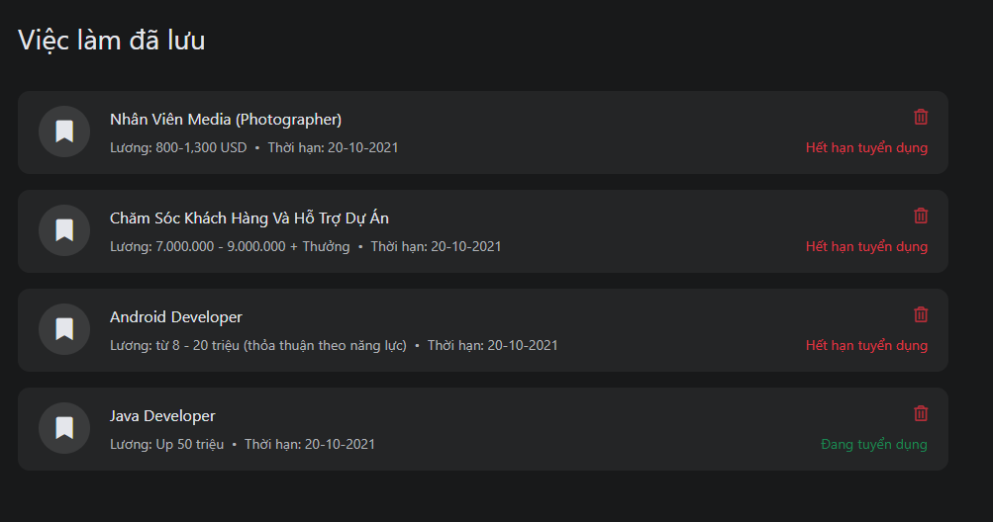

*Figure 6.34:List job save Screen*

##### 3.3.3.4 Create a request to find a job

* Step 1:Go to the homepage
* Step 2:Click “Công việc”
* Step 3:Click “viết bài tìm việc” in the left menu
* Step 4:Input all information and click the “Đăng bài” button.

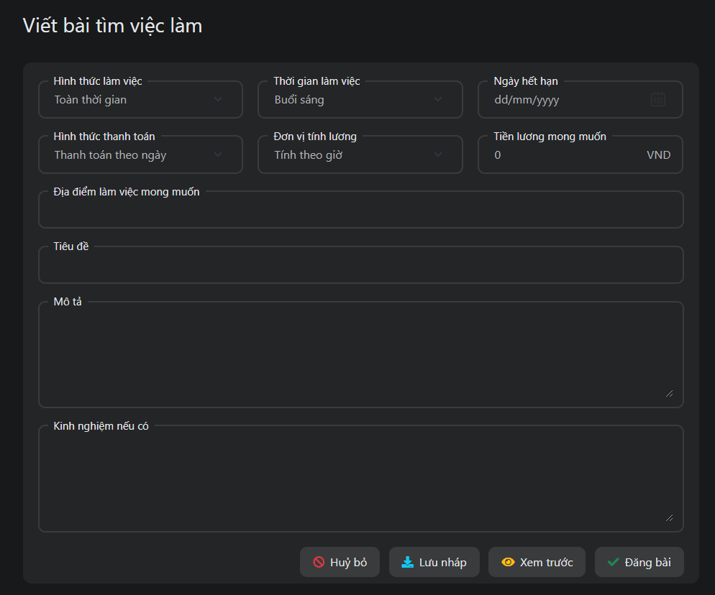

*Figure 6.35:Create request find job Screen*

##### 3.3.3.5 Delete request find a job

* Step 1:Go to the homepage
* Step 2:Click “Công việc”
* Step 3:Click “quản lý bài viết” in the left menu
* Step 4:User can delete any request of each status

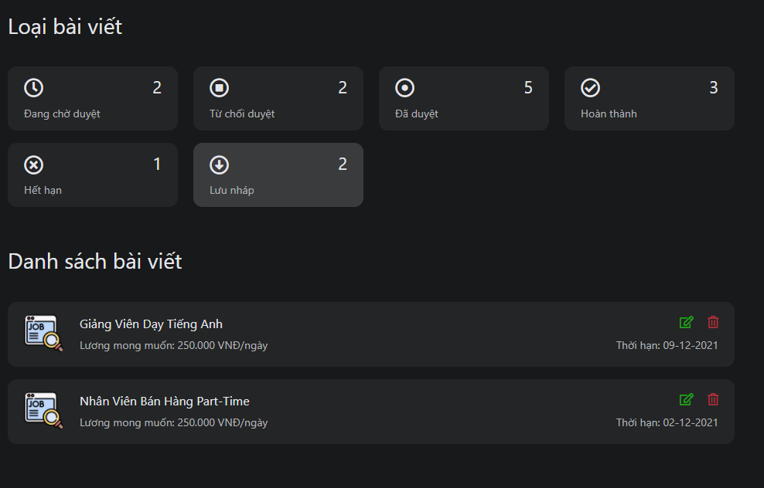

*Figure 6.36:Manage request find job Screen*

##### 3.3.3.6 Update request find a job

* Step 1:Go to the homepage
* Step 2:Click “Công việc”
* Step 3:Click “quản lý bài viết” in the left menu
* Step 4:Click “Hoàn thành” or “Hết hạn” status
* Step 5:Click repost button

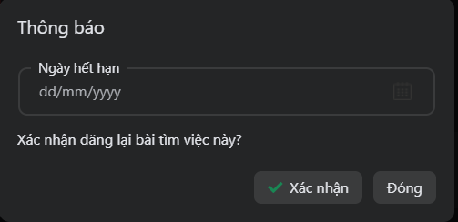

*Figure 6.37:Modal repost request find job Screen*

* Step 6:Click “Xác nhận” button

##### 3.3.3.7 Apply for a job

* Step 1:Go to the homepage
* Step 2:Click “Công việc”
* Step 3:Click “Danh sách việc làm” in the left menu
* Step 4:Click any request to find a job

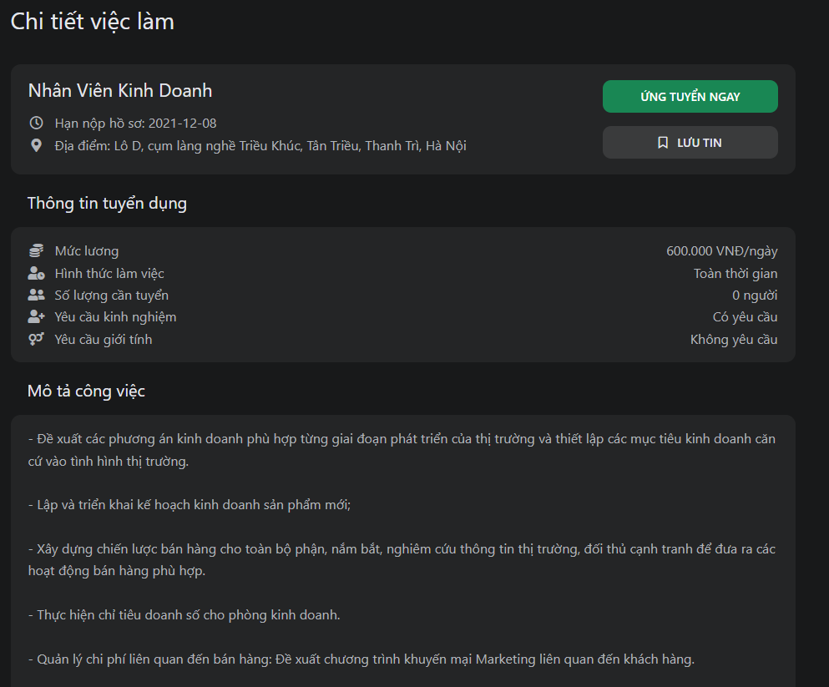

*Figure 6.38:Detail job recruitment screen*

* Step 5:Click “Ứng tuyển ngay” button

##### 3.3.3.8 Save job

* Step 1:Go to the homepage
* Step 2:Click “Công việc”
* Step 3:Click “Danh sách việc làm” in the left menu
* Step 4:Click any request to find a job



*Figure 6.39: Detail job recruitment screen*

* Step 5:Click “Lưu tin” button

#### 3.3.4 Recruitment

##### 3.3.4.1 View “danh sách tìm việc”

* Step 1:Go to the homepage
* Step 2:Click “Công việc”
* Step 3: Click “danh sách tìm việc”.Users with role recruitment can view a list find a job

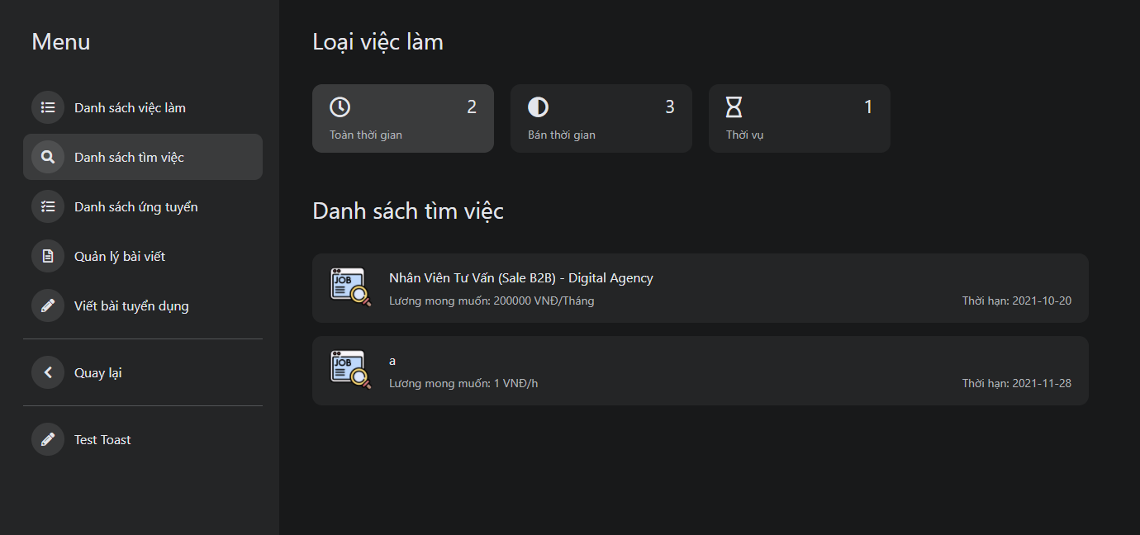

*Figure 6.40:List find job Screen*

##### 3.3.4.2 View “danh sách ứng tuyển”

* Step 1:Go to the homepage
* Step 2:Click “Công việc”
* Step 3: Click “danh sách ứng tuyển”.Users with role recruitment can view a list of jobs apply

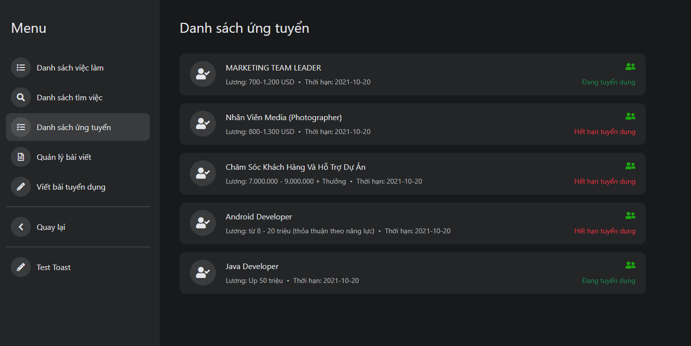

*Figure 6.41:List apply for job Screen*

##### 3.3.4.3 Create request recruitment

* Step 1:Go to the homepage
* Step 2:Click “Công việc”
* Step 3:Click “viết bài tuyển dụng” in the left menu
* Step 4:Input all information and click the “Đăng bài” button.

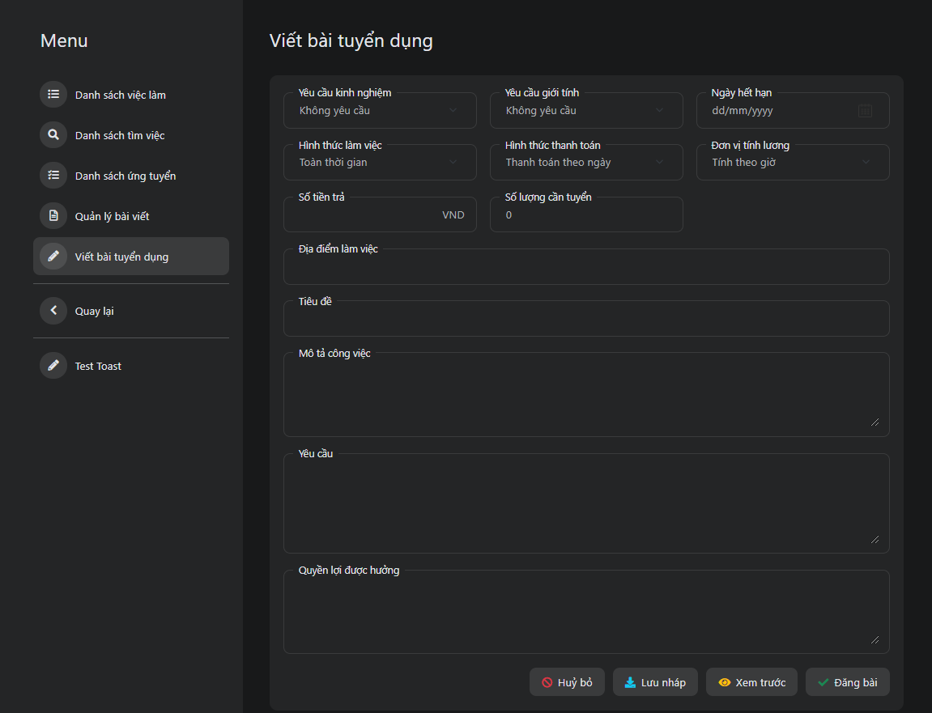

*Figure 6.42:Create request recruitment Screen*

##### 3.3.4.4 Delete request recruitment

* Step 1:Go to the homepage
* Step 2:Click “Công việc”
* Step 3:Click “quản lý bài viết” in the left menu
* Step 4:User can delete any request of each status

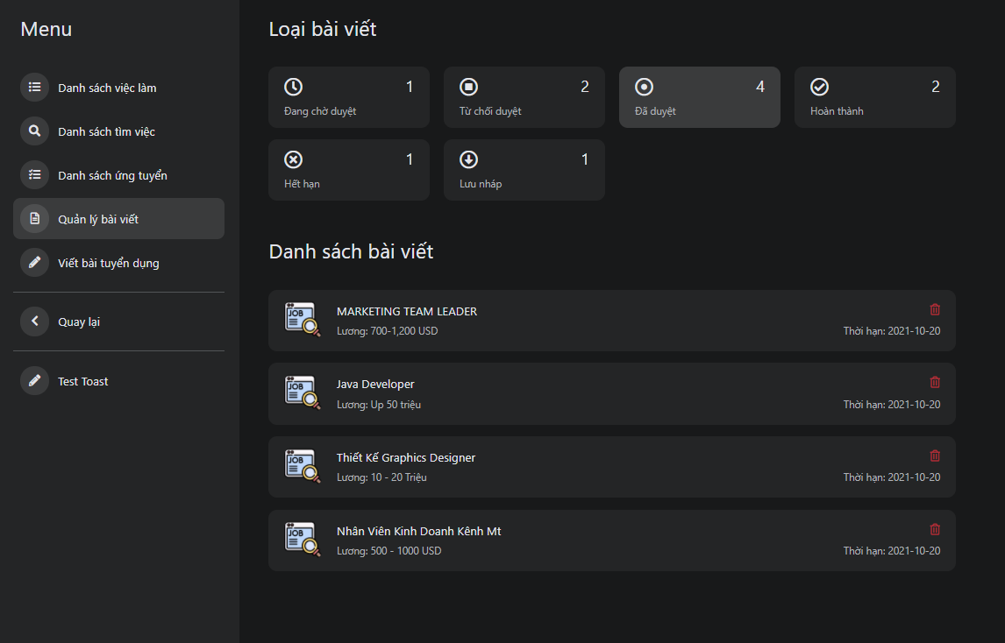

*Figure 6.43:Manage request recruitment Screen*

##### 3.3.4.5 Update request recruitment

* Step 1:Go to the homepage
* Step 2:Click “Công việc”
* Step 3:Click “quản lý bài viết” in the left menu
* Step 4:Click “Hoàn thành” or “Hết hạn” status
* Step 5:Click repost button



*Figure 6.44:Modal repost request recruitment*

* Step 6:Click “Xác nhận” button

##### 3.3.4.6 Hire worker

* Step 1:Access detail request find job screen
* Step 2: Click “thuê ngay” button



*Figure 6.45:Hire worker in detail job recruitment Screen*

#### 3.3.5 Seller

##### 3.3.5.1 Update shop information

* Step 1:Access to manage store screen
* Step 2:Click “Thông tin shop”
* Step 3:Click “Chỉnh sửa” button
* Step 4:Input information on what you need to update

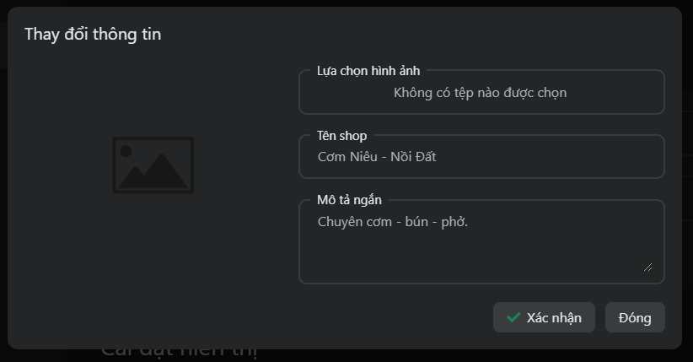 *Figure 6.46:Update shop info Screen*

##### 3.3.5.2 Update tag of food items

* Step 1:Access to manage store screen
* Step 2:Click “Quản lý thẻ - đồ ăn”
* Step 3:Click “Chỉnh sửa” button in list tag
* Step 4:Select tag to update and click the “Xác nhận” button

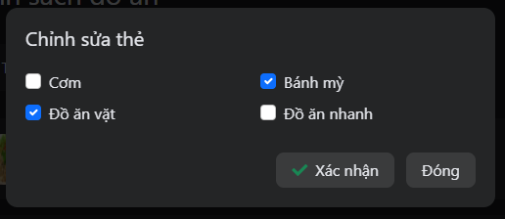

*Figure 6.47:Update tag of food Screen*

##### 3.3.5.3 Add food items to the shop

* Step 1:Access to manage store screen
* Step 2:Click “Quản lý thẻ - đồ ăn”
* Step 3:Click “Thêm sản phẩm mới” button
* Step 4:Select image, input name, price food, and select tag

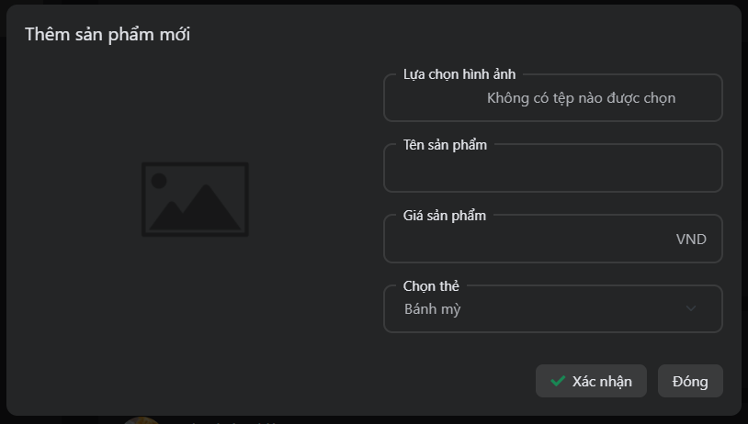

*Figure 6.48:Add food items Screen*

* Step 5:Click “Xác nhận” button

##### 3.3.5.4 Update food items

* Step 1:Access to manage store screen
* Step 2:Click “Quản lý thẻ - đồ ăn”
* Step 3:Click edit button
* Step 4:Select image,input name,price food, and select tag

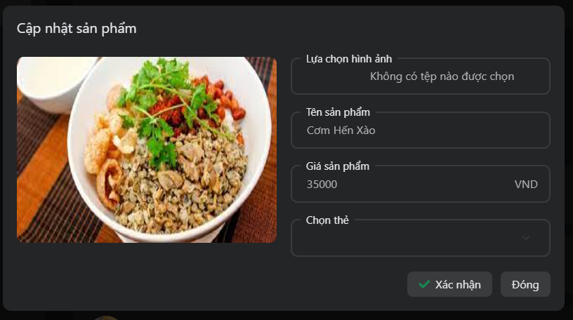 *Figure 6.49:Update food items Screen*

* Step 5:Click “Xác nhận” button

##### 3.3.5.5 Delete food items

* Step 1:Access to manage store screen
* Step 2:Click “Quản lý thẻ - đồ ăn”
* Step 3:Click delete button
* Step 4:Click “Xác nhận” button

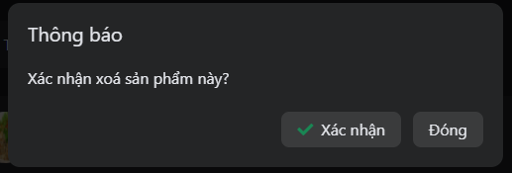

*Figure 6.50:Modal confirm delete items Screen*

##### 3.3.5.6 View list seller order

* Step 1:Access to manage store screen
* Step 2:Click “Quản lý cửa hàng”
* Step 3:Seller can view list order, detail order, approve and reject an order

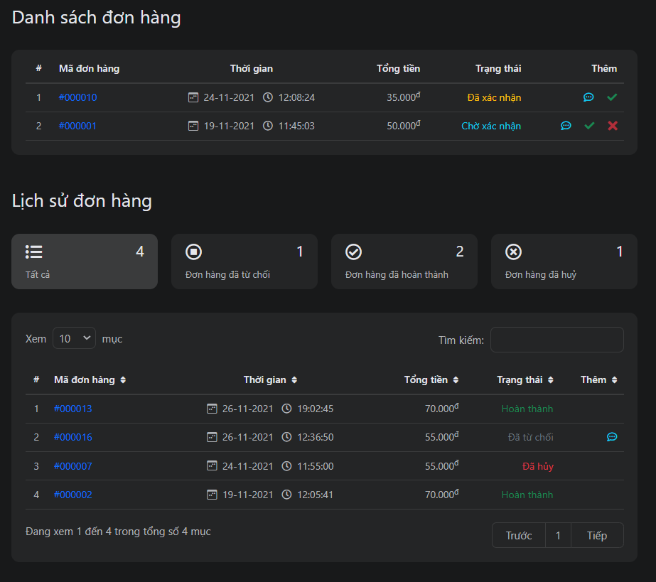

*Figure 6.51:List seller order Screen*

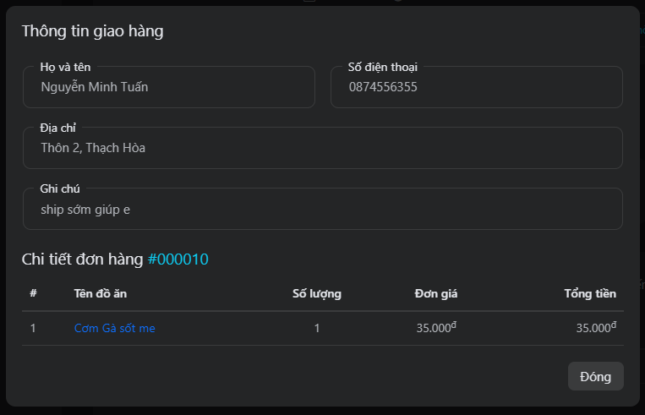

*Figure 6.52:Detail order Screen*

##### 3.3.5.7 View data-statistics

* Step 1:Access to manage store screen
* Step 2:Click “Quản lý cửa hàng”
* Step 3:Seller can view statistical chart about their store

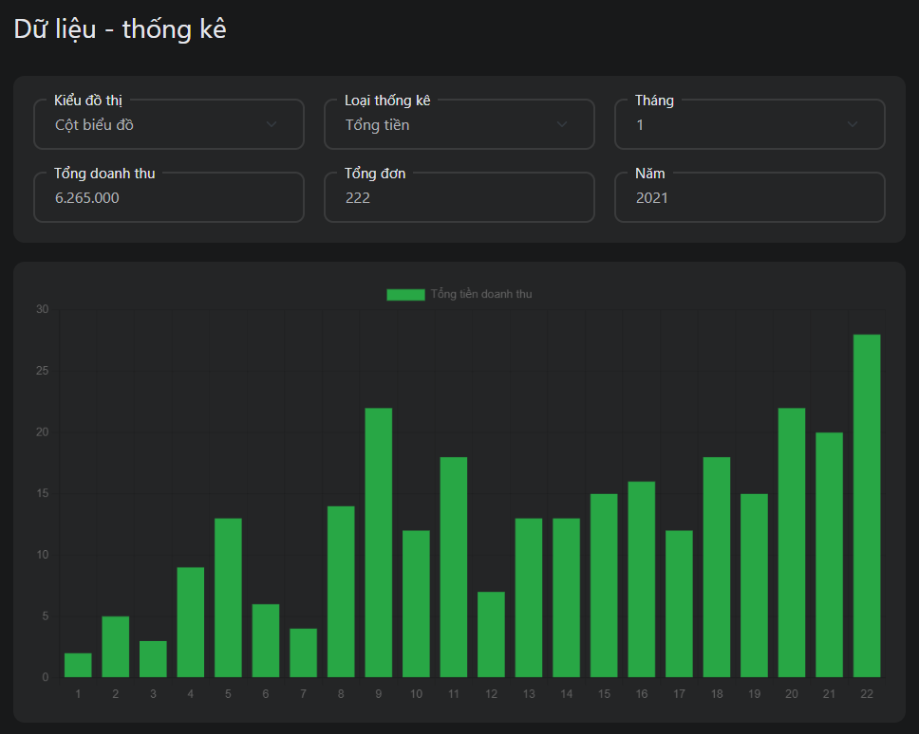

*Figure 6.53:Data-Statistics Screen*